Term Project
Winter 2016 – Group 4 – SYSC 3303

Philip Klostermann | 100983723
Rui LI | 100987686
Yanzhe Zhang | 100945940
Amr Gawish | 100897952
Loktin Wong | 100939428

Carleton University
April 4th, 2016

Table of Contents

Table of Contents 2
Team Work Breakdown 3
Iteration 1 3
Iteration 2 3
Iteration 3 3
Iteration 4 4
Iteration 5 4
Diagrams 5
Use Case Maps (UCMs) 5
Timing Diagrams 6
UML Class Diagrams 39
Readme 47
Files 47
Launching the application 48
Error Scenarios & Testing 52
Other design decisions 57

Team Work Breakdown

Iteration 1
Amr Gawish Planning, Diagrams
Loktin Wong Planning, Client, Intermediate, Server code
Yanzhe Zhang Planning, Client code, class diagrams
Rui Li Planning, Client code, class diagrams
Philip Klostermann Planning, Client code, Server protocol code Class Diagram

Iteration 2
Amr Gawish Planning, Timing Diagrams, Client menu
Loktin Wong Planning, Client error checking & handling
Yanzhe Zhang Planning, Intermediate Host Menu, Error scenario testing, Class & Timing Diagrams
Rui Li Planning, Format debugging output
Philip Klostermann Planning, Server error checking & handling, Intermediate Host error simulation, Class & Timing Diagrams

Iteration 3
Amr Gawish Client error / resending
Loktin Wong Client and server error / resending
Yanzhe Zhang All the Diagrams
Rui Li Client and Server error / resending
Philip Klostermann Intermediate Host, Client Server debugging

Iteration 4
Amr Gawish Discussions and Brainstorming, Testing
Loktin Wong Configuration, Configuration Menu, Error Handling client/server, Testing & Debugging
Yanzhe Zhang Logger class, Integration Testing, Debugging
Rui Li Timing Diagrams for IO errors, Discussions and Brainstorming
Philip Klostermann Server and Client rewrite, Server/Client IO exception handling, debugging, testing

Iteration 5
Amr Gawish Testing, Documents
Loktin Wong Update client IP modification
Yanzhe Zhang Implementing file locking, Testing
Rui Li Intermediate host logging, Testing
Philip Klostermann Updating Intermediate host for remote IPs, Testing

Diagrams

Use Case Maps (UCMs)
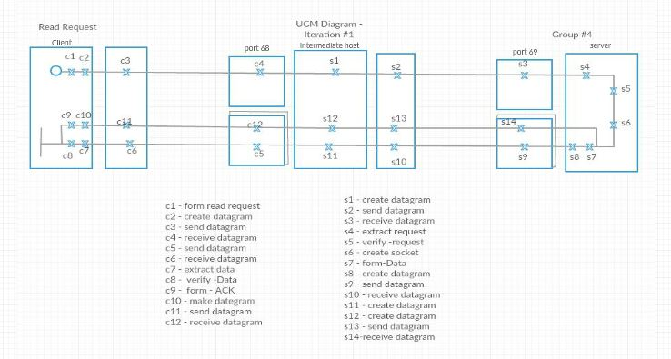
Figure 1: Read Request UCM

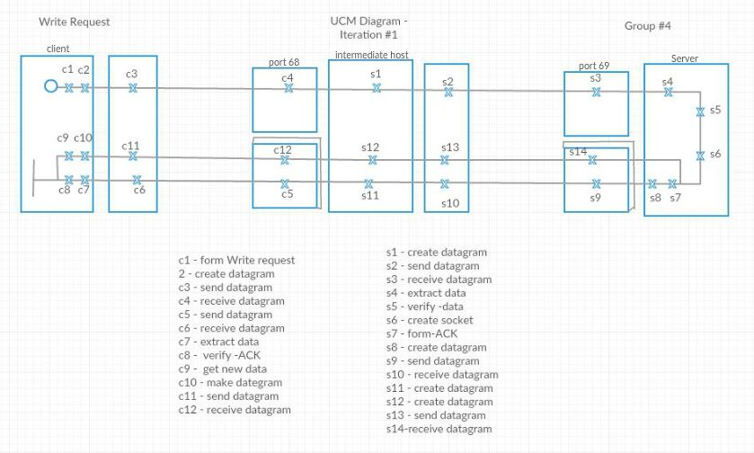
Figure 2: Write Request UCM

Timing Diagrams

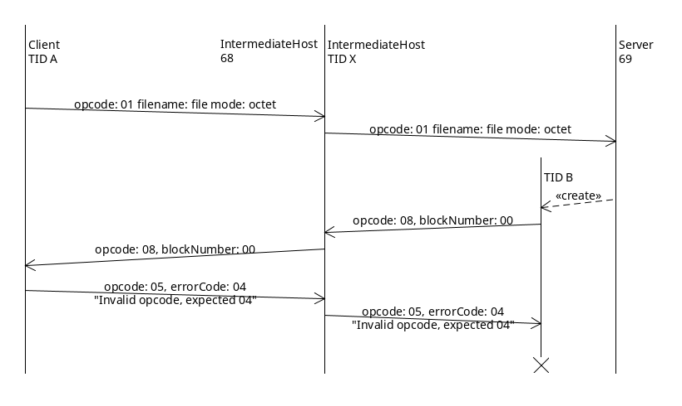
Figure 3: Invalid ACK – RRQ
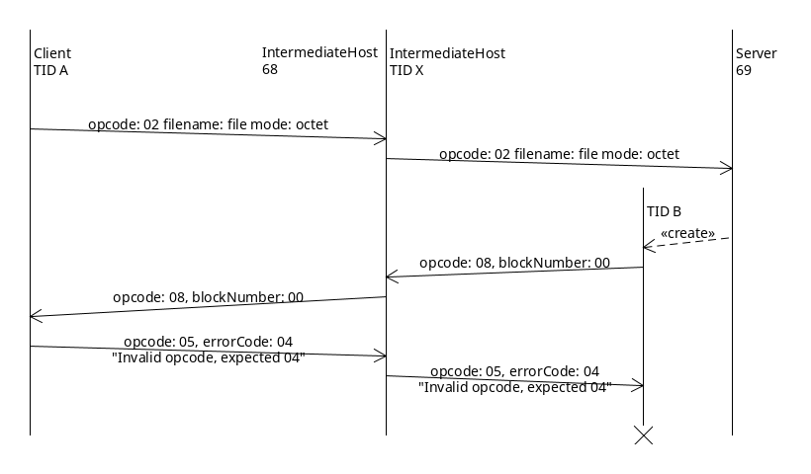
Figure 4: Invalid ACK – WRQ
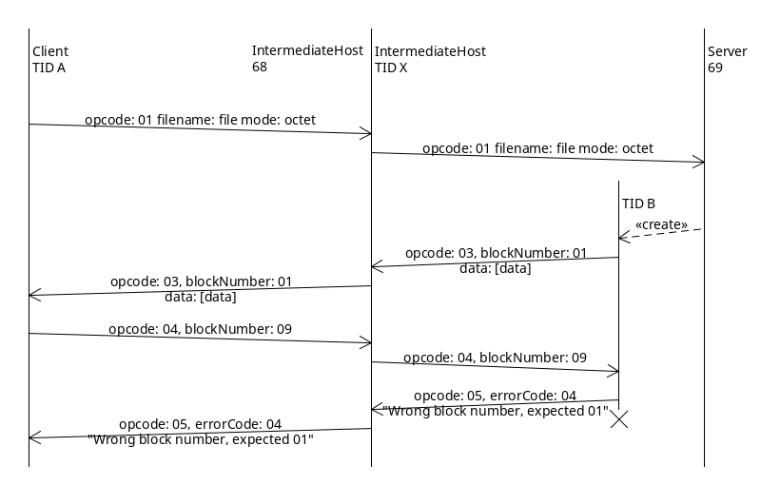
Figure 5: Invalid Block – ACK
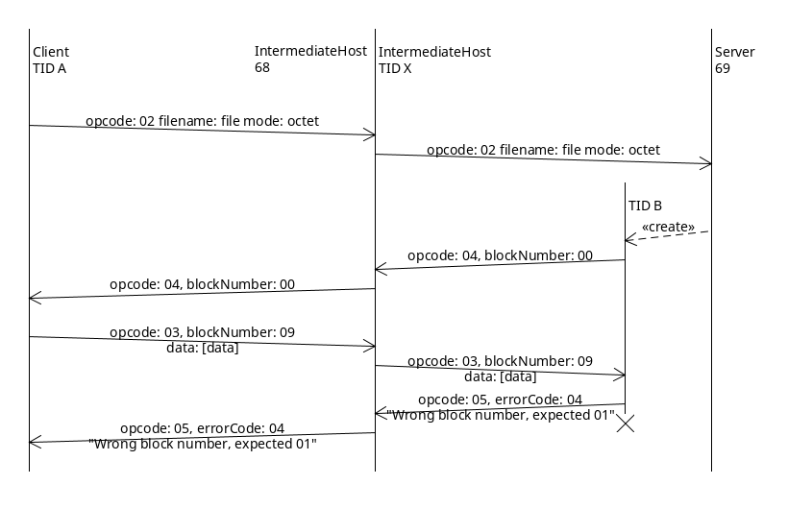
Figure 6: Invalid Block – DATA
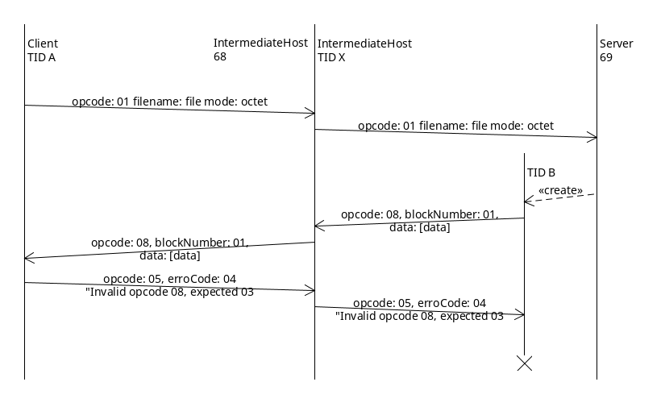
Figure 7: Invalid Data Packet – RRQ
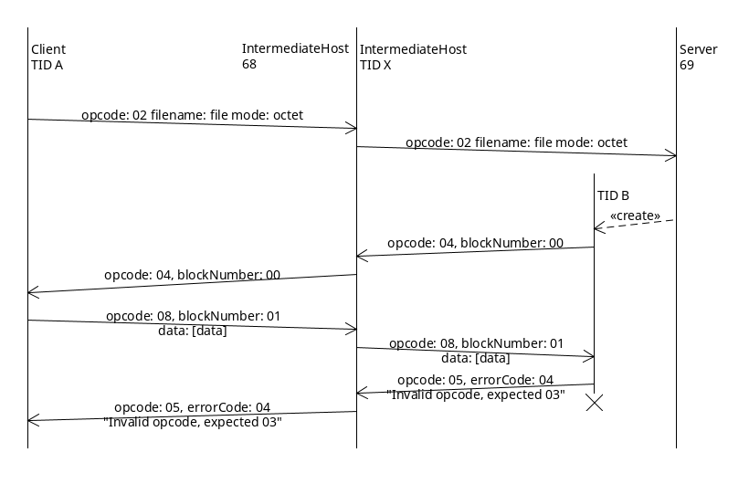
Figure 8: Invalid Data Packet – WRQ
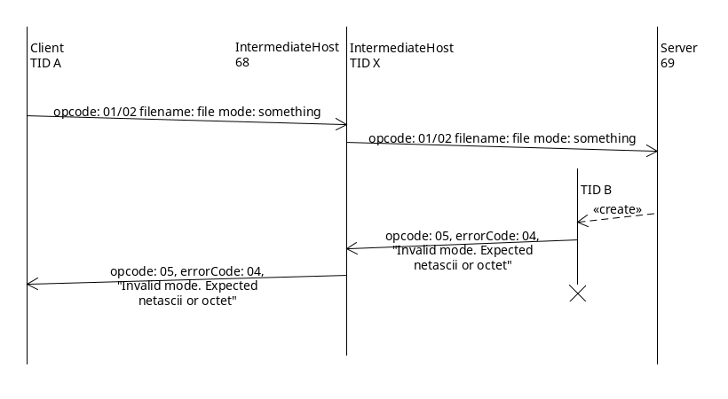
Figure 9: Invalid Request Mode
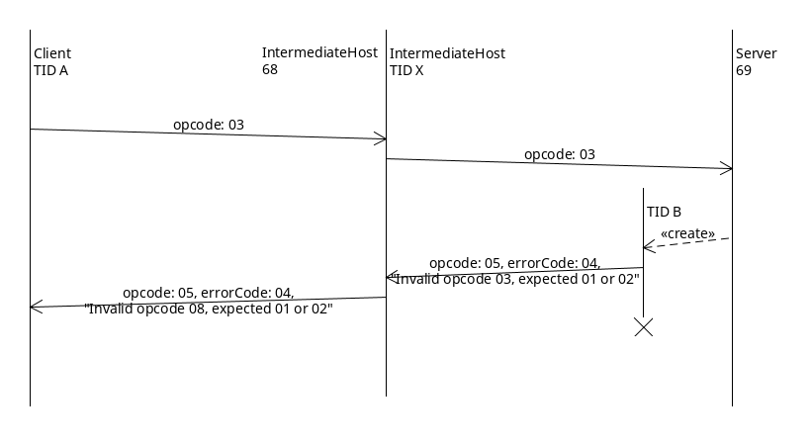
Figure 10: Timing Invalid Opcode

Figure 11: Timing Invalid Request Mode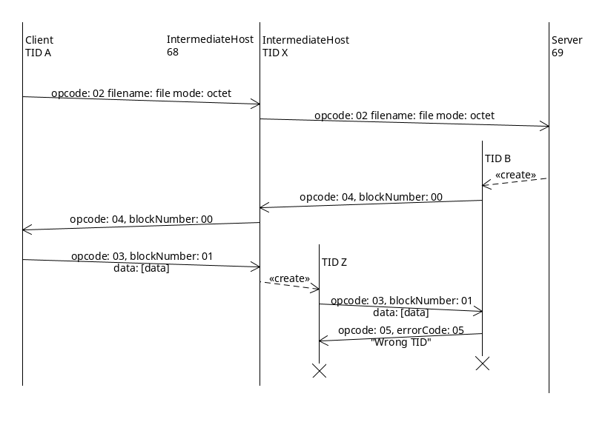
Figure 12: Wrong TID
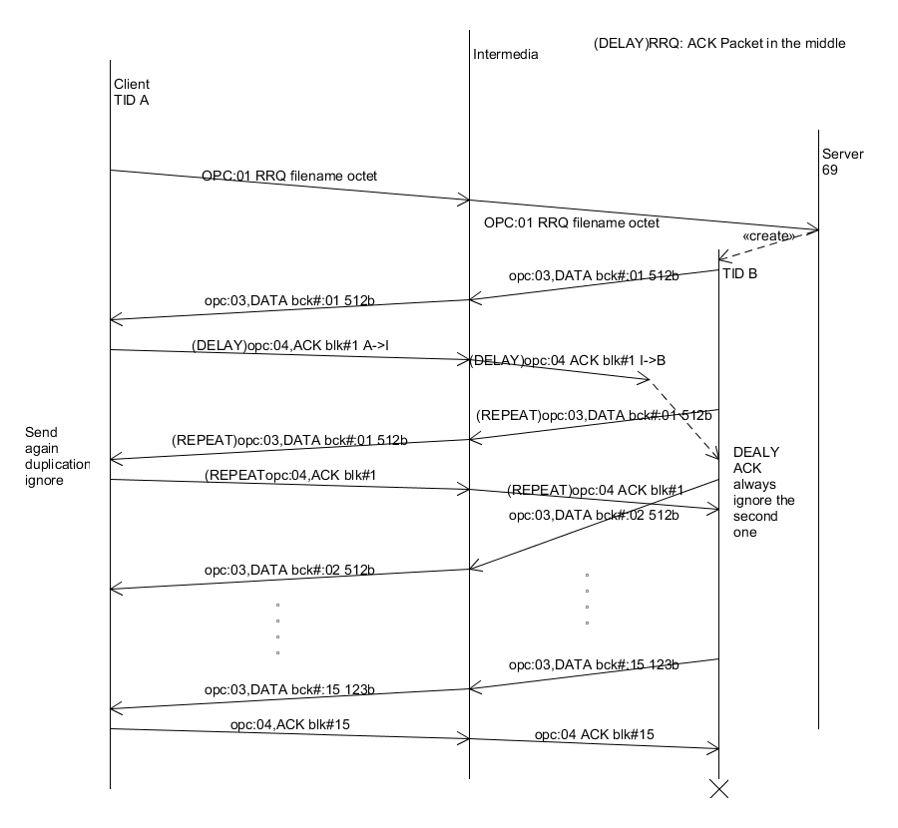
Figure 13: DEALY ACK Packet in the middle –RRQ
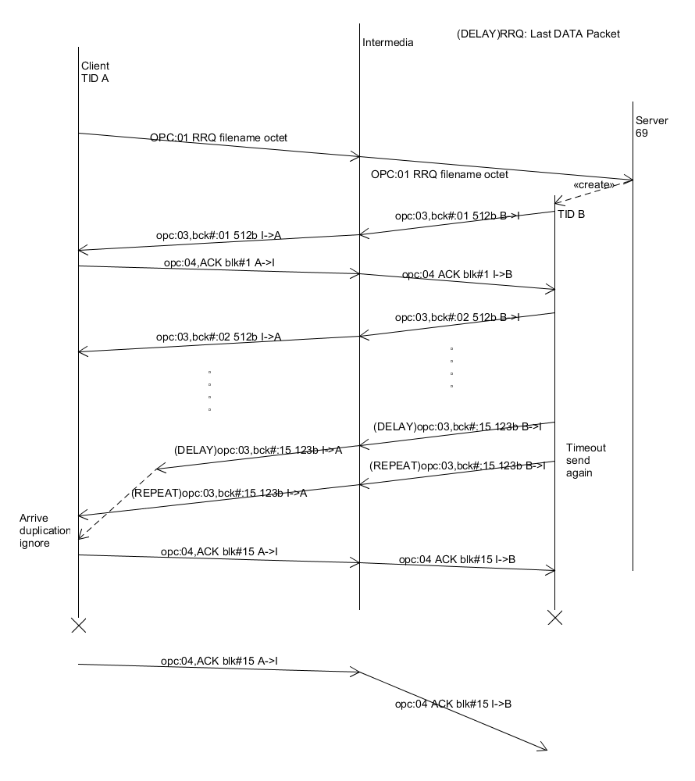
Figure 14: DELAY Last DATA Packet—RRQ
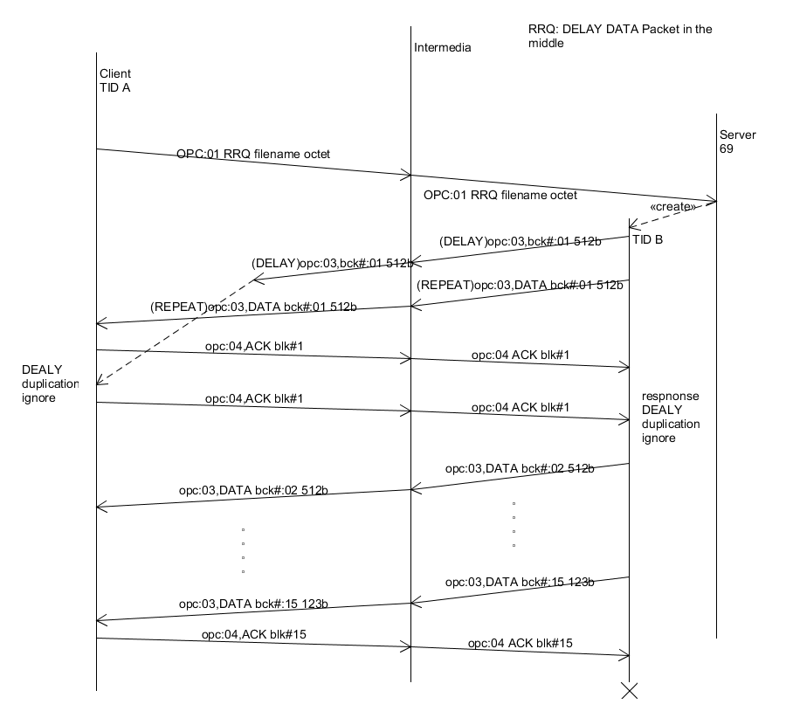
Figure 15: DELAY DATA Packet in the middle—RRQ
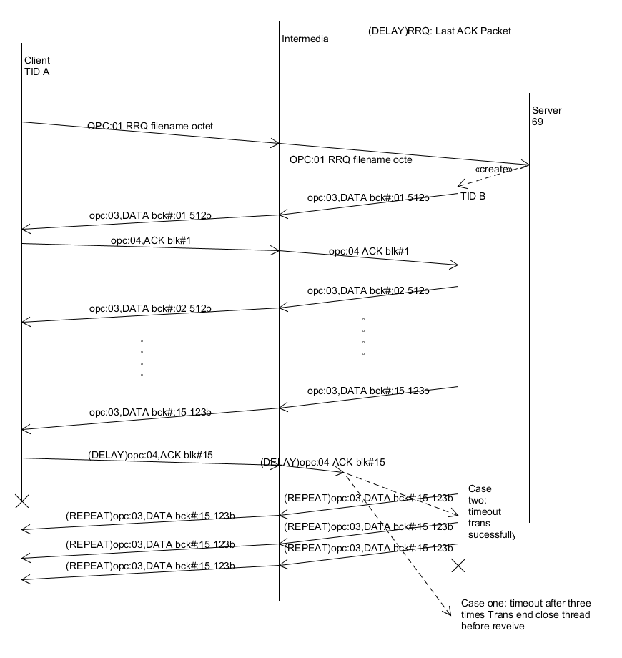
Figure 16: DELAY Last ACK Packet—RRQ
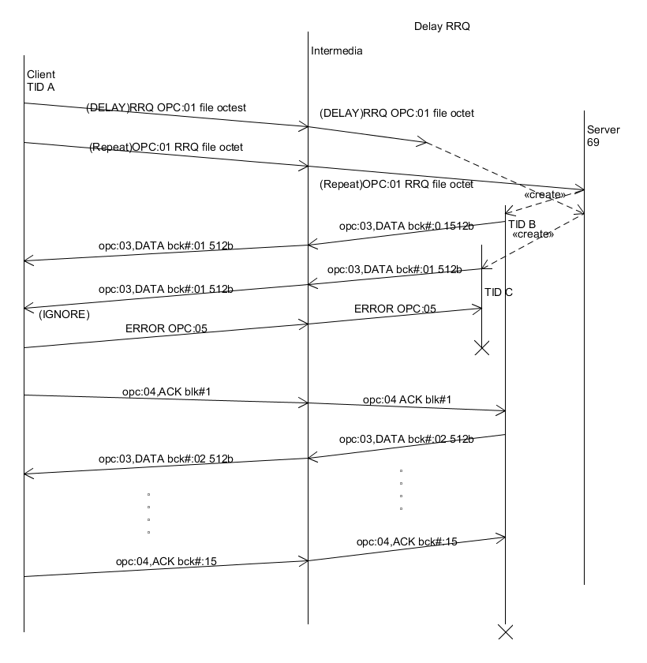
Figure 17: DELAY RRQ
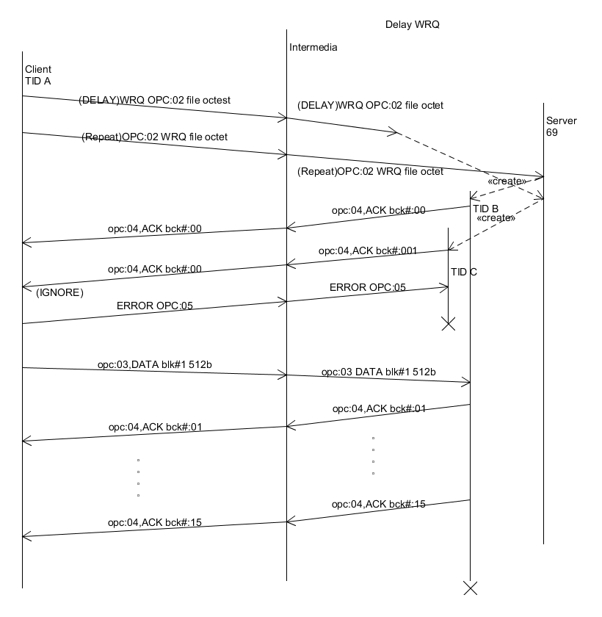
Figure 18: DeELAY WRQ –WRQ
.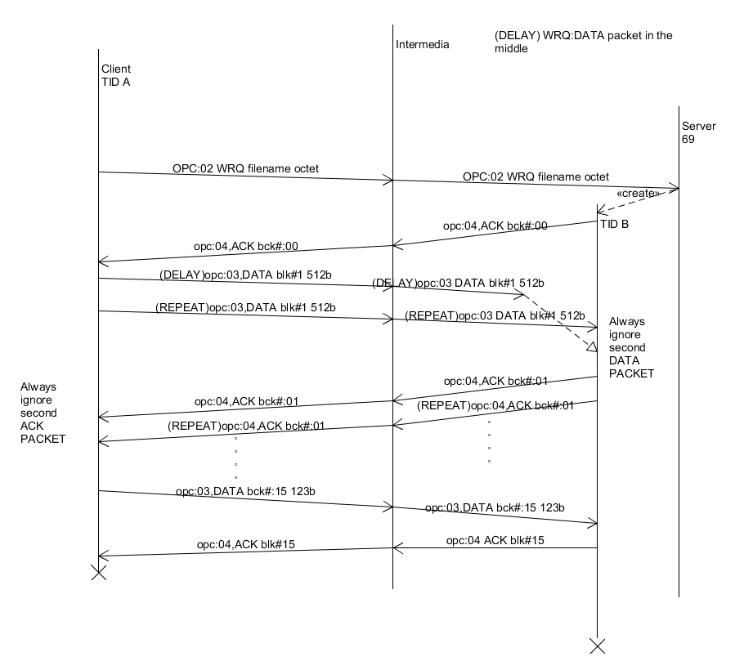
Figure 19: DELAY DATA in the middle –WRQ
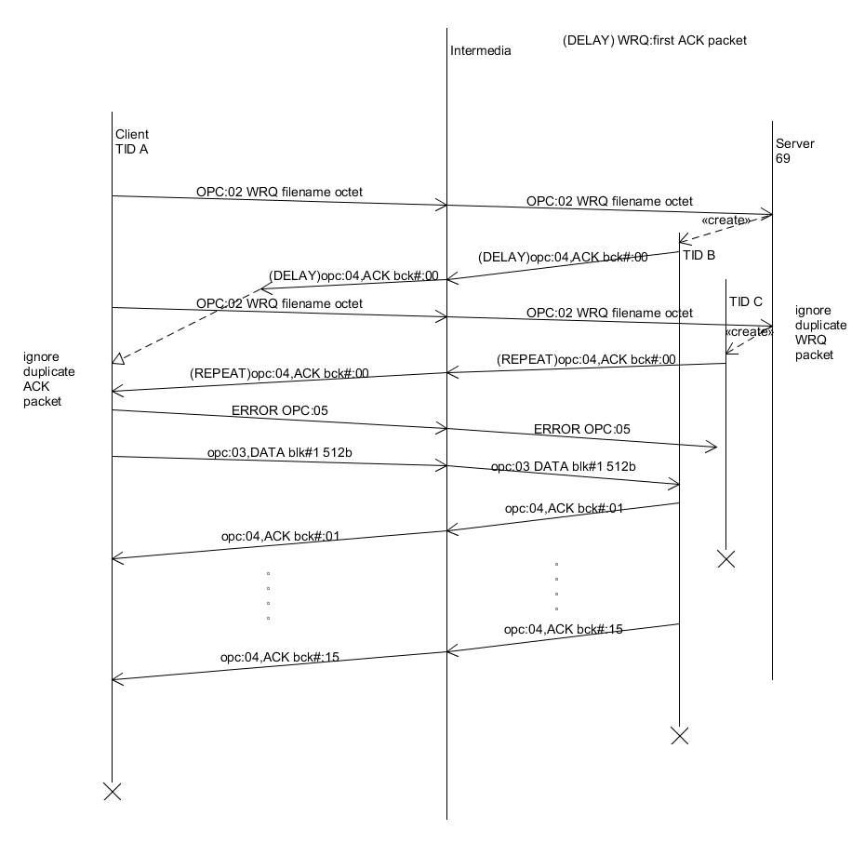
Figure 20: DELAY first ACK packet –WRQ
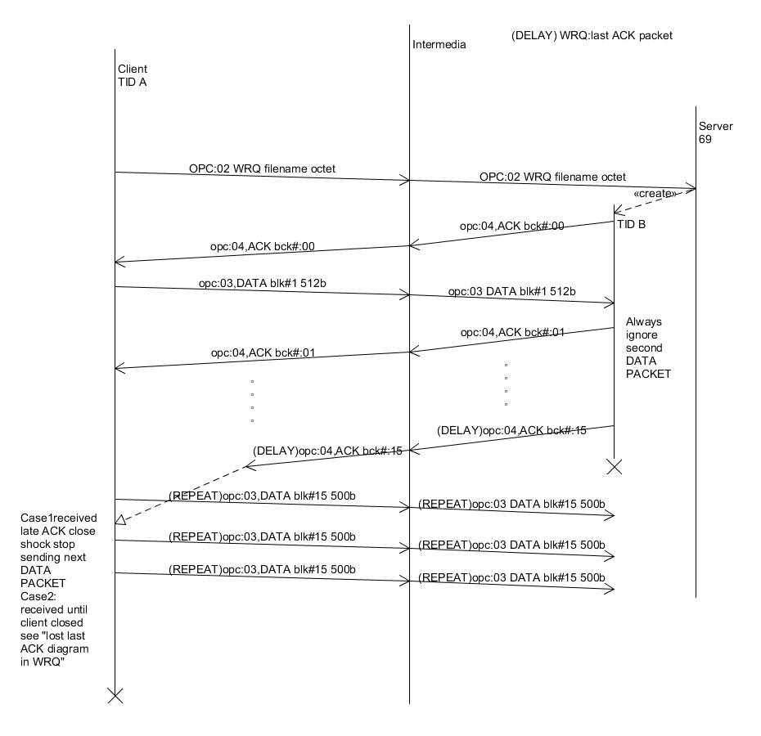
Figure 21: DELAY first ACK—WRQ
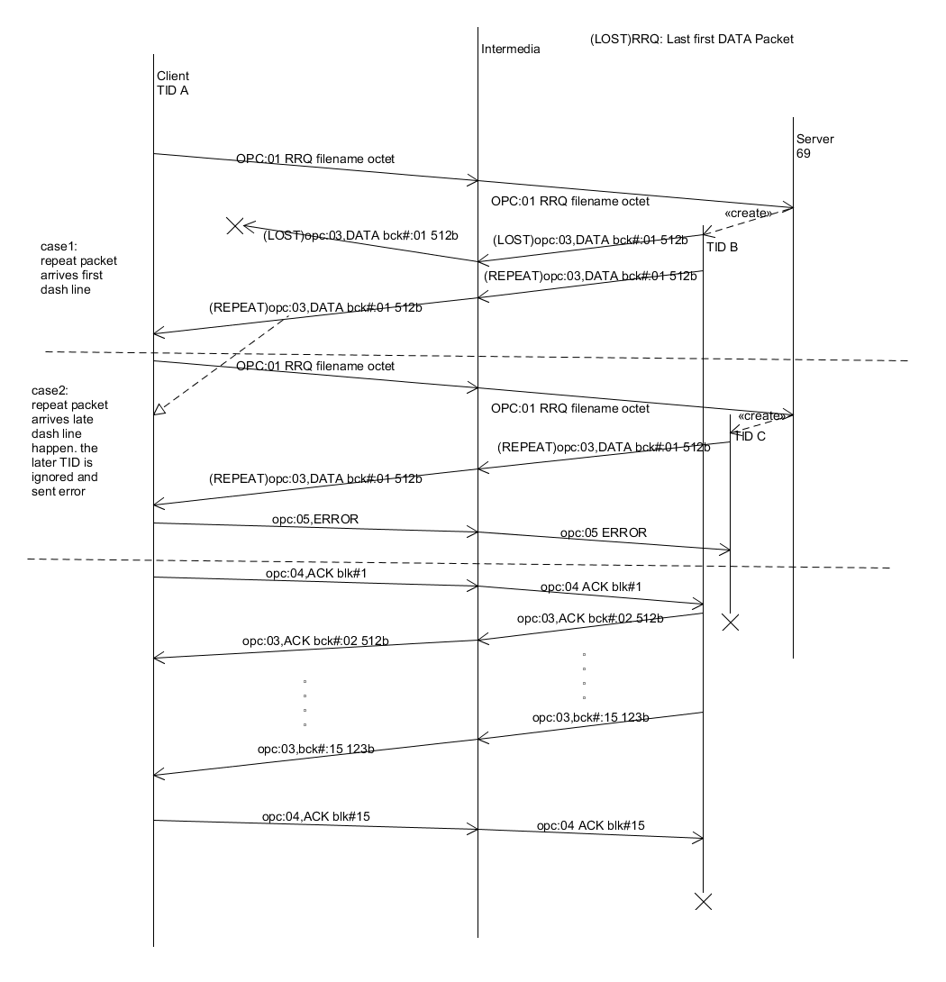
Figure 22: LOST first DATA packet –RRQ
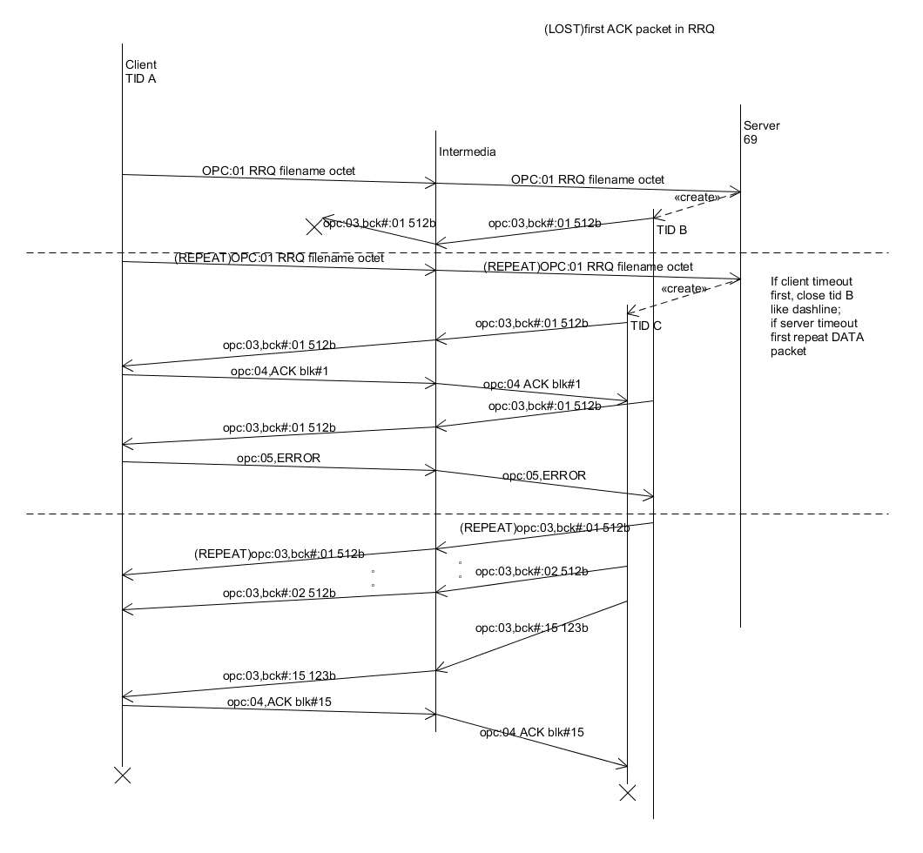
Figure 23: LOST fist ACK—RRQ
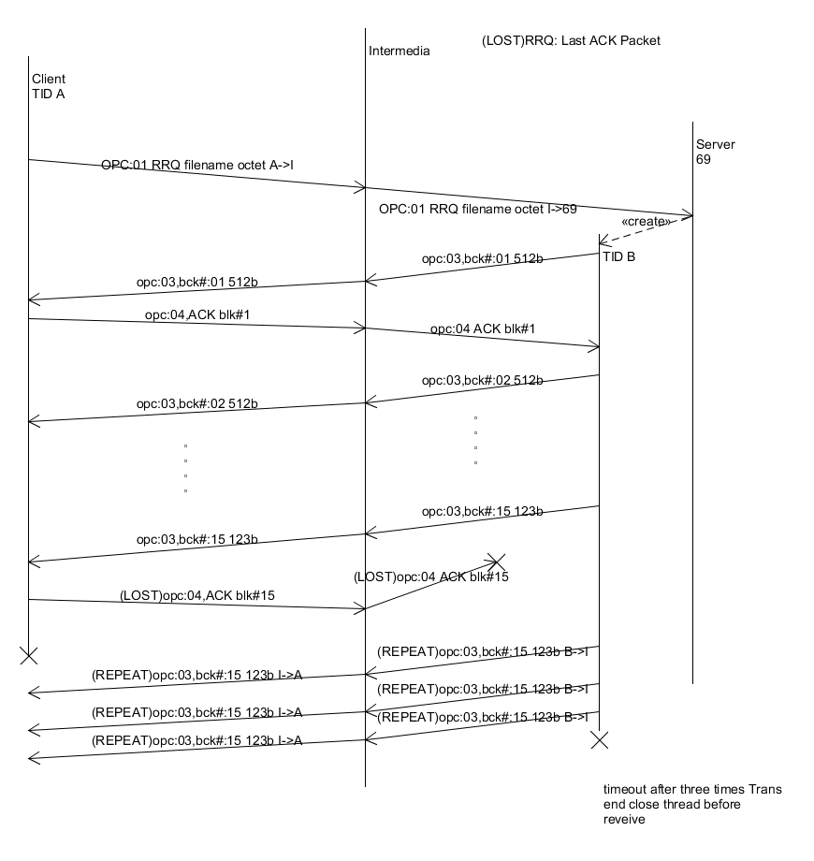
Figure 24: LOST last ACK packet—RRQ
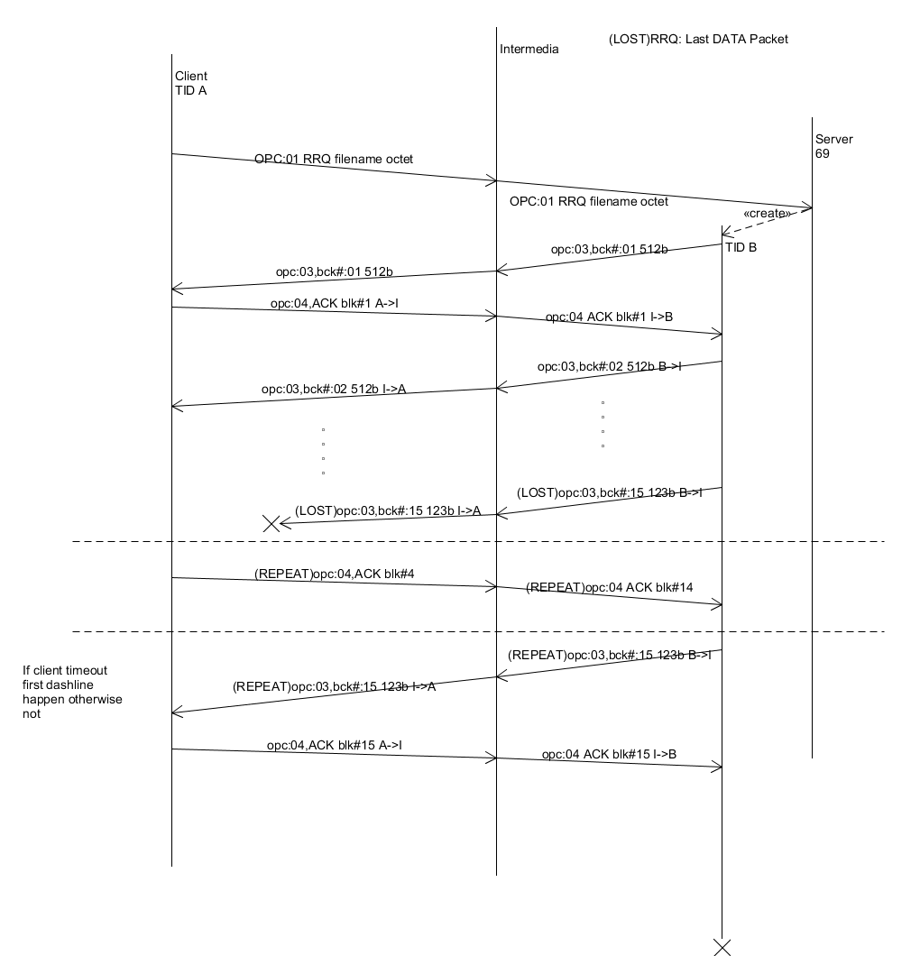
Figure 25: LOST last DATA packet –RRQ
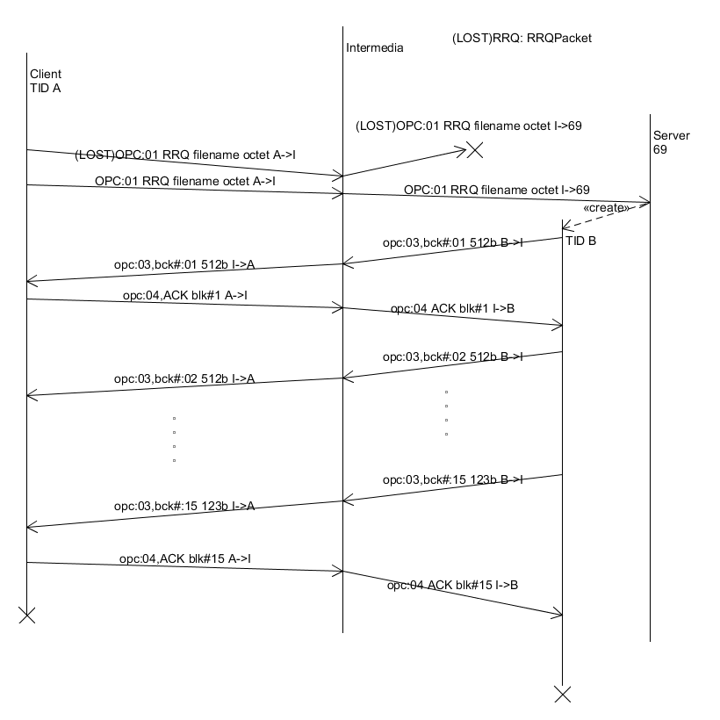
Figure 26:LOST RRQ
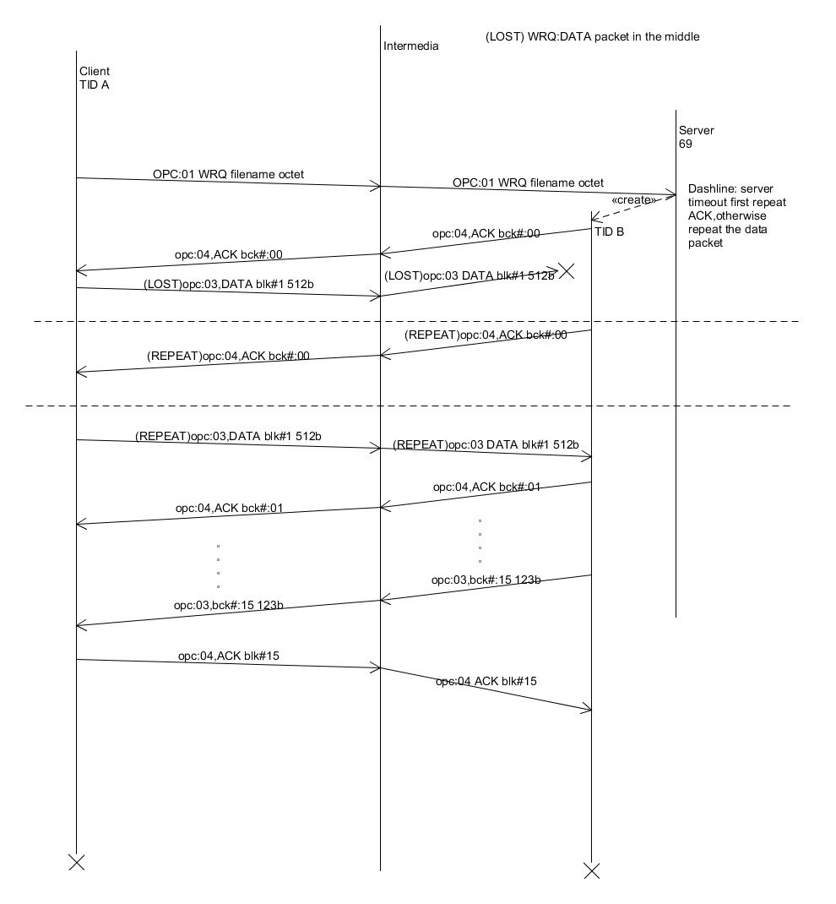
Figure 27: LOST DATA packet in the middle –WRQ
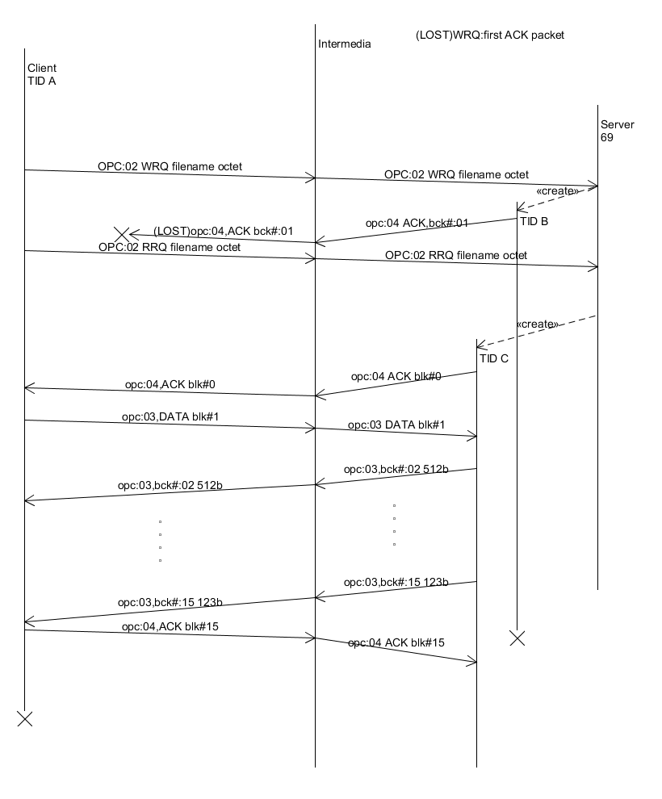
Figure 28: LOST first ACK—WRQ
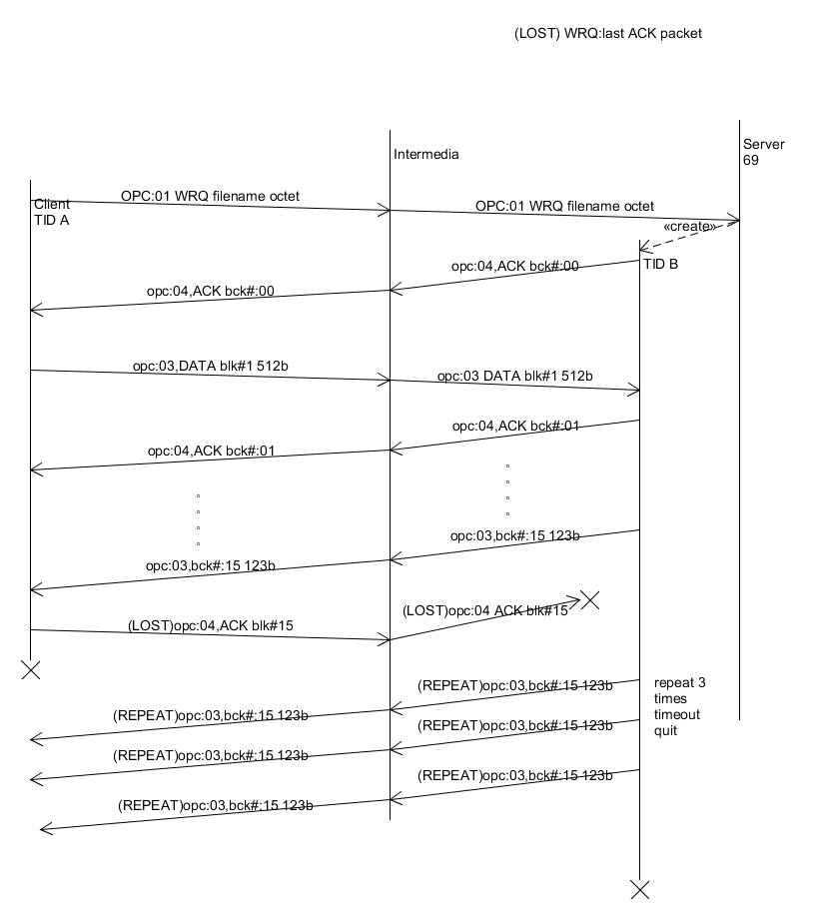
Figure 29: LOST last ACK—WRQ
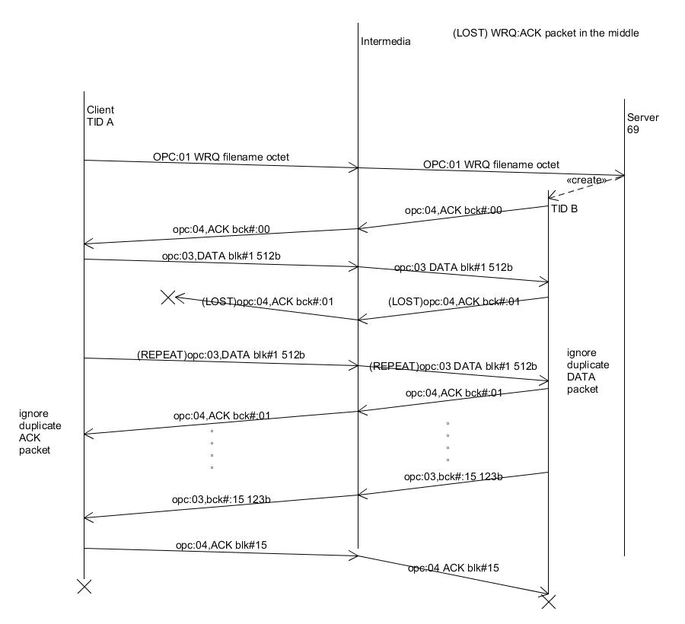
Figure 30: LOST last DATA packet –RRQ
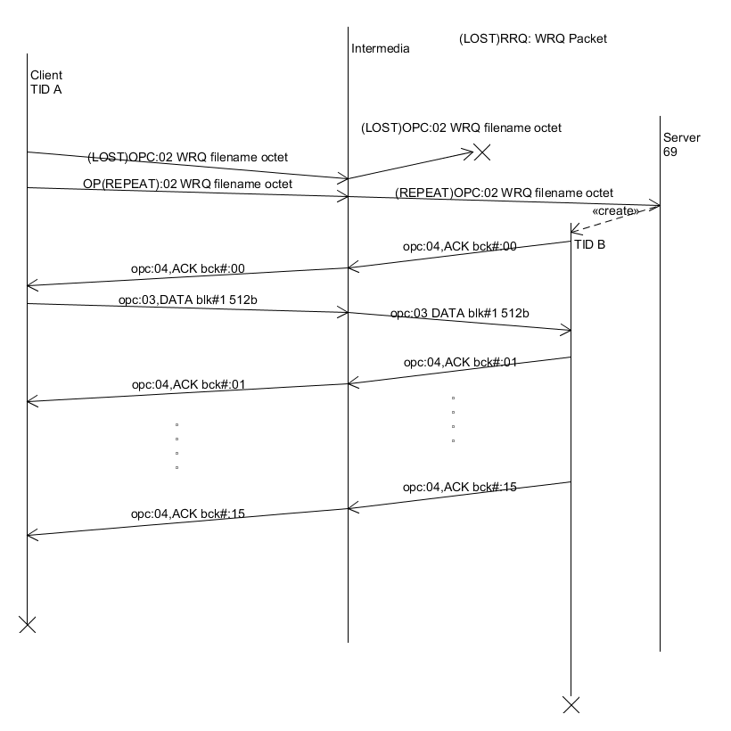
Figure 31: LOST WRQ –WRQ
Figure 32: access Violation _ RRQ
Figure 33: access Violation _ WRQ
Figure 34: disk Full Or Allocation Exceed _ RRQ
Figure 35:disk Full Or Allocation Exceed _ WRQ
Figure 36: file Already Exis t_ WRQ
Figure 37: file Not Found _ RRQ
Figure 38: file not found _ RRQ2

Figure 39: file Not Found _ WRQ

UML Class Diagrams

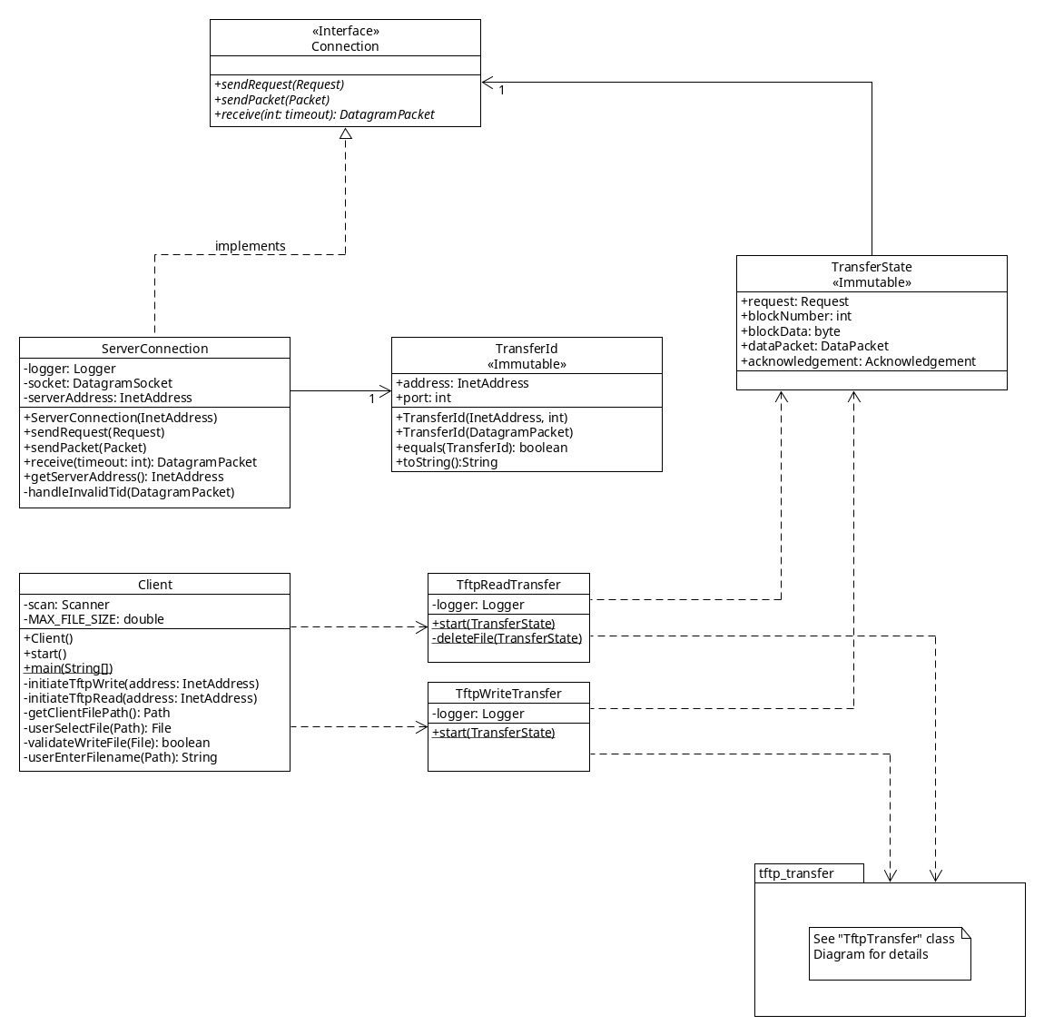
Figure 40: Client
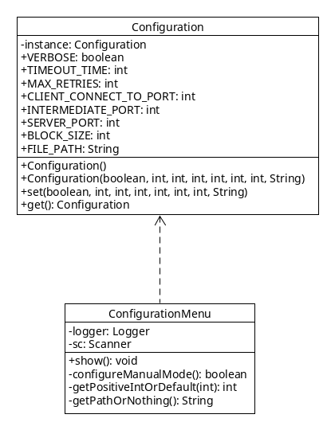
Figure 41: Configuration

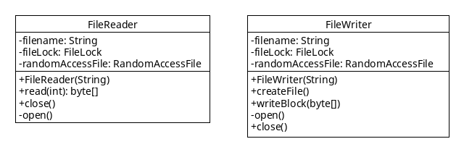
Figure 42: FileIO
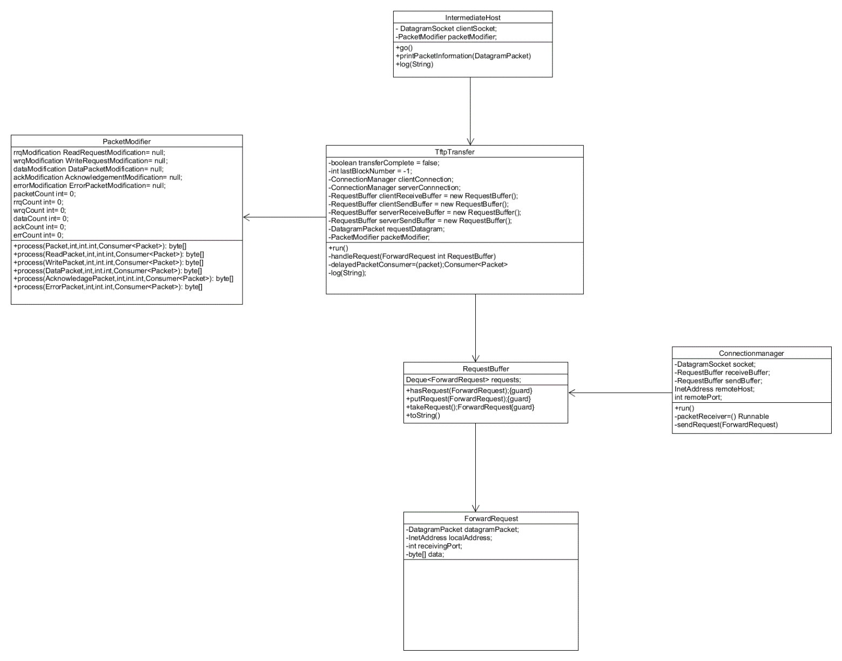
Figure 43: Intermediate Host

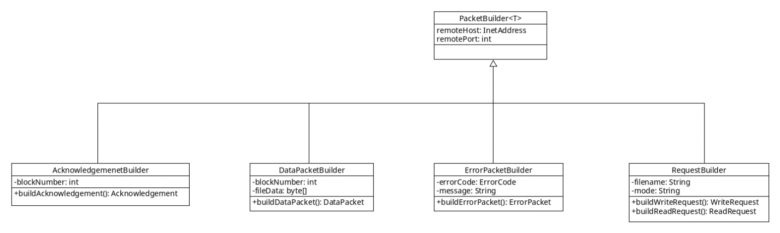
Figure 44: Packet Builder

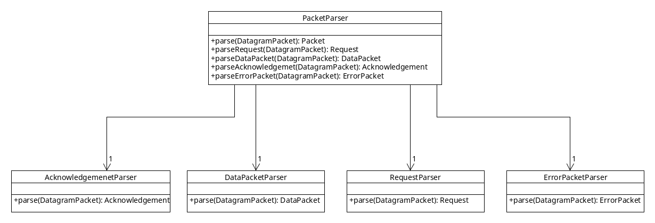
Figure 45: Packet Parser
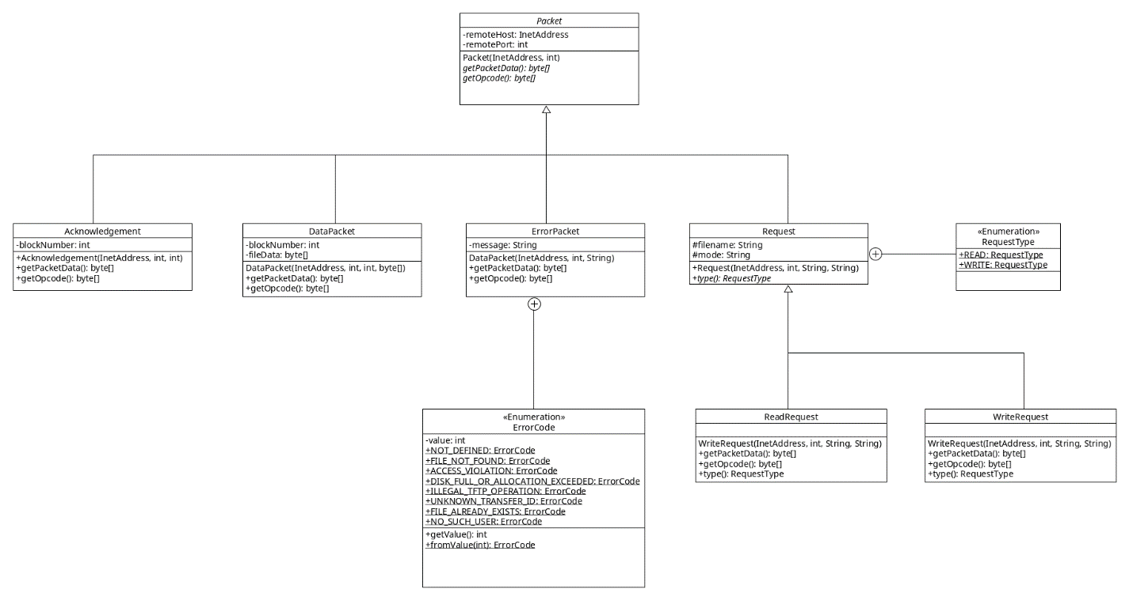
Figure 46: Packets
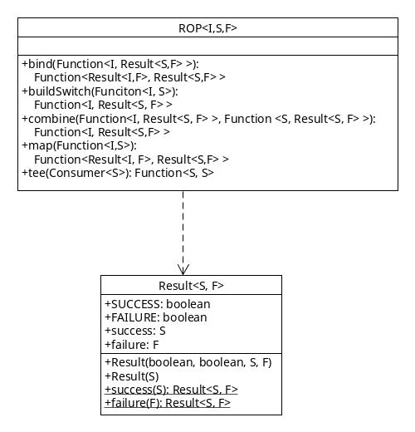
Figure 47: ROP
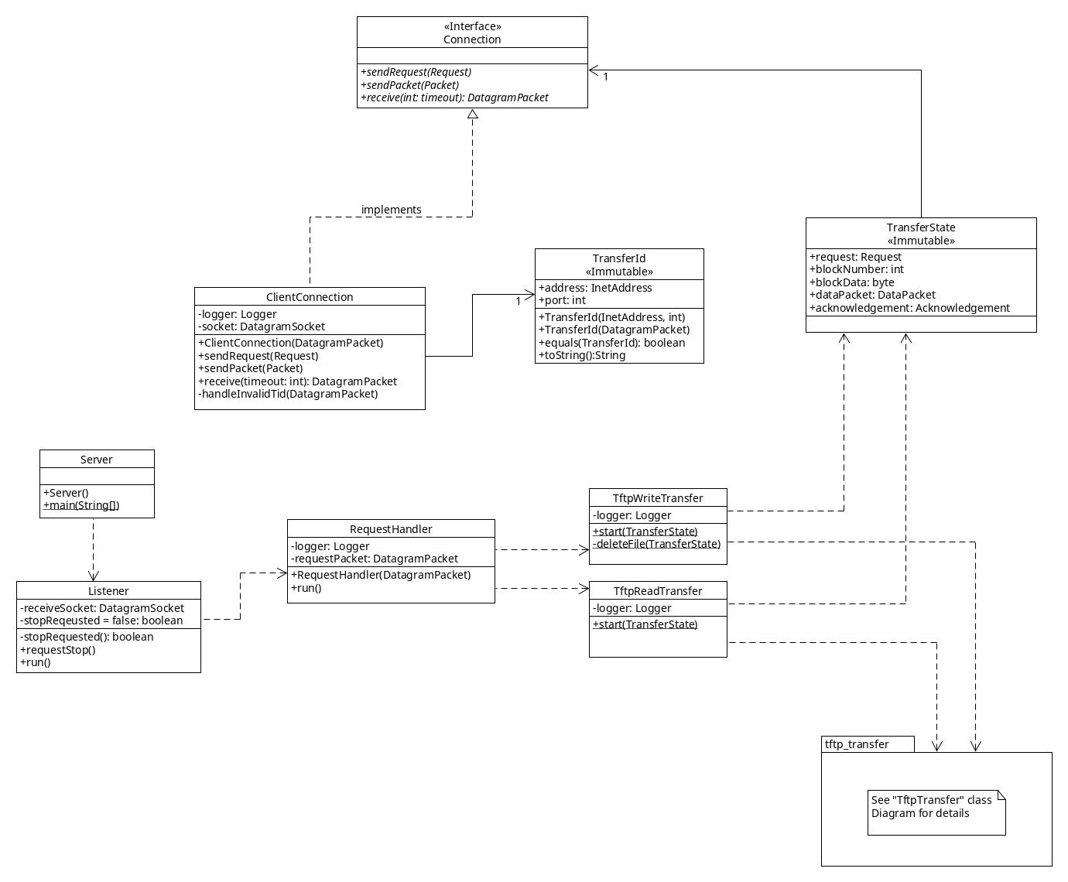
Figure 48: Server
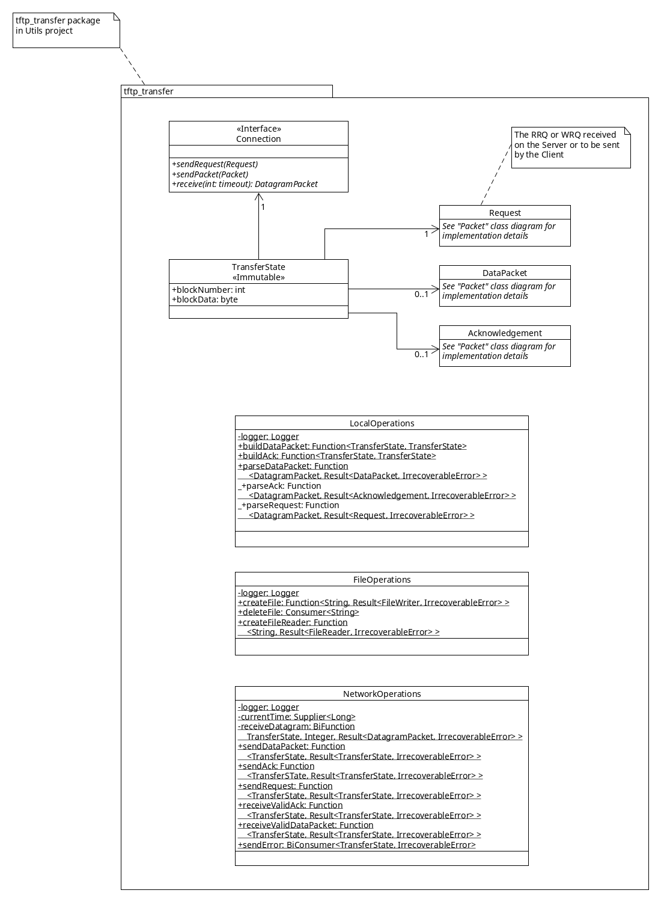
Figure 49: TFTP Transfer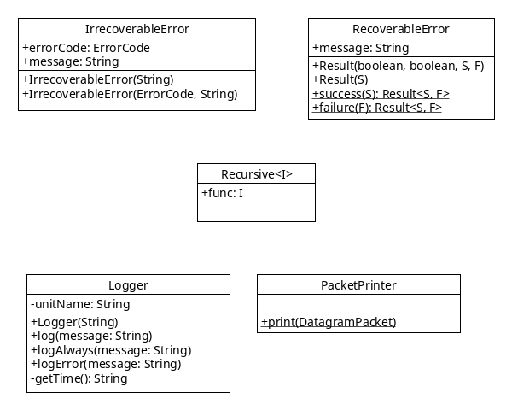
Figure 50: Utils

Readme

Files
- ReadMe.txt - this file
- Code/
  - Client/ - Code for Client
  - IntermediateHost/ - Code for Intermediate Host
  - Server/ - Code for Server
  - Utils/ - Common code between Server, Client, Intermediate Host
- Diagrams/
  - ClassDiagrams/ - Class Diagrams for the system
  - errors_4_5_TimingDiagrams/ - Error codes 4 & 5 timing diagrams (iteration 2)
  - lost_delayed_TimingDiagrams/ - Lost/Delayed packet timing diagrams (iteration 3)
  - UCMs/ - Use Case maps (iteration 1)
  - fileIO_TimingDiagrams/ - Error codes 1, 2, 3, 6 timing diagrams (iteration 4)

Launching the application
Import the projects
1) Open eclipse
2) Select File -> Import...
3) Select General -> "Existing Projects into Workspace"
4) Next to "Select root directory" click "Browse"
5) Select the Code folder of this submission
6) Click "Finish"
Run the program
1) Right click on the "Server" Project and select "Run As" -> "Java Application"
1.1) Select a configuration mode (usually Debug Mode)
2) Right click on the "IntermediateHost" Project and select "Run As" -> "Java Application"
2.1) Select a configuration mode (usually Debug Mode)
2.2) configure the desired error scenario (see below) or "No Modification"
3) Right click on the "Client" Project and select "Run As" -> "Java Application"
3.1) Select a configuration mode (usually Debug Mode)

Select a Configuration for Client/Server/IntermediateHosr
Upon start the Client/Server/IntermediateHost will ask which configuration mode to use. The mode should always be the same in all three programs, except when using Manual mode, which allows to modify all configuration values for a particular program.

Modes
Debug Mode: Verbose output, use Intermediate Host
- Verbose logging output
- 5000ms socket timeout
- Make 3 attempts to re-send a packet in case of timeout
- Client connects to port 68 (intermediate port)
- Intermediate listens on port 68
- Server listens on port 69
- File block size is 512 bytes
- File path is empty => use default directory (see below)

Test Mode: Verbose output, ignore Intermediate Host
- Verbose logging output
- 5000ms socket timeout
- Make 3 attempts to re-send a packet in case of timeout
- Client connects to port 69 (server port)
- Intermediate listens on port 68
- Server listens on port 69
- File block size is 512 bytes
- File path is empty => use default directory (see below)

Quiet Mode: very little logging output, ignore Intermediate Host
- Very little logging
- 5000ms socket timeout
- Make 3 attempts to re-send a packet in case of timeout
- Client connects to port 69 (server port)
- Intermediate listens on port 68
- Server listens on port 69
- File block size is 512 bytes
- File path is empty => use default directory (see below)

Linux Mode (for testing): verbose output, uses different ports to avoid permission problems
- verbose logging output
- 5000ms socket timeout
- Make 3 attempts to re-send a packet in case of timeout
- Client connects to port 6900 (server port)
- Intermediate listens on port 6800
- Server listens on port 6900
- File block size is 512 bytes
- File path is empty => use default directory (see below)

Manual Mode: Everything can be configured by the user
- configure ports, timeouts, etc.
- File path: Enter an absolute file path using. e.g. E:/testfolder

Configure the Intermediate Host
After selecting a configuration the intermediate host displays an extensive menu that allows for modifications. To delay / duplicate / drop a packet, first select the packet type and then the number of the packet you want to modify (RRQ and WRQ is always the first packet).
Then select one of the options (e.g. delay packet). There are a number of test files in both the Server and Client folder. These test files are named according to their size.

Transfer File locations
- By default, files on the server are placed in the Code/Server directory
- By default, files on the client are placed in the Code/Client directory
- It is possible to modify the locations by selecting Manual mode when asked for a configuration mode when the program first starts.

Included test files
- one-block 510 bytes
- one-block-exactly 512 bytes
- two-blocks 1020 bytes
- two-blocks-exactly 1024 bytes
- three-blocks 1530 bytes
- three-blocks-exactly 1536 bytes
- four-blocks 2040 bytes
- four-blocks-exactly 2048 bytes
- large-file 51000 bytes
- huge-file 33551360 bytes
- too-big 33556480 bytes
- access-restricted-file 2040 bytes

Error Scenarios & Testing

Note:
The test files are identical on both the client and server, so you may need to delete some of them on either side to test successful transmissions.

Testing Setup on separate machines
1) On one machine start the Server and select a configuration
2) On a second machine start the Client and Intermediate Host
- in the Client: enter 127.0.0.1 as the Server IP (or just hit enter)
- in the Intermediate Host: enter the IP of the first machine as the server IP

Concurrent File Access
The server and client allow only one Thread at a time to read or write from a file. This is a design decision we made to prevent any problems with concurrent file access. Thus, if one client is writing a file "x" to the server, and then another client tries to read the file "x" while it is still being written, the server will send an error code 2 (Access Violation) to the second client. This is implemented using File locks.
The same happens if two clients try to read from the same file on the server. Only one client can read from a file, the second one will receive an error code 2.
This has some implications:
When duplicating a RRQ or WRQ there is a subtle race condition that cannot be avoided. The server will simultaneously open two threads that both try to read or write to the same file. One of the threads will succeed, while the other will fail to acquire a lock on the file. The first thread will send a DataPacket or ACK to the client, the second thread will send an error code 2 (Access Violation) to the client. If the client receives the DataPacket/ACK first, it will continue the transfer and ignore the ErrorPacket from the second thread. However, if the client receives the ErrorPacket first, it will abort the transfer completely.

File Not Found
There are two possible scenarios in which this error may occur:
1) The file does not exist on the server:
The server received a RRQ but the filename contained in the request cannot be found. In that case the server sends an error (Code 1) and aborts the transfer.
On the client on a WRQ if the user enters a filename and that file does not exist, the client will show an error message and NOT send a Write Request, therefore there is no Error being sent either.

2) The file goes away during transfer (e.g. USB key unplugged)
On the server, if during a Read Transfer, the file we are reading from is (re)moved, the server cannot continue to read from it and thus will send an Error Code 1, and abort the transfer.
On the client, if during a Write Transfer, the file we are reading from is (re)moved the Client sends an Error Code 1, and aborts the transfer.
Note that some file data is buffered by the JVM and the OS, so for small files this will not occur, since the required data may already be in the buffer.

Testing
Client:
- Try to send a file that does not exist in the configured path.
  - Does not send an error packet since non-existent file is discovered before sending WRQ
- Configure the client (Manual Mode) to use a path to a USB key
Then initiate a file transfer and unplug the USB key mid-transfer.
Server:
- Try to send a RRQ for a file that does not exist on the server.
- Configure the client (Manual Mode) to use a path to a USB key. Then initiate a file transfer and unplug the USB key mid-transfer.

Access Violation
On the Client:
If, on a Write Transfer, the file the user selects cannot be read, the user is informed with an error message and we DO NOT send a WRQ to the server. Therefore the is no error packet.
On a Read Transfer the Client will first attempt to create a file. Only if that's successful will it send the RRQ.

On the Server:
If the server receives a RRQ or WRQ, and trying to read or write the file is not possible because the permissions are insufficient (no read/write access), the server responds with an Error code 2 and terminates the transfer.

Note that if the permissions change during a transfer, it does not affect the program, since it
already opened the file and has a valid file descriptor. Thus it can continue to read/write and
complete the transfer.

Testing:
Client:
- Configure the client (Manual Mode) to use a path to C:\Users\[someOtherUser] Then do a RRQ or WRQ.
  - Does not send and error packet, since missing permissions are discovered before RRQ or WRQ is sent
Server:
- Configure the server (Manual Mode) to use a path to C:\Users\[someOtherUser]. Then do a RRQ or WRQ from the client.

Disk Full
If trying to write a block to a file on disk fails, because the disk is full, both client and server will respond in the same way. First an error message (Code 3) is sent and then the file that had been written to is deleted, since it is incomplete.

Testing:
Client:
- Configure the client (Manual Mode) to use a path to a USB key that's full then do a RRQ.
Server:
- Configure the server (Manual Mode) to use a path to s USB key that's full. Then do a WRQ

File Already Exists
On the Client:
When performing a Read Transfer, we first check whether a file with the requested filename
already exists on the client. If it does, the user is notified with an error message and
we DO NOT send a RRQ to the server.
On the Server:
When receiving a WRQ the server checks whether the file already exists. If it does we send
a "File already exists" error (Code 6) and abort the transfer.
This also resolves issues if two clients try to write the same file at the same time. Only
one of them (whoever happens to be served first), will be able to write.

Testing
Client:
- Try to do a RRQ entering a file that already exists on the client.
  - Does not send an error packet, since existing file is discovered before sending RRQ.
Server:
- Try to do a WRQ sending a file that already exists on the Server.

Other design decisions

Overall Design
After grappling with many subtle bugs, related to state inconsistencies in previous iterations, we decided to scrap most of the existing code on the Client and Server and start fresh on Iteration four.
The goal was to minimize state to only the bare essentials. Thus we introduced a "TransferState" class that encapsulates all state needed for a particular transfer (Read or Write). Furthermore, every instance of TransferState is immutable, which makes it perfectly safe to pass it around to many different methods/functions. Since it cannot be changed along the way, it has become much simpler to keep track and ensure correctness of state.
By removing state completely from the behaviour we were able to break out the different steps involved in a transfer (receive an ack, read from file, create data packet, send data packet ,...) into small simple procedures. We opted to use Java 8's new Lambda implementation for most of them since it allows functions to be treated as values, along with a number of other benefits. Most of these small functions take TransferState as a parameter and return same as a result.
By completely decoupling state from behaviour, and moving the behaviour required for a transfer into small re-usable functions, we were able to break out all of that behaviour into its own package (Utils/tftp_transfer).
Clearly, at some point state does have to change, e.g. once we read a block from a file. In that case a function will ALWAYS return a new state object containing new information. Every function is designed to only change a single aspect of the state, thus most of the old state can be cloned and then new values are assigned to the new state object.
Creating a new state object for every change may seem inefficient, but as it turns out, Java is pretty efficient in creating objects. Also, the state object is pretty small, containing only a few primitive types, and a number of references to other objects. These references are simply copied over to the new state object and do not require to re-instantiate the objects they refer to. Also, the benefits by far outweigh the negatives as we'll see below.
As it turns out, performing a TFTP Read Transfer on the Server is almost the exact same as performing a TFTP Write Transfer on the Client. The same is true for Write Transfer on the Server and Read Transfer on the Client. Thus, we are now sharing a majority of that behaviour between Client and Server. So client and server both run pretty much the same code to facilitate a Tftp Transfer.
As such we have reached epic proportions of code reuse and maintainability.

Note on ROP
Railway Oriented Programming (ROP) is a concept used in Functional Programming that can aid in error handling. Essentially, all functions return a Result object which can either be a SUCCESS or a FAILURE. When composing functions, as soon as one of them returns a FAILURE result, the rest of the functions are bypassed. The error is then handled in a single place afterwards. This makes the code much cleaner and removes the need for exceptions in that situation. The Utils/rop package contains some helper functions to facilitate ROP in our project.
Source: http://fsharpforfunandprofit.com/posts/recipe-part2/

