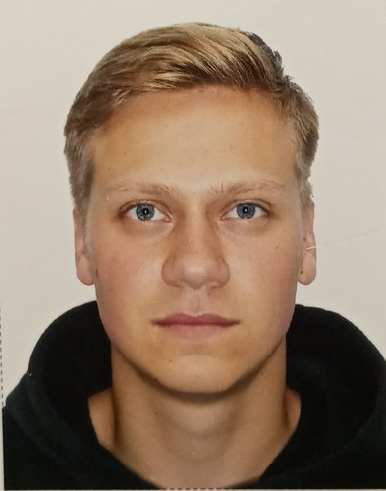 |  | Smetanin Egor  Male, 21 year, born on 15 June 1998  +7 (903) 1614826  tujh98@mail.ru — preferred means of communication  Reside in: Moscow  Citizenship: Russia, work permit at: Russia  Ready to relocate, ready for business trips
Desired position and salary
Engineer/manager  IT, Internet, Telecom  • Sales  • Support, Helpdesk  • Project Management  Employment: project work, work placement, volunteering, part time, full time  Work schedule: rotation based work, remote working, flexible schedule, full day, shift schedule  travel time to work: any |  |  | 60 000  RUB
Work experience —5 years 4 months
September 2019 — till now  7 months |  | Ростелеком  www.rostelecom.ru  Specialist (Corporate Sales Department (B2B))  -formation of consolidated technical acts;  -calculation of the cost of services rendered taking into account the agreed communication interruptions;  - preparation of cover letters and reports on income forecast
July 2016 — August 2019  3 years 2 months |  | Ростелеком  www.rostelecom.ru  Specialist (CCTV Platform Development Project Office)  -project data processing and analysis  - cross-sectionalization of project costs  -Consolidation of data on reused equipment
January 2016 — July 2016  7 months |  | Мобильные ТелеСистемы (МТС)  www.mts.ru  Auto sales assistant/consultant  - Consulting clients on a tariff plan' assistance in choosing a tariff'.  - Acceptance' Accounting' Product Labelling'  - Sales processing
July 2014 — July 2015  1 year 1 month |  | 'Lexion Development'  Assistant (in summer period) in the department of registration of rights to real estate and transactions with them  - Preparation and dispatch of notices to owners of residential premises.  -Distribution of received mail correspondence from owners of residential premises to addresses and apartments.  - Processing of documents on the internal database.  -Forming inventories to transfer cases to the archive.  - Preparation and transfer of documents after state registration to the archive of the current period.
Education
Master
2021 |  | Peoples' Friendship University of Russia, Moscow  Engineering, Nanoengineering and microsystems engineering
2019 |  | Peoples' Friendship University of Russia, Moscow  Engineering, Nanoengineering
2019 |  | Peoples' Friendship University of Russia, Moscow  Chair of Foreign Languages, Engineering Academy, Translation and Translation Studies
Key skills
Languages |  | Russian — Native  English — C1 — Advanced  German — A1 — Basic
Skills |  | Python Document Flow Английский язык MS PowerPoint Пользователь ПК Деловая переписка Управление проектами Ведение переговоров Грамотная речь Водительское удостоверение категории B Деловое общение AutoCAD Активные продажи Делопроизводство Телефонные переговоры Деловая коммуникация Управление продажами Поиск и привлечение клиентов Планирование продаж Проведение презентаций Работа в команде MS Outlook Заключение договоров
Driving experience
Own car
Driver's licence category A, B
Additional information
About me |  | 1 thesis on the development of a passive pressure sensor.  Advanced PC user. Ownership: computer-aided design systems.  Active life position, performance, responsibility, stability.  3 adult grade swimming.  GTO - gold (2015)  Crossfit, alpine skiing, football, table tennis.

