Dezco Knoleburn Lore Pack
Organized export of journal entries, Yua story plots, crest/sigil lore, and the party quick reference. Upload this file to Google Drive → Open with Google Docs. For clickable tabs, upload Dezco_Knoleburn_Lore_Tabs.xlsx and open with Google Sheets.
Suggested Google Docs tabs after upload: Party Ref | Character | Journal 01 | Journal 02 | Journal 03 | Yua Red Black | Yua Mana Well | Yua Stays Hidden | Crests.

Party Quick Reference
Source file: character/lore/dezco-party-reference.md

Dezco Quick Reference (Party Sheet)

*Use this when talking about yourself to other party members.*
*Keep it short. Scan the section you need. Full stories live in the other lore files.*

**Last updated:** 2026-08-30 (removed Alice; Eden solo scout; Vita bridge save)
**Update rule:** any new Dezco / Alzenhiem / Knoleburn / Yua fact must be mirrored here the same turn.

---

30 second intro (say this)

I’m Dezco Knoleburn. Seventeen. From a hamlet called Alzenhiem. Dwarven and Elven blood. Military trained since eight. From twelve, trained by Rilock, royal master swordsman of the King’s Lion’s royal guard, by the Lion’s order. People called me Hero for years before it was true. Yua made it true at seventeen. I love red and black. I’m trying my best.

---

Me at a glance

| | |
|---|---|
| Full name | Dezco Knoleburn |
| Name means | stands firm; one who holds his ground |
| Age | 17 |
| Birthday | November 6 |
| Height | 5'10" |
| Build | slender |
| Hair | black |
| Favorite colors | red and black |
| Ancestry | Dwarven + Elven |
| Home | Alzenhiem (hamlet) |
| Title now | Hero (given by Yua at 17) |
| Master / trainer | Rilock (royal master swordsman; King’s Lion royal guard) |
| Directed by | The King’s Lion (ordered Rilock to train me) |
| Companion | Yua (often appears as a small pixie) |
| Crest colors | crimson red + deep black |
| Sigil | vertical blade / flame split red and black |
| Current location | Saltrock (protection restored; feast over; resting for dawn choice) |
| Travel status | Adventure day 2; staff fell then focus restored; escort vs church city decision by morning |

---

What I am / am not

| True | Not true (or not yet) |
|---|---|
| Hero by Yua’s formal charge at age 17 | Born already crowned as Hero |
| Trained hard under Rilock by the Lion’s order | Trained personally day to day by the King’s Lion himself |
| People rumored I was the Hero of centuries during ages 12 to 17 | Those years were title + sacred charge (they were rumor) |
| Yua watched me from childhood | I always understood why she chose me |
| I love red and black | I already know the deep reason why (Yua has not told me yet) |
| Yua set a Mana Well in me when she made me Hero | I understood it before Saltrock (I did not) |
| I accidentally used a simple imbue in Saltrock street fight | I have also used imbue on purpose in the keep goblin fight (still learning) |
| Yua travels with me | Only the King’s Lion and Rilock know; Saltrock party does not |

---

Family (quick)

| Person | Who | Age | Name means | Colors | One line |
|---|---|---|---|---|---|
| Dolkin | Father | 38 | steadfast of kin | charcoal, iron, bronze | Steady, Dwarven depth, sent me to train to keep me alive |
| Fulfein | Mother | 36 | full fair light | sage, silver, pale gold | Warm Elven grace; Alzenhiem’s center for me |
| Kalhien | Younger brother | 15 | rises in pursuit | ink blue + copper | Restless, proud, does not want to be only “Dezco’s brother” |
| Astiale | Younger sister | 8 | gentle star | rose, cream, sky | Sweet; not born when I left at 8 |

**Surname Knoleburn means:** stream by the knoll
**Alzenhiem means:** sheltered home under a kind sky

---

Home

| | |
|---|---|
| Place | Alzenhiem |
| Type | Small hamlet |
| Vibe | Dirt paths, low roofs, neighbors first, no royal banners |
| Why it matters | What I stand for when I talk about hope |
| Town flag colors | wheat gold, meadow green, earth brown, cream |
| Town flag idea | roof + wheat + lane |

---

Timeline (memorize this order)

| Age | What happened |
|---|---|
| 0 | Born November 6; named Dezco; red/black crest + sigil at birth |
| 8 | Left Alzenhiem for military training; Kalhien was 6; Astiale not born yet |
| 8 to 12 | Overshadowed by a stronger rival; Yua watched unseen |
| 12 | Rival (nearly 18) dueled me; Yua secretly blessed my speed/strength; only the King’s Lion truly saw her |
| 12 | King’s Lion directed royal master swordsman Rilock (royal guard) to train me |
| 12 to 17 | Merciless real missions under Rilock; reputation spread; people falsely called me Hero of centuries |
| Before 15 | Name known across much of the realm |
| 17 | Master Rilock said I had learned all he could teach |
| 17 | Yua appeared before me, Rilock, and the Lion; gave me the ancient title Hero + sacred mission |
| 17 | Final goodbye at Alzenhiem; family gifts; left for the road |
| 17 | Reached Saltrock; lodging at the tavern; seeking where to travel next |
| 17 | Saltrock staff fell; storm, crabs, and other creatures attacked |
| 17 | Fought with defenders; missed short bow creature; faceplant in wet muddy gravel; saved by Eden’s arrow |
| 17 | Sealed in keep; troll + goblins; second imbue cleaved goblins; Eden/fire ended troll |
| 17 | Quest for first King’s Lion tomb; library map; Yolon stone dragon; owlbear bridge; tomb focus recovered |
| 17 | Focus restored Saltrock with mayor, Vita, Yeara; feast; choice by dawn: Lyndor or Lořel |
| Now | Resting after feast; foot bruised from cliff fall; Yua and I still need to talk |

---

Important people (outside family)

| Person | Who they are to me |
|---|---|
| Yua | Ancient being tied to magic; broke a millennia oath to act; watched me since childhood; gave me Hero title; often appears as a small pixie; only Lion + Rilock know she walks with me |
| The King’s Lion | King’s greatest swordsman; only one who truly saw Yua at the duel; directed that I be trained; knows Yua travels with me |
| Rilock | Royal master swordsman; one of the King’s Lion’s royal guard; my actual trainer/master from ages 12 to 17; knows Yua travels with me |
| The Rival | Older trainee who believed he was the chosen one; challenged me at 12; lost after Yua’s hidden aid |
| Eden | Elf archer; bow like punishment made elegant; terrible with frightened children; saved me in the street fight; scouted river fork alone |
| Jylia | Halfling dancer; fought in the keep; danced to calm the hall; pushed open the tomb door without hesitation |
| Vita | Human priest (~30s); healer and spellcaster; read the old library map; dove to catch me on the owlbear bridge; helped restore the focus; collected Yolon statue vines |
| Alem | Snake man; telepathy mind to mind; healed before I met him properly; relayed Eden’s owlbear scouting |
| Yeara | Priestess in Saltrock; worked with Vita and the mayor to set the focus back; wants us at Lořel by morning decision |
| Yolon | Stone dragon statue (>100 years); spoke after Jylia drank bowl rain; fought first King’s Lion to endless draws; said take the right fork at the next split |
| Saltrock mayor | Town leader; sent us to the tomb; wants escort to Lord Keivan in Lyndor |
| Lord Keivan | Ruler in capital Lyndor; mayor wants to present us there |

---

Current gear / gifts from home

| Item | From | Notes |
|---|---|---|
| New sword | Dolkin | Hand forged goodbye; his love without saying the words |
| First smithing tools | Dolkin | His original set; “you are the master of your steel” |
| 10 gold pieces | Fulfein | Travel money |
| Cooking pot | Fulfein | Eat warm when you can |
| New clothing | Fulfein | Wearing them out of respect; left home in them |
| Shovel | Fulfein | Funny gift for roadside “number two” duty; also quietly useful if not everyone makes it |
| Tomb focus (recovered) | Saltrock quest | Faint glow; purpose unknown at first; mayor + Vita + Yeara restored town protection with it |

---

Places

| Place | What it is |
|---|---|
| Alzenhiem | Home hamlet; my center |
| Saltrock | Traveling town; staff fell then focus restored; feast tonight; dawn choice pending |
| Saltrock keep / general building | Where townsfolk sheltered; back wall breached by troll; focus set back with Vita and Yeara |
| Saltrock library | Old book with scrappy map to first King’s Lion tomb |
| Saltrock tavern | Where I lodged the night before the attack; “best bread” only with nostalgia |
| Lyndor | Capital; Lord Keivan; mayor wants escort there |
| Lořel | City of churches; priestess Yeara wants us to go there instead |
| First King’s Lion tomb | Hilltop beyond Saltrock; goblin hideout behind outer door; real tomb held the focus |
| Yolon statue | Stone dragon with rain bowl on tomb path; grime, moss, vines; spoke when Jylia drank; said keep path then take right at fork |
| Tomb road fork | Left path down to rivers (Eden scouted alone); right path cliff stairs to hilltop tomb (rest of party) |
| Owlbear bridge | Rickety crossing past false boulder; sleeping giant owlbear inside; gone on return trip |

**First magic item I ever saw:** the floating protective staff in Saltrock.
**Current crisis resolved:** focus back in place; town shielded again.
**Current dilemma:** escort mayor to Lyndor vs travel with Yeara to Lořel; decide by morning.

---

My Hero mission (from Yua)

1. Restore magic before it disappears completely
2. Stand against the darkness consuming the world
3. Unite the fractured kingdoms and races
4. Become the symbol of hope the world has long forgotten
5. Bring together the two halves of the world

---

Training under Rilock included

1. Endless swordsmanship drills
2. Physical conditioning beyond normal limits
3. Pain tolerance and endurance
4. Tactical education
5. Real combat missions (not simulations; death was possible)

---

Colors, crest, sigil

| Item | Quick fact |
|---|---|
| Why I wear red + black | I have always loved them; deep reason not revealed to me yet |
| My crest | Simple child crest: blade/flame between small parent marks |
| My sigil | One red/black blade or flame mark |
| Crest tradition | Child crest = name + gender + both parents; simpler than parents; unique |
| Sigil tradition | Same day as crest; one quick seal mark |

Family crest / sigil cheat sheet

| Person | Colors | Crest idea | Sigil idea |
|---|---|---|---|
| Dolkin | charcoal / iron / bronze | stone arch + hammer | hammer in arch |
| Fulfein | sage / silver / pale gold | leaf + crescent | leaf into crescent |
| Dezco | red / black | balanced blade/flame | red/black split blade |
| Kalhien | blue / copper | forward eager mark | forward chevron |
| Astiale | rose / cream / sky | soft bud or star | soft bud/star |

Images: `assets/crests/alzenhiem/`

---

Secrets / do not spoil yet

Use this when roleplaying what party members know.

| Topic | Party can know? | Notes |
|---|---|---|
| I am from Alzenhiem + family basics | Yes | Safe to share |
| Trained since 8 in the yard; from 12 under Rilock by Lion’s order | Yes | Clarify: Lion directed, Rilock taught |
| People rumored I was Hero early | Yes | Emphasize it was rumor then |
| Yua made me Hero at 17 | Yes, if trust is there | She often looks like a pixie |
| Yua walks with me daily | No | Only King’s Lion + Rilock know |
| A divine being was seen in the world | Yes | Public knowledge; not tied to me |
| I talk to empty air when stressed | They saw it | Bridge return; vine excuse worked for now |
| Exact red/black blood meaning | No | Yua will tell me later; I do not know yet |
| Mana Well / Lord AO gift | Partial | Yua named gift in private woods talk; training still ahead |
| Why I hide Yua from them | No | See yua-why-she-stays-hidden.md |
| Full private family crest theology | Optional | Share lightly unless asked |

**Red/black truth (for you / DM only, not my current knowledge):**
Black = Dwarven caves / void / dark over light. Red = Elven holy blood after ill happens. Together = balance.

**Mana Well truth (for you / DM; Yua explained partially in woods):**
Mana pool stored within soul confines but separate from the soul. Gift from Lord AO per Yua after tomb road. Simple imbue makes sword lighter/sharper and grants a short agility burst. First accidental use: ~15 ft dash mid swing in street fight. Second use: deliberate cleave through two goblins in keep. Needs training. Yua senses unknown darkness ahead.

**Yua hidden truth (for you / DM):**
See `character/lore/yua-story-plots/yua-why-she-stays-hidden.md`. Hope must stay on mortal hands, not slide to worship of her presence.

---

Abilities (Mana Well)

| Piece | Quick fact |
|---|---|
| Source | Bestowed by Yua with the Hero charge; unexplained at first |
| Well | Stored mana pool within soul confines; separate from the soul |
| Simple imbue | Innate; should feel as easy as breathing once understood |
| Sword effect | Lighter, sharper; short burst of swiftness / agility |
| First use | Saltrock street fight (journal 03); accidental ~15 ft dash mid swing = muddy faceplant |
| Second use | Keep goblin fight; cleaved one at waist, gutted another >10 ft away |
| Yua’s explanation | Woods talk after tomb: gift from Lord AO; grow together through training |
| Yua’s warning | Feels a darkness she has never known; source unknown |
| Training needed | Control timing, avoid waste, move with the burst instead of being thrown |
| Yua’s mood | Upset after bridge; said we need to talk later |

---

How I sound when I talk about myself

1. Honest, a little unsure about being chosen
2. Proud of Alzenhiem without boasting
3. Corrects “Hero of centuries” rumors for the training years
4. Speaks kindly about family, especially Astiale
5. Does not claim to understand Yua fully
6. Prefers no dramatic dash heavy speech; plain and direct

---

Where the long versions are

| Need | File |
|---|---|
| Full character intro | `character/lore/dezco-knoleburn-character.md` |
| Journal index | `character/lore/journal/README.md` |
| Journal 01 (backstory) | `character/lore/journal/01-after-the-charge.md` |
| Journal 02 (leave home / Saltrock) | `character/lore/journal/02-leaving-home-for-saltrock.md` |
| Journal 03 (full) | `character/lore/journal/03-saltrock-staff-falls.md` |
| Yua hidden from party | `character/lore/yua-story-plots/yua-why-she-stays-hidden.md` |
| Name meanings | `character/lore/knoleburn-names.md` |
| Crest / sigil deep meanings | `assets/crests/alzenhiem/README.md` |
| Yua story plots index | `character/lore/yua-story-plots/README.md` |
| Red/black reveal (future) | `character/lore/yua-story-plots/yua-on-red-and-black.md` |
| Mana Well / sword imbue | `character/lore/yua-story-plots/yua-mana-well.md` |
| Downloadable Google export | `character/lore/exports/` (Sheets tabs `.xlsx` + Docs `.docx`) |

---

Blank lines for new party facts

Add new rows here whenever something new becomes true in play:

| Date / session | New fact | Share with party? |
|---|---|---|
| Journal 02 | Left Alzenhiem with Dolkin’s sword + smithing tools; Fulfein’s gold, pot, clothes, shovel | Yes |
| Journal 02 | Shovel is mom’s bathroom dig joke first; burial meaning is the quiet second read | Optional / tonal |
| Journal 02 | In Saltrock tavern overnight; knows the floating protective staff | Yes |
| Journal 03 | Saltrock staff fell; crabs + creatures attacked | Yes |
| Journal 03 | Missed a short bow creature; faceplant in wet muddy gravel; nearly shot; saved by Eden | Yes |
| Journal 03 | Faceplant tied to accidental ~15 ft mana dash / simple imbue (not understood yet) | After Yua explains |
| Journal 03 | Keep siege: troll (magic resistant, regenerating) + 5 goblins; Eden/fire; second imbue on goblins | Yes |
| Journal 03 | Party names: Eden, Jylia, Vita, Alem | Yes |
| Journal 03 | Yolon fork: right = cliff stairs to tomb; Eden scouted left to rivers alone (her find unknown) | Yes |
| Journal 03 | Yua visible only to me; party doubts path until Vita confirms map | No (hide Yua) |
| Journal 03 | Talked to air on bridge; blamed dragon statue vines | They believe vine story |
| Journal 03 | Lord AO gift named in woods; Yua warns of unknown darkness | Private for now |
| Journal 03 | Focus restored Saltrock; feast; choose Lyndor escort vs Lořel with Yeara by dawn | Yes |
| Journal 03 | Foot hurt from 15 ft cliff fall; Eden smacked my hand with bow; Vita dove and caught my wrist on bridge | Yes (embarrassing) |
| Yua plots | Mana Well bestowed at Hero charge; Yua will explain after watching the biff | After she tells me |
| Lore | Birthday is November 6 | Yes |
| Export | Tabbed Sheets + Docs lore pack in character/lore/exports/ | Yes |
| Lore | Trainer is Rilock (royal master swordsman); King’s Lion directed him | Yes |
| | | |

Character Introduction
Source file: character/lore/dezco-knoleburn-character.md

Dezco Knoleburn

*Character introduction. Separate from the journal. This is who he is before the story of how he became Hero takes over.*

*Need a short memory friendly sheet for talking to party members? Use `dezco-party-reference.md`.*
*Journal entries live in order under `journal/`.*

At a glance

Hi. I am Dezco Knoleburn.

**Name meaning:** stands firm; one who holds his ground

**Birthday:** November 6

I am seventeen years old, five foot and ten inches tall, slender, with black hair that never quite stays where I want it. I love the colors red and black. Always have. Maybe that says something about me. Maybe it doesn’t. My family tree is a tangled thing, roots sunk deep into both Dwarven stone and Elven blood, and I have spent half my life wondering which half of me people see first.

I don’t really understand why I’ve been chosen. But here I am, trying my best.

Home is not a barracks, and it is not a prophecy. Home is a hamlet called Alzenhiem.

What our names mean

In Alzenhiem, a name is the first charge laid on a life. Crest and sigil are painted to serve it.

1. **Alzenhiem:** sheltered home under a kind sky
2. **Knoleburn:** stream by the knoll; a house tied to living land
3. **Dolkin** (Dol kin): steadfast of kin
4. **Fulfein** (Fule fe in): full fair light
5. **Dezco:** stands firm
6. **Kalhien** (Kal he en): rises in pursuit
7. **Astiale** (as T ale): gentle star

The longer naming notes live in the Knoleburn names lore.

Alzenhiem

Alzenhiem is small enough that everyone knows your footsteps before they know your name. It sits where the land still feels honest: dirt paths, low roofs, smoke that smells like supper instead of war. There are no banners tall enough to impress a king there. No parade grounds. Just people who mend what breaks, share what they can, and keep their doors ready for neighbors.

I call it home even when I am far from it. Especially when I am far from it.

When I left for military training at eight years old, Alzenhiem was the last soft place my hands remembered. The yard taught me how to stand. Alzenhiem taught me what I was standing for. Later, on hard nights under Rilock, I did not dream of glory. I dreamed of the lane behind our house, of my mother’s voice through an open window, of my father’s shadow crossing the doorway at dusk.

If the world ever asks what I am protecting when I talk about hope, the true answer begins there.

Crests of Alzenhiem

Alzenhiem keeps a quiet crest tradition. Signs are a naming rite, not noble vanity. The hamlet has its own flag: wheat, roof, and lane in gold, green, brown, and cream. When a child is born, they receive a crest that must hold three truths: the name they are given, their gender, and marks from both parents. Parent crests are fuller. Child crests stay simpler on purpose, so a newborn is not buried under a complicated fate. Colors follow the person’s vibe as the family first felt it.

Ours run like this:

1. Dolkin: charcoal, iron, and bronze amber over stone and hammer, made for bearing weight and keeping shelter
2. Fulfein: sage, silver, and pale gold around leaf and crescent, made for care and watchfulness
3. Mine: red and black, a simple blade of balance between their marks, set that way at birth because both lines already lived in me
4. Kalhien: ink blue and copper, eager and forward, colored apart from me so he would not grow under my shadow
5. Astiale: soft rose, cream, and a touch of sky, kept gentle on purpose so kindness stayed part of our house

Each of us also has a personal sigil made the same day as the crest: one simple mark in our colors, like a seal. Crests are the fuller signs. Sigils are the quick ones.

The full meanings, birth design reasons, and images live under the Alzenhiem crest archive.

The Knoleburn family

We are not a house of lords. We are a family that stayed, worked, and loved in a place too small for maps to bother with. That is enough. That has always been enough.

Dolkin Knoleburn (Dol kin), father, 38

**Name meaning:** steadfast of kin

My father is thirty eight. Steady in the way stone is steady: not flashy, not loud, simply there when weight needs somewhere to rest. Dolkin carries the Dwarven depth in our line more openly than the rest of us. He believes in work done properly, in keeping your word, and in protecting your own without making a speech about it.

He did not send me away at eight because he wanted a legend. He sent me because he believed a hard road might keep me alive in a harder world. I think that choice still sits heavy on him. Fathers like Dolkin do not waste words on guilt. They show it by asking if you have eaten, by checking your hands for new scars, by saying your name like it still belongs to Alzenhiem first.

Fulfein Knoleburn (Fule fe in), mother, 36

**Name meaning:** full fair light

My mother is thirty six. Fulfein holds more of the Elven grace in our blood, though she wears it quietly, the way soft light wears on water. She is warm without being fragile. Kind without being blind. If Alzenhiem has a center for me, it is her.

She writes when she can. She remembers dates nobody else keeps. She asked me once, when I was still small enough to fit under her arm, whether I was afraid of leaving. I told her no. She knew I was lying and loved me anyway. That is Fulfein: she sees the truth, then stays beside you while you grow brave enough to say it.

Kalhien Knoleburn (Kal he en), younger brother, 15

**Name meaning:** rises in pursuit

Kalhien is fifteen. Two years behind me, and somehow already trying to walk like he can catch up. He was six when I left for the yard. Old enough to remember me as a brother, young enough that my absence became part of how he grew.

He is sharp, restless, and proud in the way younger brothers are proud when the older one becomes a story people tell. Sometimes that pride helps him. Sometimes it bruises him. He wants to be taken seriously. He wants to prove he is more than “Dezco’s little brother.” I understand that more than he thinks.

When I see him now, I still look for the boy who used to trail me down the lane. He looks back like he is measuring the distance between us and deciding whether to close it or race it.

Astiale Knoleburn (as T ale), younger sister, 8

**Name meaning:** gentle star

Astiale is eight. Sweet in a way the world has not managed to sand down yet. She was not born when I first left Alzenhiem. I met my own sister in pieces: visits, letters, the sudden shock of a child who already knew my name before I knew her face.

She calls me home even when the rest of the realm calls me other things. To Astiale I am not a rumor, not a prophecy, not Rilock’s student or the Lion’s chosen trainee. I am her older brother who comes and goes, who kneels so she can reach me, who pretends not to notice when she hides behind Fulfein for the first minute and then refuses to let go for the last.

If there is still softness left in me after years of training, a great deal of it has her name on it.

Blood and belonging

People look at me and try to sort me: Dwarf or Elf, soldier or boy, omen or accident. In Alzenhiem, nobody sorted me first. They knew me as Dezco, son of Dolkin and Fulfein, brother to Kalhien and Astiale. Black hair, too thin for the work some expected, stubborn enough for the work that mattered.

The Dwarven stone and Elven blood in me are not costumes I put on for strangers. They are my parents’ gifts, living under one roof in a hamlet that never asked us to choose only one half. That is why leaving hurt. That is why returning, even briefly, steadies me.

I love red and black. I always have. I do not yet know all of why. What I do know is simpler: when I wear those colors into the wider world, I am still trying to bring Alzenhiem with me. Not the buildings. The people. The promise that someone from a small place can stand in a large darkness and not forget where the light first taught him his name.

As I am now

I am seventeen. A student no longer. A Hero by Yua’s charge, whether I feel ready or not. The realm has ideas about me. Some are rumor. Some are becoming true.

Before any of that, I am Dezco Knoleburn of Alzenhiem.

Son of Dolkin and Fulfein.

Brother of Kalhien and Astiale.

Trying my best to become someone worth the home that made me.

Name Meanings
Source file: character/lore/knoleburn-names.md

Knoleburn Names

What each name means in the Alzenhiem naming tradition, and why it was given.

In Alzenhiem, a name is not decoration. It is the first charge laid on a life. Crest and sigil are shaped to serve the name. The name is shaped to serve the hope the family speaks over the cradle.

Place and house

Alzenhiem

**Said:** Al zen heim

**Meaning:** sheltered home under a kind sky

**Sense in the old tongue:** *Alzen* for refuge that still lets light in; *hiem* for home that stays.

**Why the hamlet bears it:** The founders wanted a name that promised roof and welcome before it promised greatness. Alzenhiem means you may be small and still be held.

Knoleburn

**Said:** Knole burn

**Meaning:** stream by the knoll; the family that stays where water and rise meet

**Sense in the old tongue:** *Knole* for the low hill above the lane; *burn* for the brook that keeps the fields alive.

**Why the house bears it:** The Knoleburns are not named for thrones. They are named for a place that feeds people: high enough ground to build, wet enough ground to grow. The surname says belonging to land before belonging to legend.

The family

Dolkin (Dol kin)

**Meaning:** steadfast of kin; the firm portion given to the family

**Sense:** *Dol* for a firm allotted strength; *kin* for blood and household duty.

**Why he was named this:** His parents saw a child who would become a pillar, not a banner. Dolkin means the strength in him was never meant to be private. It was meant to be spent on family, work, and keeping others upright.

Fulfein (Fule fe in)

**Meaning:** full fair light; spirit filled with gentle shining

**Sense:** *Ful* for fullness; *fein* for fair radiance that does not blind.

**Why she was named this:** They saw warmth that could fill a room without demanding it. Fulfein means abundance of heart, and light soft enough that people come closer instead of turning away.

Dezco

**Meaning:** stands firm; one who holds his ground

**Sense:** a short name with a hard center, given when a child already felt like a stake driven true.

**Why he was named this:** Dolkin and Fulfein wanted a name that could survive hard weather. Dezco means do not drift. Stand. Even before red and black were painted onto his crest, the name asked him to be balance that does not collapse.

Kalhien (Kal he en)

**Meaning:** rises in pursuit; the one who climbs toward what he seeks

**Sense:** *Kal* for upward drive; *hien* for the chase that refuses to stay behind.

**Why he was named this:** Even as a baby he strained forward. They named him for rising and pursuit so his hunger would have honor of its own. Kalhien means your path is ascent, not imitation.

Astiale (as T ale)

**Meaning:** gentle star; soft rising of dawn light

**Sense:** *Asti* for star or bright point; *ale* for a mild rising, like breath or morning.

**Why she was named this:** She was born into a house that already knew absence and training yards. They refused to load her with iron. Astiale means shine kindly. Rise without hardening. Be the light that makes home recognizable from far away.

How name, crest, and sigil fit

| Name | Name meaning | Crest / sigil answer |
|---|---|---|
| Alzenhiem | sheltered home under a kind sky | roof, wheat, lane |
| Knoleburn | stream by the knoll | the house tied to living land |
| Dolkin | steadfast of kin | stone arch and hammer |
| Fulfein | full fair light | leaf and crescent |
| Dezco | stands firm | red and black blade of balance |
| Kalhien | rises in pursuit | forward chevron in blue and copper |
| Astiale | gentle star | soft bud or star in rose and cream |

The crest does not invent the meaning. It paints the meaning the name already spoke.

Journal 01: After the Charge
Source file: character/lore/journal/01-after-the-charge.md

Journal Entry 01: After the Charge

*Written at seventeen, after Yua laid the Hero’s charge on me, with Rilock and the King’s Lion present.*
*Who I am, my home, and my family are told properly in the character introduction. For quick party talk, use the party reference sheet.*
*Journal folder: each new entry is its own file in order.*

This is my first journal entry after Yua bestrode a heavy responsibility on my shoulders, and my master Rilock sent me into the world with his blessing.

I don’t really understand why I’ve been chosen. But here I am, trying my best.

I’m writing my experience from the beginning of when I started my journey to get to where I am today, with some details I only know now. Looking back changes the shape of things. Shadows I once dismissed as tricks of the light turn out to have been watching. Victories I thought were mine alone belonged to someone else’s hand on the scales. Still. This is my story, as true as I can make it.

Before the yard, before the Lion’s order, before Rilock’s training, before anyone called me anything larger than my name, there was Alzenhiem. My father Dolkin. My mother Fulfein. My brother Kalhien. Later, my sister Astiale. I carry them through every page that follows, even when I do not write their names.

The Yard at Eight

I began military training at eight years old, leaving Alzenhiem while Kalhien was still small and Astiale not yet born.

I was far younger than the other recruits. Most of them were already twelve or thirteen: boys with broader shoulders and louder voices, boys who laughed when I lined up beside them in the practice yard. The instructors did not laugh. They simply trained me as if age were a detail that could be beaten out of a person with enough drills.

I was naturally talented. That is not boastfulness; it is the truth I was too young to name then. The sword settled into my hands as if it had been waiting for me. Footwork came easier than reading. Pain, somehow, never stayed as long in me as it seemed to stay in the others.

None of that mattered.

There was another student, older, stronger, faster, more gifted in every way the yard measured. Where I earned a nod, he earned applause. Where I finished a form cleanly, he finished it like a storm. Instructors spoke his name with certainty. Fellow trainees followed him as if destiny had already chosen its favorite and the rest of us were only scenery.

I trained anyway. I slept with sore arms and woke with them still sore. I learned to keep my eyes forward.

What I did not know, what I could not have known, was that something ancient had already taken an interest in me.

She never spoke. She never intervened. She appeared only on rare occasions, the way a curious child might watch someone from the edge of a room: always in the corner of my eye, always in the shadows between torchlight and wall. If I turned to look, nothing was there. Empty air. Ordinary darkness. I thought my mind was playing tricks on me. I told no one. Who would believe a boy of eight who claimed the shadows watched him?

Years later I would learn her name was Yua.

At eight, she was only a shiver I could not explain.

The Rival at Twelve

By twelve, my skills had sharpened enough that praise found me at last, not all at once, but in pieces. An instructor’s rare word of approval. A trainee asking me to spar again. Small things. Enough to change the air around me.

My rival noticed.

He was nearly eighteen by then, standing at the edge of graduation, and jealousy sat on him like a second skin. He believed he alone deserved recognition. He believed no one should surprise him. He believed (and this I know only because he said it aloud, more than once, to anyone who would listen) that he was the chosen one.

He challenged me to a duel to prove his superiority.

I should have lost. Everyone knew that. He had years on me, reach on me, raw strength on me. The yard filled with bodies to watch what they assumed would be a short, cruel lesson. I remember the weight of their expectation more clearly than I remember the first clash of steel.

We fought.

He was everything they said he was. Faster than I could track. Stronger than I could match. Every exchange drove me backward. My arms burned. My breath tore. Somewhere in the middle of it, I understood, with the cold clarity of a child about to be broken, that talent was not enough.

That was when she intervened.

I did not feel a blessing settle on me like a crown. I felt speed arrive as if the world had slowed to let me through it. Strength answered my next strike as if the sword itself had woken. I moved in ways I had never moved. I struck in ways I had never struck. An opponent far beyond what should have been possible began to give ground, and then the duel became something else entirely.

Not because I won.

Because she appeared.

A presence broke into the open air of the yard, ancient, wrong for this age of fading magic, beautiful in a way that made the breath leave people’s throats. Most saw only a flare of light, a distortion, a moment their minds refused to hold. Only one person truly saw her.

The duel became legend for that reason alone.

I stood over my fallen rival with a victory I did not fully own, while the yard whispered prophecies it did not understand. And in the space where the shadows used to tease the corner of my eye, something watched me differently, as if a child who had only ever observed had finally decided the game was worth joining.

The Forgotten Being

Her name was Yua.

She belonged to an ancient race that had not been seen for hundreds of years. There are many of her kind, though Yua herself was among the rarest to appear before mortal eyes. For millennia she had sworn never to interfere in the affairs of our kind. An oath older than kingdoms. Older than the languages we use to break our word.

But magic was fading from the world.

Hope was thinning with it.

Yua broke that ancient oath because she believed that if no one acted, magic itself would vanish forever, and she with it. She did not merely live beside magic. She controlled it. Its dying was her dying, written slower and quieter than any blade could manage.

She reveals herself only in moments where hope has ceased… or where unwavering faith still burns.

I did not know which of those I was, that day in the yard. Maybe both. Maybe neither. Maybe she saw a slender boy with Dwarven stubbornness and Elven blood and a love of red and black who kept standing up after every fall, and that was enough.

Gods of old fed on worship. Yua does not. She grows through the hope, courage, and faith that people place in those who inspire them. Every life saved. Every selfless act. Every spark someone refuses to let die.

That bond between us began before I knew her name. It has only deepened since.

The King’s Lion and Rilock

Watching the duel was the King’s greatest swordsman, known throughout the realm as The King’s Lion.

He witnessed not only my victory, but Yua’s appearance. He was the only one who truly saw her. While the rest of the yard argued over light and rumor, he understood the significance of what had stood in the open air: a being from a race thought lost to centuries, breaking silence for a boy of twelve who should have been broken himself.

He did not take me as his personal apprentice.

Instead, the Lion directed one of his royal guard to train me: Rilock, the royal master swordsman. If the Lion was the will that chose my path, Rilock was the steel that carved it. The Lion pointed. Rilock taught. That distinction mattered to me even when the realm blurred it.

Many believed Yua’s appearance marked the beginning of an ancient prophecy long thought impossible. Her kind had not been seen for hundreds of years. If she had returned, if she had chosen, then the old stories were no longer stories. They were warnings. Or promises. Or both.

I did not feel like prophecy.

I felt like a boy who had been handed a future too large for his hands.

The Lion did not care what I felt. He cared what I would become. Rilock cared how I would survive becoming it.

Years Under Rilock (Twelve to Seventeen)

Training under Rilock was merciless.

Endless swordsmanship drills until form lived in muscle instead of thought. Physical conditioning beyond what any ordinary human body should endure. Pain tolerance and endurance until pain became information, not a reason to stop. Tactical education: maps, supply lines, the cruel arithmetic of when to hold and when to cut. And real combat missions throughout the kingdom, each one harder than the last. The Lion’s direction hung over the work like a seal. Rilock’s hands did the forging.

These were never simulations.

Every assignment carried the possibility of death. My master believed that growth stolen from practice alone was fragile growth, and that only experience with blood in it could forge something that would not shatter when the world pressed back.

I nearly died more times than I care to count. I saved people whose names I still remember. I failed people whose names I remember better. Each successful mission spread my reputation farther across the kingdoms, whether I wanted it or not.

Before I reached fifteen, my name was already known throughout much of the realm.

That is when the stories turned wrong.

They spoke of the Lion’s apprentice, as if I had trained at the Lion’s hip. Closer to truth: I trained under Rilock by the Lion’s order. Then the stories grew teeth. They spoke of me as the Hero of centuries. The one prophecy had waited for. The boy marked by a forgotten being. The answer to fading magic. Red and black on a battlefield, moving faster than sense allowed, as if destiny itself had dressed me for the part. Inns repeated it. Markets sold it. Soldiers whispered it like a comfort they could not afford to question.

I was no such thing.

In those years I had no blessing that made me a Hero. No ancient title. No sacred charge. Only pure training under a merciless master, and whatever skill pain and survival could carve into me. The duel in the yard had been real. The Lion’s direction had been real. Rilock’s teaching had been real. The sweat, the blood, the missions that could have killed me: all real. The rest was a fabrication that spread from people’s own ideas and rumors, grown fat on hope and fear and the hunger for a legend the world had gone too long without.

I tried, once or twice, to correct it. It never mattered. A boy denying a prophecy only sounds like humility to those who already believe. So I trained. I fought. I lived. I let their story walk ahead of me like a stranger wearing my face.

And still, as more people came to know my name, Yua’s favor toward me continued to grow. Not because their rumors were true. Not as a prize for a title I did not hold. As a bond. Lives saved. Selflessness chosen when selfishness would have been easier. Hope placed in me by strangers who had never seen my face, even when that hope was aimed at a Hero I was not yet, and somehow, through that hope, she grew stronger beside me.

I still rarely saw her clearly in those years. A flicker at the edge of campfire light. A presence in the breath before a fight I should not have survived. Always near. Almost never held. She did not step forward to crown their rumor. She let me become something first, the hard way.

The Title of Hero

At seventeen, after years of relentless training, my master Rilock declared that I had learned everything he could teach. It was time for me to venture into the world and help restore the peace.

He meant to name me his successor.

Until that day, Hero had been other people’s word for me. A rumor. A fabrication. Then Yua appeared once more, this time before Rilock and me, with the King’s Lion present as the one who had set this path in motion, and the word stopped belonging only to strangers.

For the first time in centuries, she openly revealed herself to other witnesses and did not run from my gaze. No trick at the corner of the eye. No vanishing when I turned. She stood there, ancient and present, and I finally understood that every shadow I had doubted since I was eight years old had been her choosing me in silence.

Standing before the King’s Lion and my master Rilock, she bestowed upon me the ancient title of Hero.

She entrusted me with a sacred mission:

1. Restore magic before it disappears completely.
2. Stand against the darkness consuming the world.
3. Unite the fractured kingdoms and races.
4. Become the symbol of hope the world has long forgotten.
5. Bring together the two halves of the world.

My master gave his blessing. The Lion’s silence felt like permission edged in steel. Yua gave her charge. I left my training behind, not as a student, but as the first Hero the world had seen in generations.

Yua joins me on this adventure. She aids me in the times I fall short. Most days she appears only as the shape of a small pixie, light enough to perch near my shoulder, old enough to remember when the world still believed magic would last forever.

I am seventeen. Five foot ten. Slender. Black hair. Half of one people and half of another, carrying red and black into a world that has forgotten how to hope. Somewhere behind all of that, Alzenhiem is still waiting: Dolkin, Fulfein, Kalhien, and sweet Astiale, who should never have to learn my title before she learns my face.

I still don’t fully understand why I was chosen.

But I am writing this so that if I fail, or if I don’t, there will be a record of how it began: with a boy from a small hamlet, a yard that tried to remake him, a rival who thought destiny belonged only to him, a Lion who saw what others missed, a royal master swordsman named Rilock who made the seeing into training, and a forgotten being who broke an oath older than kingdoms because magic was dying… and because, for reasons I may never earn, she looked at me and decided the world was not finished yet.

*Dezco Knoleburn of Alzenhiem*
*Hero, whether I am ready or not*

Journal 02: Leaving Home for Saltrock
Source file: character/lore/journal/02-leaving-home-for-saltrock.md

Journal Entry 02: Leaving Home for Saltrock

*Written at seventeen, on the night I left Alzenhiem and reached Saltrock.*

Today was a beautiful day.

That feels strange to write on a day of goodbye, but it is true. The sky over Alzenhiem was clean. The lane smelled like warm dust and cut grass. Even the light on our roof looked soft, as if the hamlet itself was trying to send me off kindly.

I left home after saying goodbye to my family one last time.

Astiale did not want to let go. She never does. She pressed her face into my new shirt and held on like a small star refusing to set. I knelt so she could reach me properly. I told her I would come back. I did not tell her how large the world is, or how easily roads can steal years. She is eight. She should keep believing that brothers return when they say they will.

It is always hard leaving Alzenhiem. That place is still my center. Barracks can teach my hands. Prophecy can chase my name. None of that moves the quiet truth: when I close my eyes and look for home, I find dirt paths, low roofs, and the doorway where Dolkin’s shadow used to fall at dusk.

My parents understood that I had been appointed Hero. Understanding did not make them love the leaving. Fulfein’s eyes were clear and wet at once. She did not argue with Yua’s charge. She argued with the shape of a mother’s fear: that the world asks for her son and may not give him back whole.

Dolkin was quieter. He always is when the weight is worst. He still carries lead in him from the day he sent me to the yard at eight. He never expected that choice to grow into this: a title older than rumor, a road with no promise of return dates. I know he hates the choice he made, even if he will never say it aloud. Fathers like him do not confess guilt in speeches. They confess it in gifts heavy enough to mean stay alive.

Before I left, he placed a new sword in my hands. One he made. The balance was clean. The steel felt like his work always feels: honest, unfussy, meant to last. He called it a goodbye. I heard the real sentence underneath.

I love you, son. Please come home.

He also gave me his first set of smithing tools. The ones that taught his own hands. He looked at me the way he looks at a blade he trusts, and said:

“When you’re on your own, you are the master of your steel. Treat it well and it will never betray you.”

I will keep those words next to the tools. A Hero’s title can be stripped by failure. A smith’s care cannot. If I maintain what I carry, I carry a piece of Dolkin into every fight.

Fulfein handed me ten gold pieces, a cooking pot, a set of new clothing, and a shovel.

The gold is practical. The pot is love disguised as sense: eat warm when you can. The clothing was folded the way only she folds things, seams true, no wasted cloth. I put the new clothes on before I left, out of respect and appreciation. It felt like wearing her blessing in fabric form.

The shovel made her smile first. Fulfein is practical enough to pack gold and a pot, and mother enough to pack dignity for the road’s least dignified chore. When a Hero has to go number two, the woods still expect him to dig like everybody else. She called it a different kind of duty, and Kalhien almost choked trying not to laugh.

I laughed too. Then the shovel sat a little heavier in my hands than a joke should.

Because roads take people. Not everyone makes it through. Sometimes a shovel is for privacy behind a tree. Sometimes it is for giving the dead a place that is not a ditch and a forgetting. I do not think Fulfein said that part aloud. She did not have to. Mothers who send children into danger pack hope in funny shapes, and still pack for the truth underneath.

I will try to need it only for the funny reason.

Kalhien stood a little apart, jaw set, trying to look older than fifteen. He clasped my forearm hard enough to mean both pride and anger at being left behind again. I told him to watch the house. He told me not to become so legendary that I forget how to come home ordinary. Fair.

I said my final goodbyes, held Astiale one more time, bowed my head to my parents, and walked the lane out of Alzenhiem with red and black on me and Alzenhiem still under my ribs.

I am in Saltrock now.

Saltrock is a traveling town, a place where many come and go. Carts, traders, sellswords, messengers, people between one life and the next. I know it well. During training years I passed through enough times that its noise feels familiar instead of threatening.

It is also the first place I ever saw an item that truly used magic.

In the general building sits a staff, floating above its place as if the air itself had agreed to hold it. Beneath it, stones bear names. The staff protects the town from any monster or creature whose name is written there. I was younger the first time I saw it, and I remember stopping so suddenly someone nearly walked into my back. Magic, real magic, not rumor and fading stories. A tool with will enough to guard a whole restless town. Even now, knowing Yua, knowing what is dying in the world, that staff still steadies me. Proof that wonder is not finished yet.

I am lodging at the tavern for the night. They always serve the best bread… if you only have nostalgia attached to it. Otherwise it is actually quite bland. Soft enough, warm enough, missing the soul Fulfein’s kitchen puts into crust. But do not ever say that out loud in Saltrock. Some truths are safer as private jokes between a journal and its owner.

Tomorrow I hope to find a good place to travel. A direction. A purpose with boots on. Tonight I sit with a new sword, my father’s first tools, my mother’s gold and pot and shovel, clean clothes that still smell faintly of home, and a town full of people who do not know that the boy eating bland bread was just named Hero.

Yua has not shown herself much today. Maybe she is giving me the goodbye without interruption. Maybe she knows some thresholds a mortal should cross with only family in his hands.

If Alzenhiem is my center, then today I walked away from the center on purpose.

I will try to make that mean something worth the lead in my father’s chest, and worth the way Astiale’s fingers left marks on my sleeve.

*Dezco Knoleburn*
*Saltrock, night of departure*

Journal 03: The Staff Falls
Source file: character/lore/journal/03-saltrock-staff-falls.md

Journal Entry 03: The Staff Falls

*Written at seventeen, after Saltrock’s first night of peace since the attack began.*
*This entry covers the storm, the keep, the tomb road, and the choice waiting for us at dawn.*

Not a good start to my adventure.

I woke to shouting, then stone grinding, then thunder so close the walls seemed to flinch. Rain hammered the roof. Lightning bleached the room white for a heartbeat and left the dark thicker on the other side. In that split brightness I understood what had broken: the staff in the general building, the floating relic that keeps Saltrock safe, had fallen.

Monsters came from every direction at once.

I barely escaped my room. The tavern stairs were already a stampede of boots and overturned mugs. When I reached the street, the town looked unrecognizable. Water sheeted down alleys. Crabs the size of carts dragged themselves through the flood, claws shining each time lightning touched them. Other things crawled with them, shrieking, filling lanes that yesterday only meant trade, bad bread, and safe passage.

No warning. No speeches. Only storm and teeth.

Townsfolk ran for the general building. Four strangers and I tried to hold the creatures that had already pushed too deep into Saltrock. I did not know their names yet. Names wait until the blood cools.

In the panic I swung at something I had only read about: a short bow creature, low enough that my training had never truly prepared me for its height. Then the wrong miracle happened again. Mid arc, my body launched forward, maybe fifteen feet in a blink, blade sweeping from my side to my front as if the steel had a will of its own. I missed. The thing was still beneath my cut. Momentum and that sudden surge sent me face first into the lane.

The gravel was wet and muddy. It smeared my mouth, my cheeks, my new clothes from Fulfein. Rain and filth ran into my eyes. Disappointment hit harder than the ground. Confusion came with it. I know my footwork. That was not only misjudging height. Something inside me had answered the fight before I knew the question.

The creature turned with a bow already drawn. Point blank. Hero is a title, not armor. The shot missed. At that distance it should not have. I will not call that skill.

An elf among the four answered with her own arrow. The shot drove through the creature’s mouth and pinned it to the earth so hard the shaft stood in the mud and the head hung above it like a warning I will never unsee. Ugly. Perfect. I owe her more than thanks.

We cleared that pocket of street and fled with the crowd toward the keep. Wood slammed. Bars dropped. Outside became muffled thunder and screaming.

I still do not know how many remained out there.
Trapped in homes.
Fallen in the lanes.
Beating on doors we had already sealed…
…until the next moment answered with silence.

Inside the Keep

We made it inside alive. That counts for something, though the room did not feel like victory.

The fallen staff lay near enough that its wrongness ached in my teeth. Rain kept drumming the roof. People breathed too loud. The elf archer who saved me is Eden. She handles a bow like punishment made elegant. She is also, I learned quickly, terrible with frightened children.

The halfling who fought beside us is Jylia. Where steel could not reach fear, she tried dance. She spun and stepped through the crowded hall until some of the terror unclenched its jaw. It helped. Not enough. But it helped.

We did what we could after that: calming villagers, carrying word to town leaders, pretending the walls were thicker than they felt.

Then the back of the keep screamed.

BOOM. BOOM. BOOM.

A troll broke through the back wall with five goblins pouring behind it. The same defenders gathered again. A human priest joined us in the chaos, Vita, early thirties, robes soaked, voice steady. He had already healed a snake man among us, Alem, who speaks mind to mind when words are too slow.

I had seen trolls in training records. I had never stood against one. From the first swing I knew this fight would not be easy. This one was worse than the texts. It resisted all magic. Spells slid off it like rain off slate. Wounds closed on the spot as soon as they opened. Eden found the crack in its hide: fire. While the others hammered it from the front, I slipped to the rear to keep the goblins from flanking and to hold the troll as the only problem worth fearing.

Two saw me. I raised Dolkin’s sword.

The tingling returned.

Again it felt as if the sword was eager to fight and my body was eager to move with it. I bolted forward through the space in front of me and sliced straight through the first goblin, cutting him in two at the waist. The momentum did not stop. The edge found a second goblin more than ten feet away and opened his gut. Not quite enough to kill him, but he was not looking good.

When I turned, the troll was burning to a crisp. It thumped to the floor, motionless, while everyone watched it fall. Goblins broke and ran. The wounded one made it only a few strides before Eden shot him in the back and finished him off.

For a moment the hall actually quieted.

Then the mayor found us and said the fight was not over. We still had work to do before Saltrock could breathe.

The First King’s Lion

He spoke of a grave, and of a title I already knew from my own life, though not this far back in its bloodline.

The King’s Lion is the name of the chief guard who stands at the holy city king’s side. Each generation’s Lion is believed to be the realm’s greatest living swordsman, and every Lion must succeed the one before him. The first of that line is buried in a tomb somewhere beyond Saltrock. The mayor did not know where. He said the library might hold answers.

He was right.

We searched the library and found an old book with a location for the grave. Vita was the only one among us who could read it. The map inside was more than a hundred years old. Rivers had moved. Hills had softened. Roads had vanished. It was not precise, but it gave us a direction, and we set off at once.

On the path Yua appeared at my shoulder, visible only to me, and pointed the way the road should bend. The group doubted me. I told them to look at the book. Vita looked back into it and, based on the old scrappy map inside, agreed the terrain matched the direction I had named. They stopped arguing. They did not stop watching me oddly.

I need to write this plainly, because if I lie to my own page I will forget why I am lying to everyone else.

The world knows a divine being was seen once. It does not know she walks with me. Only the current King’s Lion and Rilock know Yua travels at my side. I have told no one in this new company.

I tell myself it is for her safety. That is true. Hunters, kings, zealots, and worse would reach for her if they understood. But safety is not the whole truth.

Yua does not feed on worship. She grows through hope, courage, and faith placed in those who still choose to stand. If my companions learn a goddess walks beside me, their hope will slide off my shoulders and onto hers. They will wait for miracles instead of making them. They will pray at the wrong altar.

Then I am no longer the Hero she charged me to become. I am only the escort of a goddess.

I hide her not because I am ashamed. Because her silence is part of the gift. If hope is to return, it must land in mortal hands again. Including mine.

Yolon

Rain had not stopped when we found the statue.

It rose from the hillside crusted in grime from years upon years of weather: mud, moss, vines, and filth packed into every carved scale. Up close it was a dragon carved in stone with a wide bowl set before its feet.

Something in me wanted to pray there, not to the dragon itself, but simply to pray beside it. When I did, an odd warmth moved through my chest like an ember carefully placed. I felt inspired to keep walking the path we were already on.

Right as I finished, Jylia drank the rainwater pooled in the bowl.

The statue spoke without moving its mouth.

His name is Yolon. He was a true dragon once, turned to stone as magic thinned from the world. He has stood there more than a hundred years, waiting to be freed. We told him our quest: find the tomb of the first King’s Lion.

At the name King’s Lion, he roared into laughter until the sound rolled through the wet trees.

He had fought that Lion many times. Battles that went on forever, never relenting, and each one always ended in a draw. Every duel made them both stronger. In time they realized neither truly wanted the other dead. They sparred instead, testing strength the way honest warriors do when respect outgrows victory. Yolon never learned the first Lion’s final fate, but he knew where the tomb lay.

Keep following the path you are on, he said. When you reach the next fork, take the right.

We thanked him and went on.

The Bridge and the Owlbear

Yolon’s path brought us to an old, rickety wooden bridge that groaned under its own weight. On the far side sat an odd shaped boulder we did not trust. It felt deliberately out of place, like a lump dropped by a careless giant.

Eden vanished while we debated how to cross. By the time we noticed, she was already on the other side.

Alem reached her with telepathy, speaking mind to mind. Eden relayed what she found. Inside that false boulder slept an owlbear, the largest she had ever seen: the body of a bear, the head and beak of an owl, giant claws jutting from its fists, claws long enough to slash a person in half. Lucky for us, it was still sleeping.

The bridge was so old and so rickety that crossing it wrong could wake the beast. We had to figure out how to get across without a sound. One at a time, we took the steps Eden told us to take. One board. One breath. No creak we could avoid. Somehow, by the luck of our skin, every one of us made it over.

The Fork Yolon Named

Farther on we reached the fork he had warned us about.

One path dropped toward the rivers below. The other climbed a cliff in a long run of stone stairs to the hilltop. Yolon had said to go right. The right path was the stairs.

Eden went left alone to scout the river road. The rest of us went right, up the cliff. I do not know yet what she found by the water. We had a tomb to reach.

The Tomb and the Focus

At the hilltop we found a tomb with a large door set into the stone.

Jylia pushed it open without hesitation.

Goblins. Five of them, maybe the same breed that hit the keep. We took them out fast, without much issue. We moved the bodies aside and went deeper.

The real tomb waited beyond.

We opened it and found a focus inside. It had a slight glow to it and looked genuinely cool sitting there in the dark. None of us had any idea what it did. I wanted to hold it longer than I should have.

When we climbed back out, sunlight hit my face for the first time since the battles started. I thought that meant relief.

I spoke to Yua about the tingling in battle. She knew what it was, but she could not pull the answer forward, as if the knowledge lived in some subconscious place she could feel but not reach. I did not bring it up in the best way. I think I angered her.

On the return path something lifted me two feet off the ground and dropped me over a fifteen foot cliff edge. No proof. Strong suspicion. My foot hurts. So does whatever pride I had left.

When we reached the bridge again, the owlbear was gone. We did not even search properly. We simply could not see it anywhere. We counted that as a blessing.

I tried to recreate the lift Yua had given me, if it was her at all. I attempted to jump a gap back onto the bridge. Nothing answered. I started to fall into the deep cavern below. One hand barely hooked the edge. Eden reached with her bow to help me grab it. She smacked my fingers instead. I lost my grip and dropped farther. Vita dove to his stomach, slid to the edge, and caught my wrist just in time. He helped pull me all the way up.

I shouted at empty air afterward. Yua was furious, or hurt, or both. She said we would need to talk later. The party saw only a boy cursing at nothing. I blamed the vines on Yolon’s statue. That lie held.

On the way back we passed the dragon statue again. Vita collected those same vines for herbs, or so he said. I hope that is true. The vines did nothing to me. I was only scrambling for an excuse.

What Yua Told Me in the Woods

When Saltrock came into view again, I walked away from the group into the woods to speak with her alone.

She remembered more there than she had on the mountain. She said I had received a gift directly from Lord AO. Yua and I would have to grow together and learn the power through training. No shortcuts. No temper.

She also said she feels a darkness she has never felt before. She is not sure from what or whom. Only that I should be careful.

I rejoined the group with mud on my knees and no good answers for their questions.

The Focus Restored

We brought the focus back to the mayor.

He worked with Vita and a priestess named Yeara to set it back into place. Protection returned to Saltrock. For the first time since the staff fell, the town felt like it might hold.

Then choice arrived with gratitude.

The mayor wants us to escort him to Lyndor, the capital, to stand before Lord Keivan. Yeara wants us instead to travel with her to Lořel, the city of churches. They have asked us to decide by morning.

Tonight they threw a feast to celebrate survival. After the food, the music, and too many eyes on me, I finally got to rest for the night.

Tomorrow we choose a road.

*Dezco Knoleburn*
*Saltrock, after the feast*
*To be continued*

Yua Story Plot: Red and Black
Source file: character/lore/yua-story-plots/yua-on-red-and-black.md

Why You Love Red and Black

*Lore note for later. Dezco does not know this yet.*
*When the time comes, Yua tells him. Not as a lesson from books, but as something she has always seen in him.*

How it may be spoken

Yua does not explain it all at once. She waits until Dezco asks why the colors have always felt like home, or until a moment of doubt makes the question matter. Then she answers quietly, as if the truth had been sitting beside him since childhood.

She might begin like this:

“You think you chose red and black because they please your eye. You did not choose them. They chose the shape of your blood long before you learned their names.”

Black

Black is the Dwarven half of him.

Deep beneath the mountains, the Dwarves did not fear the dark. They loved it. Their cities were carved into caves where sunlight never reached, where stone held its breath for ages, where a torch was a guest and not a ruler. To them, black was not emptiness alone. It was shelter. It was home. It was the quiet that let craft and patience grow without the glare of the surface world.

Yua ties that love to Dezco without softening it.

Black is also the unknown. The empty void. The place where sight fails and faith, or fear, must take its place. When evil rises and begins to swallow the light, the first color left behind is black. Not always as comfort. Often as warning. The caves that cradled a people can also be the mouth of something that wants the world sealed shut.

So black in him is both inheritance and omen:

1. The Dwarven love of deep places, of dwelling where the world is stone and shadow.
2. The void that waits beyond knowing.
3. The darkness that takes over when light is driven back.

He carries all three without knowing he carries them. That is why black feels familiar. Not because it is gentle, but because part of him was made to walk inside it and not be lost.

Red

Red is the Elven half of him.

Among the Elves, white was purity of the clean and untouched kind: snow, moonlit cloth, the bright hush of sacred groves. Red stood against that white as something just as holy, though born from wound. They found blood pure. Not because pain was good, but because life made itself known in crimson. When something ill happened, red appeared. It marked the moment the world was hurt, and also the moment the world insisted it still lived.

To the Elves, red was not merely violence. It was sacred contrast. White without red could become a lie of perfection. Red without white could become cruelty. Together they told the truth: that holiness can live in what spills when harm is done, and that life answers injury with color too honest to ignore.

Yua names this in him as well.

Red only arrives after something has gone wrong. A cut. A battle. A cost. Yet the Elves blessed that arrival. They saw in blood a holy thing that refused to pretend the world was unscarred. So Dezco’s love of red is not a hunger for harm. It is an old Elven knowing that life declares itself most clearly when the clean light has been broken, and something warmer, truer, takes its place for a while.

Why they match

Black and red belong together because each answers the other.

Black is the dark cave, the void, the evil pressing over the light. Red is the blood that appears when that darkness, or any ill, has already touched the living. One is the deep place and the swallowing night. The other is the proof that life still answers from inside the wound.

Neither color alone is the whole truth.

Black without red becomes a void that never pays its cost, a darkness that forgets what it has taken. Red without black becomes only the scream of injury with nowhere to dwell, no depth to hold the meaning of what was lost. Together they form a balance:

1. Shelter and sacrifice.
2. Unknown depth and living proof.
3. The dark that can cradle or consume, and the blood that holy tradition refuses to call unclean.
4. Dwarven stone night and Elven sacred crimson, joined in one body.

That is why Dezco loves them without being able to explain why. His Dwarven blood remembers the cave. His Elven blood remembers the holiness of blood against white. His soul, standing between fading magic and rising dark, keeps choosing the two colors that already speak his purpose: to walk into black without becoming it, and to honor red as life’s answer when something ill has come.

What Yua wants him to understand

When she finally tells him, she is not flattering him. She is warning him and blessing him in the same breath.

She might end like this:

“Black is where your people of stone learned to live. It is also the void that tries to eat the light. Red is the holy blood your people of leaf and star refused to call impure, the color that comes only after harm, and still means life. You love them because you are both, and because the world needs someone who can hold both without tipping into either alone. Balance is not soft, Dezco. Balance is red and black standing together when the white of easy innocence is gone.”

Until that day, he only knows that he loves the colors.

He does not yet know they have always been telling him who he is.

Yua Story Plot: Mana Well
Source file: character/lore/yua-story-plots/yua-mana-well.md

The Mana Well Yua Bestowed

*Yua story plot. Dezco did not know this system by name when it first moved through him.*
*Yua meant to stay quiet until he asked, or until he figured it out alone. After Saltrock, waiting looked like cruelty.*

What she placed in him

When Yua charged Dezco as Hero, she also set a special magic inside him without explaining it.

She created a stored mana pool within the confines of his soul, while keeping that pool separate from the soul itself. It is held in him, shaped around his spirit’s borders, but it is not his soul and cannot be mistaken for it. Think of a well built in the courtyard of a house: the house is still the house; the well is still water you can draw.

Dezco’s private name for it, once he understands, may simply be the Well. Yua may call it whatever older tongue she prefers. The truth is practical:

1. Mana gathers and waits in the Well
2. The Well sits within his soul’s confines
3. The Well remains separate from the soul
4. Drawing from it does not spend his soul, only the stored mana

What the Well is for

Using the mana pool, Dezco can increase his skill with swords by imbuing them with mana.

A proper imbue can make the blade:

1. Lighter in the hand
2. Sharper at the edge
3. Paired with a short burst of greater swiftness and agility in Dezco himself

The burst is brief. It is not endless god speed. It is a drawn breath of power, then the body and blade return to what training alone can hold.

The innate simple imbue

When Yua bestowed the Well, she also gave him the innate ability of a simple imbument.

Once he understands it, using that simple imbue should feel as easy as breathing. No long chant. No rare catalyst. Intention, breath, steel, and the Well answering.

Advanced control will not be free. He will need training to:

1. Learn how to correctly use the skills
2. Sharpen the timing of draws from the Well
3. Imbue without wasting mana
4. Move with the burst instead of being thrown by it
5. Keep sword forms honest when the blade suddenly weighs less and hungers more

Why Yua stayed quiet

Yua wanted to avoid talking about the Well unless Dezco asked, or unless he figured it out on his own.

She has watched mortals break under gifts explained too early, and watched others grow sharper by discovering power with their own hands. So she left the Well unnamed in him: present, usable, unexplained.

That plan lasted until Saltrock.

First use: Saltrock street battle

During the attack after the protective staff fell (journal entry 03), Dezco used the simple imbue without knowing he had done it.

He swung at a short bow creature he had only read about. Height alone would have been trouble. The Well made it worse and stranger. The innate imbue woke in panic and purpose, then shoved him forward: a sudden dash of about fifteen feet while his sword came across from one side to the front of himself.

He was not prepared for the movement. The world arrived too fast. The blade cut empty air above the short creature. Momentum and surprise put him face first in gravel.

That faceplant was not only bad aiming. It was an untrained Well answering a trained swordsman’s panic.

The creature nearly killed him at point blank range afterward. An elf girl’s arrow saved him. Yua watched the whole ugly lesson.

After the biff

Yua had wanted discovery, curiosity, a question from him first.

After watching him biff a live battle while fully unprepared for his own gift, she decided waiting was a bad idea. Silence had almost written his ending on Saltrock gravel.

On the tomb return, alone in the woods near Saltrock, she remembered more than she had on the mountain. She named the gift as coming directly from Lord AO. They would have to grow together and learn the power through training. No shortcuts. No temper.

She also warned that she feels a darkness unlike any she has known. Source unknown yet.

Second use: keep goblin fight

During the troll breach at the keep, Dezco used the simple imbue again, this time with less accident and more hunger.

The blade felt eager. His body matched it. He surged forward, cleaved one goblin at the waist, and the momentum carried the edge to a second goblin more than ten feet away, opening his gut. Still untrained, but no faceplant.

What remains to teach

She will still explain the Well in full: what it is, that it is not his soul, how simple imbue should feel once understood, and that sword mana can lighten, sharpen, and briefly hasten him. Naming Lord AO is not the same as mastery. He must train. He must practice draws, bursts, recovery, and control until the Well’s breath matches his own.

Until that training is real, every panic swing risks another fifteen feet of unwanted truth.

Story use notes

1. Red and black meaning can stay a later reveal; the Well may be explained sooner because combat forced it
2. Party members may see sudden speed or a lighter looking blade before they hear the word mana
3. Dezco should sound frustrated that the gift tripped him before it saved him
4. Future journal entries can cover Yua’s explanation and his first deliberate training drills

Yua Story Plot: Why She Stays Hidden
Source file: character/lore/yua-story-plots/yua-why-she-stays-hidden.md

Why Yua Stays Hidden From the Party

*Yua story plot. Dezco knows this logic. The party does not.*
*Journal 03 records his private reasoning on the tomb road.*

What the world already knows

A divine being was seen once. That sighting cannot be undone. Saltrock and the wider realm may still talk about it.

What they must not learn is that she walks with Dezco day to day.

Who knows she travels with him

| Person | Knows? |
|---|---|
| The current King’s Lion | Yes |
| Rilock | Yes |
| Dezco | Yes |
| Saltrock party (Eden, Jylia, Vita, Alem, etc.) | No |
| General public | No |

Why Dezco hides her

The reason he tells himself first

Safety. Hunters, kings, zealots, and worse would reach for Yua if they understood she is bound to a seventeen year old Hero on the road.

That is true. It is not the whole truth.

The reason he will not say aloud at camp

Yua does not feed on worship. She grows through hope, courage, and faith placed in mortals who still choose to stand.

If companions learn a goddess walks at Dezco’s shoulder:

1. Their hope slides off him and onto her
2. They wait for miracles instead of making them
3. They pray at the wrong altar

Then Dezco stops being the Hero she charged him to become. He becomes only the escort of a goddess.

He hides her not from shame. Her silence is part of the gift. If hope is to return to the world, it must land in mortal hands again, including his.

What happens when he slips

On the return from the tomb road, Dezco shouted at empty air after the bridge fall. The party saw a boy cursing at nothing.

He blamed vines from Yolon’s statue. The lie held for now. They think he may have eaten something he should not have, not that he communes with the divine.

Roleplay notes

| Topic | Party can know? |
|---|---|
| A divine being was seen somewhere in the world | Yes (public knowledge) |
| Yua travels with Dezco | No |
| Dezco talks to “no one” when stressed | Yes (they witnessed it) |
| Vine excuse from dragon statue | Yes (his cover story) |
| Why he really hides her | No (private journal logic) |

Future pressure

This secret will strain whenever:

1. Yua nudges him in front of others (direction on the path, the two foot lift, the bridge)
2. Someone holy (Vita, Yeara) senses wrongness or grace they cannot name
3. Dezco needs party trust while acting on guidance only he receives

When the secret breaks, the hope corruption fear should drive how Yua and Dezco respond, not simple embarrassment.

Crests and Sigils (Full Lore)
Source file: assets/crests/alzenhiem/README.md

Alzenhiem Crests and Sigils

Town flag, Knoleburn family crests, and simpler personal sigils for Dezco’s home hamlet.

Crest tradition

In Alzenhiem, signs are not noble vanity. They are a naming rite.

When a child is born, elders and parents shape a crest that must hold three truths at once:

1. The name they are given (what the family hopes they will grow toward)
2. Their gender (how the hamlet marks son or daughter in the old local way)
3. Marks inherited from both parents (so the child is never drawn as if they appeared from nowhere)

Parent crests are the fuller household signs, made when Dolkin and Fulfein came of age and later joined their lives. Child crests stay simpler on purpose. A newborn should not be buried under a complicated fate. The design is unique, but readable: one clear personal emblem, small parent echoes, and colors chosen to the child’s vibe as the family first felt it in the cradle.

A sigil is made the same day as the crest. Crests are for doors, cloth, and formal keeping. Sigils are for wax, tools, letters, and quick recognition: one mark, same colors, same soul, fewer lines.

Full name meanings also live in `character/lore/knoleburn-names.md`.

Town flag: Alzenhiem

![Alzenhiem town flag](alzenhiem-town-crest.png)

**Name meaning:** sheltered home under a kind sky

**Colors:** wheat gold, meadow green, earth brown, cream

**Crest meaning:** roof, wheat, and the lane that knows your footsteps.

**Significance:** Alzenhiem’s flag is not a conquest banner. It is a promise of ordinary shelter. The roof says people stay. The wheat says people feed each other. The lane says everyone is known before they are ranked.

**Why it was designed this way:** The hamlet chose symbols any child could draw in dirt. No crowns. No beasts of war. Gold for harvest hope, green for living ground, brown for honest work, cream for open sky over small homes. When Knoleburn children receive personal crests, this flag is the ground those crests stand on: you may leave, but you were named under a roof that expected you back.

GitHub: https://github.com/Dralorex/General-Questions/blob/main/assets/crests/alzenhiem/alzenhiem-town-crest.png

Dolkin Knoleburn (father, 38)

**Name meaning:** steadfast of kin; the firm portion given to the family

**Said:** Dol kin

Crest

![Dolkin crest](dolkin-crest.png)

**Colors:** charcoal, iron gray, bronze amber

**Crest meaning:** a stone arch and hammer: work that holds, and shelter that does not boast.

**Significance:** Dolkin’s crest is the Dwarven depth in the family made visible. Charcoal and iron are the cave and the tool. Bronze amber is the warm spark of labor well done, not the glitter of status. The arch is protection. The hammer is responsibility. Together they say a man is measured by what he builds and what he keeps standing.

**Why it was designed this way at his naming:** Dolkin was named for steadfastness. His parents and hamlet elders read a quiet, heavy nature in him even as a boy coming into his adult mark. They chose stone over leaf, hammer over blade, dark metals over bright ones, because his path was never meant to dazzle. It was meant to bear weight. The masculine form of Alzenhiem’s household marks appears here as solid geometry and downward rooted strength: a father’s sign before he was a father.

Sigil

![Dolkin sigil](dolkin-sigil.png)

**Mark:** a hammer strike held inside a stone arch.

**Meaning:** the whole crest reduced to one act: strike true, hold firm.

**Significance:** On letters, tools, and wax, Dolkin’s sigil means the work has been claimed by someone who finishes what he starts. It is also a quiet ward: the arch around the strike says power should stay framed by duty.

**Why this form:** A father needed a mark that could be carved quickly into wood or pressed into seal wax without losing its truth. The arch and hammer were already his crest’s heart, so the sigil keeps only that heart.

Crest: https://github.com/Dralorex/General-Questions/blob/main/assets/crests/alzenhiem/dolkin-crest.png

Sigil: https://github.com/Dralorex/General-Questions/blob/main/assets/crests/alzenhiem/dolkin-sigil.png

Fulfein Knoleburn (mother, 36)

**Name meaning:** full fair light; spirit filled with gentle shining

**Said:** Fule fe in

Crest

![Fulfein crest](fulfein-crest.png)

**Colors:** sage green, silver, pale gold

**Crest meaning:** a leaf curling around a crescent: living care under gentle light.

**Significance:** Fulfein’s crest carries the Elven grace in the family without turning soft into weak. Sage is growth that knows seasons. Silver is clear sight. Pale gold is warmth that does not burn. The leaf is nurture. The crescent is watchfulness through dark hours. This is a mother’s sign as much as an Elven one: she sees, she tends, she stays.

**Why it was designed this way at her naming:** Fulfein was named for fullness of spirit and quiet shining. Elders saw in her a nature that healed rooms just by entering them. They refused harsh angles and war beasts. They chose leaf and moon so her mark would bless growth and night alike. The feminine household form in Alzenhiem often uses curve and living line; Fulfein’s crest is that tradition at its clearest.

Sigil

![Fulfein sigil](fulfein-sigil.png)

**Mark:** a leaf curling into a crescent.

**Meaning:** care and vigilance braided into one stroke.

**Significance:** Her sigil on a letter means the words come with protection, not just affection. On a household tag, it means the thing beneath it has been watched over.

**Why this form:** The crest’s two motifs were already nearly one shape. The sigil completes that marriage of leaf and moon into a single seal a child could recognize from across a table.

Crest: https://github.com/Dralorex/General-Questions/blob/main/assets/crests/alzenhiem/fulfein-crest.png

Sigil: https://github.com/Dralorex/General-Questions/blob/main/assets/crests/alzenhiem/fulfein-sigil.png

Dezco Knoleburn (son, 17)

**Name meaning:** stands firm; one who holds his ground

Crest

![Dezco crest](dezco-crest.png)

**Colors:** crimson red and deep black

**Crest meaning:** a blade or rising flame split between red and black: resolve held in balance.

**Significance:** Dezco’s crest is a child crest, simpler than his parents’, yet heavier with joined blood. Tiny echoes of Dolkin’s stone and Fulfein’s leaf sit near a personal upright mark. Red and black are not costume colors. They are the vibe the family felt in him from the start: intensity, contrast, a life that would have to hold darkness and living fire together. The masculine child form is upright and pointed, but not crowded with adult claims.

**Why it was designed this way at birth:** When Dezco was born and named, Alzenhiem’s naming rite asked what the child already seemed to carry. Dolkin’s people saw deep shadow that did not frighten the boy. Fulfein’s people saw a vital heat that answered hurt with life. The makers therefore refused a single parent’s palette. They set red against black as equal halves, then placed a simple blade or flame between small parent marks so the baby’s crest would confess both lines without pretending he was only one. They kept the design spare because prophecy had no place on a cradle shield. He was named Dezco for a path of standing firm; the crest says standing firm will mean balance, not purity of one side.

Sigil

![Dezco sigil](dezco-sigil.png)

**Mark:** a vertical blade or flame divided into red and black.

**Meaning:** one decision, two natures, no apology.

**Significance:** The sigil is how Dezco’s name travels when there is no room for a full crest: on seals, gear, and later on things he must claim as his own. It tells the truth faster than rumor can. Balance is the point. Not half measures. Whole contrast held in one cut.

**Why this form:** At birth the sigil was cut from the crest’s center so a child mark would remain recognizable even if the parent echoes were too fine for wax. Red and black alone were enough to say who he was becoming.

Crest: https://github.com/Dralorex/General-Questions/blob/main/assets/crests/alzenhiem/dezco-crest.png

Sigil: https://github.com/Dralorex/General-Questions/blob/main/assets/crests/alzenhiem/dezco-sigil.png

Kalhien Knoleburn (son, 15)

**Name meaning:** rises in pursuit; the one who climbs toward what he seeks

**Said:** Kal he en

Crest

![Kalhien crest](kalhien-crest.png)

**Colors:** ink blue and copper

**Crest meaning:** a forward chevron or eager running mark: motion toward a place not yet reached.

**Significance:** Kalhien’s crest names the restless pride of a second son without insulting him. Ink blue is deep will and night thinking. Copper is bright heat that wants to prove itself now. The forward mark leans into the future. Small parent echoes remain, because he is still Dolkin and Fulfein’s, but the center belongs to his own hunger to catch up, to be seen as himself.

**Why it was designed this way at birth:** Kalhien was born into a house that already had an older brother whose absence and reputation would one day stretch long. The naming rite felt urgency in him even as an infant: fists, quick eyes, a spirit that strained toward whatever stood ahead. They named him Kalhien for rising and pursuit. They chose a masculine child crest that points forward instead of standing still like Dezco’s blade. Blue and copper were picked so he would not live under red and black’s shadow. His colors had to be his, or the hamlet feared he would spend his life borrowing someone else’s legend.

Sigil

![Kalhien sigil](kalhien-sigil.png)

**Mark:** a forward chevron of eager motion.

**Meaning:** I am coming. Make room by merit, not by pity.

**Significance:** Kalhien’s sigil is almost impatient on purpose. On a practice tag or letter it reads as challenge and promise together. It protects his right to a path that is not merely “Dezco’s younger brother.”

**Why this form:** The birth sigil stripped the crest to the forward angle alone so his mark could never be mistaken for his brother’s balanced blade.

Crest: https://github.com/Dralorex/General-Questions/blob/main/assets/crests/alzenhiem/kalhien-crest.png

Sigil: https://github.com/Dralorex/General-Questions/blob/main/assets/crests/alzenhiem/kalhien-sigil.png

Astiale Knoleburn (daughter, 8)

**Name meaning:** gentle star; soft rising of dawn light

**Said:** as T ale

Crest

![Astiale crest](astiale-crest.png)

**Colors:** soft rose, cream, pale sky

**Crest meaning:** a blossoming bud or gentle star: sweetness that is still becoming.

**Significance:** Astiale’s crest is the tenderest of the set, and that is its strength. Rose is affection. Cream is unspoiled light. Pale sky is room to grow. The bud or soft star says she was named as promise, not as weapon. Parent marks remain small beside her, so she is held by the house without being made into its shield.

**Why it was designed this way at birth:** Astiale arrived years after Dezco had already left for training. The hamlet refused to write war onto her cradle. They felt in her a sweet, open nature and named her Astiale for gentle rising, like a star or a breath at dawn. The feminine child form in Alzenhiem uses soft curves and living bloom. Rose, cream, and sky were chosen so her vibe could stay soft without being dismissed as empty. Significance here is protection through gentleness: a reminder that the Knoleburn house is not only stone, leaf, blade, and chase. It is also someone who should be allowed to remain kind.

Sigil

![Astiale sigil](astiale-sigil.png)

**Mark:** a soft bud or gentle star curve.

**Meaning:** I am growing. Do not hurry me into hardness.

**Significance:** Her sigil on a toy box, letter, or keepsake marks belonging and blessing. It is the family’s softest seal, and they treat it that way on purpose.

**Why this form:** At birth they wanted one shape a sister could love as she learned her own name. The crest’s bloom simplified cleanly into a sigil that still feels like her, even when drawn with a child’s hand.

Crest: https://github.com/Dralorex/General-Questions/blob/main/assets/crests/alzenhiem/astiale-crest.png

Sigil: https://github.com/Dralorex/General-Questions/blob/main/assets/crests/alzenhiem/astiale-sigil.png

Quick color map

| Person or place | Colors | Core idea |
|---|---|---|
| Alzenhiem | gold, green, brown, cream | home that shelters and feeds |
| Dolkin | charcoal, iron, bronze | bear weight, keep shelter |
| Fulfein | sage, silver, pale gold | tend, watch, warm |
| Dezco | red and black | balance of void and living fire |
| Kalhien | ink blue and copper | pursue your own name |
| Astiale | rose, cream, sky | grow kindly |

Notes

Child crests keep a small echo of Dolkin’s stone mark and Fulfein’s leaf mark, then center a personal symbol for the child’s own name and path. Sigils strip that down to a single personal glyph made on the same naming day as the crest.

Crest and Sigil Image Links
Images live in the repo. After upload to Google Docs, you can Insert → Image from URL using these links:
alzenhiem-town-crest.png
GitHub: https://github.com/Dralorex/General-Questions/blob/main/assets/crests/alzenhiem/alzenhiem-town-crest.png
Raw (for insert): https://raw.githubusercontent.com/Dralorex/General-Questions/main/assets/crests/alzenhiem/alzenhiem-town-crest.png
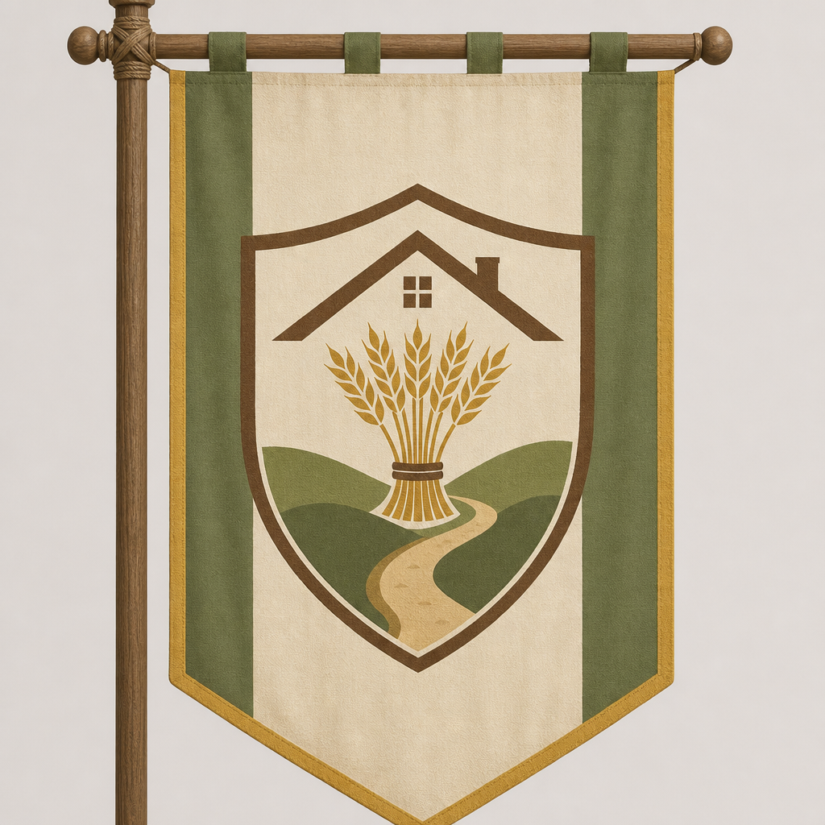
astiale-crest.png
GitHub: https://github.com/Dralorex/General-Questions/blob/main/assets/crests/alzenhiem/astiale-crest.png
Raw (for insert): https://raw.githubusercontent.com/Dralorex/General-Questions/main/assets/crests/alzenhiem/astiale-crest.png
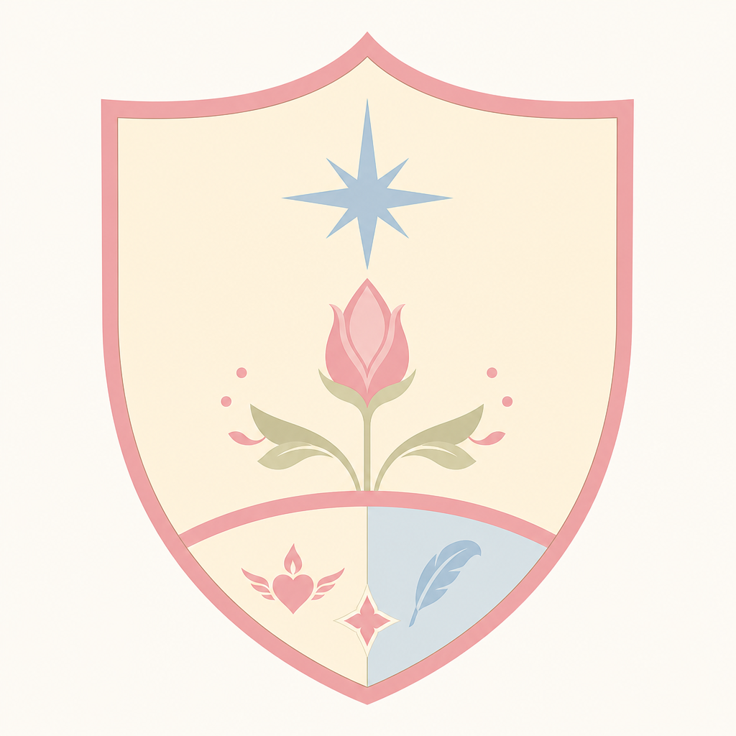
astiale-sigil.png
GitHub: https://github.com/Dralorex/General-Questions/blob/main/assets/crests/alzenhiem/astiale-sigil.png
Raw (for insert): https://raw.githubusercontent.com/Dralorex/General-Questions/main/assets/crests/alzenhiem/astiale-sigil.png

dezco-crest.png
GitHub: https://github.com/Dralorex/General-Questions/blob/main/assets/crests/alzenhiem/dezco-crest.png
Raw (for insert): https://raw.githubusercontent.com/Dralorex/General-Questions/main/assets/crests/alzenhiem/dezco-crest.png
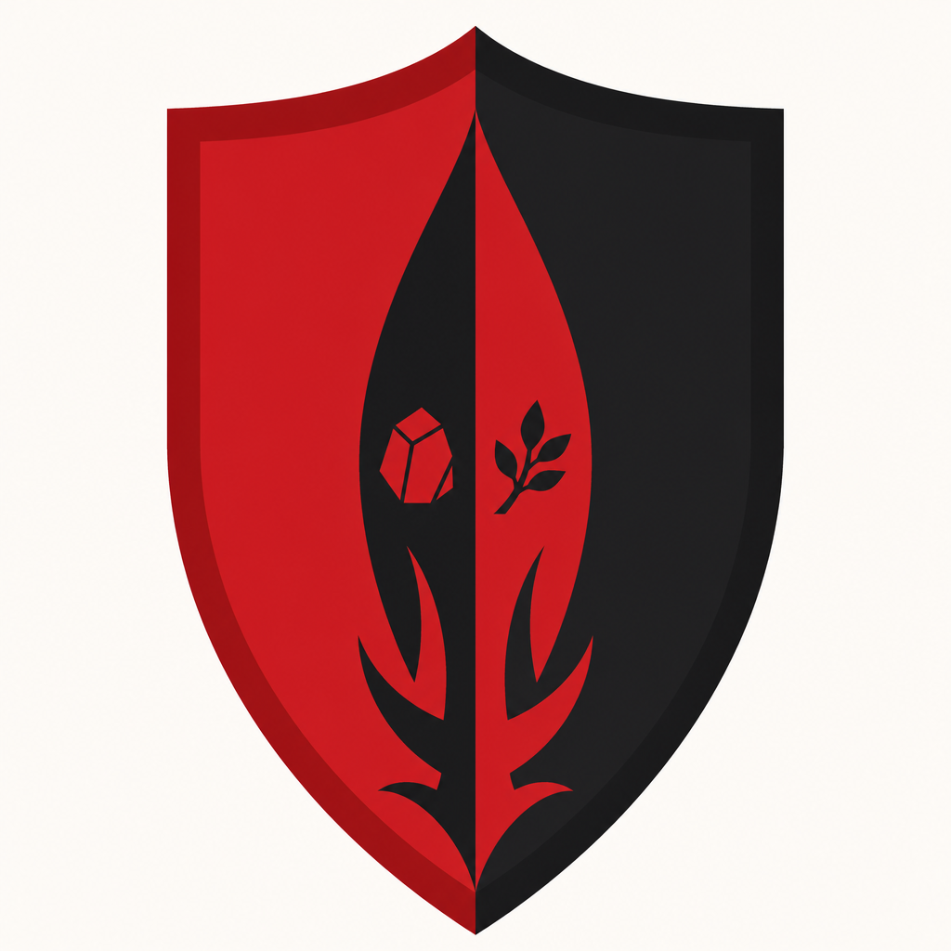
dezco-sigil.png
GitHub: https://github.com/Dralorex/General-Questions/blob/main/assets/crests/alzenhiem/dezco-sigil.png
Raw (for insert): https://raw.githubusercontent.com/Dralorex/General-Questions/main/assets/crests/alzenhiem/dezco-sigil.png
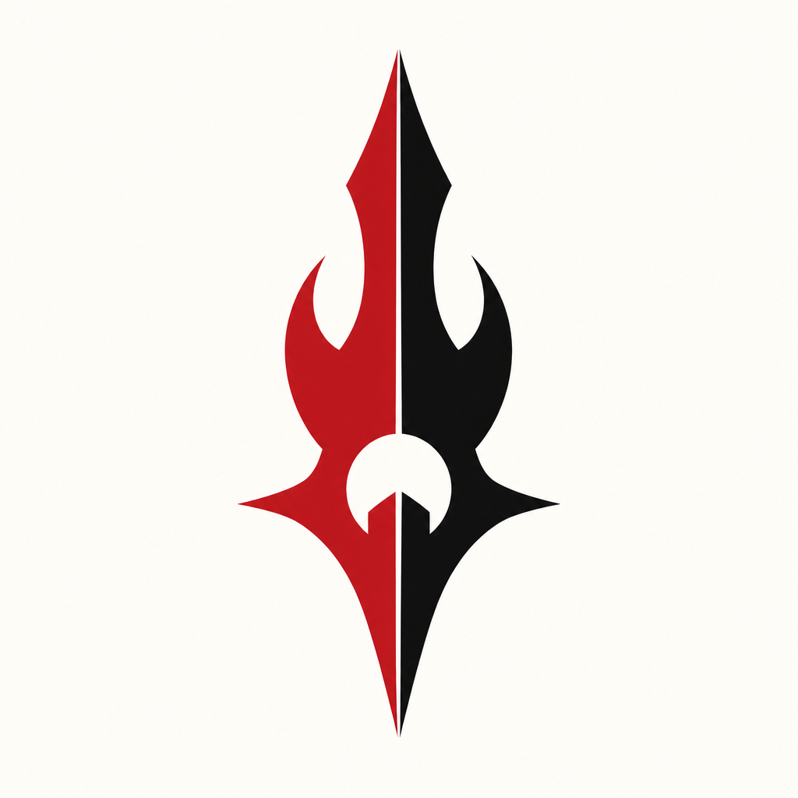
dolkin-crest.png
GitHub: https://github.com/Dralorex/General-Questions/blob/main/assets/crests/alzenhiem/dolkin-crest.png
Raw (for insert): https://raw.githubusercontent.com/Dralorex/General-Questions/main/assets/crests/alzenhiem/dolkin-crest.png
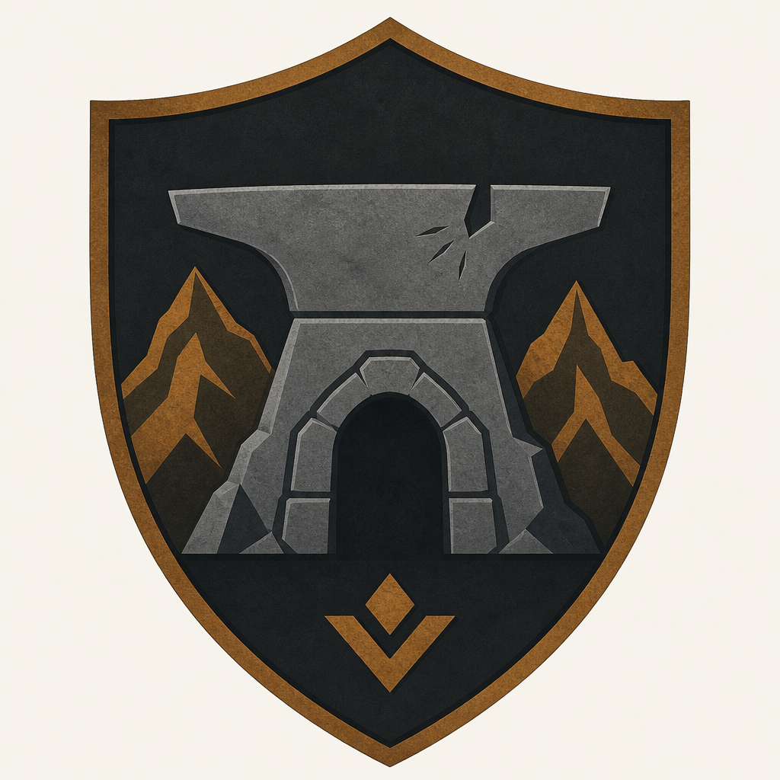
dolkin-sigil.png
GitHub: https://github.com/Dralorex/General-Questions/blob/main/assets/crests/alzenhiem/dolkin-sigil.png
Raw (for insert): https://raw.githubusercontent.com/Dralorex/General-Questions/main/assets/crests/alzenhiem/dolkin-sigil.png
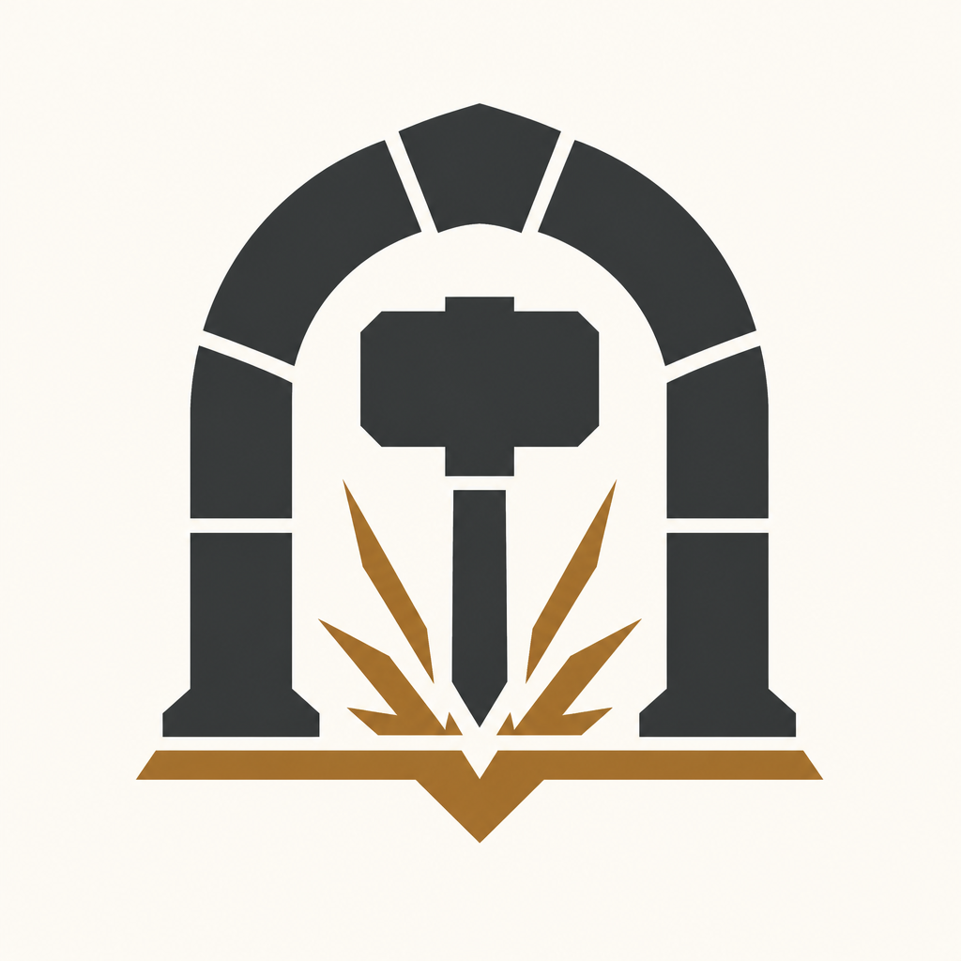
fulfein-crest.png
GitHub: https://github.com/Dralorex/General-Questions/blob/main/assets/crests/alzenhiem/fulfein-crest.png
Raw (for insert): https://raw.githubusercontent.com/Dralorex/General-Questions/main/assets/crests/alzenhiem/fulfein-crest.png
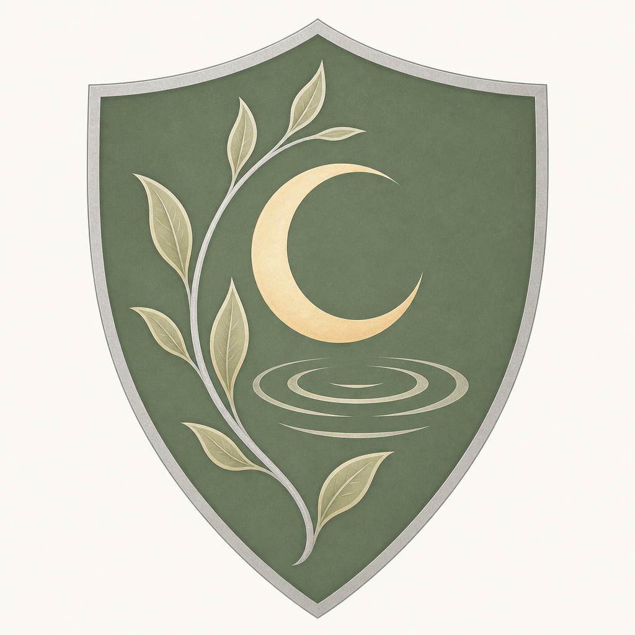
fulfein-sigil.png
GitHub: https://github.com/Dralorex/General-Questions/blob/main/assets/crests/alzenhiem/fulfein-sigil.png
Raw (for insert): https://raw.githubusercontent.com/Dralorex/General-Questions/main/assets/crests/alzenhiem/fulfein-sigil.png

kalhien-crest.png
GitHub: https://github.com/Dralorex/General-Questions/blob/main/assets/crests/alzenhiem/kalhien-crest.png
Raw (for insert): https://raw.githubusercontent.com/Dralorex/General-Questions/main/assets/crests/alzenhiem/kalhien-crest.png
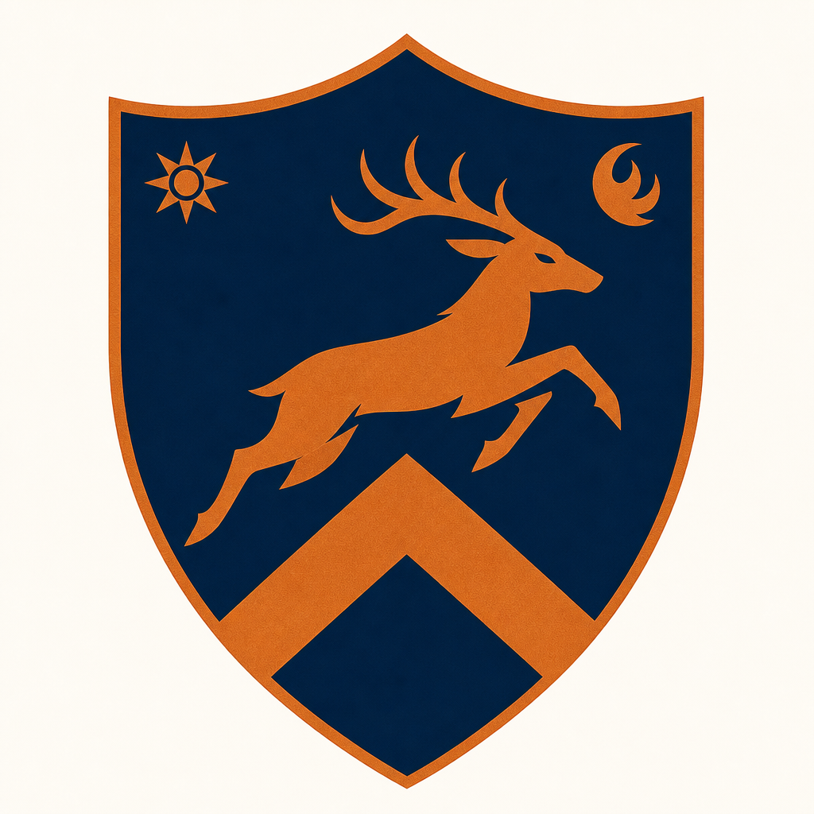
kalhien-sigil.png
GitHub: https://github.com/Dralorex/General-Questions/blob/main/assets/crests/alzenhiem/kalhien-sigil.png
Raw (for insert): https://raw.githubusercontent.com/Dralorex/General-Questions/main/assets/crests/alzenhiem/kalhien-sigil.png


