Key message: Share the 7 score card changes and metric revisions with EU and UK DSPs

Send out date: CW15

Audience: All EU + UK - 1.0 and 2.0 DSPs - Owners and OSMS

Title: Score Card Changes and Target Revisions

Body:

on road

At Amazon we get your feedback and use it to action the necessary changes to continue fostering a strong partnership with you. Based on your recent feedback, we are revising metric targets and weights, as well as introducing category tiers on your weekly performance scorecards. Starting on Week 18 (for Week 17 scorecards) we are bringing (7 – for UK, FR and ES; 6 – for rest of countries) XX changes . In the sections below, we dive deeper into each of these changes. If you would like to learn more about each change or have any questions, feel free to reach out to your Account Manager or Business Coach.

**Change 1: Delivered Not Recieved (DPMO) metric | Targets Update**

The first change that we are excited to share with you is updating current Delivery Not Received (DNR) (DPMO) metric targets on scorecards. The revision to the targets has been implemented to reflect the current delivery landscape and to take into account Region Grid Unit (RGU) adjustments and expansions. On road.

Please reach out to your Account Managers to learn about your station specific targets. These targets will also be updated on Page 5 of scorecards under metric definition as ‘A DSP who has Fantastic standing would receive a <= ___ in DNR DPMO’



**Change 2: Contact Compliance metric | Targets Update**

The second change we are bringing is adjusting current contact compliance ‘Fantastic’ target to accommodate group stop deliveries, communication signal challenges in remote places, poor weather impact (seasonal), and any tech issues.

The revised targets for being ‘Fantastic’ for contact compliance metric is 98.00% (for UK, IE, DE, AT and NL) / 99.00% (for FR, BE, ES, IT). These targets will also be updated on Page 5 of scorecards under metric definition.



**Change 3: Photo on Delivery Compliance metric | Targets Update – For ES and FR only**

The third change we are introducing is adjusting current Photo on Delivery metric targets on scorecards. New targets are reflected below and will also be updated on Page5 of scorecards under metric definition as ‘A DSP who has Fantastic standing would receive a >= XX in POD Compliance.

|  |  |
| --- | --- |
| Metric Target | Metric Tier |
| POD compliance >= 94.00% | Fantastic |
| POD compliance >= 93.00% | Great |
| POD compliance >= 90.00% | Fair |
| POD compliance < 90.00% | Poor |





**Change 4: Scan compliance metric deprecation**

The next change we are happy to share with you and your teams is the deprecation of the scan compliance metric from your weekly scorecards.

**Change 5: Converting CAS metric to Binary (Not applicable in BE and NL at present)**

To support standardization, we are converting Comprehensive Audit Score metric from weekly scoring to binary (In compliance / Not in Compliance) mode. We will evaluate (In compliance / Not in Compliance) based on your last CAS audit results and if your score is <87.5 (not in compliance), your final weekly scores will be restricted to maximum of 84.99 (Great Status).

**Change 6: Metric Weights restructuring and availability on scorecards**

We are restructuring available metrics weights to three categories on the scorecards- 1) Safety and Compliance, 2) Quality and Standard Work Compliance, and 3) Customer Feedback and Team. Please reach out to your Account Managers to learn about your scorecard metric weights.



**Change 7: Category Tiers**

We are rolling up individual metrics contributions at 3 category levels (as explained above) to provide category level performance tiers (Fantastic, Great, Fair, Poor). We believe these tiers will help you in a waterfall way to identify performance on scorecards category and then particular metrics.

**Scorecard Mockup**

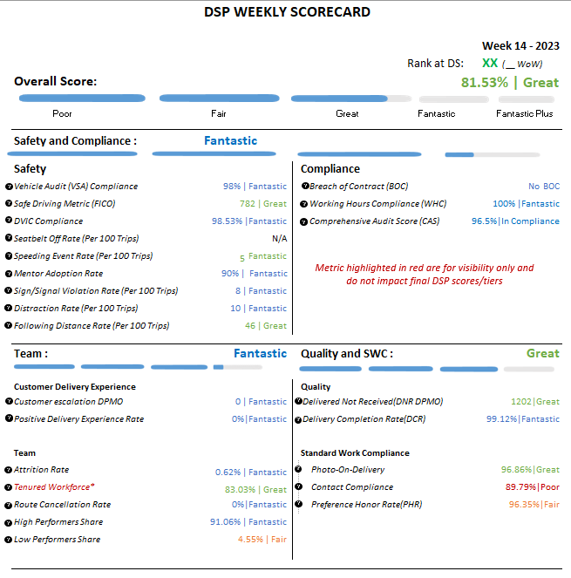

**Change 8: Micromobility**

|  |  |  |  |
| --- | --- | --- | --- |
| *#* | **Country** | **Station** | **DSP** |
| *1* | **IT** | DNP1 | TERS |
| *2* | **IT** | DLG1 | BSPA |
| *3* | **IT** | DLO1 | TERS |
| *4* | **IT** | DER1 | SRL |
| *5* | **ES** | DQA5 | VAYV |
| *6* | **ES** | DQV6 | JSIS |
| *7* | **ES** | DCT4 | LIEE |
| *8* | **ES** | DMA3 | CIIN |
| *9* | **ES** | DMA3 | ECSC |
| *10* | **ES** | DMA3 | KOIK |
| *11* | **ES** | DQA4 | SDRO |
| *12* | **ES** | DQA2 | SDRO |
| *13* | **ES** | DZG2 | CIIN |
| *14* | **ES** | TBC | KOIK |
| *15* | **ES** | DMA6 | OMLL |
| *16* | **DE** | DBW5 | ELAR |
| *17* | **DE** | DNW8 | FRLG |
| *18* | **DE** | DMU2 | ELAR |
| *19* | **DE** | DNW3 | DMLG |
| *20* | **DE** | DNZ2 | VGSG |
| *21* | **AT** | DVI2 | SMAO |
| *22* | **AT** | DVI3 | GLPG |
| *23* | **FR** | DIF1 | SLOP |
| *24* | **FR** | DIF1 | PRNA |
| *25* | **FR** | DIF3 | STTP |
| *26* | **FR** | DIF3 | RICU |
| *27* | **FR** | DIF3 | SIHE |
| *28* | **FR** | DIF2 | FALO |
| *29* | **FR** | DIF2 | MIST |
| *30* | **FR** | DIF2 | TRSA |
| *31* | **FR** | DIF2 | UGLO |
| *32* | **FR** | DAR1 | CRSR |
| *33* | **FR** | DND1 | ULS |
| *34* | **FR** | DAC9 | URBY |
| *35* | **FR** | DLP9 | SEVC |
| *36* | **FR** | DLP2 | SNGS |
| *37* | **FR** | DAR2 | COLA |
| *38* | **FR** | DWP2 | TSCN |
| *39* | **FR** | DIF1 | SLOP |
| *40* | **FR** | DAO1 | TCMN |
| *41* | **FR** | DWP7 | EILL |
| *42* | **FR** | DIF6 | TRYF |
| *43* | **FR** | DIF5 | TRYF |
| *44* | **FR** | DIF3 | URBB |
| *45* | **FR** | DIF3 | CRSR |
| *46* | **BE** | DHG2 | COBQ |
| *47* | **UK** | DXE1 | OTLL |
| *48* | **UK** | DBR1 | OTLL |
| *49* | **UK** | DXM2 | OLOG |
| *50* | **UK** | DHA2 | FAYD |

Starting from Week 17, the Daily Vehicle Inspection (DVIC) metric will be applicable to all micro-mobility modes of transport. Accordingly, please ensure that all drivers completing micro mobility routes continue to conduct the Daily Vehicle Checklist via E-Driving. This metric will be captured under the Safety category of the Scorecard.