**Course: Introduction to Data Science (DS2006) - Laboratory 02**

**Student:**

Hello everyone! During this course we will have several laboratory activities which are designed to help you better understand practical aspects of python programming as well as dealing with different types of data science situations.

**Task 1**: Implement the python code presented in Figure.1 in a new project (new folder in Visual Studio Code). The name of the file should be [dice.py](http://dice.py).

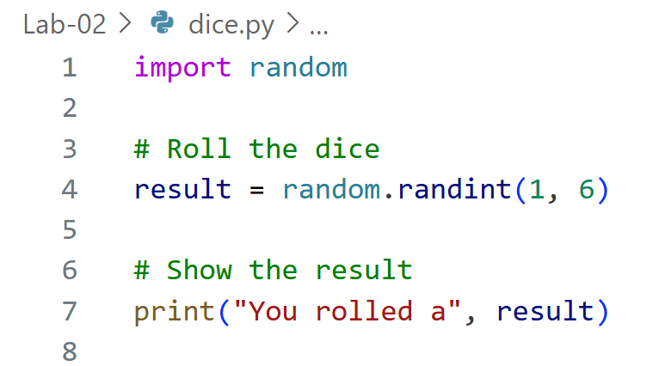

Fig. 1 - The source code of dice.py

**Task 2**: Run your dice.py code at least 3 times and print screen the results and paste it here in your report.

**Task 3**: What happens when you change the order of the instructions in the code, as shown in Figure 2?

**Task 4**: What happens when you try to run the code shown in Figure 2?

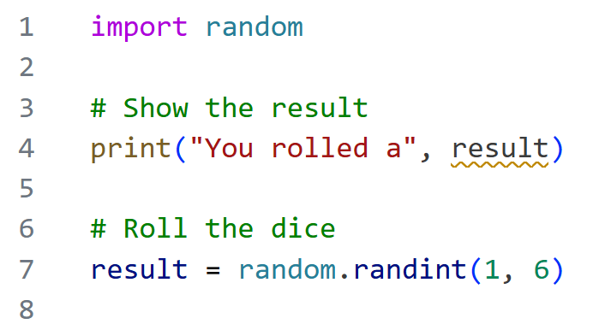

Fig. 2. A modified source code for dice.py

**Task 5**: Go back to using the code in Figure 1. How can you modify the code to allow the equivalent of a d20 (a dice with 20 sides) is rolled instead of a d6?

**Task 6**: How can you customize the print method call to add information that the result obtained by the roll now is related to a D20 instead of a D6?

**Task 7**: Implement the code for only making the dice roll after the user presses enter.

**Task 8**: Make these changes (Tasks 5,6,7) in your code and run it at least 3 times. Print screen the results and paste it here in your report.