**A NOVEL ON THE ADVANCEMENT OF NANOMATERIALS FOR TARGETED DRUG DELIVERY**

**OLADELE SULIYAT ENIOLA**

**MATRIC NO: BMS/18/19/0361**

**SUPERVISOR’S NAME: DR MURTALA A .A**

**A SEMINAR**

**PRESENTED TO:**

**DEPARTMENT OF PHARMACOLOGY AND THERAPEUTICS,**

**FACULTY OF BASIC MEDICAL SCIENCES,**

**OBAFEMI AWOLOWO COLLEGE OF HEALTH SCIENCES,**

**OLABISI ONABANJO UNIVERSITY,**

**SAGAMU CAMPUS.**

**2023**

**OUTLINE**

1. Introduction 3
2. Nano Technology 3
3. Nano medicine 4
4. Biopolymeric nanoparticles in diagnosis, detection and imaging 6
5. Drug designing and drug delivery process and mechanism 6
6. Mechanism for controlled release of drugs using different types of nanocarriers 6
7. Nanoparticles used in drug delivery system 8  
    Biopolymeric nanoparticles 9
8. Natural product based nanotechnology and drug delivery 10
9. Future of nanomedicines and drug delivery system 10
10. Conclusion 12
11. References 13

**1.0 INTRODUCTION**

Modern medicines are mainly derived from herbs on the basis of traditional knowledge and practices. Nearly, 25% of the major pharmaceutical compounds and their derivatives available today are obtained from natural resources. Natural compounds with different molecular backgrounds present a basis for the discovery of novel drugs. (Sainz et al., 2015)

Nanomedicine and Nano delivery systems are a relatively new but rapidly developing science where materials in the nanoscale range are employed to serve as means of diagnostic tools or to deliver therapeutic agents to specific targeted sites in a controlled manner. Nanotechnology offers multiple benefits in treating chronic human diseases by site-specific and target-oriented delivery of precise medicines.

The use of large sized materials in drug delivery poses major challenges, including in vivo instability, poor bioavailability, and poor solubility, poor absorption in the body, issues with target-specific delivery, and tonic effectiveness, and probable adverse effects of drugs. Therefore, using new drug delivery systems for targeting drugs to specific body parts could be an option that might solve these critical issues. Hence, nanotechnology plays a significant role in advanced medicine/drug formulations, targeting arena and their controlled drug release and delivery with immense success. (Martinho & Damgé, 2011, Jahangirian et al., 2017

**2.0 NANO TECHNOLOGY**

**Nanotechnology** employs curative agents at the nanoscale level to develop nanomedicines. The field of biomedicine comprising nanobiotechnology, drug delivery, biosensors, and tissue engineering has been powered by nanoparticles. (Swamy et al., 2016)

As **nanoparticles** comprise materials designed at the atomic or molecular level, they are usually small sized nanospheres. Hence, they can move more freely in the human body as compared to bigger materials. Nanoscale sized particles exhibit unique structural, chemical, mechanical, magnetic, electrical, and biological properties. (Swamy et al., 2016)

Being **nanosized**, these structures penetrate in the tissue system, facilitate easy uptake of the drug by cells, permit an efficient drug delivery, and ensure action at the targeted location. The uptake of nanostructures by cells is much higher than that of large particles with size ranging between 1 and 10 µm. Hence, they directly interact to treat the diseased cells with improved efficiency and reduced or negligible side effects. At all stages of clinical practices, nanoparticles have been found to be useful in acquiring information owing to their use in numerous novel assays to treat and diagnose diseases. The main benefits of these nanoparticles are associated with their surface properties; as various proteins can be affixed to the surface. (Mirza et al., 2014)

**3.0 NANO MEDICINE**

**Nanomedicine** is an emerging field implementing the use of knowledge and techniques of nanoscience in medical biology and disease prevention and remediation.

It implicates the utilization of nanodimensional materials including nanorobots, nanosensors for diagnosis, delivery, and sensory purposes, and actuate materials in live cells. For example, a nanoparticle-based method has been developed which combined both the treatment and imaging modalities of cancer diagnosis. (Hassan et al., 2017)

**Nanodrugs** show higher oral bioavailability because they exhibit typical uptake mechanisms of absorptive endocytosis. (Hassan et al., 2017)

The use of ideal Nano-drug delivery system is decided primarily based on the biophysical and biochemical properties of the targeted drugs being selected for the treatment. However, problems such as toxicity exhibited by nanoparticles cannot be ignored when considering the use of nanomedicines. More recently, nanoparticles have mostly been used in combination with natural products to lower the toxicity issues. The green chemistry route of designing nanoparticles loaded with drugs is widely encouraged as it minimizes the hazardous constituents in the biosynthetic process. (Watkins et al., 2015)

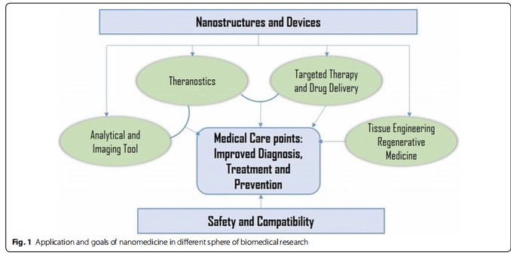

**Nanostructures** stay in the blood circulatory system for a prolonged period and enable the release of amalgamated drugs as per the specified dose. Thus, they cause fewer plasma fluctuations with reduced adverse effects. (Kabanov, et al., 2002)

**3.1 Biopolymeric nanoparticle in diagnosis, detection and imaging**

The integration of therapy and diagnosis is defined as **Theranostic** and is being extensively utilized for cancer treatment. Theranostic nanoparticles can help diagnose the disease, report the location, identify the stage of the disease, and provide information about the treatment response. In addition, such nanoparticles can carry a therapeutic agent for the tumor, which can provide the necessary concentrations of the therapeutic agent via molecular and/or external stimuli.

Chitosan is a biopolymer which possesses distinctive properties with biocompatibility and presence of functional groups. (Swierczewska et al., 2016). It is used in the encapsulation or coating of various types of nanoparticles, thus producing different particles with multiple functions for their potential uses in the detection and diagnosis of different types of diseases. (Agrahar et al., 2016, Wiley, 2017)

**3.2 Drug designing and drug delivery process and mechanism**

Although there are several nanocarriers with different drug release profiles, strategies are currently being formulated to improve the specificity of the nanostructures to target regions of the organism , and to reduce the immunogenicity through their coating or chemical functionalization with several substances, such as polymers , natural polysaccharides , antibodies , cell-membrane , and tunable surfactants , peptides etc. (Agrahar,et al., 2016, Wiley, 2017)

On the other hand, stimuli-responsive nanocarriers have shown the ability to control the release profile of drugs (as a triggered release) using external factors such as ultrasound, heat , magnetism, light, pH, and ionic strength, which can improve the targeting and allow greater dosage control. (Agrahar,et al., 2016, Wiley, 2017)

**3.3 Mechanism for controlled release of drugs using different types of nanocarriers**

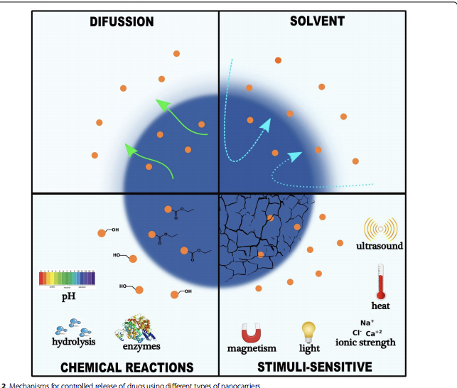

**3.4 Nano particles used in drug delivery system Biopolymeric nanoparticles.**

1. **Chitosan**: Chitosan exhibits muco-adhesive properties and can be used to act in the tight epithelial junctions. Thus, chitosan are widely used for continued drug release systems for various types of epithelia, including buccal , intestinal , nasal , eye and pulmonary to the eye. Silva et al. [114] prepared and evaluated the efficacy of a 0.75% w/w isotonic solution of hydroxypropyl methylcellulose (HPMC) containing chitosan/sodium tripolyphosphate/hyaluronic acid nanoparticles to deliver the antibiotic ceftazidime to the eye. (Grumezescu et al., 2017)
2. **Alginate**: Another biopolymeric material that has been used as a drug delivery is alginate. This biopolymer presents final carboxyl groups, being classified as anionic mucoadhesive polymer and presents greater mucoadhesive strength when compared with cationic and neutral polymers. Patil and Devarajan developed insulin-containing alginate nanoparticles with nicotinamide as a permeation agent in order to lower the serum glucose levels and raise serum insulin levels in diabetic rats (Patil & Devarajan 2016)
3. **Cellulose**: Cellulose and its derivatives are extensively utilized in the drug delivery systems basically for modification of the solubility and gelation of the drugs that resulted in the control of the release profile of the same. Elseoud et  al. [129] investigated the utilization of cellulose nanocrystals and chitosan nanoparticles for the oral releasing of repaglinide (an anti-hyperglycemic—RPG). The chitosan nanoparticles showed a mean size distribution of 197nm while the hybrid nanoparticles of chitosan and cellulose nanocrystals containing RPG. Chitosan hybrid nanoparticles and oxidized cellulose nanocrystals containing RPG had a mean diameter of 251–310 nm.

The presence of the hydrogen bonds between the cellulose nanocrystals and the drug, resulted in sustained release of the same, and subsequently the nanoparticles made with oxidized cellulose nanocrystals presented lower release when compared to the nanoparticles produced with native cellulose nanocrystals. (Grumezescu et al., 2017)

1. **Liposomes**: They are vesicles of spherical form composed of phospholipids and steroids usually in the 50–450 nm size range. These are considered as a better drug delivery vehicles since their membrane structure is analogous to the cell membranes and because they facilitate incorporation of drugs in them. It has also been proved that they make therapeutic compounds stable, improve their biodistribution, can be used with hydrophilic and hydrophobic drugs and are also biocompatible and biodegradable. (Grumezescu et al., 2017)
2. **Inorganic nanoparticles**: These include silver, gold, iron oxide and silica nanoparticles are included. Metal nanoparticles, silver and gold, have particular properties like SPR (surface plasmon resonance), that liposomes, dendrimers, micelles do not possess. They showed several advantages such as good biocompatibility and versatility when it comes to surface functionalization. (Grumezescu et al., 2017)
3. **Dendrimers**: Dendrimers are highly bifurcated, monodisperse, well-defined and three-dimensional structures. They are globular-shaped and their surface is functionalized easily in a controlled way, which makes these structures excellent candidates as drug delivery agents. Dendrimers are grouped into several kinds according to their functionalization moieties: PAMAM, PPI, liquid crystalline, core–shell, chiral, peptide, glycodendrimers and PAMAMOS, being PAMAM, the most studied for oral drug delivery because it is water soluble and it can pass through the epithelial tissue boosting their transfer via the paracellular pathway. Dendrimers are limited in their clinical applications because of the presence of amine groups. These groups are positively charged or cationic which makes them toxic, hence dendrimers are usually modifed in order to reduce this toxicity issue or to eliminate it.( Noriega-Luna et al., 2014)

**4.0 Natural product based nanotechnology and drug delivery**

Pharmaceutical industries have continuously sought the development and application of new technologies for the advancement and design of modern drugs, as well as the enhancement of existing ones. In this sense, the accelerated development of nanotechnology has driven the design of new formulations through different approaches, such as, driving the drug to the site of action (nanopharmaceutics); image and diagnosis (nanodiagnostic), medical implants (nanobiomaterials) and the combination diagnosis and treatment of diseases (nanotheranostics). (Paul et al., 2014, Kushwaha et al., 2015).

As per the World Health Organization (WHO) report, in developing countries, the basic health needs of approximately 80% of the population are met and/or complemented by traditional medicine. Currently, the scientific community is focusing on the studies related to the bioactive compounds, its chemical composition and pharmacological potential of various plant species, to produce innovative active ingredients that present relatively minor side effects than existing molecules. (Metz et al., 2015)

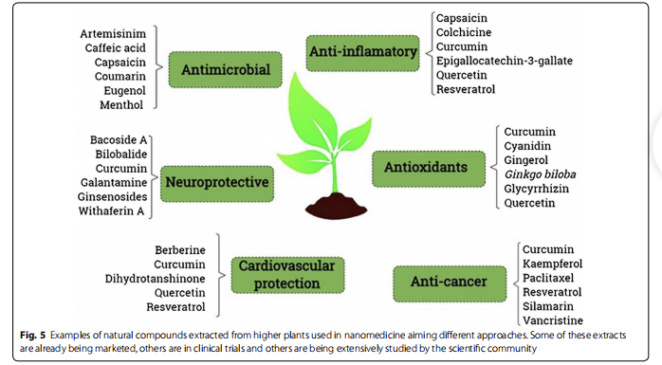

**4.1 Natural product‑based nanotechnology and drug delivery cont’d**

For the first approach, the microorganism that aids the synthesis procedure is prepared in the adequate growth medium and then mixed with a metal precursor in solution and left for incubation to form the nanoparticles either intracellularly or extracellularly. (Paul et al., 2014, Kushwaha et al., 2015).

As for the second approach, the plant extract is prepared and mixed afterwards with the metal precursor in solution and incubated further at room temperature or boiling temperature for a definite time or exposed to light as an external stimulus to initiate the synthesis of nanoparticles. Presently, these natural product based materials are considered as the key ingredients in the preparation and processing of new nano-formulations because they have interesting characteristics, such as being biodegradable, biocompatible, availability, being renewable and presenting low toxicity. In addition to the aforementioned properties, biomaterials are, for the most part, capable of undergoing chemical modifications, guaranteeing them unique and desirable properties for is potential uses in the field of nanomedicine. Gold, silver, cadmium sulfide and titanium dioxide of diferent morphological characteristics have been synthesized using a number of bacteria namely Escherichia coli, Pseudomonas aeruginosa, Bacillus subtilis and Klebsiella pneumoniae. These nanoparticles, especially the silver nanoparticles have been abundantly studied in vitro for their antibacterial, antifungal, and cytotoxicity potential due to their higher potential among all metal nanoparticles. In the event of microorganism mediated nanoparticle synthesis, maximum research is focused on the way that microorganisms reduce metal precursors and generate the nanoparticles.

**Future of nanomedicines and drug delivery system**

The science of nanomedicines is currently among the most fascinating areas of research. A lot of research in this field in the last two decades has already led to the filling of 1500 patents and completion of several dozens of clinical trials. As outlined in the various sections above, cancer appears to be the best example of diseases where both its diagnosis and therapy have benefited from nonmedical technologies.

By using various types of nanoparticles for the delivery of the accurate amount of drug to the affected cells such as the cancer/tumor cells, without disturbing the physiology of the normal cells, the application of nanomedicine and Nano-drug delivery system is certainly the trend that will remain to be the future arena of research and development for decades to come.

The fundamental markers of diseased tissues including key biological markers that allow absolute targeting without altering the normal cellular process is one main future area of research. Ultimately, the application of nanomedicine will advance with our increasing knowledge of diseases at molecular level or that mirrors a nanomaterial-subcellular size comparable marker identification to open up avenues for new diagnosis/therapy. Hence, understanding the molecular signatures of disease in the future will lead to advances in nanomedicine applications. Beyond what we have outlined in this review using the known nanoprobes and nanotheragnostics products, further research would be key for the wider application of nanomedicine

**Conclusion**

The present review discusses the recent advances in nanomedicines, including technological progresses in the delivery of old and new drugs as well as novel diagnostic methodologies. A range of nano-dimensional materials, including nanorobots and nanosensors that are applicable to diagnose, precisely deliver to targets, sense or activate materials in live system have been outlined. Initially, the use of nanotechnology was largely based on enhancing the solubility, absorption, bioavailability, and controlled-release of drugs

Initially, the use of nanotechnology was largely based on enhancing the solubility, absorption, bioavailability, and controlled-release of drugs. since the 1990s, the list of FDA-approved nanotechnology-based products and clinical trials has staggeringly increased and include synthetic polymer particles; liposome formulations; micellar nanoparticles; protein nanoparticles; nanocrystals and many others often in combination with drugs or biologics.

One of the great interest in the development of nanomedicine in recent years relates to the integration of therapy and diagnosis (theranostic) as exemplified by cancer as a disease model.

Thanks to advances in nanomedicine, our ability to diagnose diseases and even combining diagnosis with therapy has also become a reality.

**References**

1. Sainz V, Conniot J, Matos AI, Peres C, Zupanǒiǒ E, Moura L, Silva LC, Florindo HF, Gaspar RS. Regulatory aspects on nanomedicines. Biochem Biophys Res Commun. 2015;468:504–10.
2. Swamy MK, Sinniah UR. Patchouli (Pogostemon cablin Benth.): botany, agrotechnology and biotechnological aspects. Ind Crops Prod. 2016;87:161–76.
3. Mohanty SK, Swamy MK, Sinniah UR, Anuradha M. Leptadenia reticulata (Retz.) Wight & Arn. (Jivanti): botanical, agronomical, phyto‑ chemical, pharmacological, and biotechnological aspects. Molecules. 1019;2017:22.
4. Hassan S, Prakash G, Ozturk AB, Saghazadeh S, Sohail MF, Seo J, Dok‑ meci MR, Zhang YS, Khademhosseini A. Evolution and clinical transla‑ tion of drug delivery nanomaterials. Nano Today. 2017;15:91–106.
5. Mirza AZ, Siddiqui FA. Nanomedicine and drug delivery: a mini review. Int Nano Lett. 2014;4:94
6. Agrahari V, Agrahari V. Facilitating the translation of nanomedicines to a clinical product: challenges and opportunities. Drug Discov Today. 2018;23(5):974–91.
7. Patil NH, Devarajan PV. Insulin-loaded alginic acid nanoparticles for sublingual delivery. Drug Deliv. 2016;23:429–36.
8. Caster JM, Patel AN, Zhang T, Wang A. Investigational nanomedicines in 2016: a review of nanotherapeutics currently undergoing clinical trials. Wiley Interdiscip Rev. 2016;2017:9.
9. Wacker MG, Proykova A, Santos GML. Dealing with nanosafety around the globe—regulation vs. innovation. Int J Pharm. 2016;509:95–106
10. Anselmo AC, Mitragotri S. Nanoparticles in the clinic. Bioeng Transl Med. 2016;1:10–29.
11. Grumezescu AM. Nanoscale fabrication, optimization, scale‑up and bio‑ logical aspects of pharmaceutical nanotechnology. New York: William Andrew; 2017.
12. Caster JM, Patel AN, Zhang T, Wang A. Investigational nanomedicines in 2016: a review of nanotherapeutics currently undergoing clinical trials. Wiley Interdiscip Rev. 2017;9:e1416.
13. Drug approvals and databases. https ://www.fda.gov/Drugs /Infor matio nOnDr ugs/defau lt.htm. Accessed 16 Aug 2018.
14. D’Mello SR, Cruz CN, Chen M‑L, Kapoor M, Lee SL, Tyner KM. The evolv‑ ing landscape of drug products containing nanomaterials in the United States. Nat Nanotechnol. 2017;12:523
15. Metz KM, Sanders SE, Pender JP, Dix MR, Hinds DT, Quinn SJ, Ward AD, Duffy P, Cullen RJ, Colavita PE. Green synthesis of metal nanoparticles via natural extracts: the biogenic nanoparticle corona and its effects on reactivity. ACS Sustain Chem Eng. 2015;3:1610–7.
16. Watkins R, Wu L, Zhang C, Davis RM, Xu B. Natural product-based nano‑ medicine: recent advances and issues. Int J Nanomed. 2015;10:6055
17. Swierczewska M, Han H, Kim K, Park J, Lee S. Polysaccharide-based nanoparticles for theranostic nanomedicine. Adv Drug Deliv Rev. 2016;99:70–84
18. Paul D, Sinha SN. Extracellular synthesis of silver nanoparticles using Pseudomonas aeruginosa KUPSB12 and its antibacterial activity. JJBS. 2014;7:245–50. 210. Kushwaha A, Singh VK, Bhartariya J, Singh P, Yasmeen K. Isolation and identification of E. coli bacteria for the synthesis of silver nanoparticles: characterization of the particles and study of antibacterial activity. Eur J Exp Biol. 2015;5:65–70.
19. Iravani S. Bacteria in nanoparticle synthesis: current status and future prospects. Int Sch Res Notices. 2014;2014:359316. 212. Mittal AK, Chisti Y, Banerjee UC. Synthesis of metallic nanoparticles using plant extracts. Biotechnol Adv. 2013;31:346–56