* **Use the following information to answer questions 1-3.**
* **An investor purchased an 8% bond which matures in 10 years at 95.**
* **1. How much did the investor pay for this bond?**
  + $9.95
  + $95
  + $950
  + $9,500
* **2. This bond was purchased at a:**
  + Discount
  + Premium
* **3. How much will the investor receive when the bond mature?**
  + $800
  + $950
  + $1,040
  + $1,080
* **A zero-coupon bond would be an appropriate investment for which of the following investors?**
  + A retired person who needs regular income to supplement social security
  + Someone who needs a lump sum in 10 years to pay off the balloon mortgage on his house

**Calculating Returns on Fixed-Income Securities**

* **Use the following information to answer questions 1 through 3.**
* **1. An investor purchased an 8% Lemon Country Bond at 80.**
* **What is the bond’s nominal yield?**
  + 6%
  + 8%
  + 9%
  + 10%
* **2. What is the bond’s current yield?**
  + 6%
  + 8%
  + 9%
  + 10%
* **3. The yield to maturity will be:**
  + The same as the nominal and current yield
  + Greater than the current yield
  + Less than the current yield
  + Less than both the current and nominal yields
* **Which of the following securities is likely to decrease the most in price if interest rates rise?**
  + A bond maturing in 2 years
  + A bond maturing in 15 years
* **An investor recently invested $100,000 in bonds. What will happen to the value of his portfolio if interest rates increase?**
  + It will decrease
  + It will remain the same
  + It will increase
  + It cannot be determined from the information given
* **Jessica just received an inheritance from her Uncle Sam. She plans to use the money for a down payment on a house in six months, but she wants to earn some interest on the money in the meantime. Which of the following investments would suitable for her?**
  + Treasury bills
  + Treasury STRIPS
  + Treasury bonds
  + Common stocks
* **A U.S. government bond is selling in the market at 98.08. The dollar value of this bond is:**
  + $980.25
  + $980.80
  + $982.50
  + $9,808.00
* For example, a corporation bond is offered at 94 5/8. What is the cost for each $1,000 bond?

**5/8 = 0.625**

**94 5/8 ->94.625->94.625%**

**94.625% X $1,000 = $946.25**

* **XYZ convertible debentures are convertible into 20 shares of XYZ Corporation common stock. If the bonds were selling in the market at $980, what would the common stock have to be selling at to be at parity?**
  + $20
  + $45
  + $49
  + $50
* **A bond is purchased that is callable at 105 in five years. How much will the investor receive if the bond id called after five years?**
  + $800
  + $950
  + $1,000
  + $1,050
* **Which of the following securities would you recommend to investors who need monthly income?**
  + Treasury STRIPS
  + GNMA pass-through certificates
  + Treasury notes
  + Common stocks 、
* 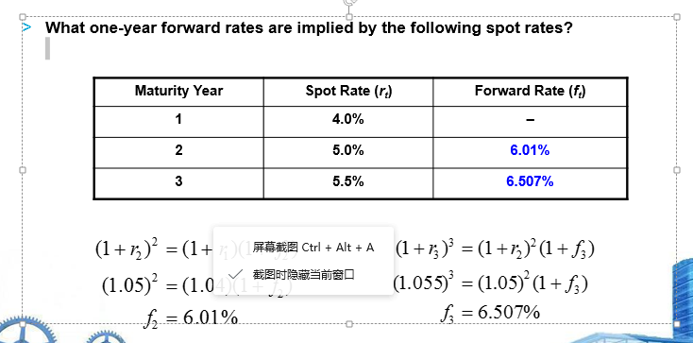、、
* 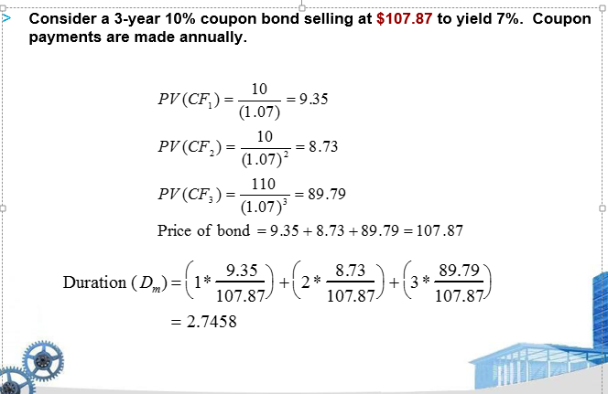
* 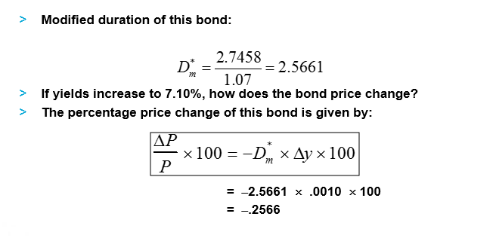
* 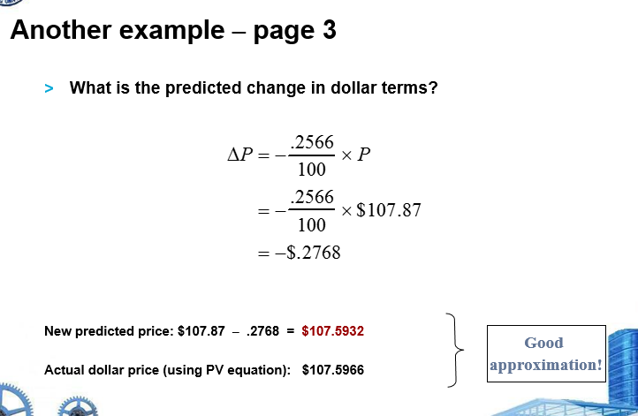

If you read that the Japanese yen is trading at $0.01232, how many yen will each dollar buy?

* + 0.01232
  + 1.232
  + 81.169
  + 8.119

The U.S. dollar was recently quoted at CHF0.8594 (Swiss francs). If you have placed an order for CHF 50,000 worth of watches from a Swiss watch dealer, how many dollars will this order cost?

* + $58,180
  + $42,970
  + $50,000
  + $52,180
* For example, If the Mexican Peso moves from $0.09 to $0.10, the Peso has
* appreciated – each Peso can buy $0.10 now instead of $0.09.
* For US dollar, it has depreciated. By how much?

What will cause a nation’s currency to appreciate?

* Slow growth of income relative to one’s trading partners will cause imports to lag behind exports
* A rate of inflation that is lower than that of one’s trading partners
* Domestic real interest rates that are greater than real interest rates abroad

What will cause a nation’s currency to depreciate?

* Rapid growth of income relative to one’s trading partners that stimulates imports relative to exports
* A rate of inflation that is higher than that of one’s trading partners
* Domestic real interest rates that are lower than real interest rates abroad

If the Mexico Peso moves from $0.09 to $0.10, which of the following is true?

* + It becomes more expensive for Americans to buy Mexican goods
  + It becomes less expensive for Mexicans to buy American goods
  + Mexican industry becomes less competitive with Americans in the U.S. market
  + All of the above are true

You receive a bid-ask quote for pesos 8.00-8.50. If you have $100, how many pesos will you be able to buy?

* + 118
  + 125
  + 800
  + 850

What will happen if you hold pesos and want to convert back to USD?

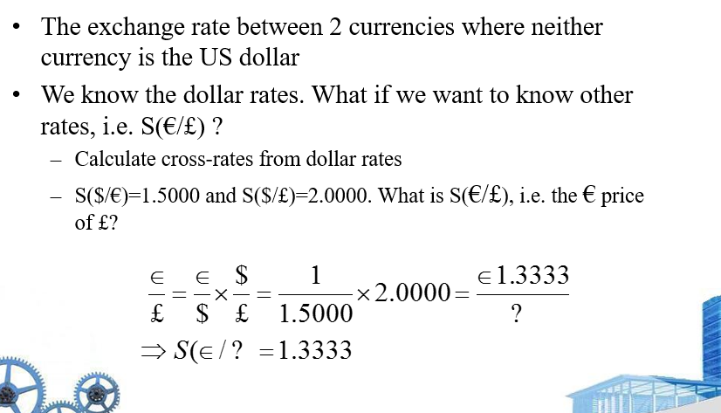

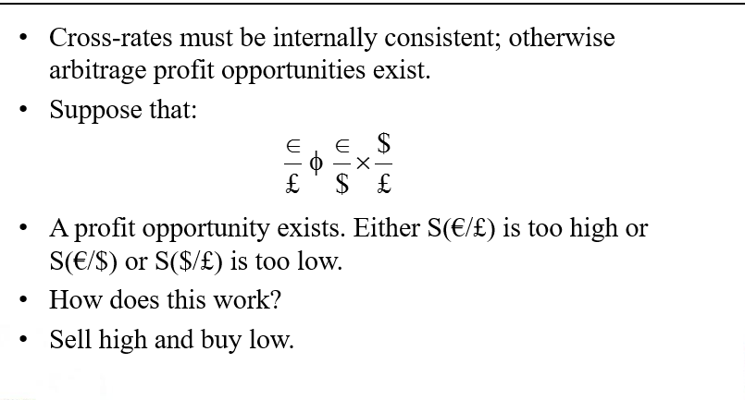

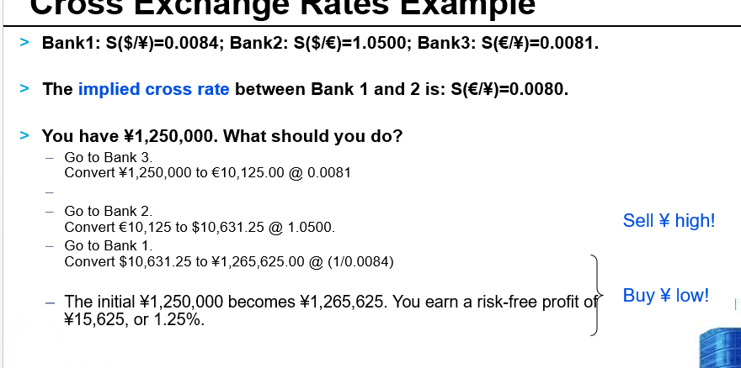

The peso quote is 8.00-8.10. The mark quote is 2.00-2.10. What is the peso/mark bid-ask?

4.00-4.05

3.81-4.05

3.81-3.86

2.47-2.63

The current spot rate quote is 7HKD/$. A forward discount of 0.02 would reflect a forward price of:

* + 7.04
  + 6.96
  + 7.02
  + 6.98