

**C1.1 CaSE STUDY**

**Case Study of “The GPS Auto-navigation System Verification Project”**



**NAME：XUANMING LIU**

**ID：3180106071**

**SUBMIT DATE：2020.12.10**

### Requirement 1: Project Organization

#### develop an initial project charter

|  |  |  |
| --- | --- | --- |
| **Project number** | 20201205 | |
| **Project name** | The GPS Auto-navigation System Verification Project | |
| **Project background** | An external product audit had been conducted by randomly selecting three of the 15 prototypes for a “tear down” audit inspection. The inspection had been completed and there were some discrepancies in the audit, ranging from engineering design issues to workmanship. | |
| **Project propose** | 5 systems would receive a “tear down” workmanship assessment and engineering design review to determine any product/manufacturing implications of defects identified in the workmanship review. The purpose of this operation is to prove that IRIS was a great system, capable of exceeding all field expectations for reliability. | |
| **Project manager** | Xuanming LIU, The Manager of Reliability Engineering | |
| **Project member** | 1. Gail YU, Manager of Quality Engineering 2. Tom HUANG, Manager of Design and Product Engineering 3. Jesse LIU, a senior engineer from Product Manufacturing 4. Pete DONG, a senior engineer from Administration responsible for component purchasing and incoming testing of materials. | |
| **Scope** | We need to finish this test project as soon as possible, including tasks listed below:  (1) developing the project plan and schedule  (2) conducting the reliability testing of the guidance systems,  (3) conducting the tear down audit and interpreting the results  (4) reporting the results of the project to Senior Management. | |
| **Time schedule** | task | Deadline |
| a briefing in one week concerning your plan for the reliability testing | end of first week |
| meeting to develop the company position and strategy | end of second week |
| Primary tests result | end of second week |
| a full customer briefing | end of third week |
| Finish the tests | end of third week |

#### (b) develop a complete Linear Responsibility Chart

**Key**

**1-responsibility,**

**2-supervision,**

**3-must be consulted,**

**4-may be consulted,**

**5-must be notified,**

**6-approval authority.**

|  |  |  |  |  |  |
| --- | --- | --- | --- | --- | --- |
| **Task** | **Xuanming LIU** | **Gall YU** | **Tom HUANG** | **Pete DONG** | **Jesse LIU** |
| Design test plan | 126 | 36 | 36 | 4 | 4 |
| Guidance system reliability testing | 125 | 126 | 135 | 35 | 35 |
| Module decomposition audit | 125 | 126 | 135 | 135 | 35 |
| Analysis test and result of audit | 126 | 135 | 135 | 135 | 35 |
| Submit a project summary report | 126 | 35 | 35 | 35 | 4 |

#### (c) complete a stakeholder analysis.

**1. stakeholders in project team**

|  |  |  |  |  |
| --- | --- | --- | --- | --- |
| **Name** | Organization | Role | Profit | Impact |
| **Peter WANG** | Senior manager | Senior vice-president, director of product manufacturing | High | High |
| **Thomas GU** | Senior manager | Director of marketing and sales | High | Medium |
| **Jane YANG** | Senior manager | Director inspection & test | Pretty high | High |
| **Xuanming, LIU** | Project team | The Manager of Reliability Engineering | Pretty high | Pretty high |
| **Gall YU** | Project team | Manager of Quality Engineering | Pretty high | High |
| **Tom HUANG** | Project team | Manager of Design and Product Engineering | Pretty high | High |
| **Jesse LIU** | Project team | senior engineer from Product Manufacturing | Pretty high | High |
| **Pete DONG** | Project team | senior engineer from Administration responsible for component purchasing and incoming testing of materials. | Pretty high | High |

**2. stakeholders from other apartments in company**

|  |  |  |  |  |
| --- | --- | --- | --- | --- |
| **Name** | Organization | Role | Profit | Impact |
| **James TAN** | Senior manager | Director of engineering | Pretty high | Pretty high |
| **George WU** | Senior manager | Project manager | Pretty high | Pretty high |

**3. stakeholders from customers**

|  |  |  |  |  |
| --- | --- | --- | --- | --- |
| **Name** | Organization | Role | Profit | Impact |
| **Robert HOU** | Customer representative | Interal customer representative | High | Medium |

### REQUIREMENT 2: Network Planning for the Reliability Testing and Workmanship Auditing

#### Develop a CPM Activity on Node diagram for the project

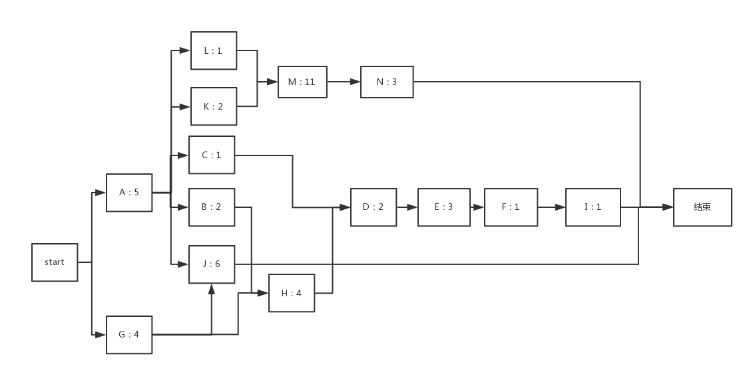

#### (b) Determine the critical path and the duration of the critical path for the project

The critical path of this project is A->K->M->N. So, the total day would be cost is 5 + 2 + 11 + 3 = 21days.

#### (c) What conclusions can you draw from the CPM diagram?

I can conclude conclusions listed as below:

A, G are predecessors of all events, so we need to do A and G first.

The duration of the critical path is 21 days. And we need to start from A and G、N、J, I is the end.

The main workload and cost concentrate on the reliability testing. Only to ensure the testing completed on time, the whole project can not be postponed and the project’s processing can be balanced by tracing the critical path.

#### (d) Discuss the assumptions, limitations, and implications for using the CPM as an approach for scheduling this project?

**Assumptions**

(1). we can use PM as an approach when we need to assert the time schedule of activities having sequential relationship.

(2). it identifies the most critical elements in the project.

(3). Each elements has a time attribute.

(4) CPM provides with the quickest (lower bound) time of finishing a project, since resources are infinite for every activity as you suggest.

**Limitations**

(1) the real-life project network often includes thousands of activities, which are extremely easy to omit when formulating the network map.

(2) the priority relationship between wages is not necessarily clear, and it is difficult to make drawings.

(3) The time of each activity often needs to be utilized. Probability distribution to estimate the point in time, possible deviations.

**Implications**

Taking advantage of CPM, we can know which task should be done first and which tasks should be done concurrently in order to increase the efficiency. It can also provide important help to the project, provide a graphical display of the project and its main activities, which provide quantitative information vital basis for identifying potential risk of project delays.

### REQUIREMENT 3: PERT as a method to schedule the Project

#### Develop a PERT Activity on Node diagram for the project (This diagram must specify the critical path and duration of the CP

|  |  |  |  |  |  |
| --- | --- | --- | --- | --- | --- |
| **Task ID** | **Optimistic**  **Duration (days)** | **Most Likely**  **Duration (days)** | **Pessimistic**  **Duration (days)** | **Duration**  **（days）** | **Predecessor(s)** |
| A | 4 | 5 | 6 | 5 | -- |
| B | 1 | 2 | 8 | 2.9 | A |
| C | 1 | 1 | 1 | 1 | A |
| D | 1 | 2 | 8 | 2.9 | C,H |
| E | 3 | 3 | 9 | 4 | D |
| F | 1 | 1 | 5 | 1.7 | E |
| G | 3 | 4 | 5 | 4 | -- |
| H | 3 | 4 | 11 | 5 | B,G |
| I | 1 | 1 | 5 | 1.7 | F |
| J | 4 | 6 | 7 | 5.9 | A,G |
| K | 1 | 2 | 2 | 1.9 | A |
| L | 1 | 1 | 2 | 1.2 | A |
| M | 10 | 11 | 12 | 11 | K,L |
| N | 2 | 3 | 4 | 3 | M |

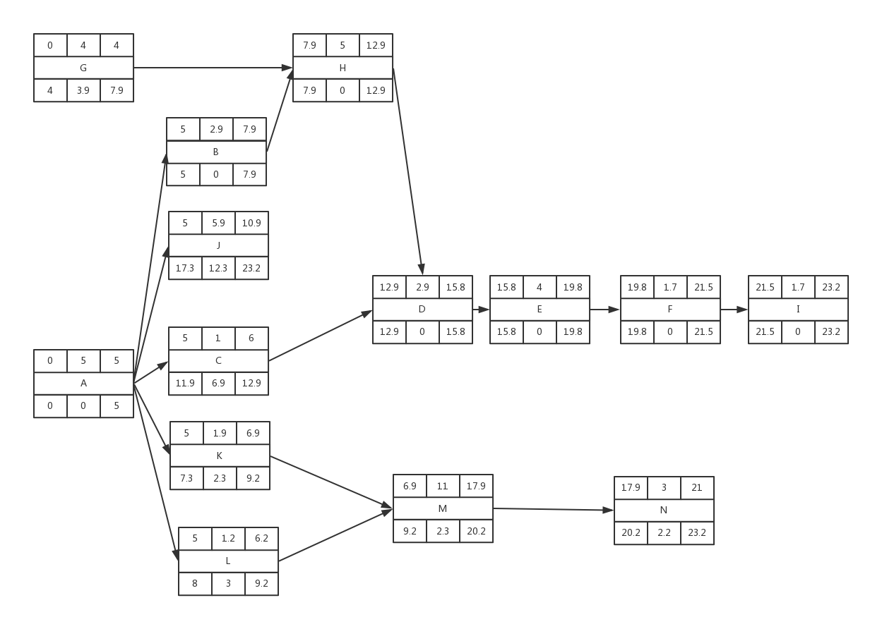

The critical path is A 🡪 B 🡪 H 🡪 D 🡪 E 🡪 F 🡪 I, the duration of this critical path is 23.2.

#### (b) Construct a table which identifies: Activity, duration, Early Start, Early Finish, Late Start, Late Finish, and Slack (Float), and Activity Standard Deviation (round to 1 decimal place)

|  |  |  |  |  |  |  |  |
| --- | --- | --- | --- | --- | --- | --- | --- |
| **Activity** | **A** | **B** | **C** | **D** | **E** | **F** | **G** |
| Duration | 5 | 2.8 | 1 | 2.8 | 4 | 1.7 | 4 |
| Early start | 1 | 5 | 5 | 12.9 | 15.8 | 19.8 | 1 |
| Early finish | 5 | 7.9 | 6 | 15.8 | 19.8 | 21.5 | 4 |
| Late start | 0 | 5 | 11.9 | 12.9 | 15.8 | 19.8 | 4 |
| Late finish | 5 | 7.9 | 12.9 | 15.8 | 19.8 | 21.5 | 7.9 |
| slack | 0 | 0 | 6.9 | 0 | 0 | 0 | 3.9 |
| Activity Standard deviation | 0.3 | 1.2 | 0 | 1.2 | 1 | 0.7 | 0.3 |

|  |  |  |  |  |  |  |  |
| --- | --- | --- | --- | --- | --- | --- | --- |
| **Activity** | **H** | **I** | **J** | **K** | **L** | **M** | **N** |
| Duration | 5 | 1.7 | 5.8 | 1.8 | 1.2 | 11 | 3 |
| Early start | 7.9 | 21.5 | 5 | 5 | 5 | 7 | 18 |
| Early finish | 12.9 | 23.2 | 11 | 7 | 7 | 18 | 21 |
| Late start | 7.9 | 21.5 | 17.2 | 7.2 | 7.2 | 9.2 | 20.2 |
| Late finish | 12.9 | 23.2 | 23.2 | 9.2 | 9.2 | 20.2 | 23.2 |
| Slack | 0 | 0 | 12 | 2.2 | 2.2 | 2.2 | 2.2 |
| Activity Standard deviation | 1.3 | 0.7 | 0.5 | 0.2 | 0.2 | 0.3 | 0.3 |

#### (c) What can you conclude about the project duration from analysis of the PERT network diagram?

The critical path is A 🡪 B 🡪 H 🡪 D 🡪 E 🡪 F 🡪 I, so we need to finish these five tasks at the highest priority.

According to analysis the PERT chart’s critical path, we know that module decomposition audit and. result of audit is the key point of the project. So if we can control the time spend on module decomposition audit, it can be narrow the whole project’s time

#### (d) What are the primary concerns that a PM must consider in using PERT for project scheduling?

We can find whether the total progress is determined by one or two key matters. If so, we should complete these matters efficiently at any costs. When the resource allocation is in conflict, the resources of the activities on the non-critical path can be appropriately mobilized to support the activities on the critical path to ensure the completion progress of the project in the most effective way.

And there are the disadvantages of the PERT:

1. It is not easily scalable and is less helpful for smaller projects
2. Printing the charts can be a challenge due to their size and complexity
3. The complexity can also make it hard to analyze the findings once a project has grown significantly in size
4. Using PERT in project management is less useful for measuring progress than a GANTT chart
5. Subjectivity can make the data that is captured less than reliable
6. Gathering the data and assembling the chart can be a time-intensive solution, so you need to know for certain that it will be useful before embarking upon it.
7. More complicated projects involving multiple suppliers and activities can make it impossible to predict every eventuality, causing the PERT chart to become inaccurate

In conclusion, if manager wants to plan for shorter project completion times and cost savings the primary concerns that he must consider must be focusing on the critical path.

### REQUIREMENT 4: Risk Management

#### (a) discuss the statement made by James TAN

Project risk management is an important aspect of project management. According to the Project Management Institute's PMBOK, Risk management is one of the ten knowledge areas in which a project manager must be competent. Project risk is defined by PMI as, "an uncertain event or condition that, if it occurs, has a positive or negative effect on a project’s objectives."

Therefore, to some extent, he is right. Because risk management do decrease the impact of project failure. However, it is impossible to totally eliminate this impact in most situation.

#### (b) identify primary sources of risk inherent in this project

1) My team members are not skillful enough to finish this project.

2) My team members are not responsible enough to finish this project.

3) Time schedule is too tight to catch.

4) My team can’t get enough support from companies.

5) Customers refuse to accept our test results for some reasons.

#### (c) develop and discuss the role that risk management can play in successful accomplishment of THIS project.

1) **Time schedule:**

risk management can assure that time schedule is executed tightly. If some activities last beyond deadline, the project manager will be alarmed.

2) **technology support:**

risk management will evaluate technology accuracy of our project through all process. If some mistakes or troubles are found, technology support team of this company will be enrolled to solve these problems.

3) **communication assurance:**

risk management will assure that different apartment of this company and this project team keep in a great communication, in order to decrease information asymmetry.