

**C1.2 CASE STUDY**

**Case Study of “客户投诉处理” and “The GPS Auto-navigation System Verification Project”**



**NAME：XUANMING LIU**

**ID：3180106071**

**SUBMIT DATE：2020.12.10**

#### 1. Planning the operating frame and workflow of the user helping center of "Software Engineering Series Teaching Auxiliary Web site".

**Operating frame**

**The basic description of the user help center operation process is as follows:**

The user help center indirectly guides the user through the customer service department or autonomous help system based on the relevant content in the background database and performs relevant operations on the database.

**We builds the following job framework:**

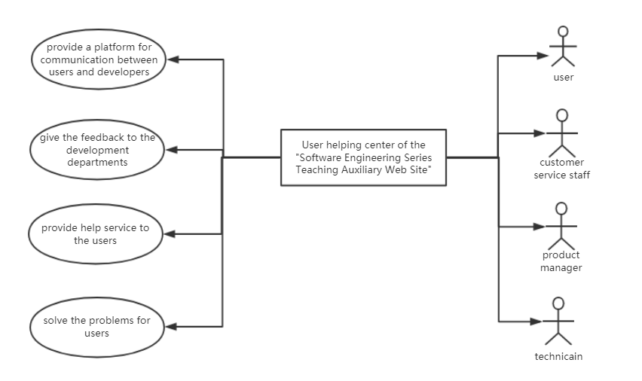

**Workflow**

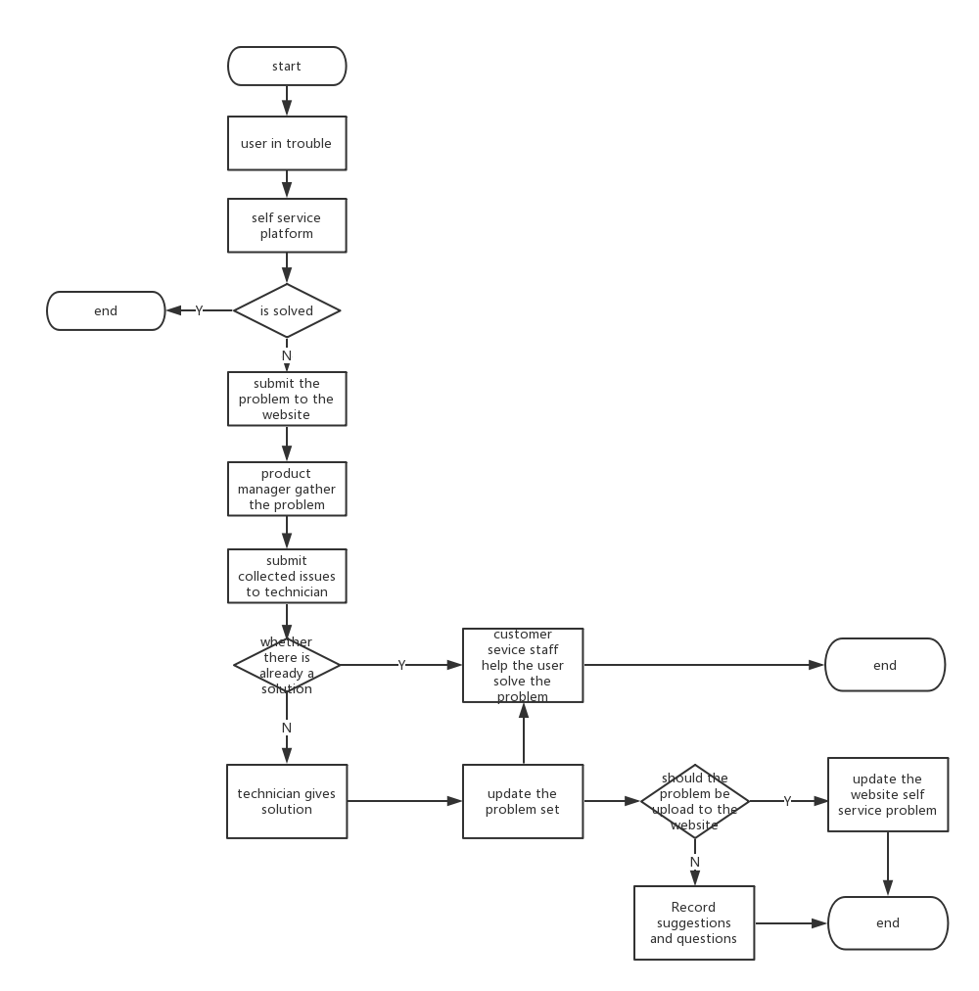

#### 2. Design the roles of the relevant stakeholders in the user helping center and their responsibilities or possible patterns of behavior.

**User**

* **Duties**

Use the instructional support site in the normal way and use the Help Center to resolve problems when they arise.

* **Behavioral Patterns**

(1) Normal use of teaching aid websites

(2) Problems encountered while using the website

(3) Use the website help center to select the way to solve the problem.

(4) Problem solving with autonomous help systems or with human services

**Product manager (Duties)**

* **Duties**

Identify quality, scope, etc. in the instructional support site, consider the cost of the project, plan the process activities of the project, and also control the progress and quality of the project through the organization of the roles of the project team.

* **Behavioral Model**

(1) Understanding the actual scenario

(2) Identify the problem

(3) Planning and assigning tasks to problems

(4) Get announcements and feedback from other people.

(5) Confirmation of problem resolution

**Service Staff**

* **Duties**

They are responsible for communicating with users who give feedback on problems and distinguish the types of problems based on the users' descriptions of the problems, and when they encounter non-technical problems, they should assist users in solving the problems, and when the problems encountered involve technology-related aspects, they should transfer to technical support, which should provide help services to users.

* **Behavioral Model**

(1) Receive feedback from users on problems

(2) Distinguish between problem types based on problem description

(3) Assist users in solving non-technical problems.

(4) Transferring technical problems to technical support

(5) Record user problems

**Developer**

* **Duties**

Responsible for the development of instructional support websites and subsequent technical support for instructional support software.

* **Behavioral Model**

(1) Accepting tasks from the project manager

(2) Conduct project development and problem solving

(3) Announcement of progress in resolving problems

(4) Notify the tester of the test

(5) Correction based on test results

(6) Feedback to the project manager on the final results

**Tester**

* **Duties**

After the developer owns the progress of the project, test the project according to the developer's notification and give feedback to the developer about the problems therein and make sure that the wanted problems are solved.

* **Behavioral Model**

(1) Receive test notifications from developers

(2) Testing of projects developed by developers

(3) Announcement of test progress

(4) Feedback test results to project developers

#### 3. How do you manage your role if you are the head of a user helping center?

* **The division of roles**

There are project manager, developer, tester, customer service staff, customer, five roles in total.

Besides customers, the roles of help center staff are divided into a help center front office and a help center back office based on whether they interact with customers or not, with the front office role reporting to customer service and technical support staff who are strong communicators among developers, and the back office role including all developers, testers, and project managers. And establish a reasonable, effective and open rewards and punishments system and resolutely implement it.

* **Requirements for each role**

The four roles of Help Center staff are required to perform their duties in a manner that normally follows a defined pattern of behavior and requires timely feedback and announcement of work content and progress.

* **Performance Appr**

The Key Performance Indicator (KPI) method is used to evaluate the performance of roles, and rewards or penalties are assessed based on the performance evaluation of each role.

The following indicators are specified for the four roles.

(1) Project manager's indicators are set for project progress, project quality, and use of project funds.

(2) Developers' indicators are set for development progress and development quality.

(3) The tester's indicators are set to test progress and the final quality of the project.

(4) Indicators for customer service personnel are set for user rating, problem classification, and problem resolution speed.

#### 4. If you are the person in charge of user helping center, how do you design communication plan and communication management?

**Communication Plan**

(1) Provide regular training to help center staff on communication skills and increase staff efficiency in IT-oriented communication.

(2) Helping to establish cell phone and Internet contact lists of staff within the center to ensure timely communication.

(3) Clarify the communication responsibilities of the various roles of staff in the Help Center and the communication protocols, the different methods of internal and external communication, and the boundaries of internal and external information.

(4) Keeping communication records and information backups when communicating with users.

(5) Distribute communication-related requirements in the form of official documents to ensure smooth execution of communication-related operations.

**Communication Management**

(1) Develop norms for external communications, unify industry terminology, and ensure accuracy of expressions and meanings.

(2) Develop a complete internal communication process to improve the efficiency of internal communication and reduce unnecessary spending on communication within the team.

(3) Set up message posting specifications to ensure that customer service agents accurately express user feedback according to format requirements.