OPEN ENDED PROJECT REPORT
On
Customer Segmentation: Clustering
DIV – III
SUBJECT: Data Mining and Data warehousing
Team Members:
Mevada Drashtant Pareshkumar
(ET24BTCO176)
Nirav Panwala
(ET24BTCO181)
Priyanshu Makani
(ET24BTCO170)
Merit Patel
(ET24BTCO185)
Heet Sutariya
(ET24BTCO204)
Sarvajanik College of Engineering & Technology (SCET)
Sarvajanik University, Surat
Academic Year 2025–26 | Semester V

ABSTRACT
Customer segmentation is an important application of data mining in which customers are grouped into meaningful segments according to similarities in their characteristics and behaviour. This Open Ended Project, titled CustomerLens, implements an end-to-end clustering workflow using a mall customer dataset containing 200 customer records. The project follows the required stages of preprocessing, clustering, K-Means clustering, K-Medoids clustering, optimal-k selection, visualization and interpretation.
Annual Income (k$) and Spending Score (1-100) were selected as the primary clustering variables. The selected numerical variables were standardized using StandardScaler before clustering. Candidate values of K from 2 through 10 were evaluated. Silhouette Score and Davies-Bouldin Index were used to evaluate cluster quality, while K-Means inertia and K-Medoids medoid cost were examined as algorithm-specific objective measures.
Both K-Means and K-Medoids identified K = 5 as the strongest choice based on the clustering-quality evaluation. At K = 5, K-Means obtained a Silhouette Score of 0.554657 and Davies-Bouldin Index of 0.572236, while K-Medoids obtained a Silhouette Score of 0.556218 and Davies-Bouldin Index of 0.566089. The two resulting partitions showed an Adjusted Rand Index of 0.9597, indicating very high agreement between the two cluster assignments.
The final system includes customer profiling, business-oriented segment interpretation, a Streamlit analytics dashboard and a React-based analytics frontend. Automated tests were used to validate dataset assumptions, the optimal K, model cluster counts and customer assignments.
Keywords
Customer Segmentation, Data Mining, Clustering, K-Means, K-Medoids, PAM, Silhouette Score, Davies-Bouldin Index, Elbow Method, Optimal K, Data Preprocessing, Customer Analytics.

1. INTRODUCTION
Customer segmentation is the process of dividing a customer population into groups whose members exhibit similar characteristics. In a retail context, segmentation can help an organization understand different combinations of purchasing potential and customer engagement. Clustering is particularly suitable because the desired groups are not supplied as predefined class labels.
CustomerLens applies unsupervised learning to a mall customer dataset. The main segmentation variables are Annual Income (k$) and Spending Score (1-100). The project compares K-Means and K-Medoids, determines an appropriate number of clusters and presents the resulting segments through analytical dashboards.
1.1 Problem Statement
To develop a customer segmentation system that preprocesses customer data, determines a suitable number of clusters, applies K-Means and K-Medoids clustering, evaluates the resulting partitions and visualizes customer groups using Annual Income and Spending Score.
1.2 Objectives
• Inspect and preprocess the customer dataset.
• Select appropriate numerical attributes for customer segmentation.
• Standardize the selected clustering features.
• Evaluate candidate cluster counts from K = 2 to K = 10.
• Implement K-Means clustering.
• Implement K-Medoids clustering using PAM.
• Evaluate clusters using Silhouette Score and Davies-Bouldin Index.
• Create the required Income-versus-Spending Score visualization.
• Compare the two algorithms and interpret customer segments.
1.3 Scope
The project focuses on unsupervised customer segmentation using the specified numerical variables. CustomerID is treated as an identifier rather than a predictive feature. Age and Gender are retained for profiling but are not primary clustering dimensions.

2. DATASET AND DATA UNDERSTANDING
The final implementation uses the Mall Customer Segmentation dataset containing 200 customer records. The dataset provides CustomerID, Gender, Age, Annual Income (k$) and Spending Score (1-100). Annual Income and Spending Score are used as the primary clustering features.
Spending Score is a dataset-provided behavioural score and should not be interpreted as a direct measurement of rupee expenditure.
Table 1. Dataset attributes used in CustomerLens
Attribute | Type | Role in Project
CustomerID | Integer | Identifier; excluded from clustering
Gender | Categorical | Retained for profiling
Age | Integer | Retained for profiling
Annual Income (k$) | Numeric | Primary clustering feature
Spending Score (1-100) | Numeric | Primary clustering feature
2.1 Dataset Selection
The originally suggested Kaggle source was considered during planning. The final dataset was selected because it explicitly provides both Annual Income and Spending Score, matching the required visualization.
2.2 Data Audit
The project includes audited and processed customer files. Data quality checks include missing-value inspection, duplicate identification, required-feature validation and descriptive analysis.
2.3 Feature Selection
Annual Income and Spending Score provide an interpretable two-dimensional space for the assignment. CustomerID is excluded because an identifier has no meaningful distance-based interpretation. Age and Gender are retained for descriptive profiling.

3. DATA PREPROCESSING
Preprocessing is necessary before applying distance-based clustering methods. The project first verifies dataset quality and then prepares the selected numerical features.
3.1 Data Quality Checks
• Verify required clustering columns.
• Check selected features for missing values.
• Inspect duplicate customer identifiers.
• Review descriptive statistics and distributions.
• Separate identifier and profiling attributes from clustering features.
3.2 Standardization
Annual Income and Spending Score are measured on different numerical scales. StandardScaler is applied so that both selected dimensions contribute comparably to distance-based clustering. The fitted scaler is persisted as scaler.joblib.
3.3 Processed Data Artifacts
The final project stores customerlens_final.csv, customers_audited.csv, customers_with_cluster_assignments.csv, final_customer_segmentation.csv and clustering_features_scaled.csv. These artifacts make the transformations and outputs inspectable.

4. METHODOLOGY
The methodology follows a sequential data-mining workflow: data audit, feature selection, standardization, candidate-K evaluation, final clustering, evaluation, visualization and interpretation.
4.1 Workflow
• Raw customer dataset
• Data audit and exploratory analysis
• Selection of Annual Income and Spending Score
• Feature standardization
• Evaluation of K = 2 to K = 10
• Selection of K = 5
• K-Means clustering
• K-Medoids clustering using PAM
• Silhouette and Davies-Bouldin evaluation
• Cluster profiling and interpretation
• Dashboard presentation
4.2 K-Means
K-Means assigns observations to the nearest centroid and iteratively updates centroids. The final K = 5 model is stored as kmeans_k5.joblib. Its recorded objective is inertia, the within-cluster sum of squared distances to centroids.
4.3 K-Medoids
K-Medoids represents each cluster using an actual observation called a medoid. The project implements the Partitioning Around Medoids (PAM) approach and stores the final model as kmedoids_pam_k5.joblib.
K-Means inertia and K-Medoids medoid cost are different objective definitions and are therefore not directly compared as if they were the same quantity.
4.4 Evaluation Metrics
Silhouette Score is higher-is-better and evaluates separation and cohesion. Davies-Bouldin Index is lower-is-better and evaluates similarity between clusters. Both are used during candidate-K evaluation and final model comparison.

5. OPTIMAL NUMBER OF CLUSTERS
Candidate values K = 2 through K = 10 were evaluated. Both algorithms reached their highest recorded Silhouette Score at K = 5, providing a consistent basis for selecting five clusters.
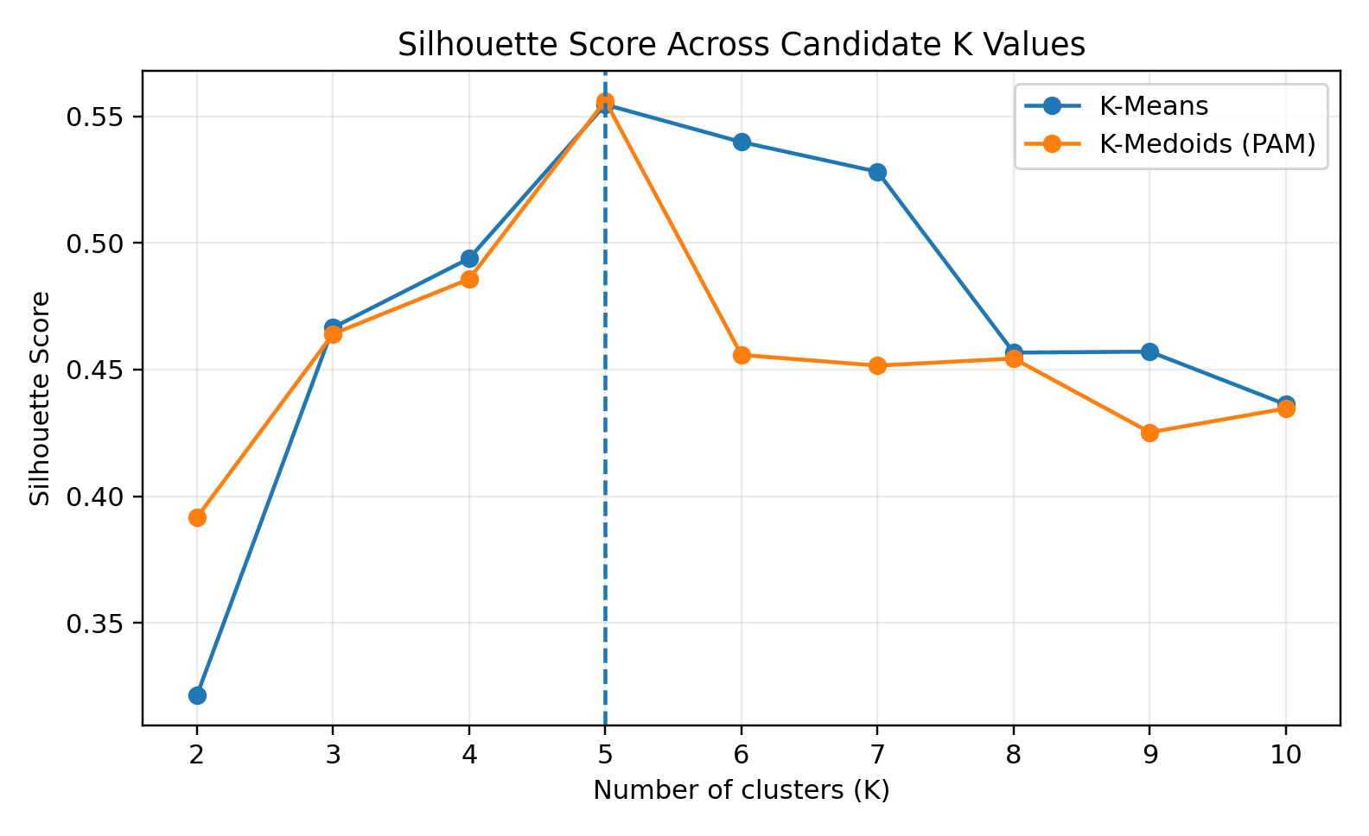
Figure 1. Silhouette Score across candidate K values, derived from the project’s recorded optimal-K result artifacts.
Table 2. Silhouette Scores for K = 2 to K = 10
K | K-Means | K-Medoids
2 | 0.321271 | 0.391585
3 | 0.466585 | 0.464115
4 | 0.493907 | 0.485719
5 | 0.554657 | 0.556218
6 | 0.539880 | 0.455792
7 | 0.528149 | 0.451588
8 | 0.456721 | 0.454380
9 | 0.457085 | 0.425235
10 | 0.436212 | 0.434654
At K = 5, K-Means reaches 0.554657 and K-Medoids reaches 0.556218. The scores decline after K = 5 for both algorithms, supporting K = 5.
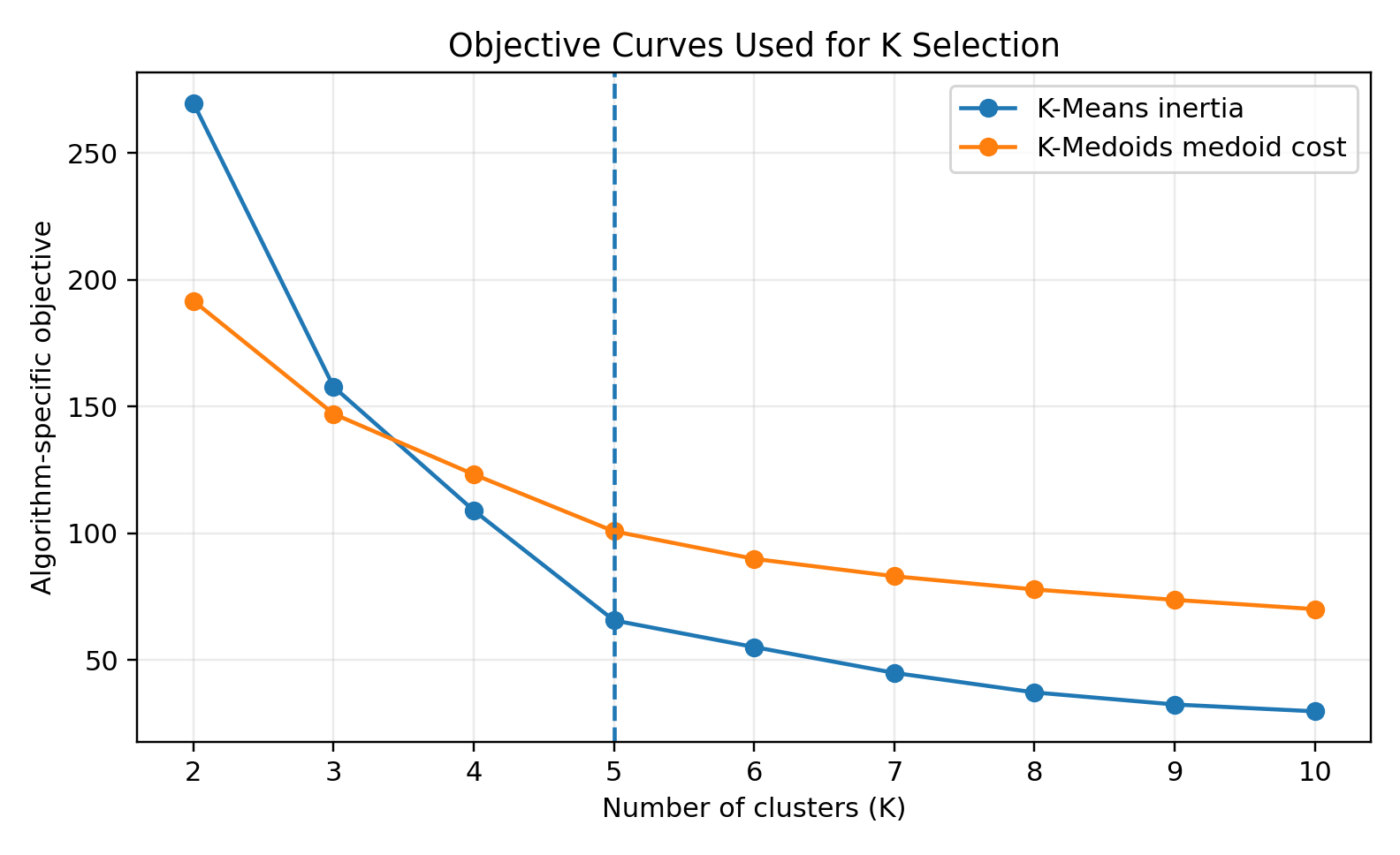
Figure 2. Algorithm-specific objective curves used alongside clustering-quality evaluation.

6. CLUSTERING RESULTS
6.1 Final Algorithm Comparison
Table 3. Final clustering results at K = 5
Metric | K-Means | K-Medoids (PAM)
Number of clusters | 5 | 5
Silhouette Score | 0.554657 | 0.556218
Davies-Bouldin Index | 0.572236 | 0.566089
Runtime | 0.164474 s | 0.076011 s
At K = 5, K-Medoids has a marginally higher Silhouette Score and lower Davies-Bouldin Index in this experiment. The recorded runtime was also lower for K-Medoids. Runtime is implementation- and environment-specific and should not be generalized.
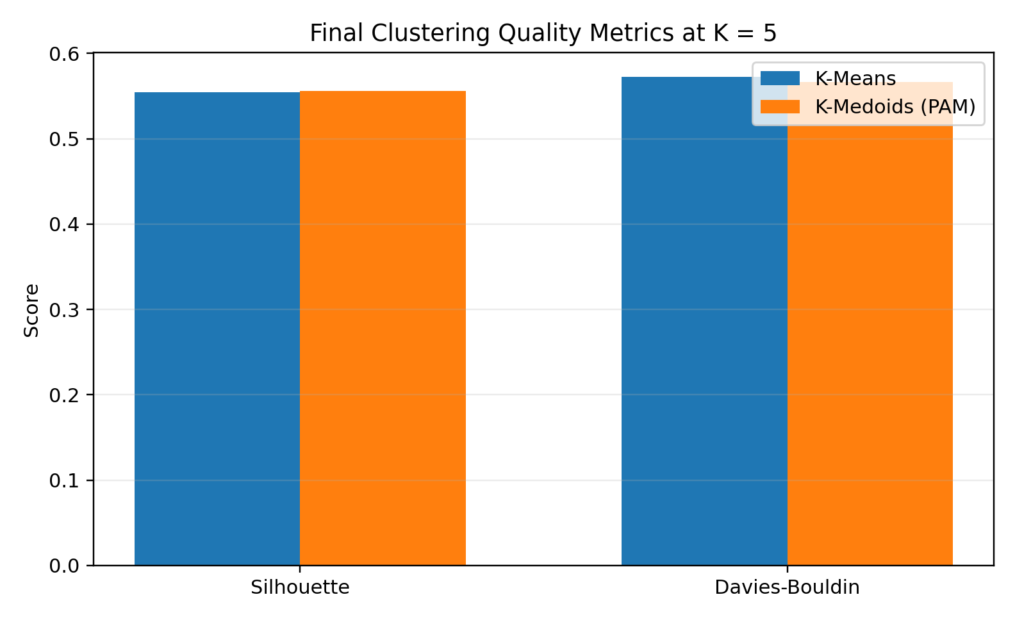
Figure 3. Final clustering-quality metrics at K = 5.
6.2 Agreement Between Algorithms
The final cluster assignments have an Adjusted Rand Index of 0.9597. This indicates very high agreement between the two partitions. ARI is an agreement measure between clusterings, not an accuracy percentage.
6.3 Cluster Profiles
The project produces K-Means and K-Medoids cluster-profile CSV files plus a final business-segment profile. The profiles contain customer counts, age, income, spending and percentage summaries.
Table 4. Cluster-profile fields
Field | Purpose
Customers | Number of customers in the cluster
Avg_Age / Median_Age | Age-based descriptive profile
Avg_Income / Median_Income | Income-based profile
Avg_Spending / Median_Spending | Spending-score profile
Percentage | Share of total customers
Segment_Type | Descriptive cluster interpretation

7. REQUIRED VISUALIZATION
The assignment requires a two-dimensional scatter plot of Income versus Spending Score with customers color-coded by cluster. CustomerLens uses Annual Income (k$) on one axis and Spending Score (1-100) on the other. The dashboard provides cluster exploration and comparison views.
The submitted project artifact inventory contains artifacts/figures/kmeans_customer_segmentation.png. The interactive dashboard additionally provides the required customer-segmentation visualization. The saved artifact and application should be considered together when reviewing the complete visual output.
Table 5. Required visualization specification
Component | Implementation
X-axis | Annual Income (k$)
Y-axis | Spending Score (1-100)
Color | Cluster assignment
Primary model view | K-Means
Comparison model | K-Medoids (PAM)
Purpose | Visual interpretation of customer segments
7.1 Interpretation
The visualization provides an intuitive representation of customer separation according to income and spending behaviour. Cluster identifiers are algorithmic labels; business descriptions are assigned after examining cluster-level summaries.

8. CUSTOMER PROFILING AND BUSINESS INSIGHTS
After clustering, each cluster is profiled using the original customer attributes. This converts numerical cluster assignments into descriptive groups. The interpretations are descriptive and are not supervised class labels.
8.1 Segment Interpretations
• Higher-income and higher-spending customers can be viewed as a high-value engagement segment.
• Higher-income but lower-spending customers may represent customers with purchasing capacity whose engagement could be improved.
• Lower-income but higher-spending customers may respond to targeted offers despite lower income.
• Lower-income and lower-spending customers may be better suited to value-oriented communication.
The exact cluster composition is computed from the final clustering output. The final_business_segment_profile.csv and segment_business_insights.csv artifacts store the project’s computed summaries and interpretations.
Table 6. Representative K-Means profile from the final project output
Metric | Cluster 0
Customers | 81
Percentage | 40.5%
Average Age | 42.72
Median Age | 46.0
Average Income | 55.3 k$
Median Income | 54.0 k$
Average Spending Score | 49.52
Median Spending Score | 50.0
Profile Type | Low Income - Low Spending
This example demonstrates how a numeric cluster is translated into an interpretable profile. The label is descriptive and based on observed cluster characteristics.

9. CUSTOMERLENS ANALYTICS DASHBOARD
The project includes a Streamlit analytics dashboard named CustomerLens. The dashboard loads the processed dataset, persisted scaler and clustering models, optimal-K results and cluster-profile artifacts.
Table 7. Dashboard modules
Module | Purpose
Overview | Project summary and methodology
Data Quality & EDA | Data quality and exploratory analysis
Optimal K | Candidate-K evaluation and selection
Cluster Explorer | Explore customer clusters and profiles
Algorithm Comparison | Compare K-Means and K-Medoids
Business Insights | Interpret cluster characteristics
Customer Explorer | Inspect individual customer assignments
The project also includes a React/Vite frontend that presents the analytical evidence in an interactive interface. The persisted model and result artifacts make the workflow reproducible.

10. TESTING AND VALIDATION
Automated tests validate dataset structure, clustering features, missing values, selected optimal K, final model cluster counts and customer assignments.
Table 8. Automated validation tests
Test | Validation
Dataset structure | Expected customer count and columns
Required features | Annual Income and Spending Score are available
Missing values | Selected clustering features contain no missing values
Optimal K | Final optimal K is 5
K-Means clusters | Five clusters
K-Medoids clusters | Five clusters and five medoids
K-Means assignments | All customers receive valid labels
K-Medoids assignments | All customers receive valid labels
The final recorded test run completed with 8 passed tests. The React frontend was also validated using its production build command and ESLint.

11. TECHNOLOGIES USED
Table 9. Technology stack
Technology | Use
Python | Core analysis and machine learning
Pandas | Data processing
NumPy | Numerical computation
Scikit-learn | Standardization and evaluation
Matplotlib / Seaborn | Visualization and EDA
Joblib | Model persistence
Jupyter | Data audit and EDA
Streamlit | Analytics dashboard
React / TypeScript / Vite | Interactive frontend
Tailwind CSS / Recharts / Lucide | Frontend styling and visualization
Pytest | Automated testing
Git / GitHub | Version control
11.1 Project Artifact Structure
• data/raw/ contains the raw dataset.
• data/processed/ contains audited, transformed and assigned data.
• artifacts/models/ contains the scaler and trained models.
• artifacts/results/ contains evaluation and profiling outputs.
• artifacts/figures/ contains the saved clustering visualization.
• notebooks/ contains the data-audit and EDA notebook.
• tests/ contains automated validation tests.
• app.py contains the Streamlit dashboard.
• frontend/ contains the React analytics interface.

12. LIMITATIONS AND FUTURE SCOPE
• The dataset contains only 200 customer records, so conclusions should not be generalized without additional validation.
• Spending Score is a dataset-provided behavioural score rather than direct transaction value.
• Only two primary numerical variables are used for clustering.
• Cluster labels depend on the selected features and clustering method.
• The project demonstrates segmentation and interpretation rather than causal inference.
• Runtime comparisons are environment- and implementation-dependent.
12.1 Future Scope
• Validate the approach on larger and more diverse customer datasets.
• Add transaction-level and behavioural variables when available.
• Perform stability analysis across seeds and samples.
• Compare segments with real business outcomes such as retention or revenue.
• Add periodic re-clustering and monitoring for new customer data.

13. CONCLUSION
CustomerLens successfully implements the required customer-segmentation workflow using preprocessing, K-Means and K-Medoids. Annual Income and Spending Score were selected as the primary clustering dimensions and standardized before analysis.
Both algorithms supported K = 5 as the strongest operating point. At K = 5, K-Means achieved a Silhouette Score of 0.554657 and Davies-Bouldin Index of 0.572236, while K-Medoids achieved 0.556218 and 0.566089 respectively. The final partitions also showed an ARI of 0.9597, demonstrating strong agreement between the two approaches.
The project extends beyond model execution by providing cluster profiles, descriptive business interpretations, automated tests, a Streamlit dashboard and a React analytics frontend. It therefore demonstrates a complete practical application of data-mining concepts to customer segmentation.

14. REFERENCES
• Kaggle, Mall Customer Segmentation Dataset, Vijay Choudhary, used for the final customer-segmentation implementation.
• Scikit-learn documentation for StandardScaler and clustering evaluation metrics.
• Kaufman, L. and Rousseeuw, P. J., Finding Groups in Data: An Introduction to Cluster Analysis, Wiley.
• MacQueen, J., Some Methods for Classification and Analysis of Multivariate Observations, Proceedings of the Fifth Berkeley Symposium.
• CustomerLens project source code, processed datasets, model artifacts, evaluation results, notebook and automated tests.

