**ARTIST**

**LIST OF ARTIST:**

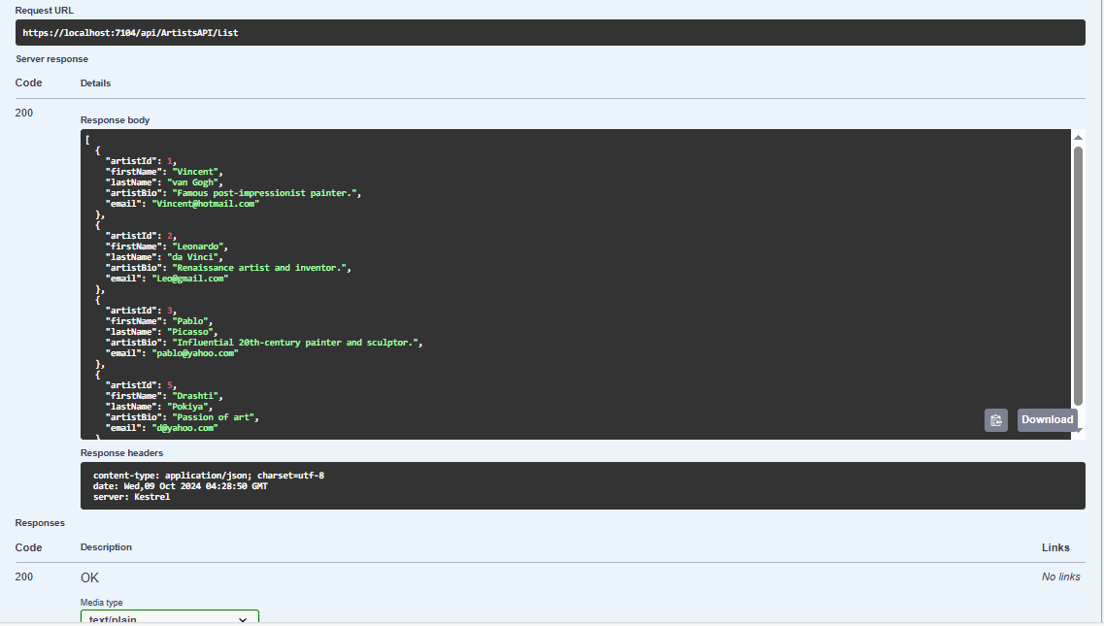

**GET ARTIST:  
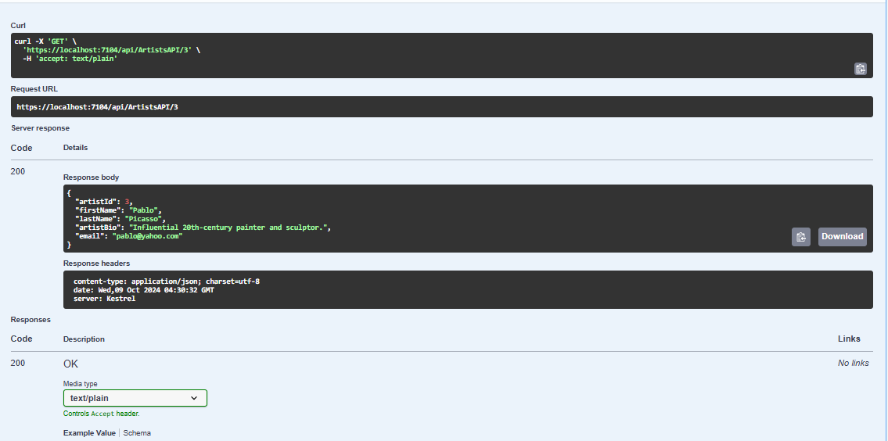**

**CREATE ARTIST:**

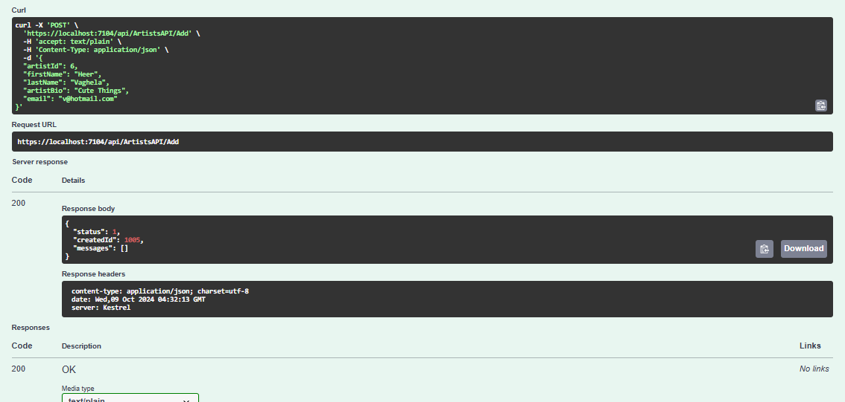

**UPDATE ARTIST:**

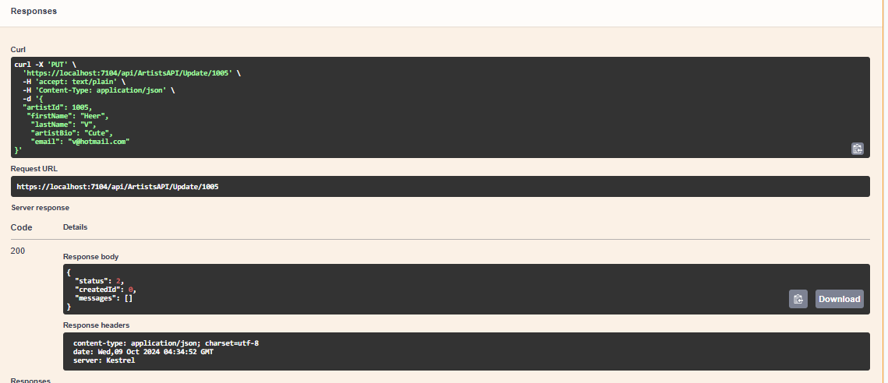

**DELETE ARTIST:**

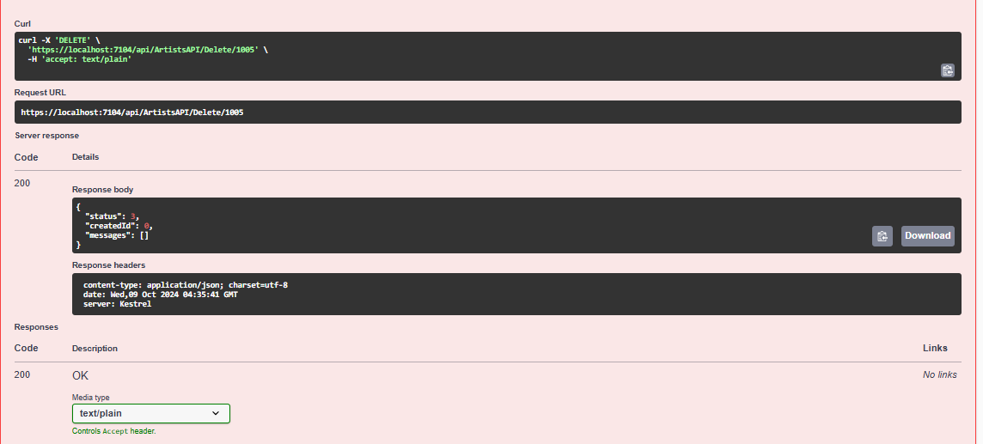

**ARTWORK**

**LIST OF ARTWORK:**

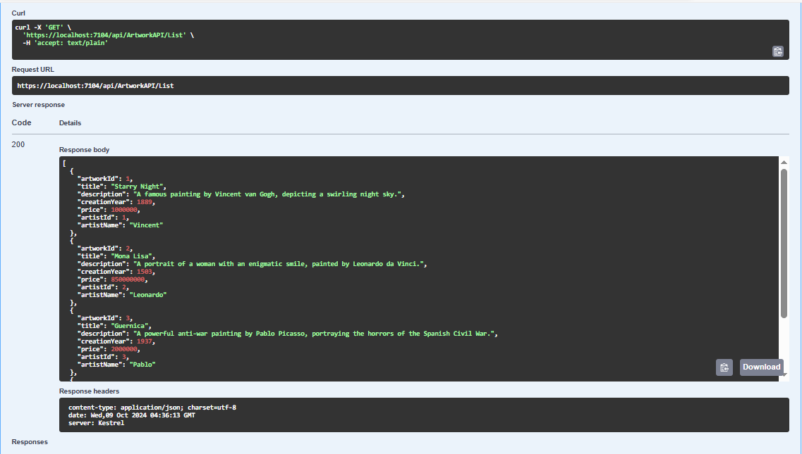

**GET ARTWORK:**

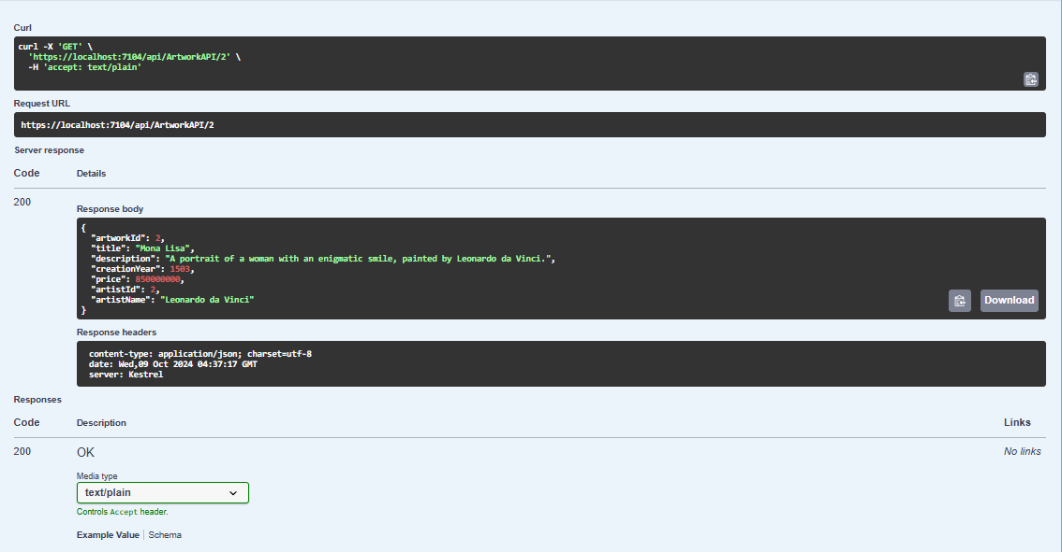

**CREATE ARTWORK:**

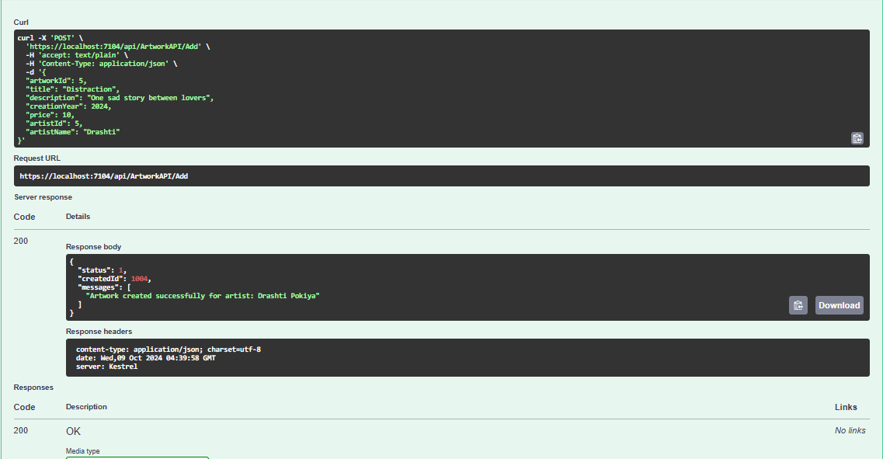

**UPDATE ARTWORK:**

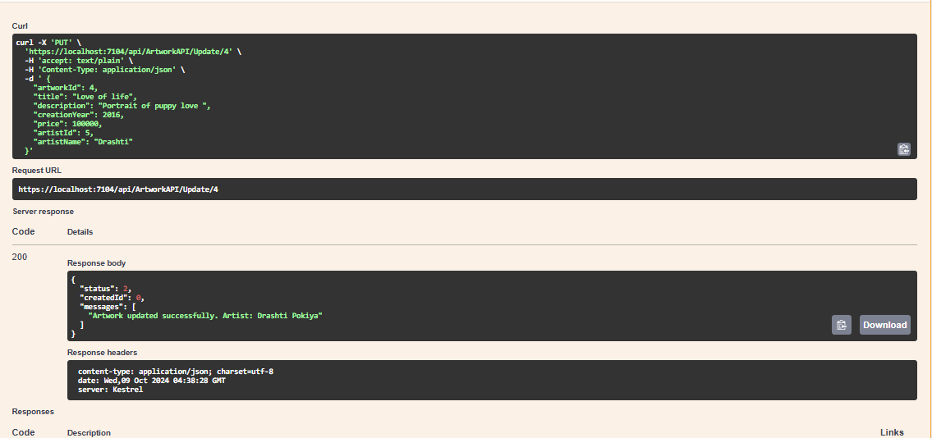

**DELETE ARTWORK:**

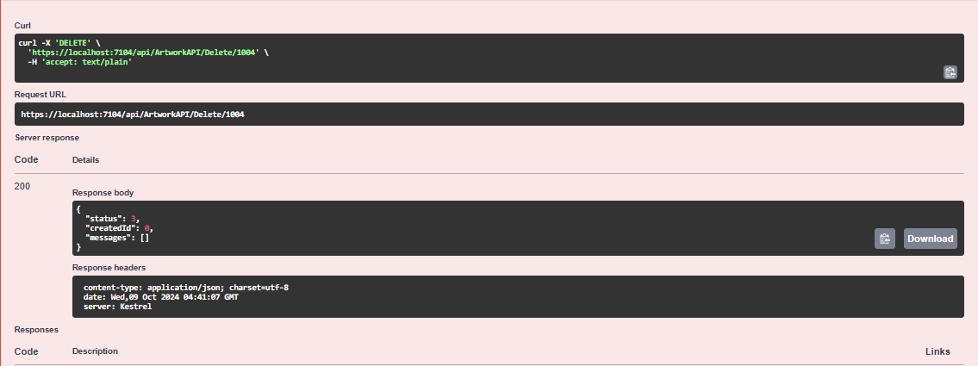

**EXHIBITON**

**LIST OF EXHIBITIONS:**

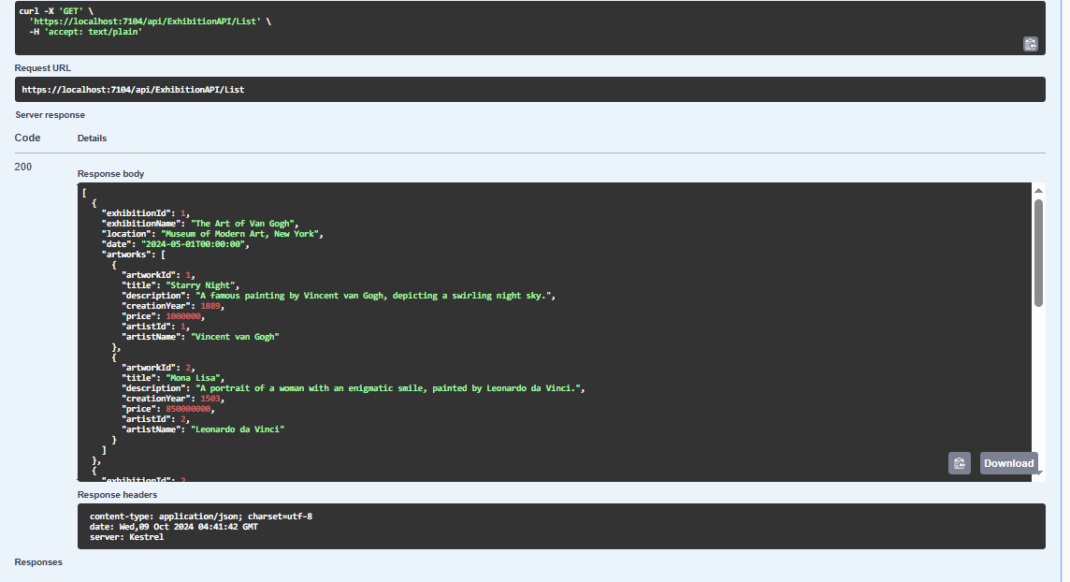

**GET EXHIBITION:**

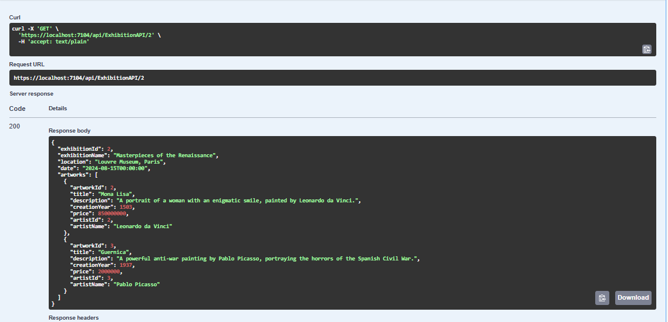

**CREATE EXHIBITION:**

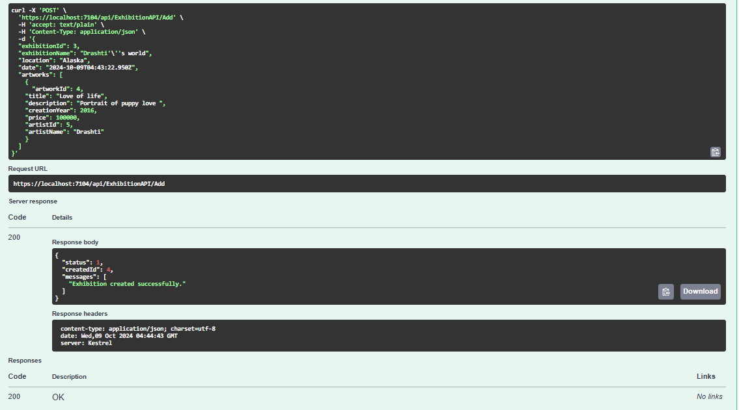

**UPDATE EXHIBITIONS:**

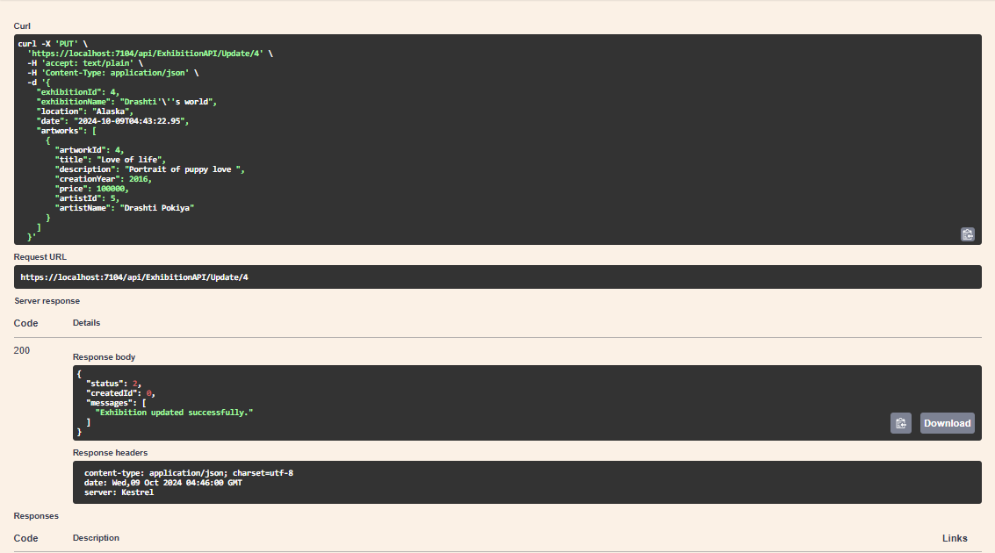

**DELETE EXHIBITIONS:**

