**Web Technology With**

**UI/UX**

Task-1: Create a GIT repository named as your enrollment number. Create 2 folder in

your repository named as Assignment_1 and Assignment_2.

Prepare a word file which contains each step of this task.

Upload your assignments in the respective folder. Share your git repository link in a

google form asked to you at the time of submission.

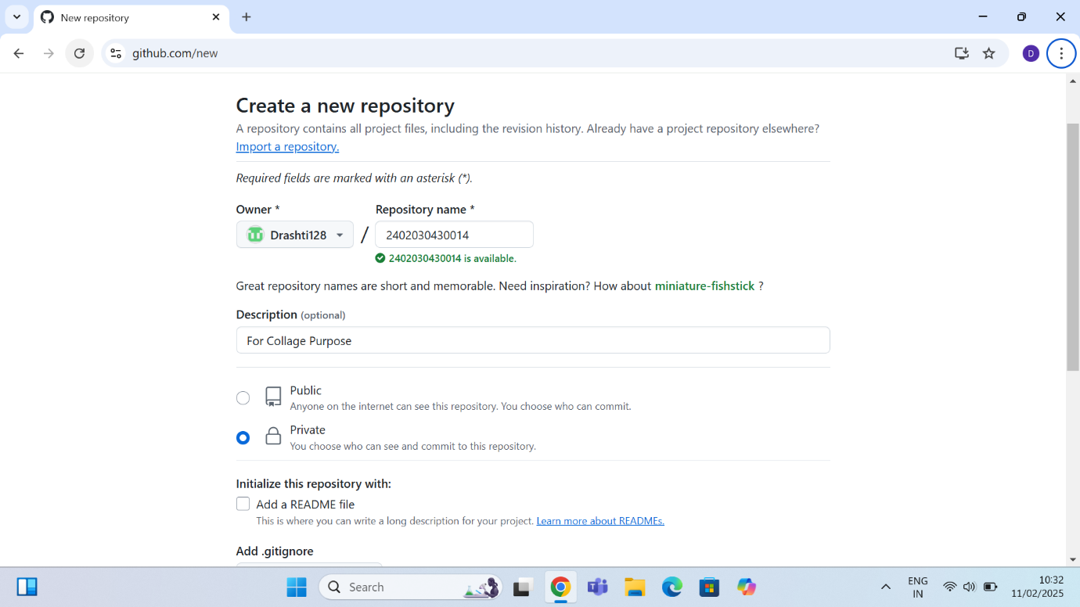

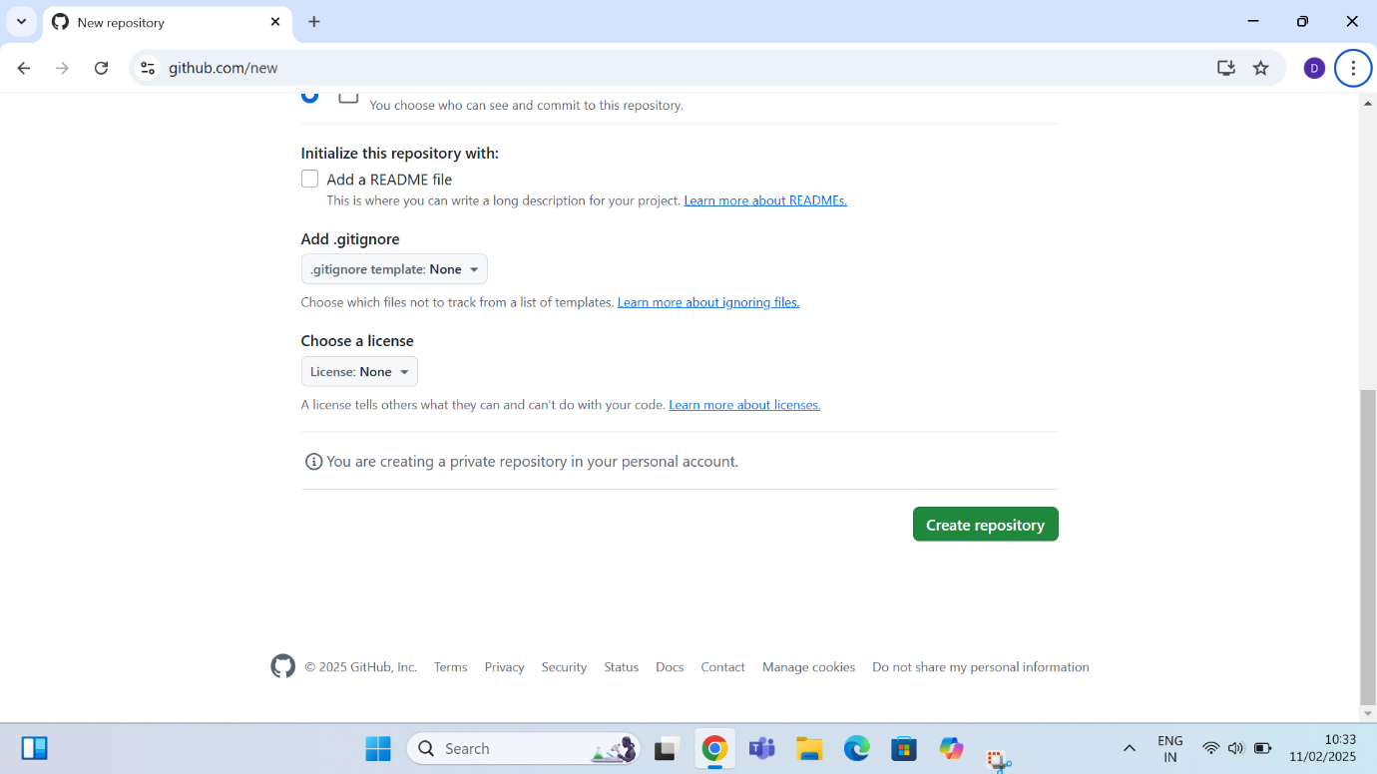

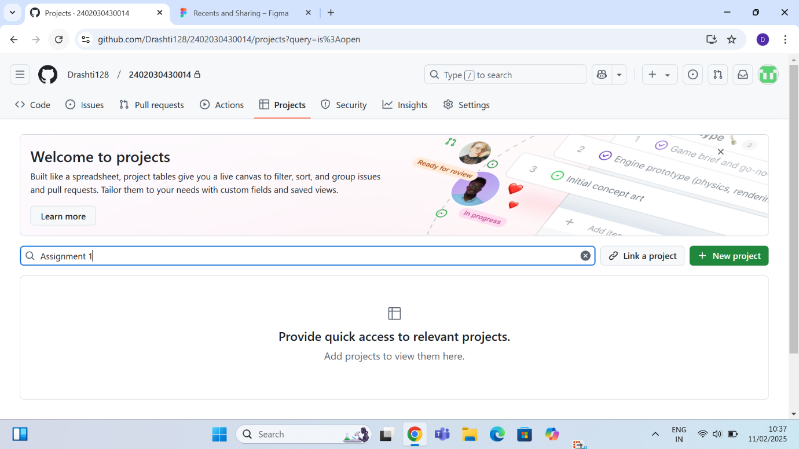

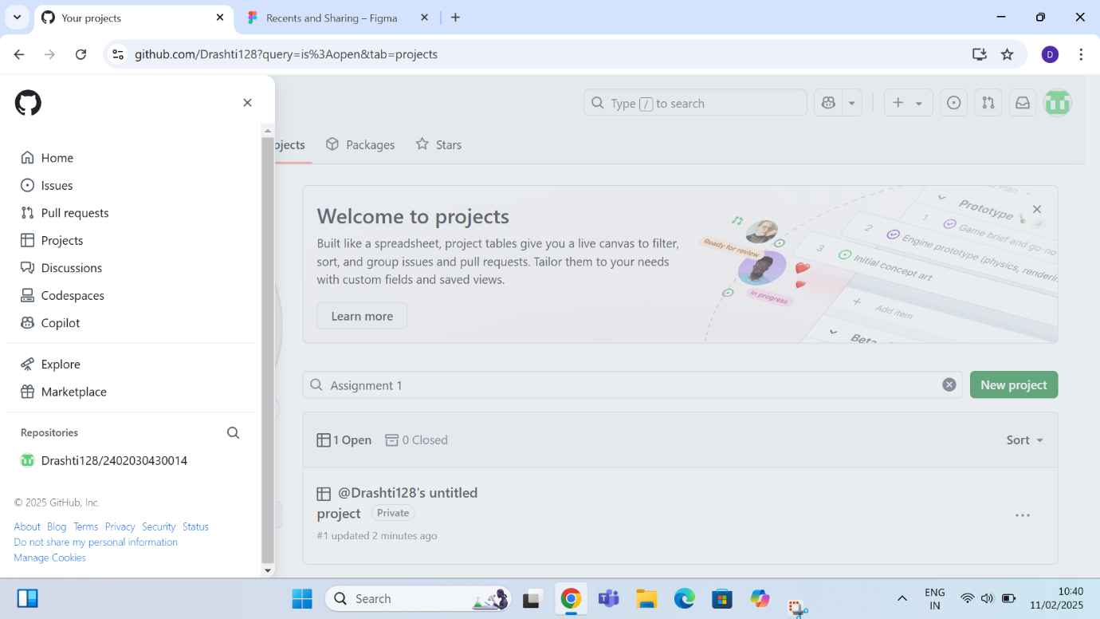

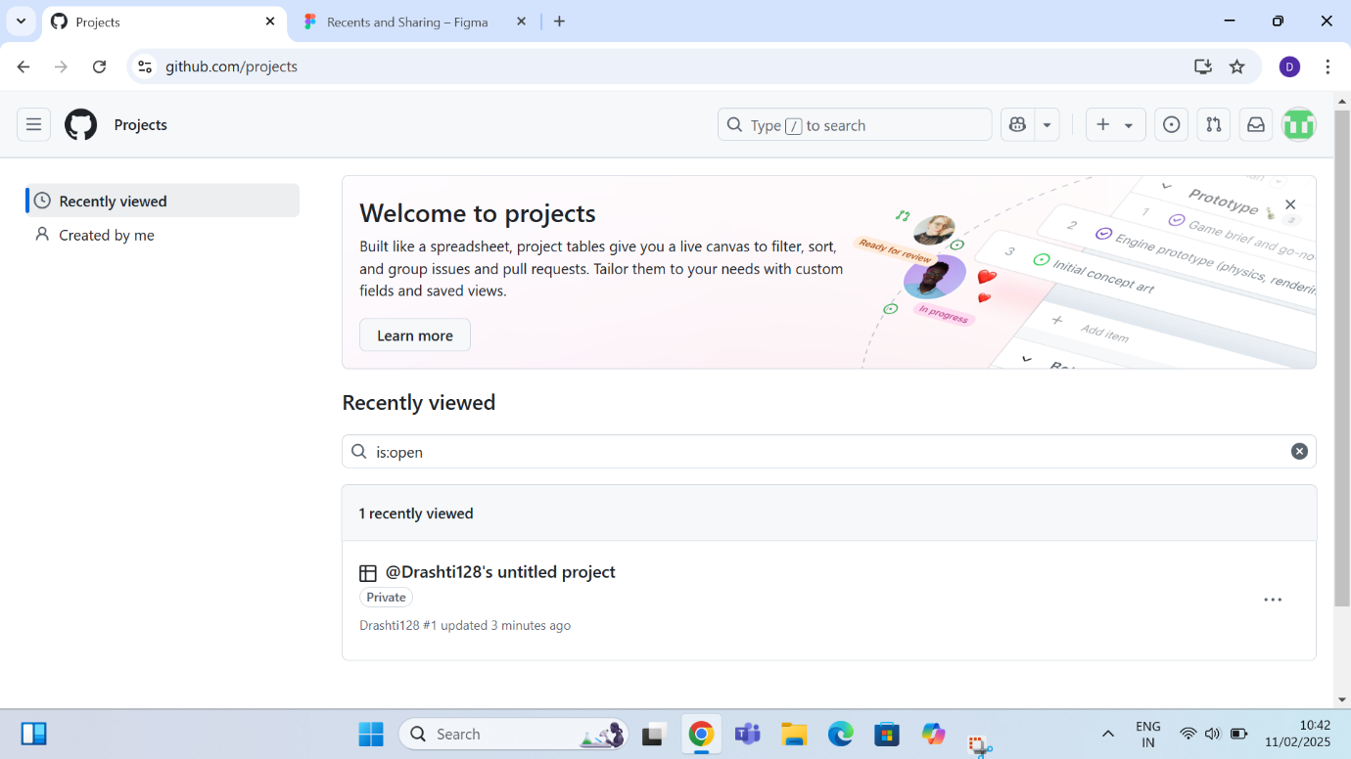

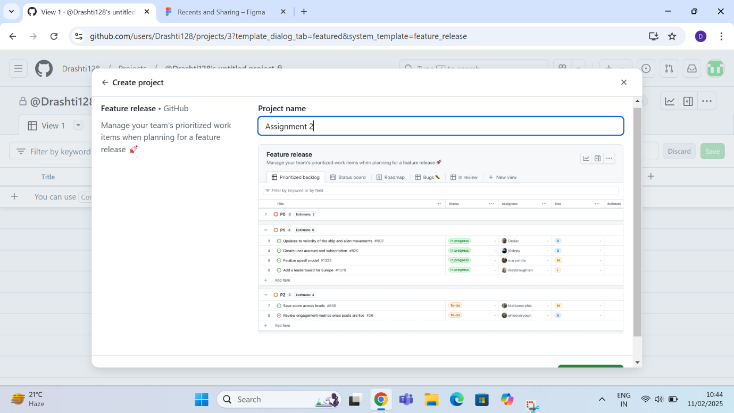

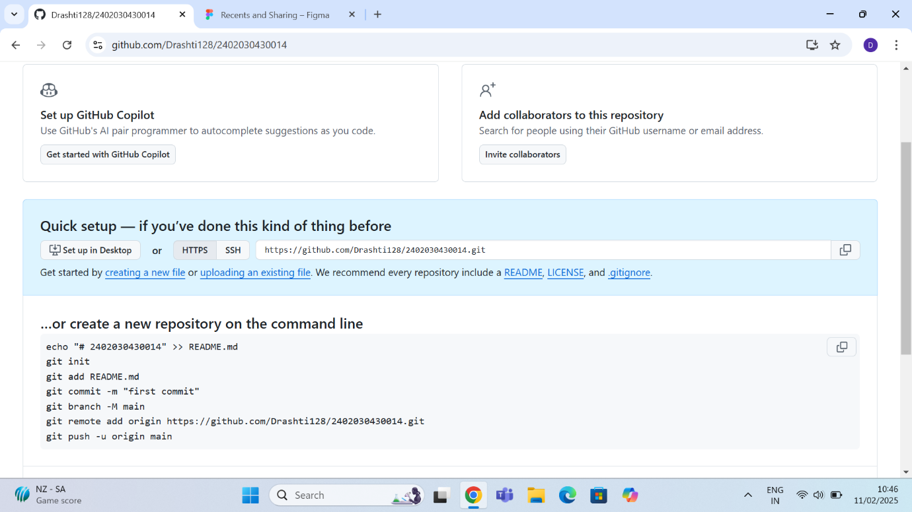

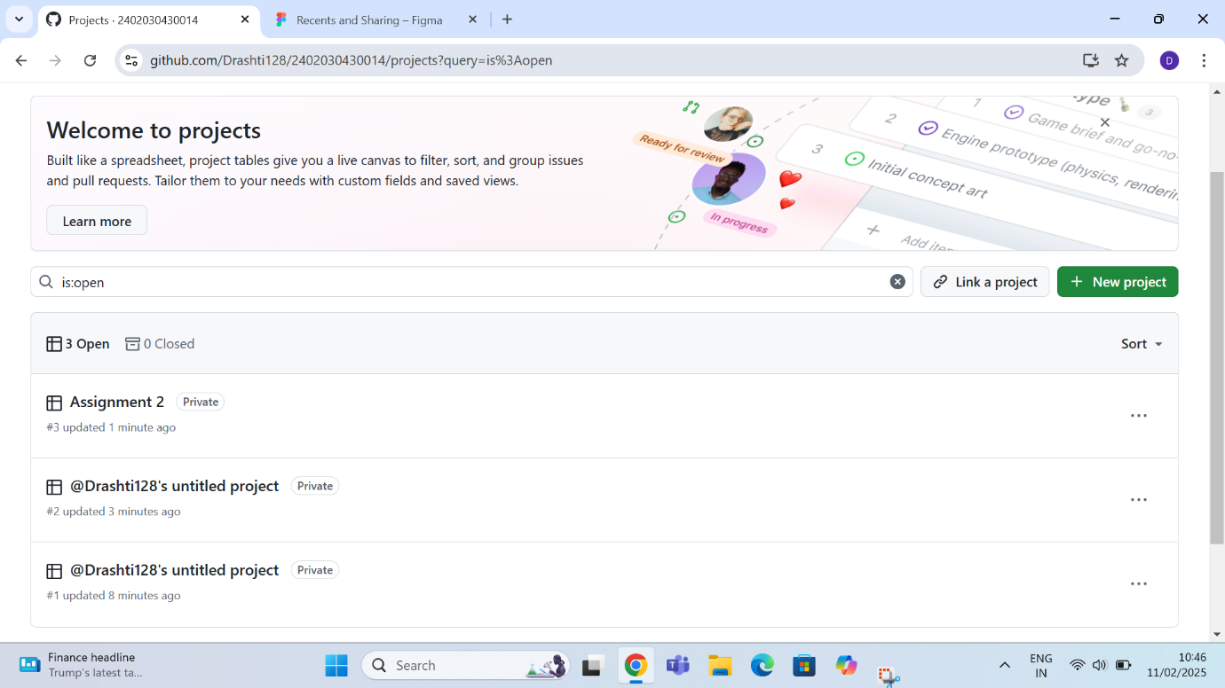

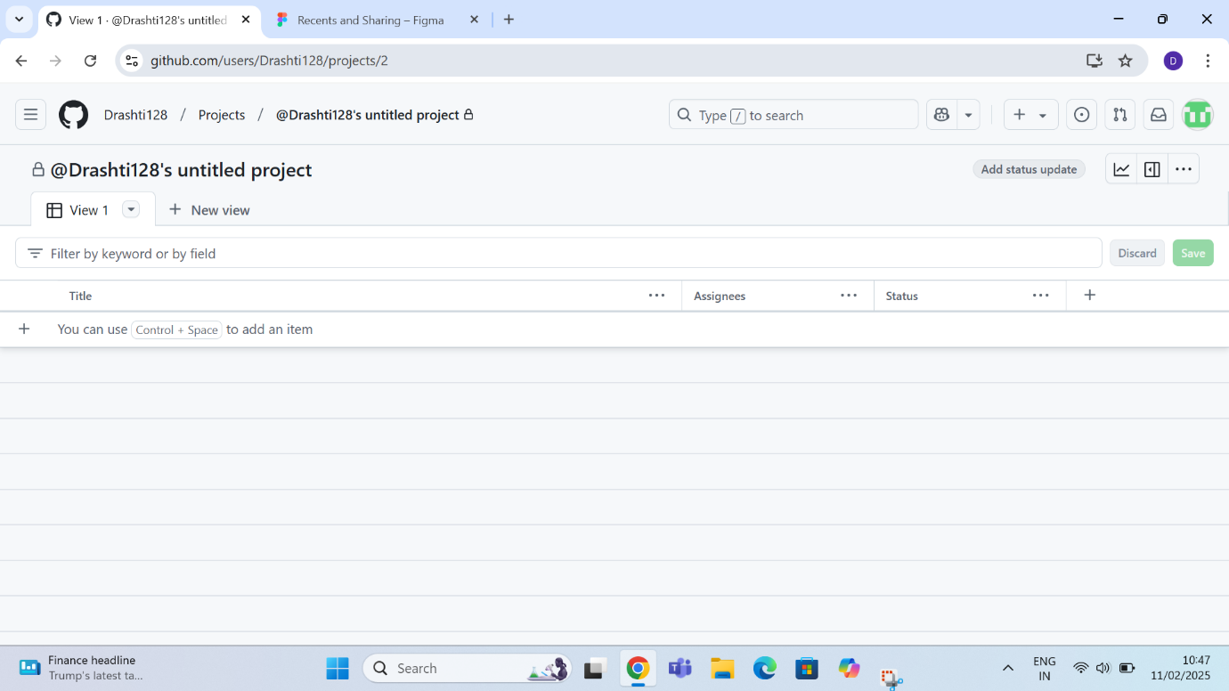

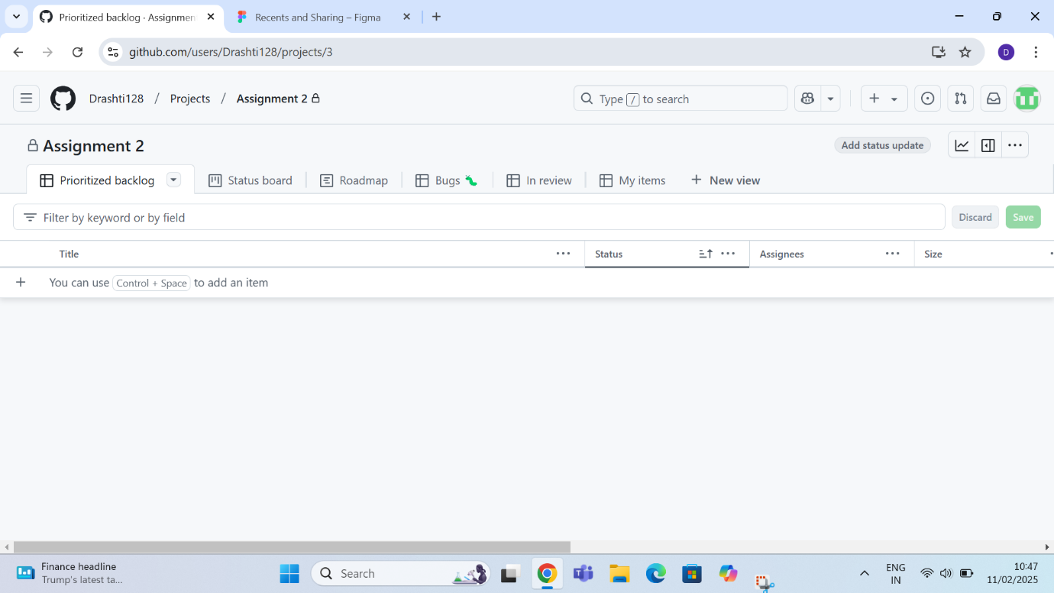

**Guided By :-**

**Mr.Jaykumar Gandhrva**

**Prepared BY –**

**Drashti Dobariya**

**2402030430014**

**4CE_B_065**