Descriptive Statistics :
Descriptive statistics summarize and organize the main features of a dataset through numerical measures or graphs without making conclusions beyond the data itself.

Central Tendency: Finds the center point or a typical value of a dataset.
- Mean: The mathematical average of all data points.
- Median: The middle number when all values are sorted in order.
- Mode: The value that appears most frequently. [1, 2, 3, 4]

Dispersion (Variability): Shows how spread out or clustered the data values are.
- Range: The difference between the highest and lowest values.
- Variance: The average of the squared differences from the mean.
- Standard Deviation: The square root of the variance, showing average distance from the mean

Distribution Shape: Describes how data points are allocated across values.
- Skewness: Measures if data leans more to one side (left or right tail).
- Kurtosis: Measures whether the data has heavy or light tails compared to a normal distribution. [1, 2, 3]

Inferential Statistics :

Population: The entire group you want to study (like all voters in a country).
Population Mean (μ): The true average of all values in the population.
Population Standard Deviation (σ): The true measure of how spread out the data points are across the whole group.
Population Proportion (p): The true percentage or fraction of the entire group that shares a specific trait. [1, 2, 3]

Sample: A smaller, manageable piece of that group you actually measure (like 1,000 surveyed voters).

Hypothesis:
A statistical hypothesis is a testable assumption or claim about a population parameter, such as a mean or a proportion, which is evaluated using sample data

Null Hypothesis (H₀):
- A statement proposing that there is no effect, no difference, or no relationship between variables in a population.
Alternative Hypothesis (H₁):
- A statement proposing that a real effect, difference, or relationship exists.

Hypothesis Test:
Significance Level (α): Set a threshold (commonly 0.05 or 5%) to determine how much evidence is needed to reject the null hypothesis.
P-Value: The probability of obtaining your observed sample results (or more extreme) assuming the null hypothesis is true.
Test Statistic: A number that helps us decide if the data supports or rejects the claim.
Critical Value: The cutoff point to compare with the test statistic.
Degrees of freedom: A number that depends on the data size and helps find the critical value.

Types of Errors
- Type I Error (α): Rejecting a true null hypothesis (a false positive).
- Type II Error (β): Failing to reject a false null hypothesis (a false negative). [1, 2]

1. Shapiro–Wilk Test (Normality Check)
The Shapiro–Wilk test is a statistical test used to check whether a sample of numerical data is consistent with a normal distribution. It is commonly used before applying statistical methods that assume normality, such as certain t-tests and ANOVA.

Hypotheses
- H₀ (Null hypothesis): The data come from a normal distribution.
- H₁ (Alternative hypothesis): The data do not come from a normal distribution.

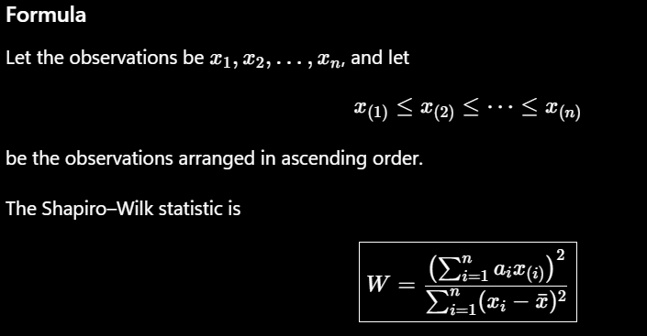

Symbol | Meaning
$$n$$ | Number of observations
$$x_{i}$$ | Original data value
$$x_{\left(i\right)}$$ | $i$-th smallest observation
$$\overset{ˉ}{x}$$ | Sample mean
$$a_{i}$$ | Shapiro–Wilk coefficients
$$W$$ | Test statistic
$p$-value | Probability used to assess evidence against $H_{0}$
$$α$$ | Significance level, commonly 0.05

2. Levene’s Test (Homogeneity of Variance Check)
Levene’s test is a statistical test used to determine whether two or more independent groups have equal variances. It is commonly used before ANOVA and other statistical methods that assume homogeneity of variance.
Hypotheses
- H₀ (Null hypothesis): All groups have equal population variances.
- H₁ (Alternative hypothesis): At least one group has a different population variance.
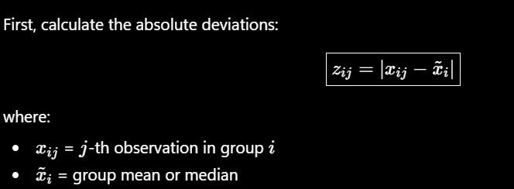
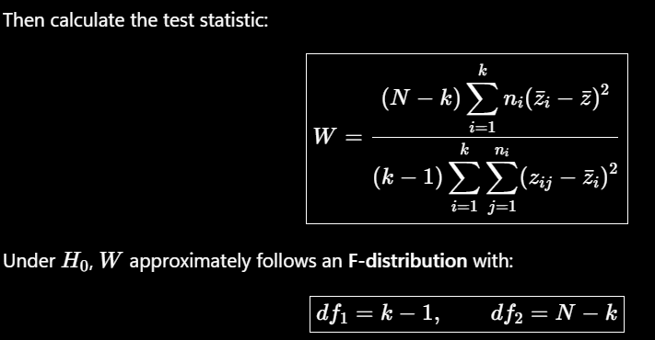

Symbol | Meaning
$$k$$ | Number of groups
$$n_{i}$$ | Number of observations in group $i$
$$N$$ | Total number of observations
$$x_{ij}$$ | Observation $j$in group $i$
$${\tilde{x}}_{i}$$ | Group mean or median
$$z_{ij}$$ | Absolute deviation from group center
$${\overset{ˉ}{z}}_{i}$$ | Mean of deviations in group $i$
$$\overset{ˉ}{z}$$ | Overall mean of all deviations
$$W$$ | Levene’s test statistic
$$df_{1}$$ | Between-groups degrees of freedom
$$df_{2}$$ | Within-groups degrees of freedom
$p$-value | Evidence against equal variances
$$α$$ | Significance level, commonly 0.05

3. t-Test (Comparison of Means)
A t-test is a statistical test used to determine whether the mean of a numerical variable differs significantly between a sample and a reference value, or between two groups.
Hypotheses
For a two-sided test:
- H₀: The population means are equal (or the sample mean equals the reference value).
- H₁: The population means are different.
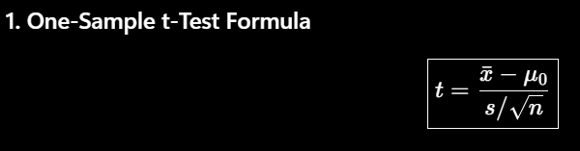
Symbol | Meaning
$$\overset{ˉ}{x}$$ | Sample mean
$$μ_{0}$$ | Hypothesized population mean
$$s$$ | Sample standard deviation
$$n$$ | Sample size
$$t$$ | Test statistic
$$df$$ | Degrees of freedom

4. Two-Sample t-Test (Comparison of Two Means)
A two-sample t-test is used to determine whether the means of two groups are significantly different.

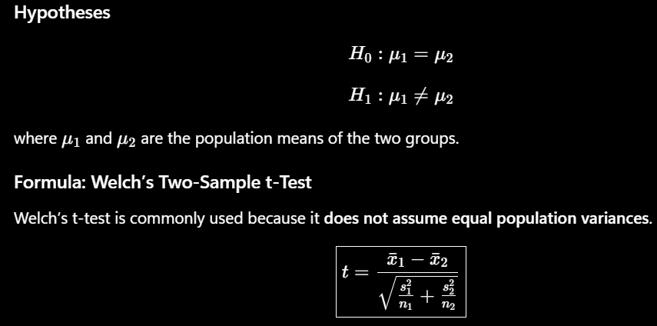

Symbol | Meaning
$${\overset{ˉ}{x}}_{1}$$ | Mean of Group 1
$${\overset{ˉ}{x}}_{2}$$ | Mean of Group 2
$$s_{1}^{2}$$ | Sample variance of Group 1
$$s_{2}^{2}$$ | Sample variance of Group 2
$$s_{1},s_{2}$$ | Sample standard deviations
$$n_{1}$$ | Sample size of Group 1
$$n_{2}$$ | Sample size of Group 2
$$t$$ | Test statistic
$$df$$ | Degrees of freedom

5. Mann–Whitney U Test (Non-Parametric Comparison)
The Mann–Whitney U test is a non-parametric test used to compare two independent groups. It is an alternative to the independent two-sample t-test when the normality assumption is not appropriate.

Hypotheses
For a two-sided test:
- H₀: The two groups have the same distribution.
- H₁: The two groups have different distributions.

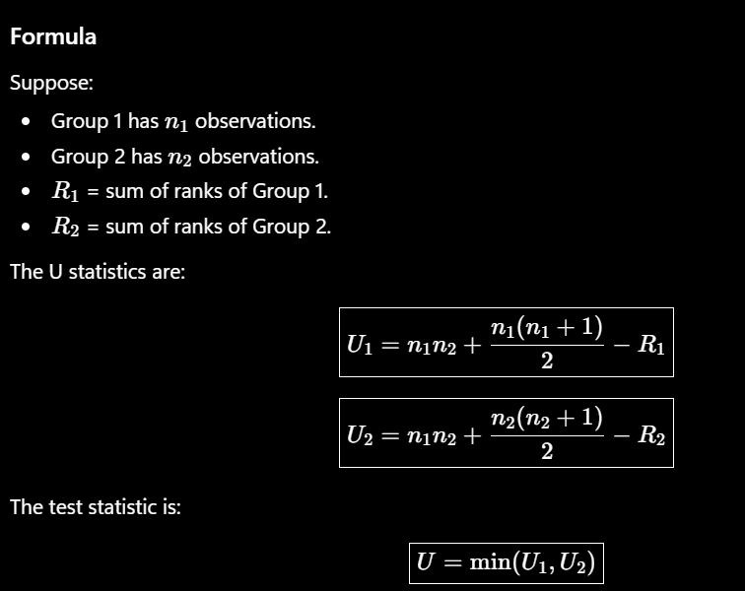

Symbol | Meaning
$$n_{1}$$ | Sample size of Group 1
$$n_{2}$$ | Sample size of Group 2
$$R_{1}$$ | Sum of ranks of Group 1
$$R_{2}$$ | Sum of ranks of Group 2
$$U_{1},U_{2}$$ | U statistics for the two groups
$$U$$ | Smaller U statistic
$p$-value | Evidence against $H_{0}$
$$α$$ | Significance level, commonly 0.05
6. Chi-Square Test (Categorical Data)
The Chi-Square test ($χ^{2}$) is a statistical test used to determine whether categorical data show a significant difference from what is expected.

Hypotheses
- H₀: The observed frequencies follow the expected distribution.
- H₁: The observed frequencies do not follow the expected distribution.

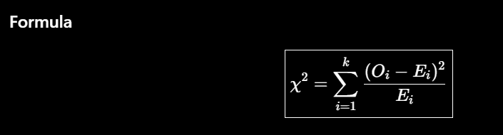
Symbol | Meaning
$$O_{i}$$ | Observed frequency
$$E_{i}$$ | Expected frequency
$$k$$ | Number of categories
$$χ^{2}$$ | Chi-square test statistic
$$df$$ | Degrees of freedom
$p$-value | Evidence against $H_{0}$
$$α$$ | Significance level, commonly 0.05
7. One-Way ANOVA (Comparison of Three or More Means)
One-Way ANOVA (Analysis of Variance) is a statistical test used to determine whether the means of three or more independent groups are significantly different.

Hypotheses
- H₀: All population means are equal.
$$μ_{1}=μ_{2}=⋯=μ_{k}$$
- H₁: At least one population mean is different.
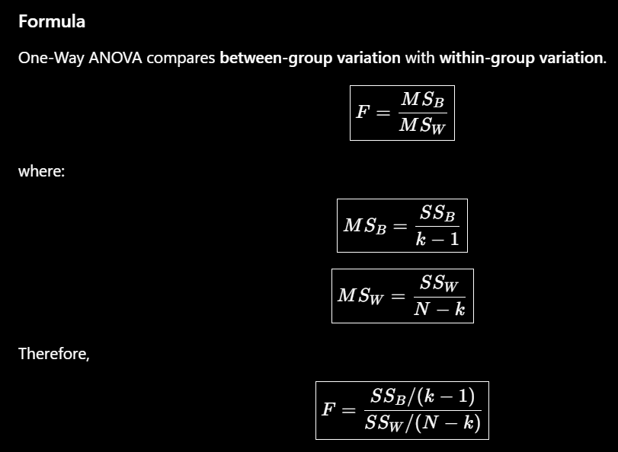

Symbol | Meaning
$$k$$ | Number of groups
$$n_{i}$$ | Number of observations in group $i$
$$N$$ | Total number of observations
$${\overset{ˉ}{x}}_{i}$$ | Mean of group $i$
$$\overset{ˉ}{x}$$ | Grand mean of all observations
$$SS_{B}$$ | Between-group sum of squares
$$SS_{W}$$ | Within-group sum of squares
$$MS_{B}$$ | Between-group mean square
$$MS_{W}$$ | Within-group mean square
$$F$$ | ANOVA test statistic
$$df_{1}$$ | Between-group degrees of freedom
$$df_{2}$$ | Within-group degrees of freedom
$p$-value | Evidence against equal means
$$α$$ | Significance level, commonly 0.05

Interpretation of Estimated Coefficients $\left(β\right)$
In linear regression, estimated coefficients $\hat{β}$describe how the predicted value of a dependent variable changes when an independent variable changes.
Confidence Intervals (CI)
A confidence interval is a range of values used to estimate an unknown population parameter, such as a population mean $μ$or a regression coefficient $β$.
Instead of giving only one estimate, it gives an estimate + uncertainty.

R² and Adjusted R²
Both R² and Adjusted R² are measures used in regression to evaluate how well the independent variables explain the variation in the dependent variable.
1. R² — Coefficient of Determination
Meaning
R² represents the proportion of variation in the dependent variable $Y$explained by the regression model.

2. Adjusted R²
Meaning
Adjusted R² is a modified version of R² that considers:
- The number of predictors in the model.
- The sample size.
- The improvement in model fit.
It penalizes the model for adding unnecessary predictors.

Gauss–Markov Diagnostic Checks
1. Linearity
The linearity assumption states that the relationship between the dependent variable $Y$and the predictors $X$is linear in the model parameters.

2. Homoscedasticity
Homoscedasticity means that the variance of the error term is constant for all values of the predictors.

3.Normality of Residuals
The normality of residuals assumption states that the error terms are approximately normally distributed around zero.

4. Multicollinearity
Multicollinearity occurs when two or more independent variables in a multiple regression model are highly correlated with each other.

