Assignment 4 : Create Stored procedure in Northwind database to insert or update a
record in a table

1. Create a stored procedure in the Northwind database that will calculate the average
value of Freight for a specified customer.Then, a business rule will be added that will
be triggered before every Update and Insert command in the Orders controller,and
will use the stored procedure to verify that the Freight does not exceed the average
freight. If it does, a message will be displayed and the command will be cancelled.

Sql:
Alter Procedure spCalculateAvgFreight
@CustomerID nchar(10),
@AvgFreight money out
as
Begin
Select @AvgFreight = avg(Freight)
From Orders
Where CustomerID = @CustomerID
End

--Trigger for before update and insert
Alter Trigger check_freight
ON Orders
Instead of Insert, Update
as
Begin
Declare @Avg money
Declare @CustomerId nchar(10)
Declare @OrderId int

Select @CustomerId = CustomerID
From inserted

Exec spCalculateAvgFreight @CustomerId, @Avg out

Declare @Freight money
Select @Freight = Freight from inserted
if(@Freight > @Avg)
Begin
Print cast(@Freight as varchar) + ' is greater than ' + cast(@Avg as varchar) + ' so Command is cancelled and Data is not Inserted Or Updated'
Return
End

Select @OrderID = OrderID
From inserted

IF EXISTS(SELECT 1 FROM Orders
WHERE OrderID = @OrderId)
BEGIN
UPDATE Orders
SET Orders.Freight = (select freight from inserted)
Where OrderID =@OrderId

print 'Data Updated Successfully'
END

ELSE
BEGIN
INSERT INTO "Orders"
("CustomerID","EmployeeID","OrderDate","RequiredDate",
"ShippedDate","ShipVia","Freight","ShipName","ShipAddress",
"ShipCity","ShipRegion","ShipPostalCode","ShipCountry")
SELECT CustomerID,EmployeeID,OrderDate,RequiredDate,
ShippedDate,ShipVia,Freight,ShipName,ShipAddress,
ShipCity,ShipRegion,ShipPostalCode,ShipCountry
FROM inserted
END
End

INSERT INTO "Orders"
("CustomerID","EmployeeID","OrderDate","RequiredDate",
"ShippedDate","ShipVia","Freight","ShipName","ShipAddress",
"ShipCity","ShipRegion","ShipPostalCode","ShipCountry")
VALUES (N'VINET',1,'7/4/1996','8/1/1996','7/16/1996',3,5,
N'Vins et alcools Chevalier',N'59 rue de l''Abbaye',N'Reims',
NULL,N'51100',N'France')

UPDATE Orders
Set Freight=34
Where OrderID = 10248

output:
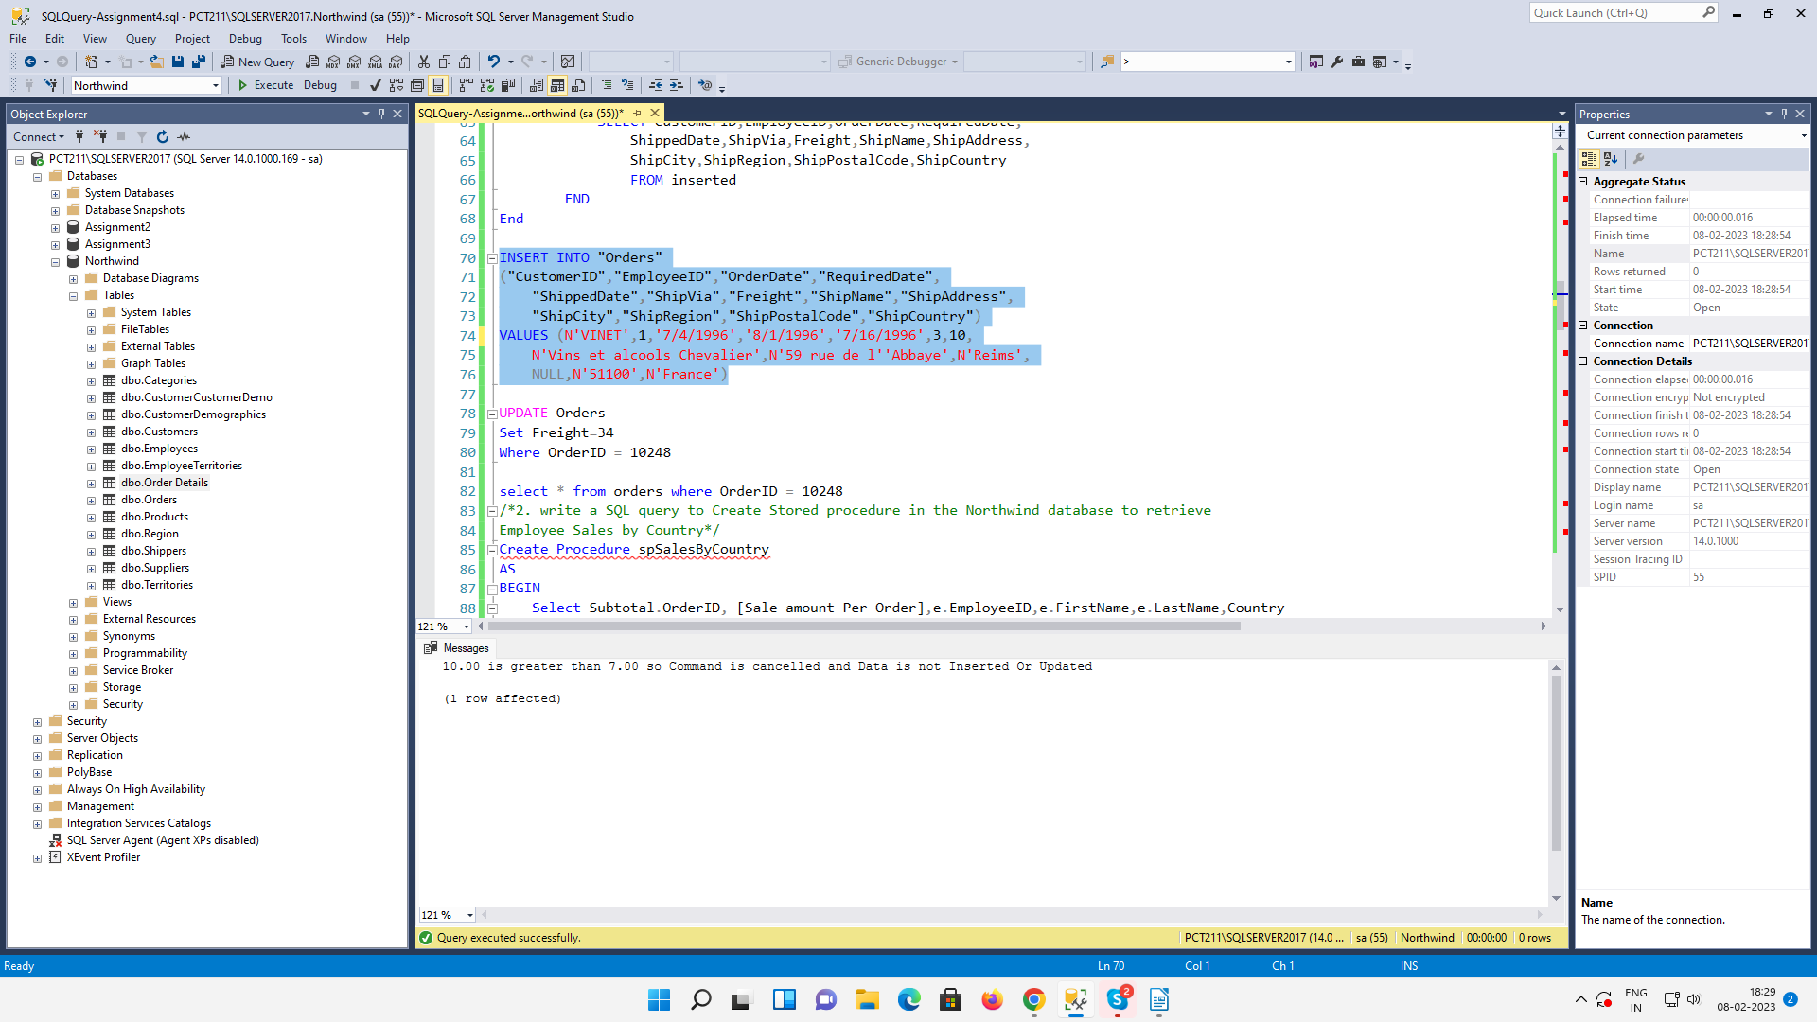

2. write a SQL query to Create Stored procedure in the Northwind database to retrieve
Employee Sales by Country
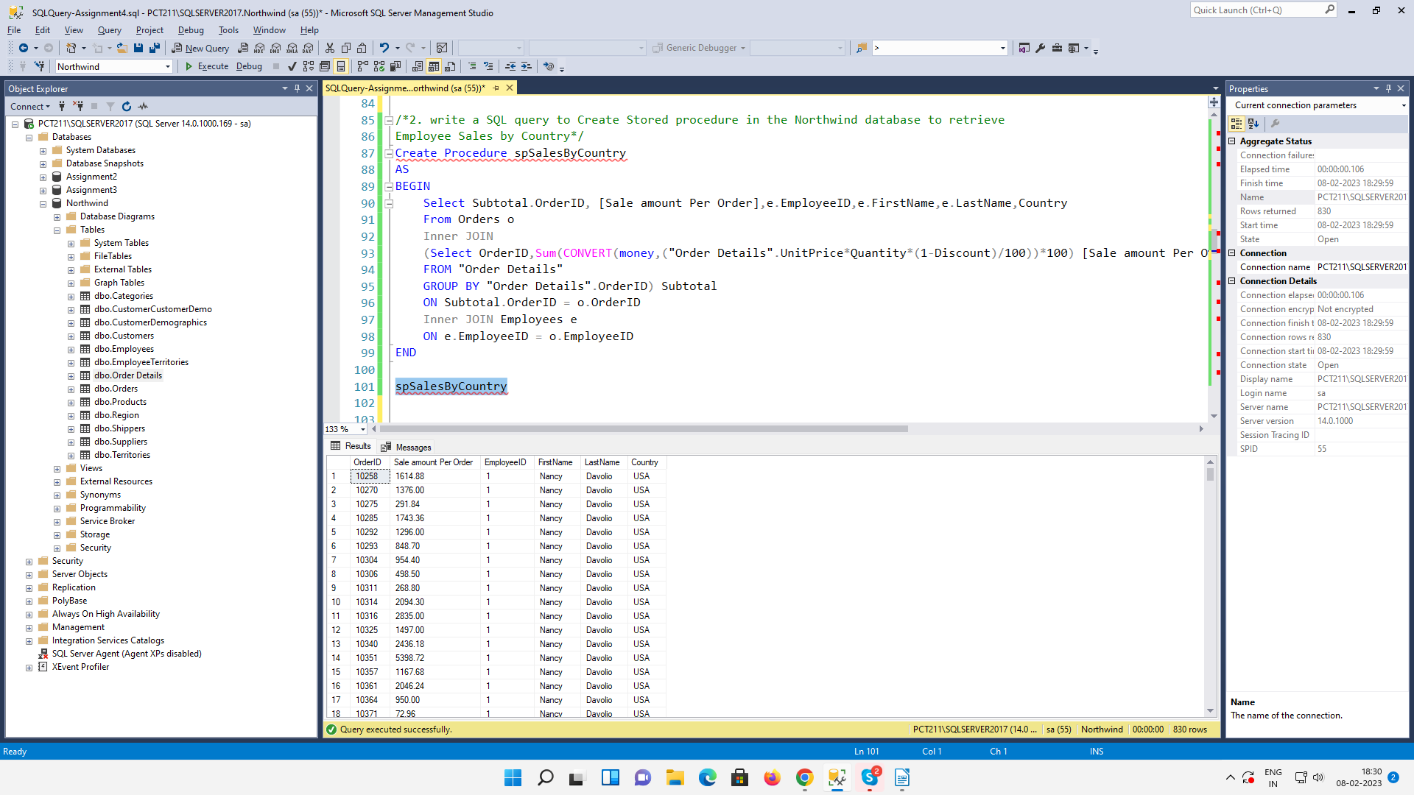

3. write a SQL query to Create Stored procedure in the Northwind database to retrieve
Sales by Year
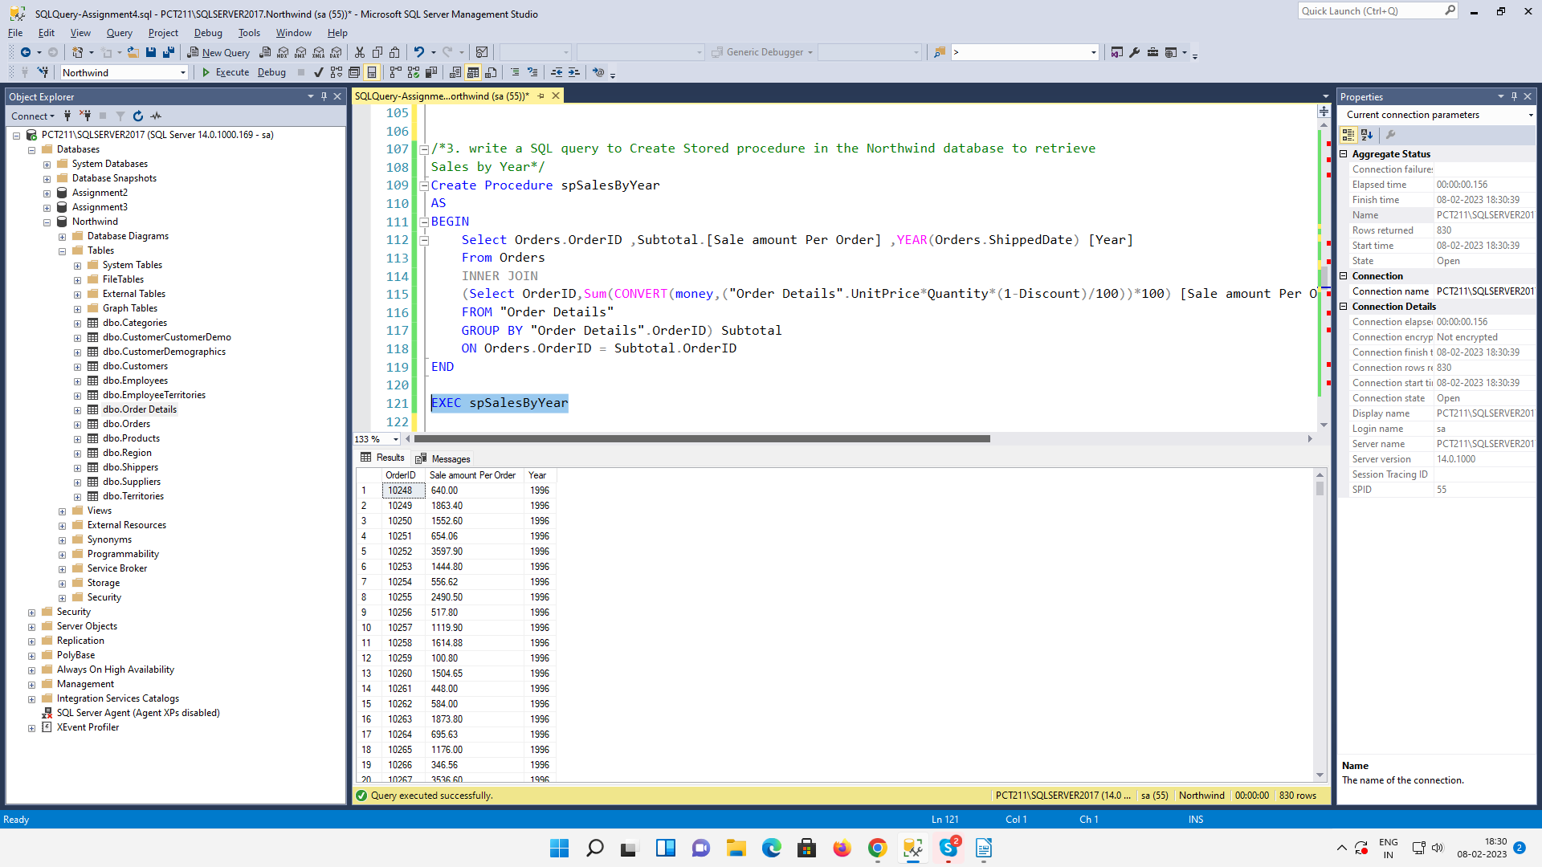

4. write a SQL query to Create Stored procedure in the Northwind database to retrieve
Sales By Category
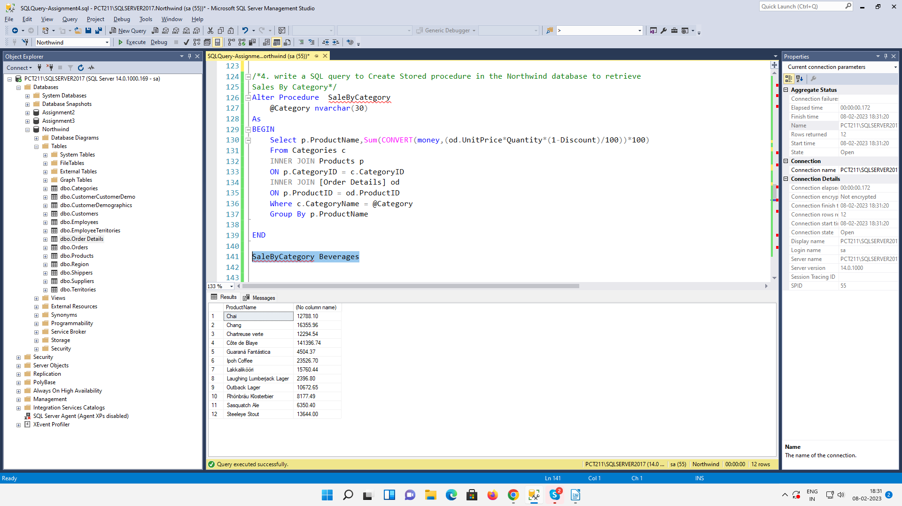

5. write a SQL query to Create Stored procedure in the Northwind database to retrieve
Ten Most Expensive Products
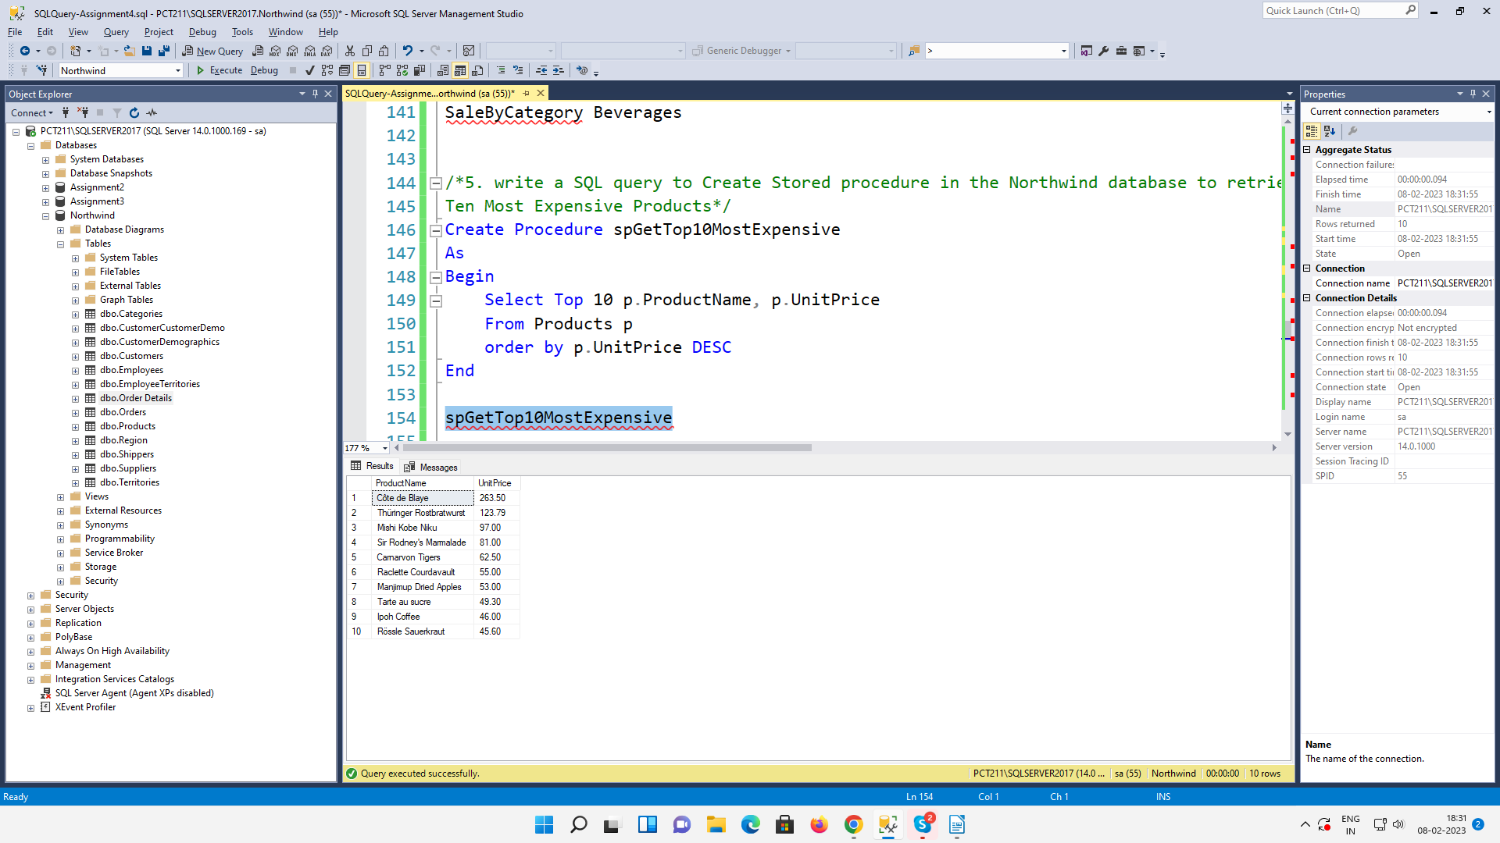
6. write a SQL query to Create Stored procedure in the Northwind database to insert
Customer Order Details
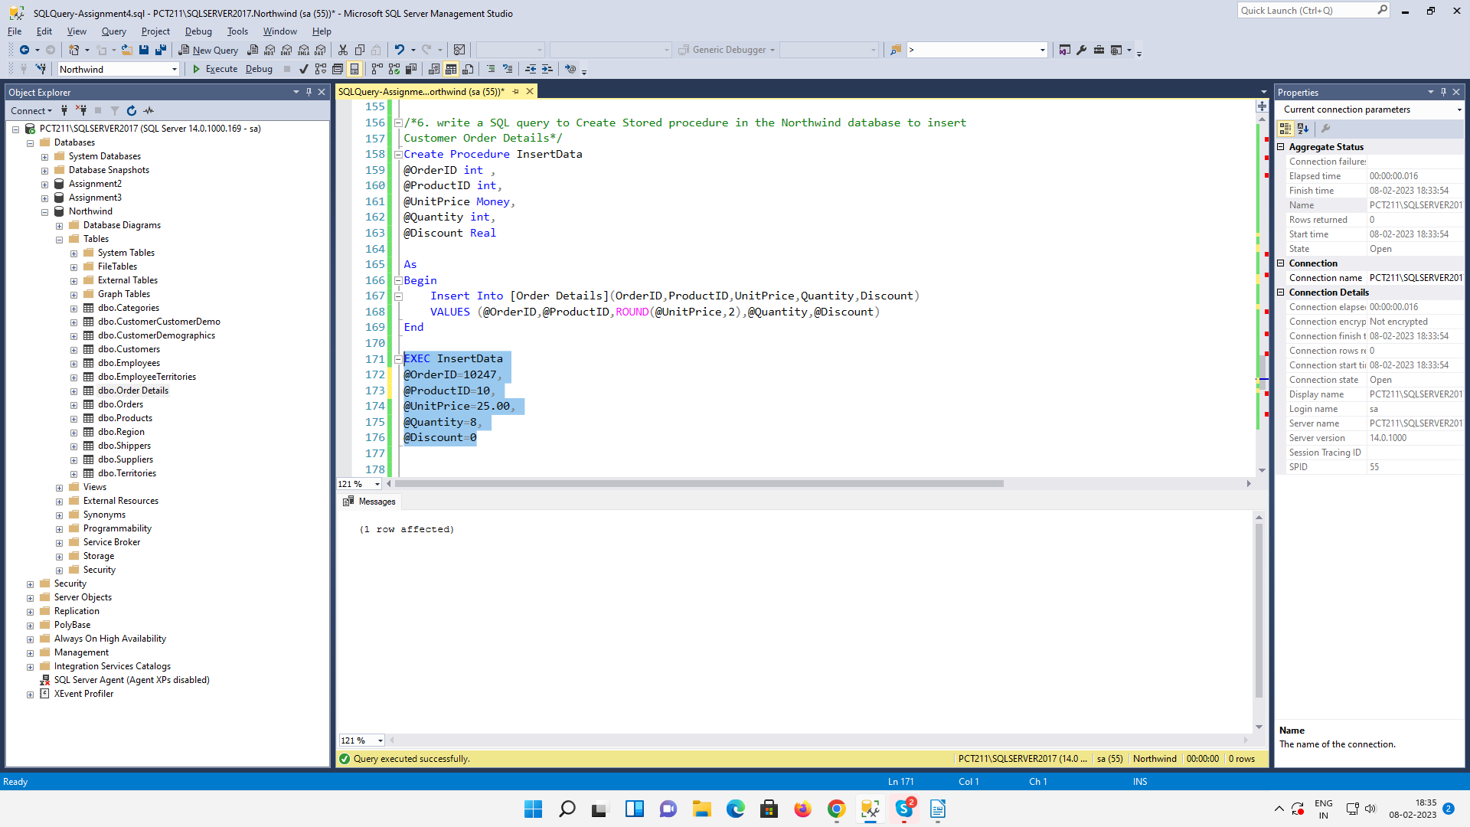

7. write a SQL query to Create Stored procedure in the Northwind database to update
Customer Order Details
