Assignment 3 : Retrieve data using Group By clause

1. write a SQL query to find Employees who have the biggest salary in their Department
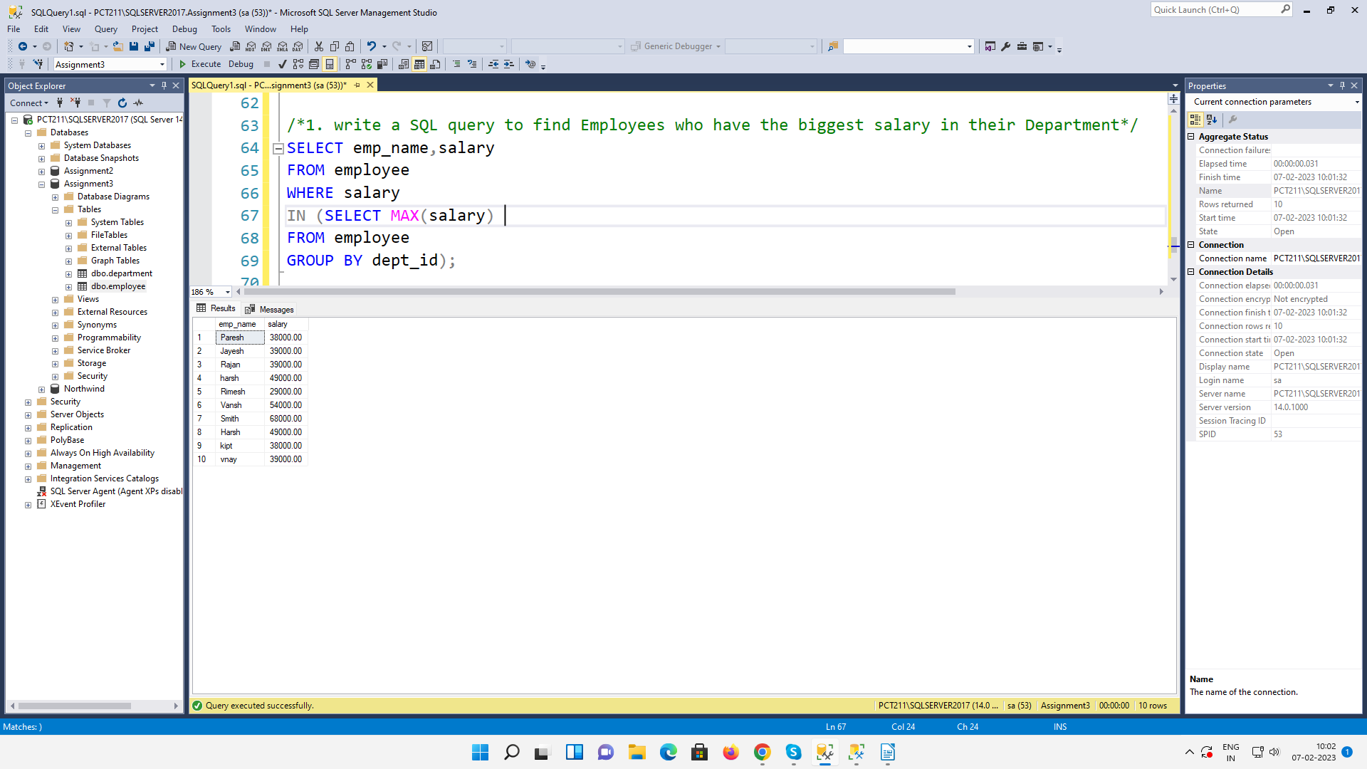
2. write a SQL query to find Departments that have less than 3 people in it
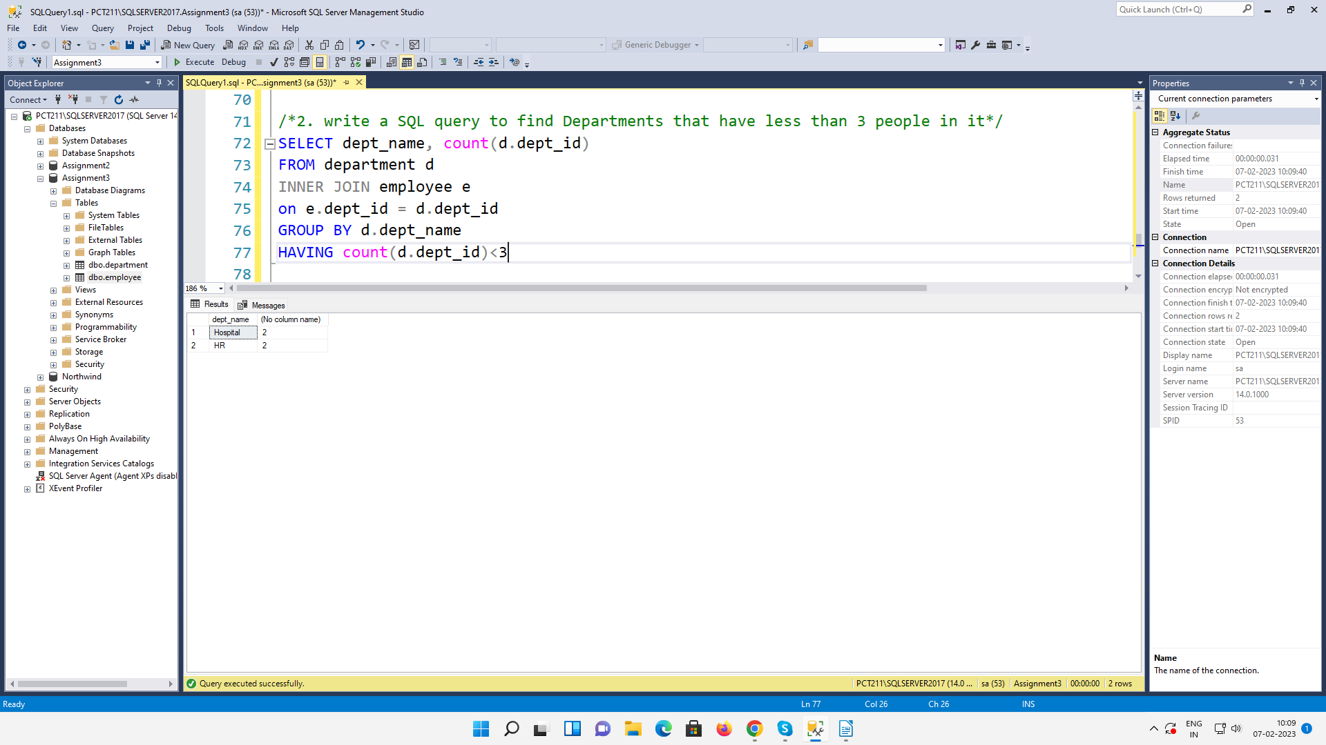
3. write a SQL query to find All Department along with the number of people there
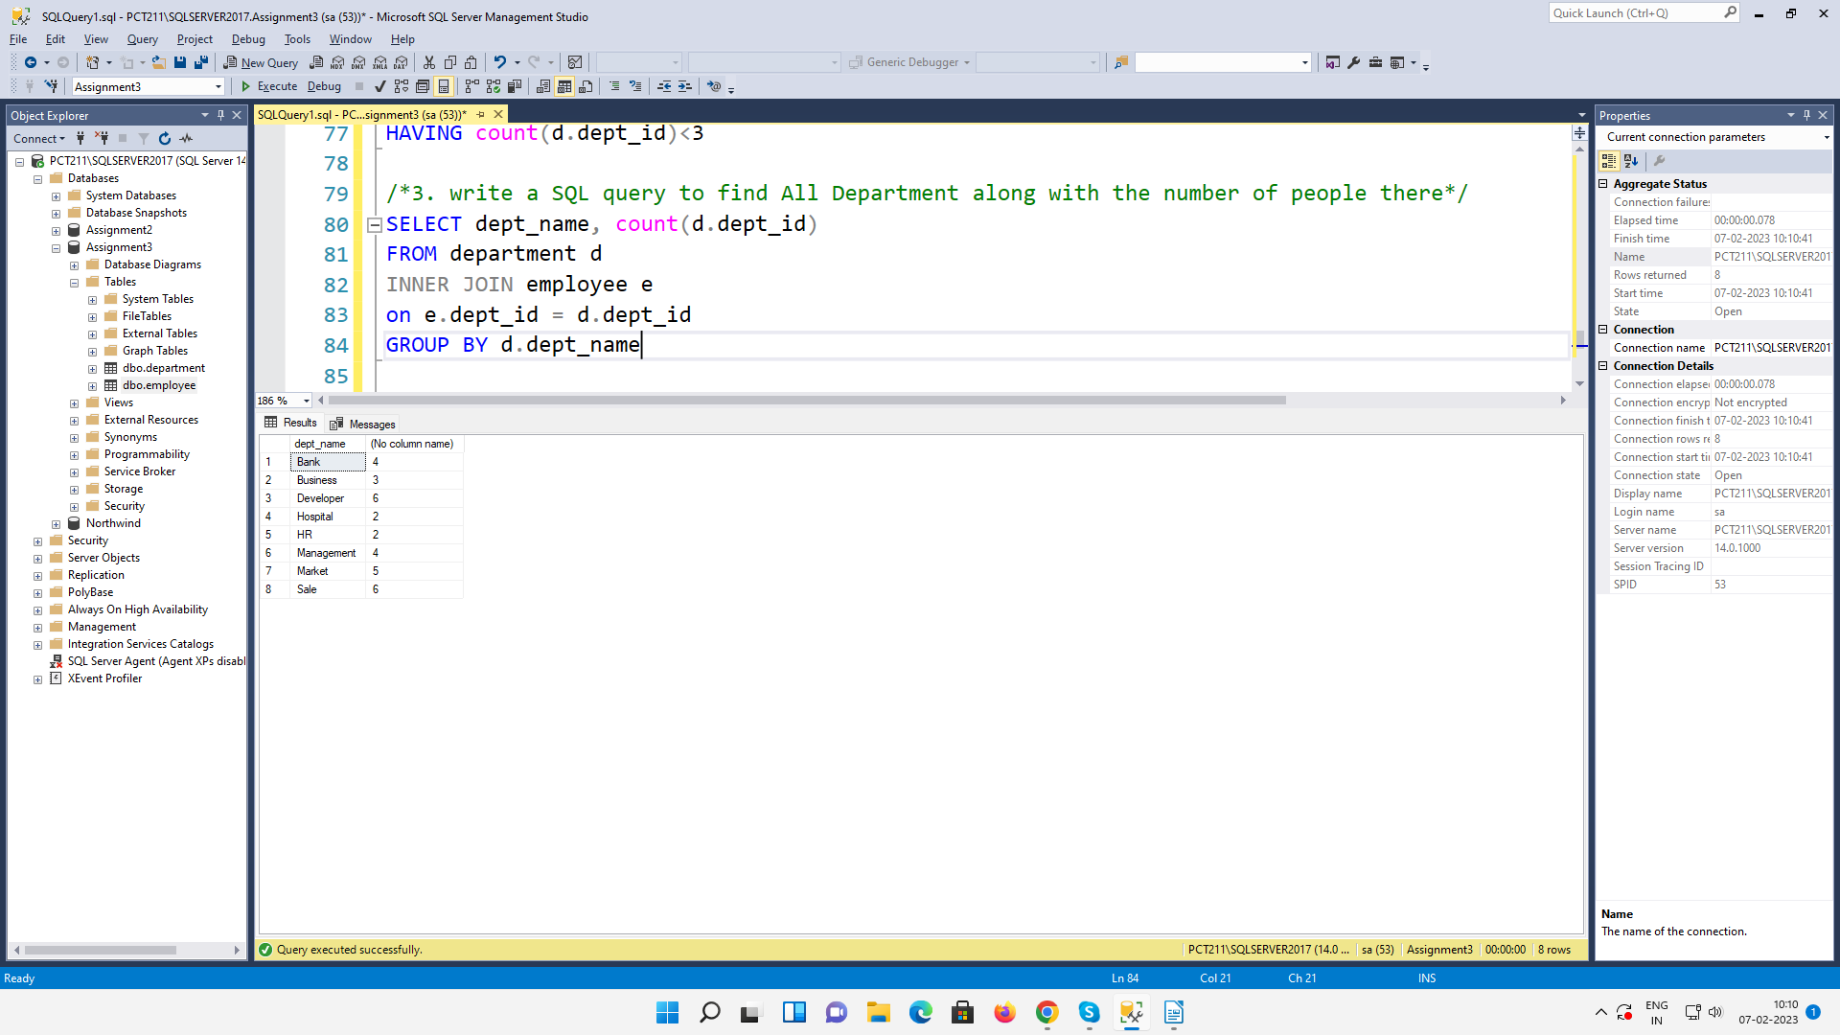
4. write a SQL query to find All Department along with the total salary there
