Assignment 1 : Simple SQL Query with a single table with where clause

1.Write a query to get a Product list (id, name, unit price) where current products cost
less than $20.
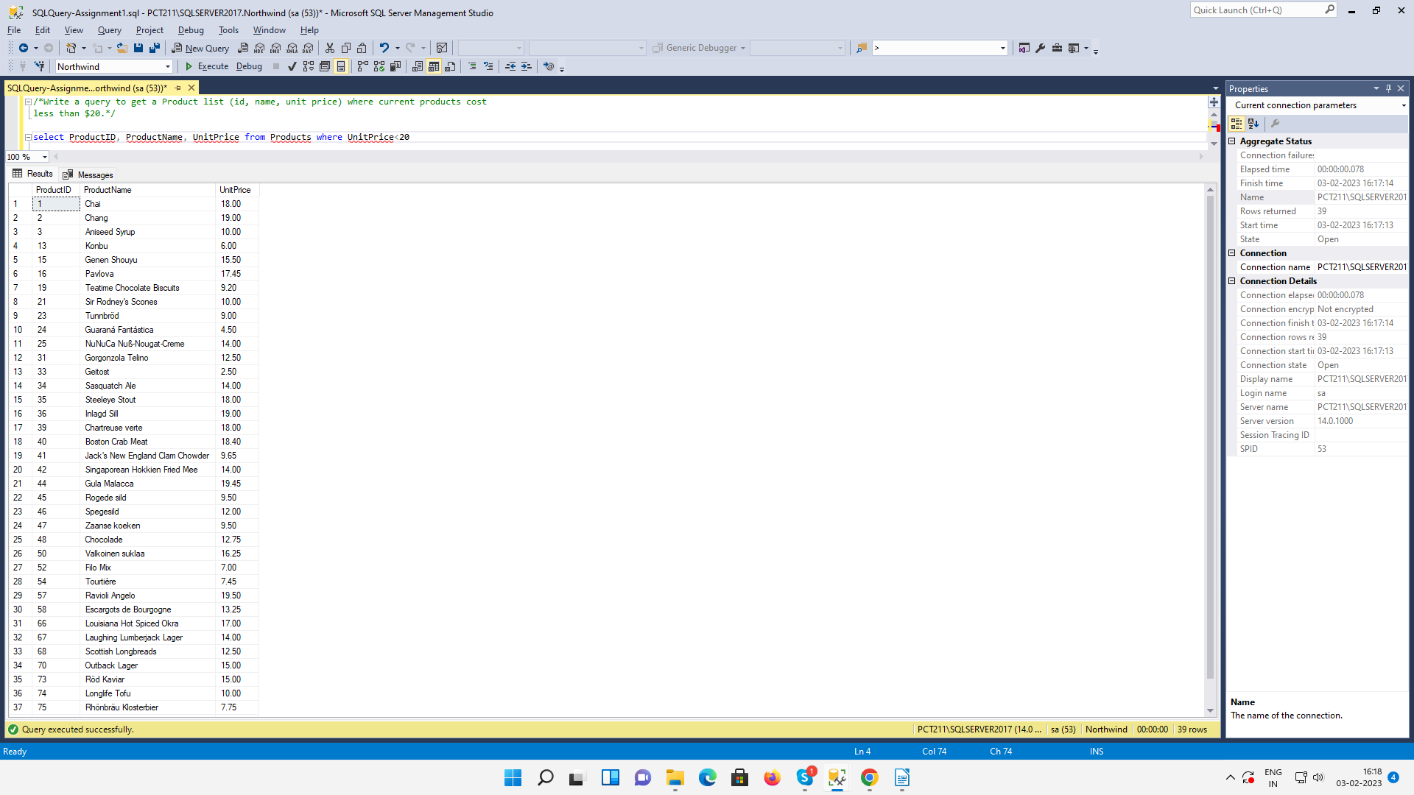

2.Write a query to get Product list (id, name, unit price) where products cost between
$15 and $25.
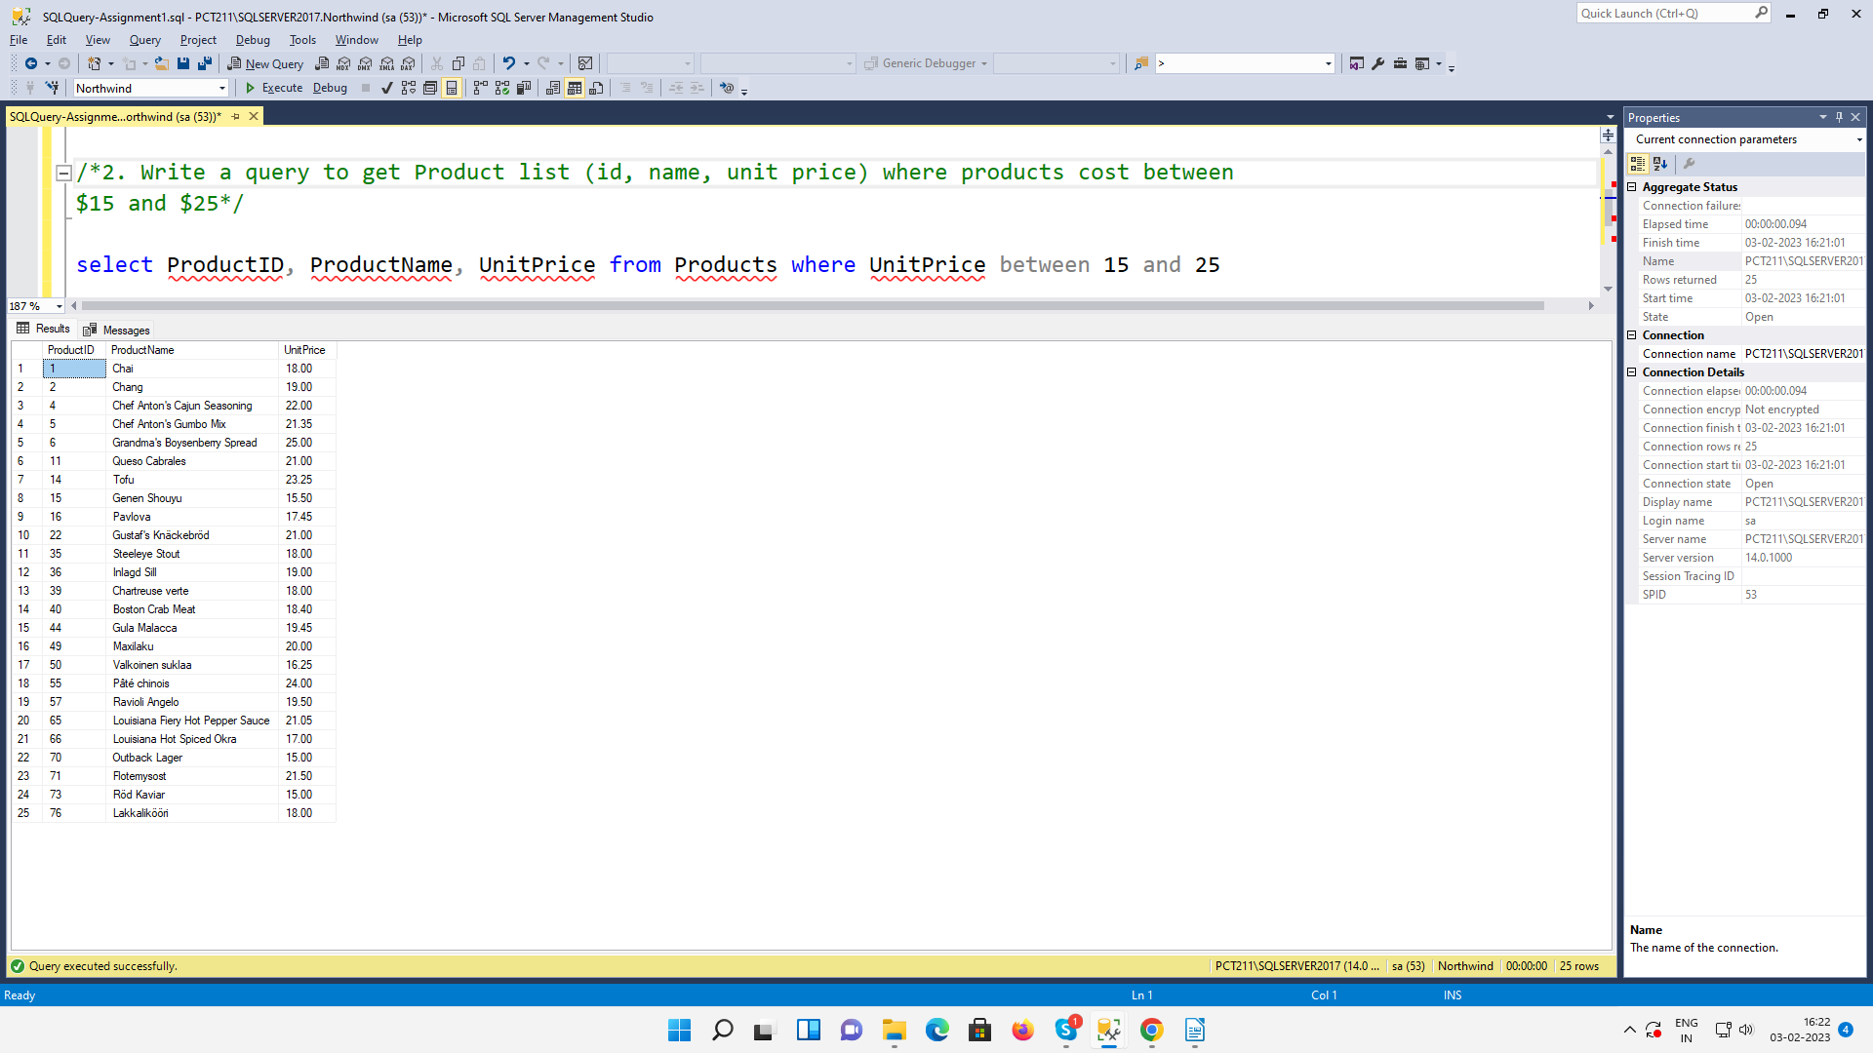
3. Write a query to get Product list (name, unit price) of above average price.
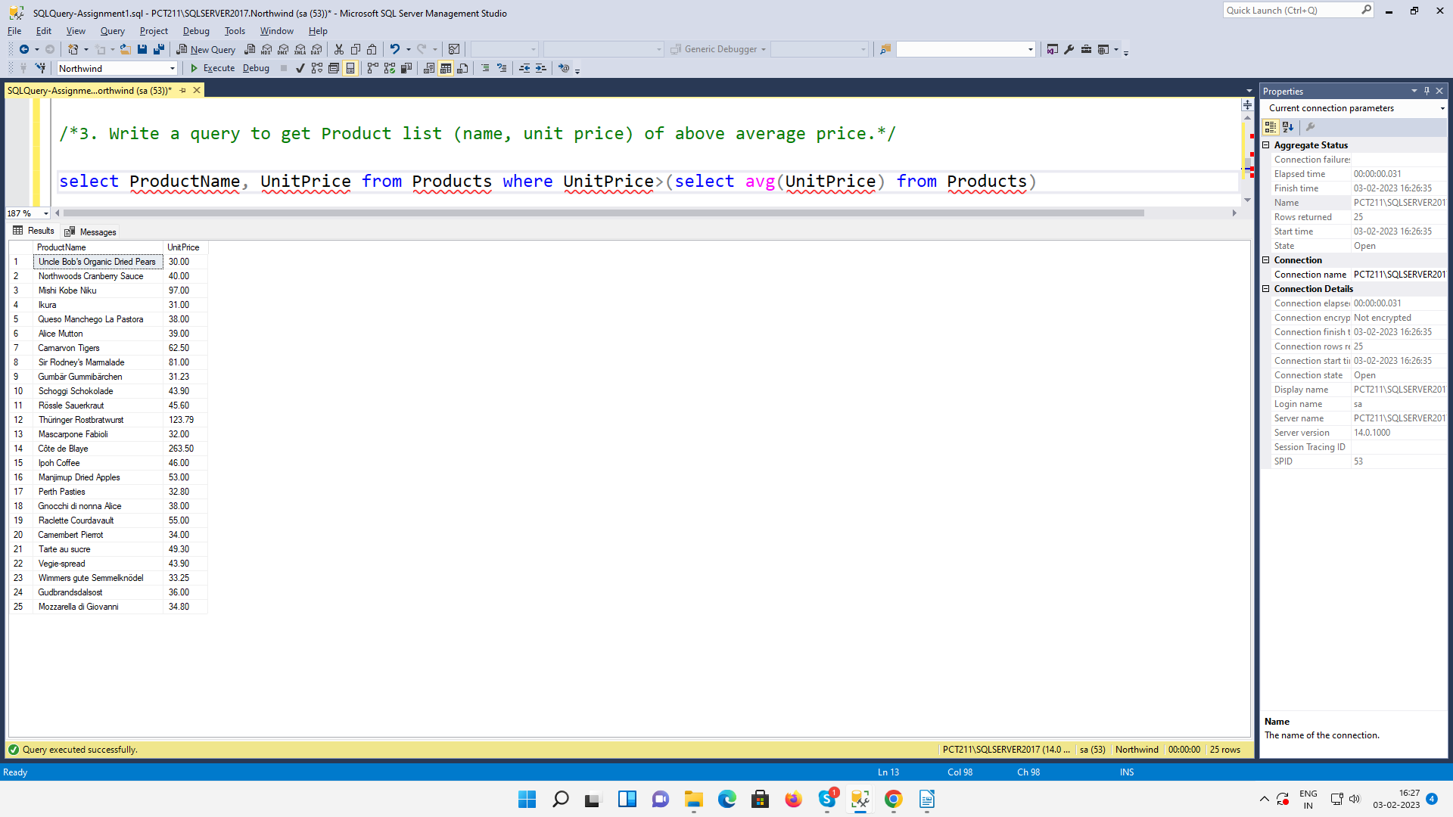

4. Write a query to get Product list (name, unit price) of ten most expensive products.
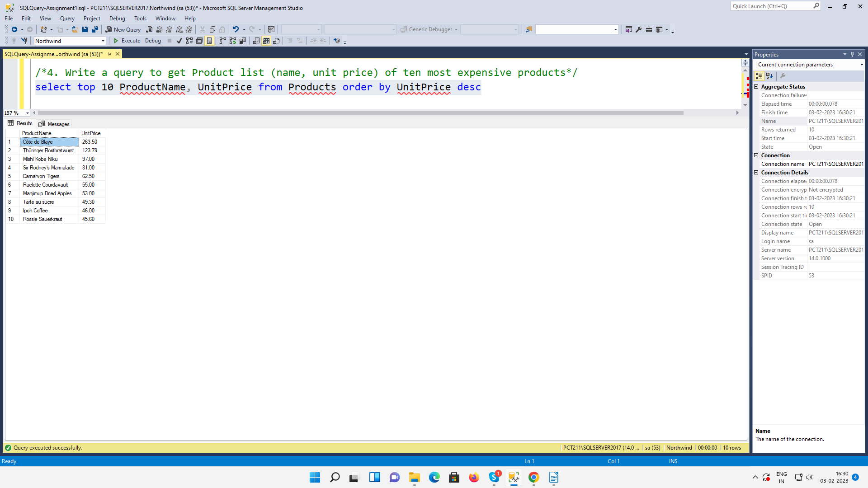

5. Write a query to count current and discontinued products.
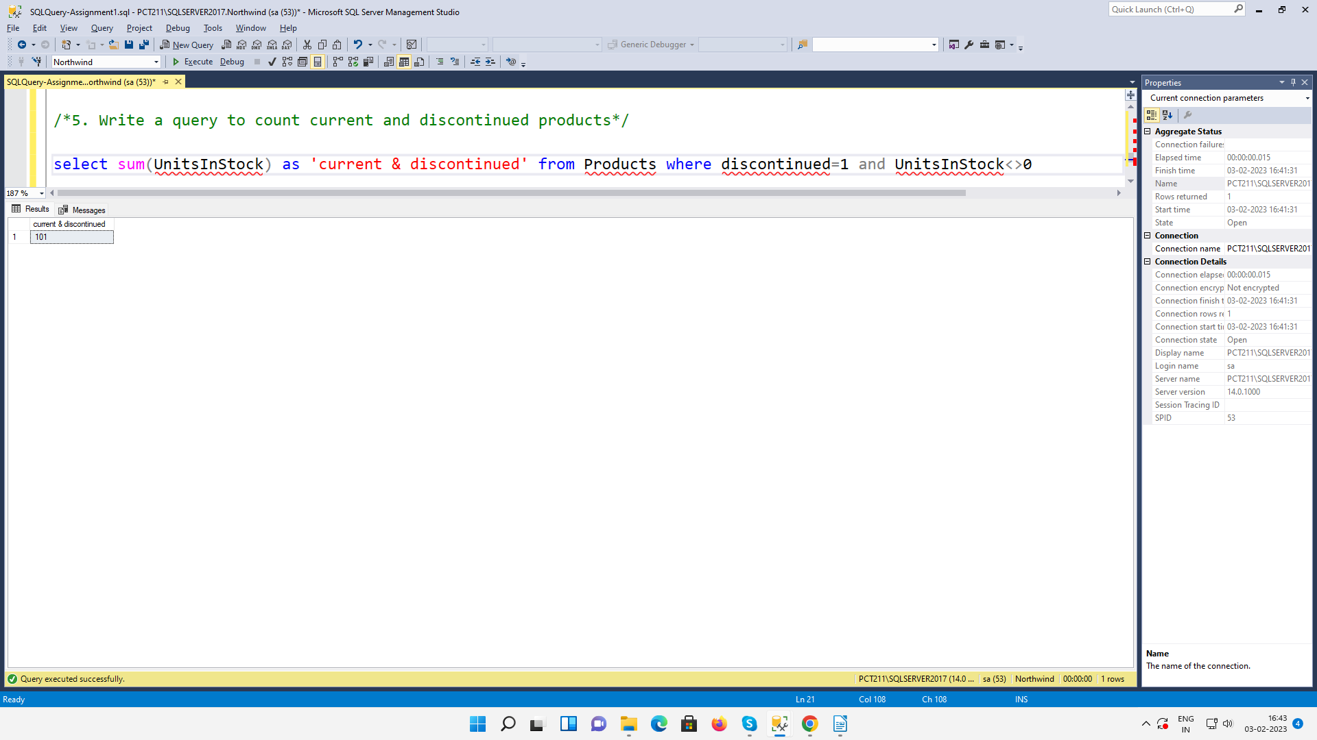

6.Write a query to get Product list (name, units on order , units in stock) of stock is less
than the quantity on order.
