DATA 266 HOMEWORK 1
Autoregressive Models, Neural Networks, and CUDA Matrix Multiplication
Complete experimental report
Drashti Shah
September 1, 2026

What are autoregressive models? Provide real-world examples.
Autoregressive models are statistical or machine learning models that use previous sequence values to predict the next value. The word “autoregressive” means that the model performs regression using its own past outputs as inputs. For observations x1 through xt, the model represents the current value using its history, such as P(xt | x1, ..., xt minus 1).
Modern language models are based on the same general premise. They assess the likelihood of the next token using all previous tokens:
Real-world uses include:

- Language generation: Using the conversation or context thus far, transformers like ChatGPT predicts one token at a time.
- Demand forecasting: Retailers anticipate future sales by analyzing prior sales, seasonal patterns, and recent demand.
- Financial analysis: Analysts can use past market values to predict future trends, but unforeseen events make financial forecasting challenging.
- Weather forecasting uses past temperature, rainfall, and air measurements to anticipate future conditions.
- Speech and music generation: Models produce sounds or musical notes progressively, using previous sections of the sequence as background.

One significant advantage is that these models can produce realistic and logically related sequences. However, because each prediction depends on preceding knowledge, errors can compound and harm subsequent projections.

Dataset and Preprocessing
The diabetes CSV file comprises 759 observations, eight numeric features, and one binary result. Because the file lacked a header row, header=None was used, along with explicit feature names. Validation checks revealed 759 rows, zero missing data, no duplicate rows, and outcome counts of 263 for label 0 and 496 for label 1.
The supplied features had already been quantitatively scaled. To keep the framework comparison under control, a StandardScaler was fitted exclusively to the training subset and left unmodified for the validation and test sets. Numeric zero was not categorized as missing since it is a legitimate value in this modified file, and the previous missing value representation cannot be reliably restored.

2.1 Correlation matrix
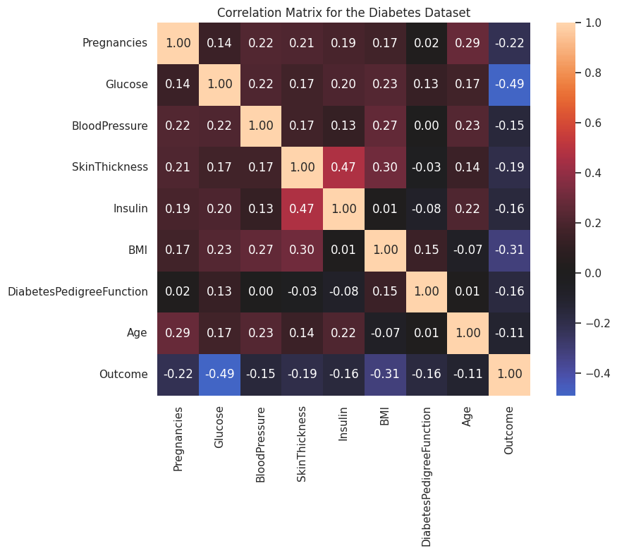

The correlation matrix reveals that glucose has the strongest absolute link with the outcome, with a correlation coefficient of -0.49. This shows that glucose could be one of the most informative predictors in the sample. The next greatest association is BMI (-0.31), followed by pregnancies (-0.22). The negative direction of these associations varies according to how the outcome classes were encoded. If the positive diabetes class was assigned the lowest numerical value, higher glucose or BMI levels would appear to be adversely correlated with the outcome, despite the fact that they are typically associated with an increased risk of diabetes.
Skin thickness and insulin show the strongest positive association of the predictor variables, at 0.47, which may indicate their shared relationship with body composition and metabolic activity. Skin thickness has a moderate link with BMI (0.30), while pregnancy and age have a correlation of 0.29. The majority of other correlations are weak, implying that the predictors measure various sorts of information rather than the same underlying quality.

2.2 Feature distributions
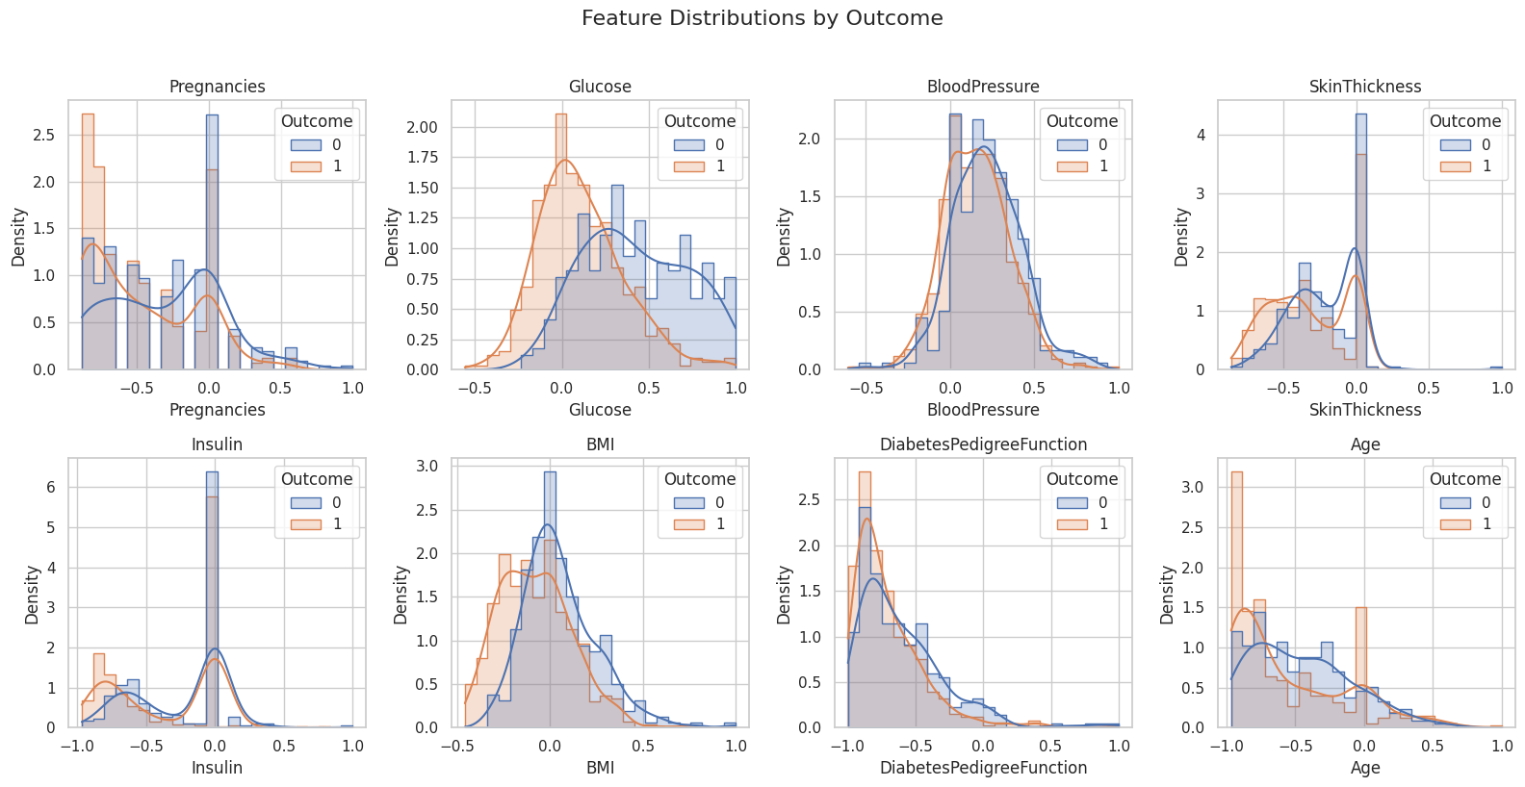
Figure 2. Density distributions for each feature separated by the supplied outcome label.
Glucose has the clearest separation between the outcome groups, making it the strongest individual predictor in the graph. BMI and pregnancy also exhibit significant changes, however their distributions overlap more. Blood pressure distributions are quite comparable between the two groups, although skin thickness shows just a minor difference with a high concentration at zero.
Insulin also exhibits a significant spike at zero, which could imply that missing samples were reported as zeros rather than genuine clinical values. Age and the diabetes pedigree function are right skewed, with significant overlap between groups. Overall, no single feature completely distinguishes the classes, implying the employment of a multivariable nonlinear model capable of combining data from several predictors.

3. Experimental Design
The dataset was split once, using random_state=2046 and stratification. 70% was allocated to teaching, 15% to validation, and 15% to testing. Each PyTorch and TensorFlow run used the exact identical split and standardized arrays.
Subset | Rows | Share | Label 1 rate
Training | 531 | 70.0% | 0.653
Validation | 114 | 15.0% | 0.658
Testing | 114 | 15.0% | 0.649

3.1 Model configurations
Model | Hidden layers | Learning rate | Epochs | Batch | Seeds
Baseline | [64, 32] | 0.001 | 30 | 32 | 2046 to 2048
Modified HP_ID 0 | [32] | 0.001 | 30 | 32 | 2046 to 2048
Both implementations employed ReLU hidden activations, binary cross entropy, Adam, batch size 32, a 0.5 threshold, and test accuracy. The needed HP_ID 0 adjustment decreases model capacity from two hidden layers to one 32-unit hidden layer while keeping the learning rate and training duration constant. Each model was trained using the seeds 2046, 2047, and 2048.

4. Neural Network Results

4.1 Individual test runs
Framework | Model | Seed 2046 | Seed 2047 | Seed 2048
PyTorch | Baseline | 0.7544 | 0.7281 | 0.7544
PyTorch | Modified HP_ID 0 | 0.7456 | 0.7456 | 0.7544
TensorFlow | Baseline | 0.7281 | 0.7368 | 0.7281
TensorFlow | Modified HP_ID 0 | 0.7632 | 0.7368 | 0.7544

4.2 Mean and standard deviation
Framework | Model | Mean accuracy | Std. dev.
PyTorch | Baseline | 0.7456 | 0.0152
PyTorch | Modified HP_ID 0 | 0.7485 | 0.0051
TensorFlow | Baseline | 0.7310 | 0.0051
TensorFlow | Modified HP_ID 0 | 0.7515 | 0.0134
In PyTorch, the adjusted model improved mean test accuracy from 0.7456 to 0.7485, a difference of 0.0029 or 0.29 percentage points. This difference is tiny enough that the models are nearly indistinguishable in terms of accuracy. The adjusted model was more stable over the three runs, with the standard deviation decreasing from 0.0152 to 0.0051.
The adjusted TensorFlow model improved mean test accuracy from 0.7310 to 0.7515, a gain of 0.0205 or 2.05 percentage points. Its standard deviation grew from 0.0051 to 0.0134, indicating that the accuracy improvement was associated with improved sensitivity to the training seed.

4.3 PyTorch loss curves
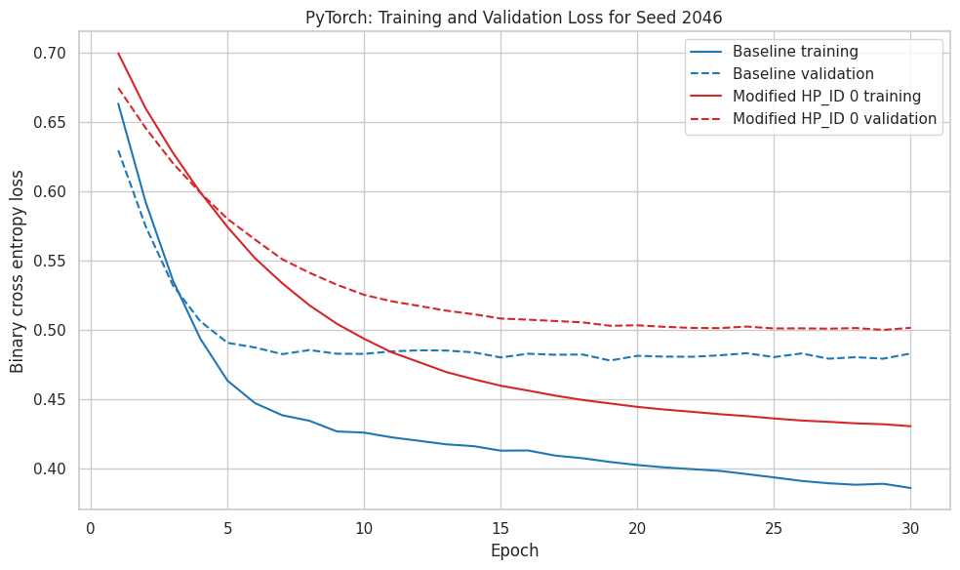
Figure 3. PyTorch training and validation loss for the seed 2046 run.

The PyTorch baseline had a training loss of 0.3857 and a validation loss of 0.4829, but the modified HP ID 0 model had losses of 0.4304 and 0.5015. For both models, training loss decreased while validation loss flattened after the early epochs, indicating modest overfitting because extra training did not improve generalization. The baseline had a smaller training and validation loss, indicating that it learned the data more efficiently. Although the adjusted model achieved comparable threshold accuracy, its larger validation loss reflects less confident or poorly calibrated probability predictions.

4.4 TensorFlow loss curves
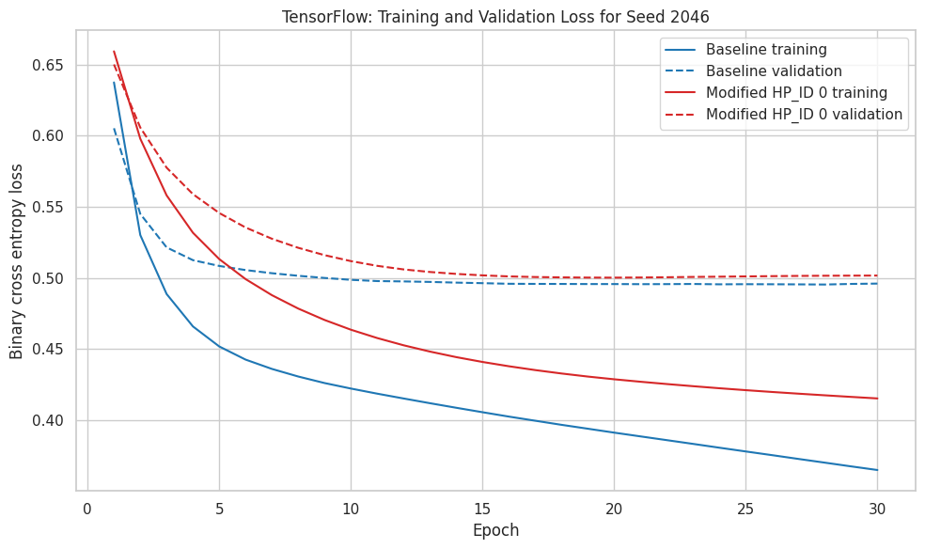
Figure 4. TensorFlow training and validation loss for the seed 2046 run.

The TensorFlow baseline had a training loss of 0.3652 and a validation loss of 0.4961, but the updated HP ID 0 model had losses of 0.4155 and 0.5017. Both validation curves flattened near 0.50, while training loss continued to fall, showing mild overfitting because further training improved the fit to the training data but not the validation performance. The baseline had the lowest validation loss, indicating slightly superior probability estimations. However, the updated model obtained higher threshold accuracy, that is, it classified more observations correctly at the 0.5 decision threshold, even if its projected probabilities were not better according to binary cross entropy.

Compare the baseline and HP_ID-modified models in each framework using the same split and metric.
With the identical seed 2046 data split and binary cross entropy metric, the baseline model outperformed both frameworks. In PyTorch, the baseline model had lower final training and validation losses of 0.3857 and 0.4829, compared to 0.4304 and 0.5015 for the HP ID modified model. In TensorFlow, the baseline model had lower training and validation losses of 0.3652 and 0.4961, compared to 0.4155 and 0.5017 for the updated model.

Overall, the assigned adjustment reduced loss-based performance in both frameworks. The changed models learnt more slowly and had larger training and validation losses, indicating a lower learning ability. Both validation curves flattened, but training loss decreased, indicating slight overfitting beyond the early epochs.The adjustment had little influence on PyTorch threshold accuracy and increased TensorFlow threshold accuracy, but not binary cross entropy. As a result, the modified TensorFlow model made more accurate decisions at the 0.5 threshold, while the baseline models provided superior probability estimates overall.

4.5 Neural error analysis
The main difficulty appears to be significant overlap between the two outcome classes, rather than severe overfitting. This makes some observations intrinsically difficult to identify, and it is likely to contribute to both false positives and false negatives. The loss curves also reveal some moderate overfitting because training loss continues to drop after validation loss flattens off.

PyTorch and TensorFlow have similar fundamental structures, but weight initialization, batch ordering, numerical operations, and framework-specific optimization can generate slightly different outcomes. Evaluating three seeds captures part of the variability, but additional seeds would provide a more accurate measure of model stability. Accuracy is reported because it is needed by the assignment; however, future analysis should include precision, recall, F1 score, a confusion matrix, and ROC AUC to illustrate which classes and error kinds are most affected.

5. CUDA Matrix Multiplication

5.1 Blocks, threads, and shared memory
The CUDA kernel uses a two dimensional block of 16 by 16 threads, or 256 threads per block. Each thread computes one element of output matrix C. A two dimensional grid covers the full output matrix, using ceiling division so boundary checks also support sizes that are not exact multiples of 16.
constexpr int TILE = 16;
dim3 threads(TILE, TILE);
dim3 blocks((n + TILE - 1) / TILE, (n + TILE - 1) / TILE);
tiled_matrix_multiply<<<blocks, threads>>>(A, B, C, n);

During each tile phase, each thread places one value from A and one value from B in shared memory. Following synchronization, the 256 threads reused the values for 16 multiply and accumulate operations. This minimizes recurring global memory traffic. The application warms up the kernel, averages five kernel runs with CUDA events, separates host-to-device and device-to-host copies, and compares to an optimized OpenMP CPU implementation.

5.2 Timing results
Size | CPU ms | Kernel ms | H2D + D2H ms | Speedup | Max error
256 | 3.2055 | 0.0652 | 0.2948 | 8.90 | 0.0000
1024 | 195.0054 | 3.4445 | 2.8619 | 30.92 | 0.0000
4096 | 19294.7413 | 201.5781 | 43.8562 | 78.61 | 0.0001
End-to-end GPU time is calculated by adding the measured kernel time to the transmission time between the host and the device. At all tested sizes, the GPU was faster. Speedup increased from 8.90 at 256 to 30.92 at 1024 and 78.61 at 4096 as matrix multiplication grew cubically and transfer volume grew quadratically. The maximum absolute error remained at or below 0.0001 after rounding, demonstrating that the GPU output closely matched the CPU reference.

5.3 Nsight Compute profile
Nsight Compute profiled the 1024 by 1024 tiled kernel on a Tesla T4. Profiling needed nine instrumentation passes, therefore the measured duration does not directly compare to the lower overhead CUDA event timing. The profile validates the anticipated 64 by 64 grid, 16 by 16 block, 4,096 blocks, 256 threads per block, and 1,048,576 total threads.
Profiler metric | Measured value
Profiler | Nsight Compute
Profiled size | 1024 by 1024
Instrumented duration | 5.79 ms
Compute throughput | 74.40%
Memory throughput | 74.40%
L1/TEX cache throughput | 95.34%
Theoretical occupancy | 100.00%
Achieved occupancy | 98.69%
Static shared memory per block | 2.05 KB
Nsight Compute described compute and memory as evenly balanced. The achieved occupancy of 98.69 percent indicates that the GPU maintained almost all available warps active. The profile does not suggest that all resources are fully optimized, but it does confirm that the block size allows for high occupancy and that both arithmetic work and memory traffic contribute significantly to runtime.

5.4 End to end crossover
The smallest tested matrix size with end-to-end GPU benefit was 256, with a measured speedup of 8.90. At that scale, the amount of parallel arithmetic was already significant enough to outweigh the transfer and launch overhead.
The crossover is not at size zero because GPU work incurs fixed setup, launch, synchronization, and transfer costs. Smaller matrices perform insufficient math to recoup those expenses, whereas larger matrices give multiple threads enough work to make parallel operation increasingly advantageous.

6. Overall Conclusion
The reduction in capacity from [64, 32] to [32] had framework-dependent implications. In PyTorch, the accuracy difference was minimal, and the smaller model was more stable across seeds, but with larger losses indicating slight underfitting. In TensorFlow, the smaller model increased mean accuracy by 2.05 percentage points while varying more among seeds and not improving cross entropy loss. As a result, the allocated capacity decrease did not generate a single universal outcome: it served as a useful accuracy simplification in TensorFlow and an essentially identical lower capacity alternative in PyTorch.
The CUDA experiment produced much clearer scaling results. The tiled GPU kernel outperformed the CPU reference at all tested sizes, and its advantage grew with matrix size.Separate kernel and transfer measurements, a successful correctness check, and the Nsight Compute profile all support the conclusion that the observed speedups are due to productive parallel work rather than omitted transfer costs.

