**Module 6) JAVASCRIPT BASIC & DOM**

**Q.1 What is JavaScript. How to use it?**

JavaScript is commonly used for creating web pages. It allows us to add dynamic behavior to the webpage and add special effects to the webpage.

**Q.2 How many type of Variable in JavaScript?**

There are two types of variable

1. local variable
2. Globle variable

**Q.3 Define a Data Types in js?**

There are two types of datatypes:

i)Primitive datatype

ii)Non-primitive datatype

In Primitive datatype there are seven types :

1. String
2. Boolean
3. Bigint
4. Number
5. Null
6. Undefined
7. Symbol

In Non-primitive datatype there are three types:

1. Array
2. Object
3. Function

**Q.4 Write a mul Function Which will Work Properly When invoked With**

**Following Syntax.**

The MUL function is a miniature of the multiplication function. In this function, we call the function that required an argument as a first number, and that function calls another function that required another argument and this step goes on.

Syntax:

function mul(x) {

return function (y) {

return function (z) {

return x * y * z;

};

};

}

**Q.5 What the deference between undefined and undeclare in JavaScript?**

Undeclared variables are those that have not been declared or defined in the current scope, while undefined variables are those that have been declared but not given a value.

Q.6 Using console.log() print out the following statement:

The quote 'There is no exercise better for the heart than reaching down and lifting people up.' by John Holmes teaches us to help one another.

Using console.log() print out the following quote by Mother Teresa:

console.log( “There is no exercise better for the heart than reaching down and lifting people up.'by John Holmes teaches us to help one another.”);

**Q.7 Check if typeof '10' is exactly equal to 10. If not make it exactly equal?**

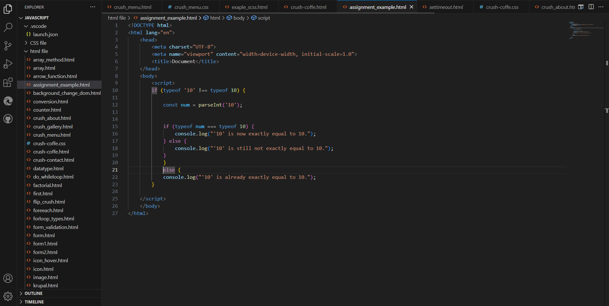

**Q.8 Write a JavaScript Program to find the area of a triangle?**

Area=2/1 ×base×height

function calculateTriangleArea(base, height) {

// Check if base and height are positive numbers

if (base > 0 && height > 0) {

// Calculate the area

const area = 0.5 * base * height;

return area;

} else {

// If base or height is not positive, return an error message

return "Base and height must be positive numbers.";

}

}

// Example usage:

const base = 5;

const height = 8;

const area = calculateTriangleArea(base, height);

console.log("The area of the triangle with base", base, "and height", height, "is:", area);

**Q.9 Write a JavaScript program to calculate days left until next Christmas?**

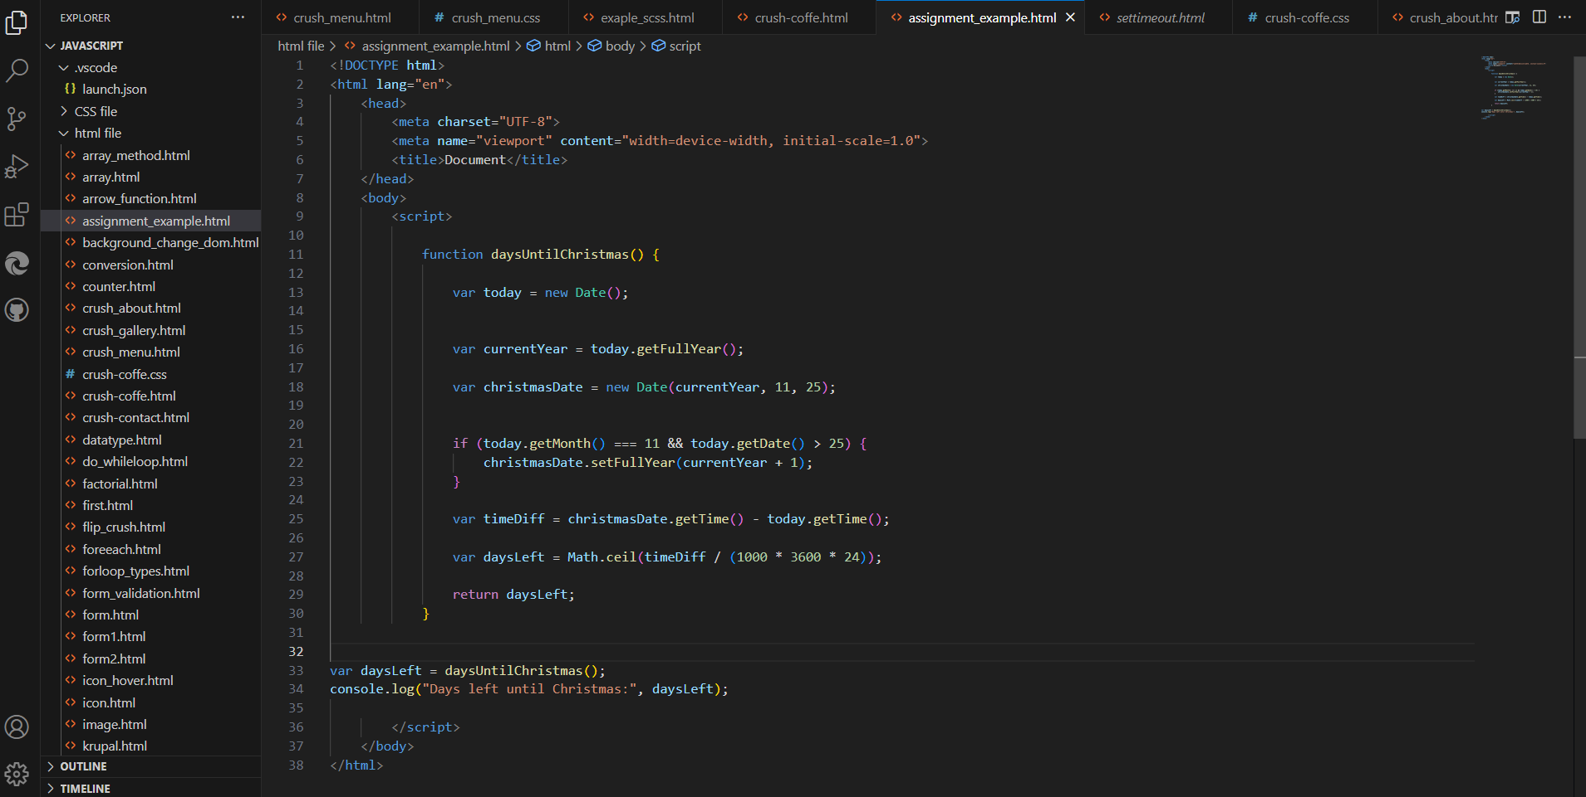

**Q.10 What is Condition Statement?**

Conditional statements are used to perform different actions based on different conditions.

In JavaScript we have the following conditional statements:

* Use if to specify a block of code to be executed, if a specified condition is true
* Use else to specify a block of code to be executed, if the same condition is false
* Use else if to specify a new condition to test, if the first condition is false
* Use switch to specify many alternative blocks of code to be executed

**Q.11 Find circumference of Rectangle formula : C = 4 * a ?**

the formula you've provided,

C=4×a, calculates the perimeter of a square, where 𝑎 a represents the length of one side of the square.

For a rectangle, where you have two different side lengths (width and height), you calculate the circumference (perimeter) using the formula:

𝐶=2×(𝑤𝑖𝑑th + height)

This formula accounts for going around all four sides of the rectangle. If the rectangle happens to be a square (where width equals height), then the formula

C=4×a would be applicable, as all sides of a square are equal.

**Q.12 WAP to convert years into days and days into years?**

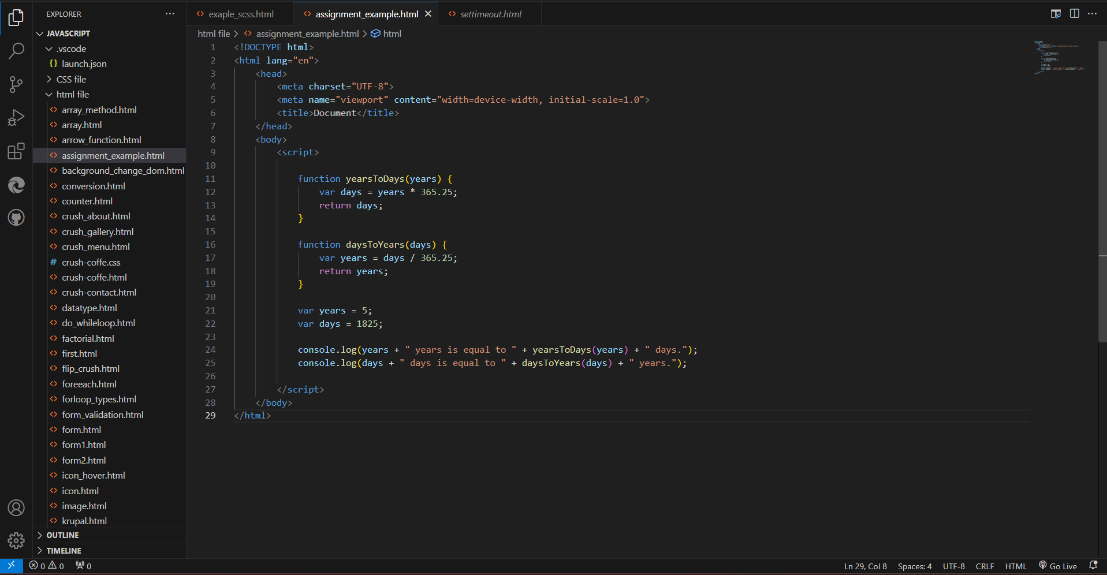

**Q.13 Convert temperature Fahrenheit to Celsius? (Conditional logic Question)**

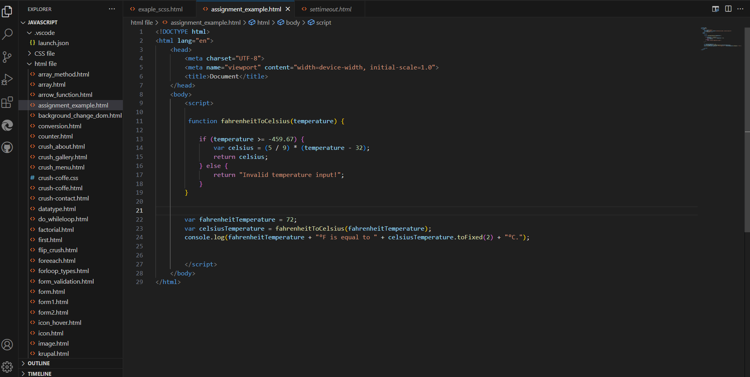

**Q.14 Write a JavaScript exercise to get the extension of a filename.?**

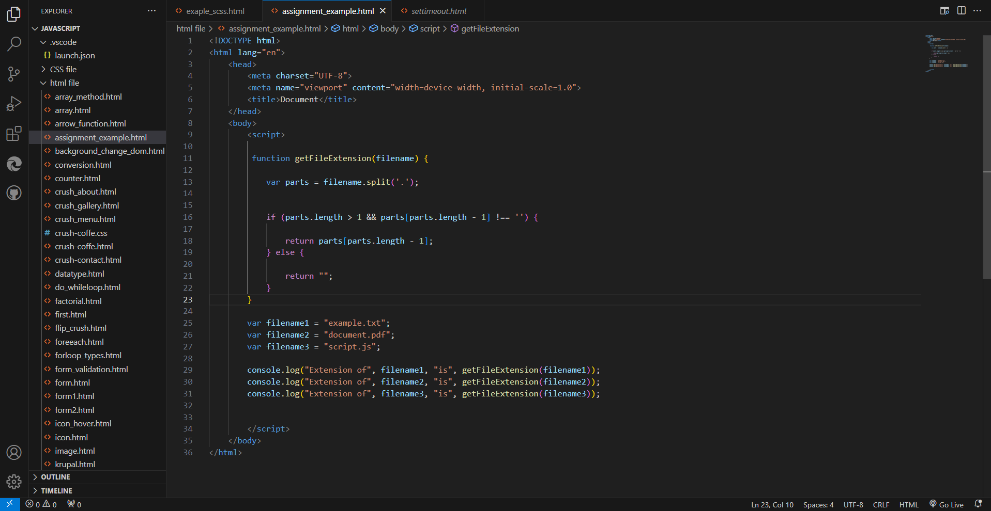

**Q.15 What is the result of the expression (5 > 3 && 2 < 4)?**

The expression (5 > 3 && 2 < 4) involves two logical operators:

>: Greater than

<: Less than

&&: Logical AND

Here's how it evaluates:

5 > 3 evaluates to true because 5 is greater than 3.

2 < 4 evaluates to true because 2 is less than 4.

Then, true && true evaluates to true because both conditions are true.

So, the result of the expression (5 > 3 && 2 < 4) is true.

**Q.16 What is the result of the expression (true && 1 && "hello")?**

The expression (true && 1 && "hello") involves the logical AND operator (&&).

When using the logical AND operator:

* If all operands are truthy values, the expression evaluates to the last truthy value.
* If any operand is falsy, the expression short-circuits and evaluates to that falsy value without evaluating the remaining operands.

In this case:

* true is truthy.
* 1 is truthy.
* "hello" is truthy.

So, the expression evaluates to the last truthy value, which is "hello". Therefore, the result of the expression is "hello".

Top of Form

Bottom of Form

**Q.17 What is the result of the expression true && false || false && true?**

In JavaScript, logical AND (&&) has higher precedence than logical OR (||).

Here's how the expression is evaluated step by step:

1. true && false evaluates to false because if any operand of AND is false, the expression is false.
2. false || false evaluates to false because if any operand of OR is true, the expression is true.
3. false && true evaluates to false.

So, the result of the expression true && false || false && true is false

**Q.18 What is a Loop and Switch Case in JavaScript define that ?**

**Loops:** Loops are control structures that repeat a block of code multiple times until a specified condition is met. JavaScript provides several types of loops:

for (initialization; condition; increment/decrement) {

// code block to be executed

}

while (condition) {

// code block to be executed

}

do {

// code block to be executed

} while (condition);

for (variable in object) {

// code block to be executed

}

for (variable of iterable) {

// code block to be executed

}

**Switch Case:** Switch case is a control structure used to perform different actions based on different conditions. It evaluates an expression and matches the value of the expression with a case label. If a match is found, it executes the corresponding block of code. If no match is found, an optional default case can be executed.

switch (expression) {

case value1:

// code block to be executed if expression equals value1

break;

case value2:

// code block to be executed if expression equals value2

break;

...

default:

// code block to be executed if expression doesn't match any case

}

**Q.19 What is the use of is Nan function?**

The isNaN() function is commonly used to check whether the result of a mathematical operation or a user input is a valid number before performing further operations.

isNaN(NaN); // true

isNaN("Hello"); // true (cannot be converted into a number)

isNaN("123"); // false (can be converted into a number)

isNaN(123); // false

**Q.20 What is the difference between && and || in JavaScript?**

Logical AND (&&):The && operator returns true if both operands are true; otherwise, it returns false.

true && true; // true

true && false; // false

false && true; // false

false && false; // false

Logical OR (||):The || operator returns true if at least one of the operands is true; otherwise, it returns false.

true || true; // true

true || false; // true

false || true; // true

false || false; // false

**Q.21 What is the use of Void (0)?**

JavaScript void 0 means returning undefined (void) as a primitive value. You might come across the term “JavaScript:void(0)” while going through HTML documents. It is used to prevent any side effects caused while inserting an expression in a web page

**Q.22 Check Number Is Positive or Negative in JavaScript?**

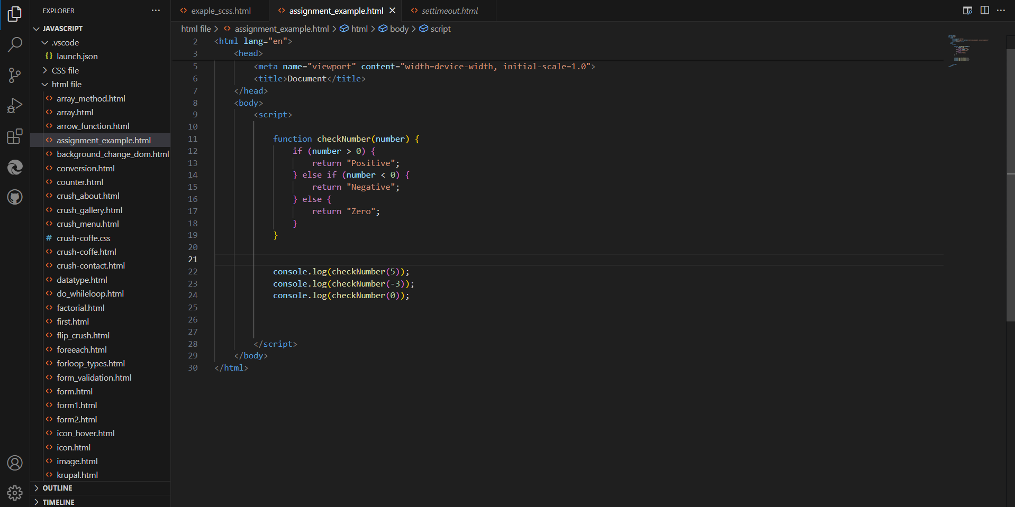

**Q.23 Find the Character Is Vowel or Not** ?

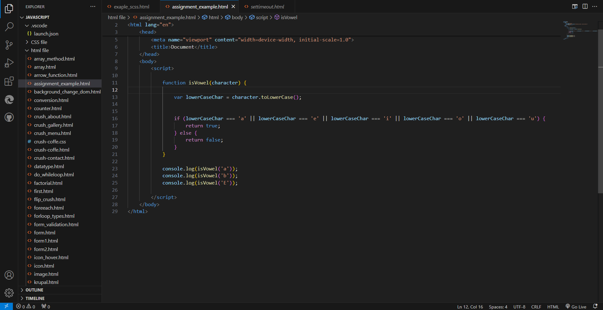

**Q.24 Write to check whether a number is negative, positive or zero?**

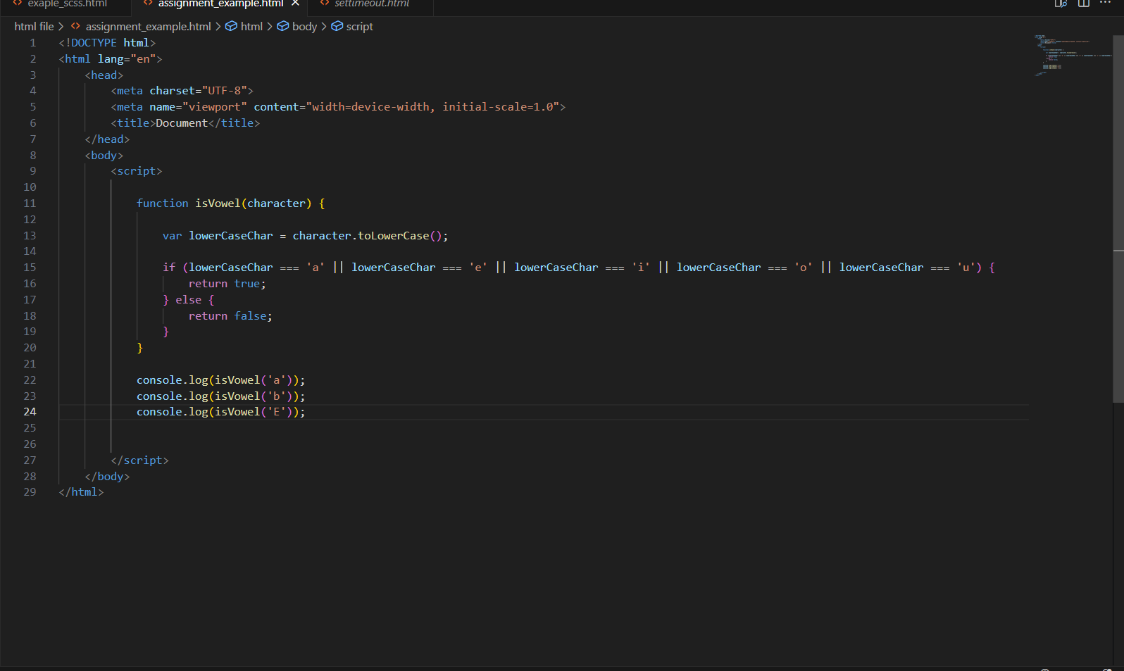

**Q.25 Write to find number is even or odd using ternary operator in JS?**

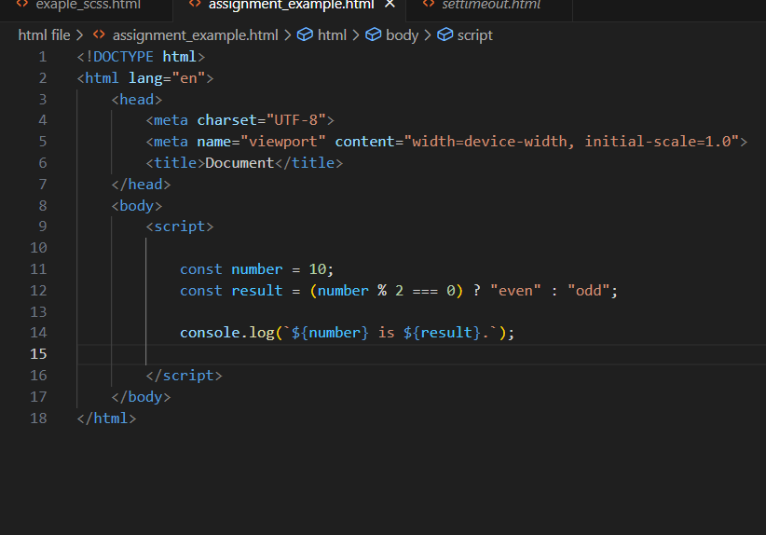

**Q.26 Write find maximum number among 3 numbers using ternary operator in JS?**

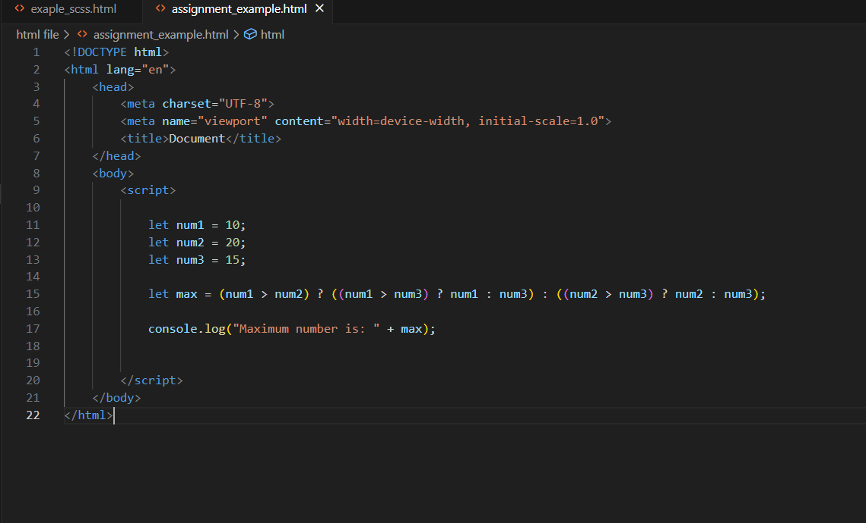

**Q.27 Write to find minimum number among 3 numbers using ternary operator in JS?**

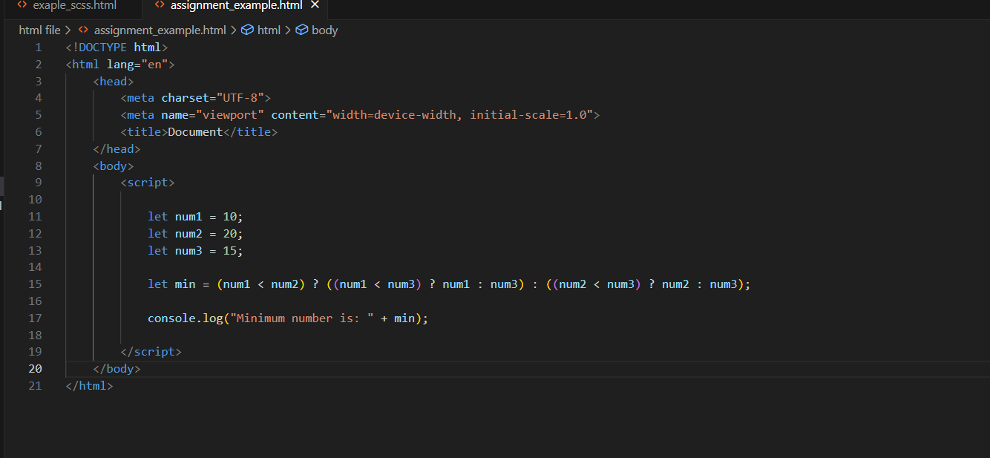

**Q.28 Write to find the largest of three numbers in JS?**

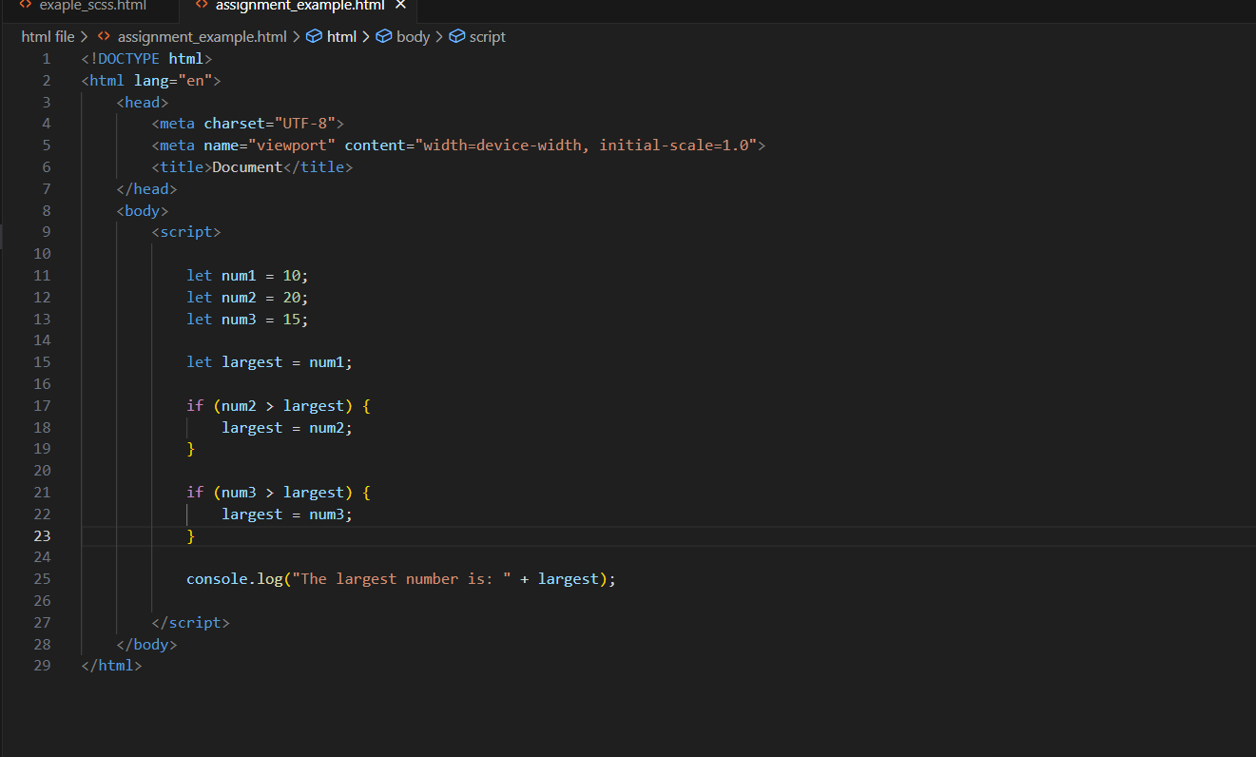

**Q.29 Write to show**

**i. Monday to Sunday using switch case in JS?**

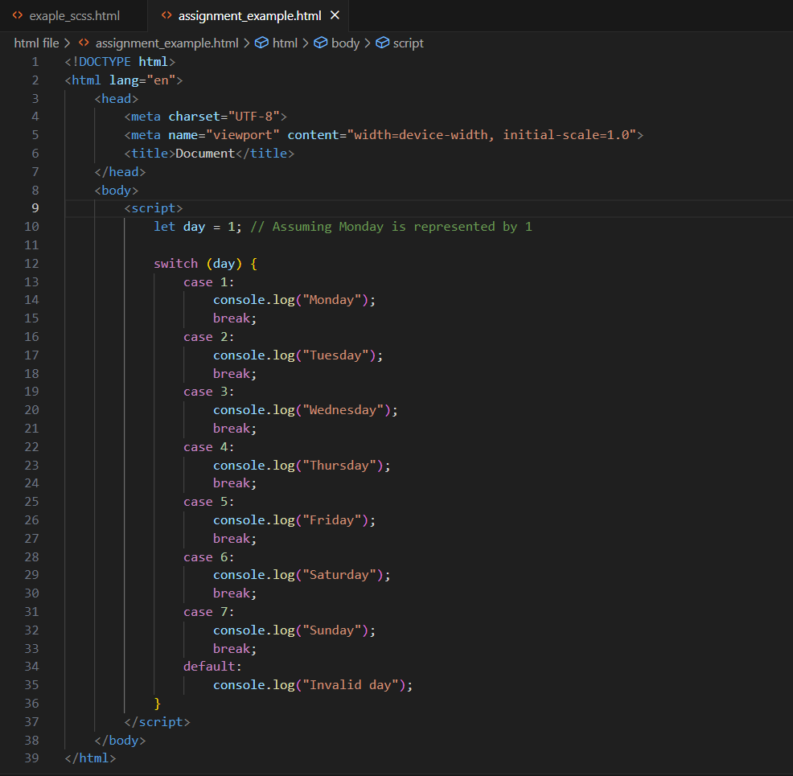

**ii. Vowel or Consonant using switch case in JS?**

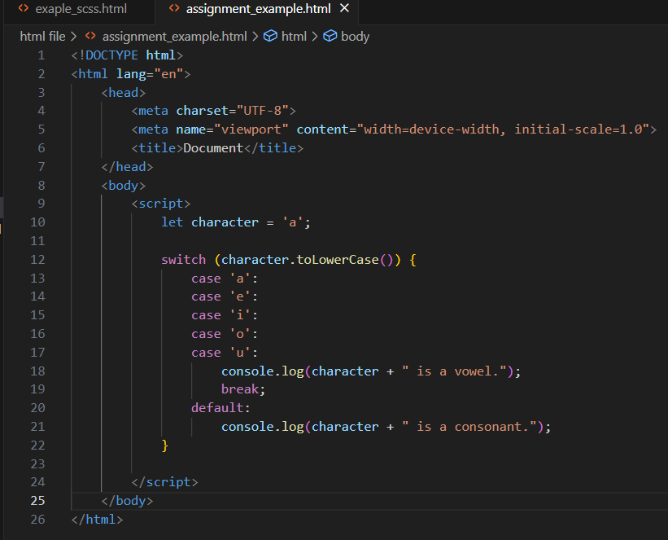

**(Conditional looping logic Question)**

**Q.30 What are the looping structures in JavaScript? Any one Example?**

JavaScript Loops are powerful tools for performing repetitive tasks efficiently. Loops in JavaScript execute a block of code again and again while the condition is true.

for (let i = 0; i < 5; i++) {

console.log(i);

}

**Q.31 Write a print 972 to 897 using for loop in JS?**

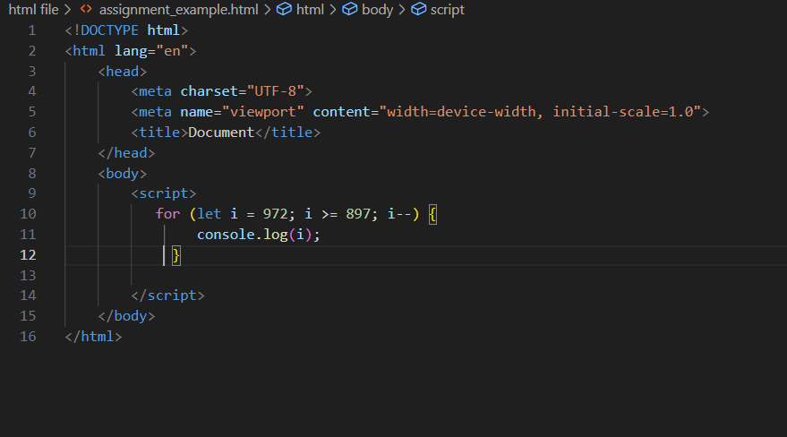

**Q.32 Write to print factorial of given number?**

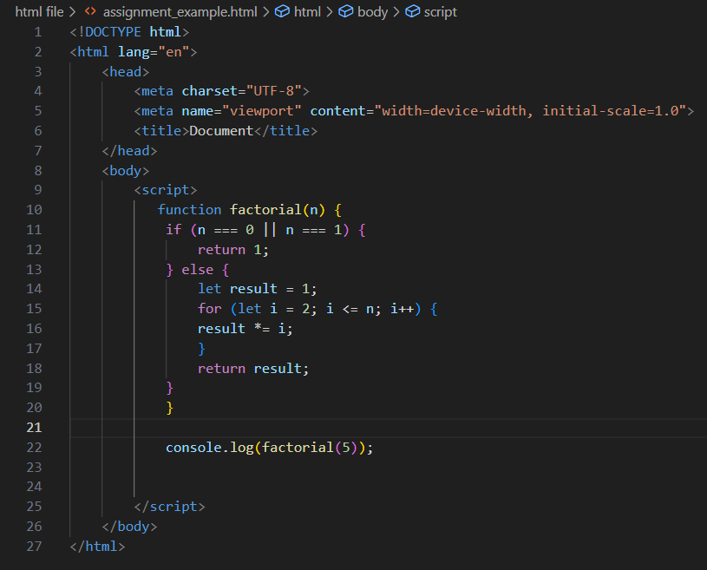

**Q.33 Write to print Fibonacci series up to given numbers?**

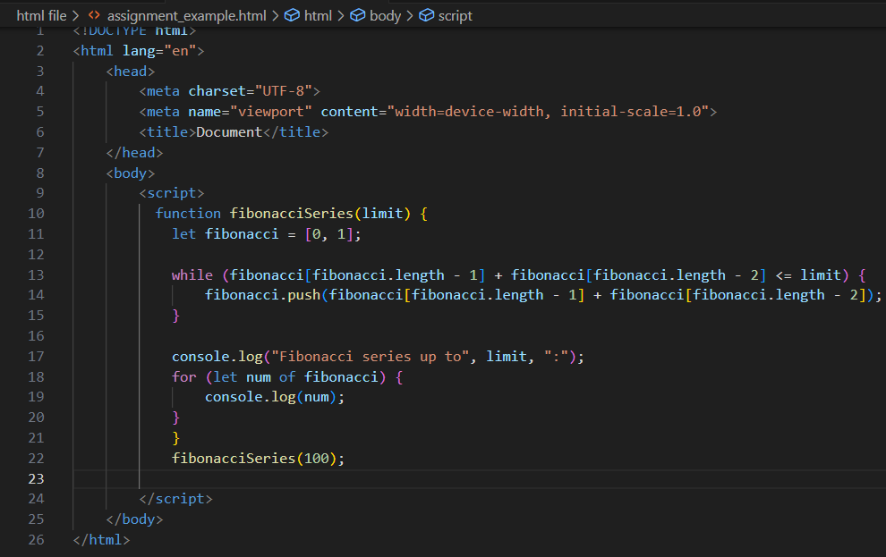

**Q.34 Write to print number in reverse order e.g.: number = 64728 ---> reverse =82746 in JS? Q.35 Write a program make a summation of given number (E.g., 1523 Ans: - 11) in JS?**

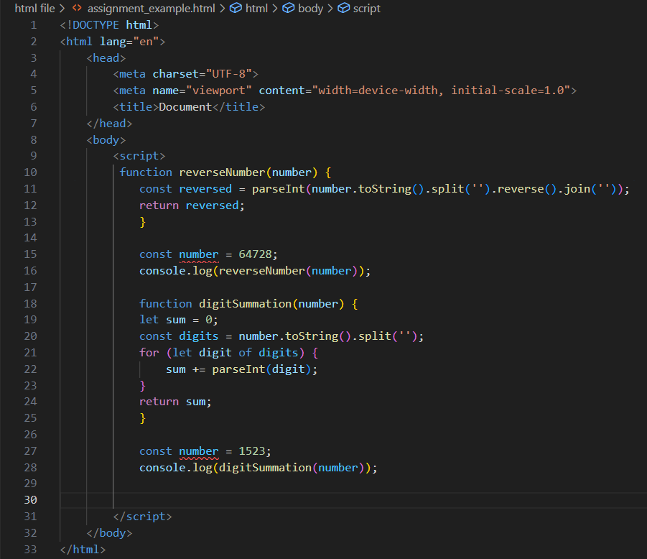

**Q.36 Write a program you have to make a summation of first and last Digit. (E.g., 1234 Ans: -5) in JS?**

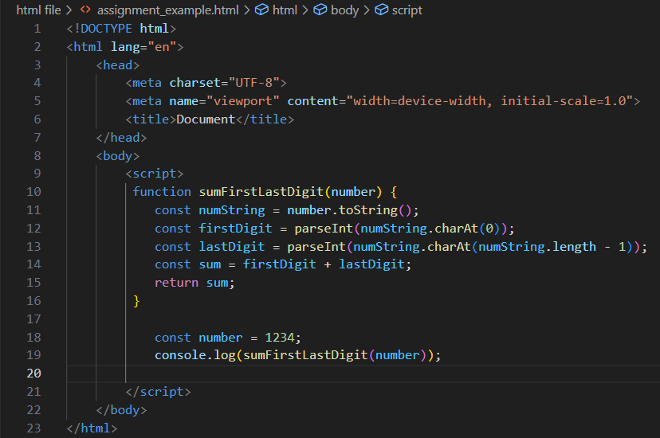

**Q.37 Use console.log() and escape characters to print the following pattern in JS?**

1 1 1 1 1

2 1 2 4 8

3 1 3 9 27

4 1 4 16 64

5 1 5 25 125

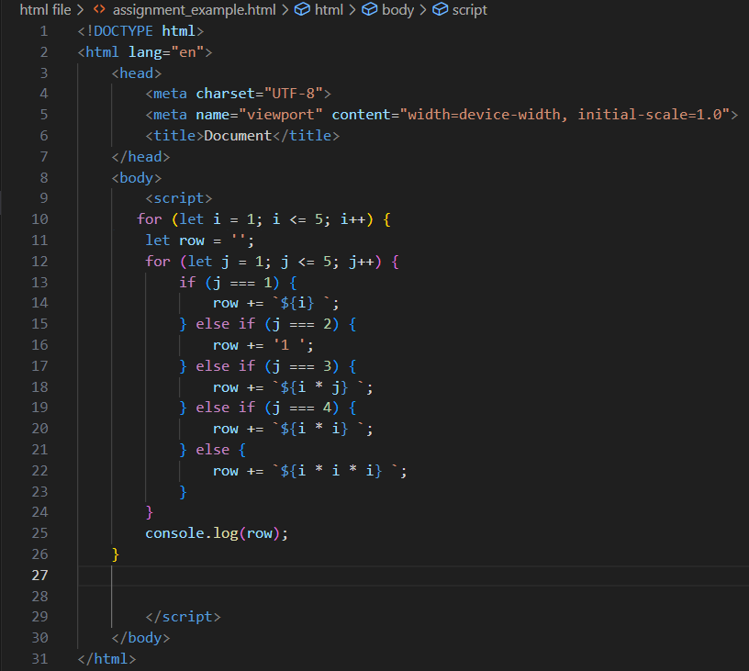

**Q.38 Use pattern in console.log in JS?**

1) 1

1 0

1 0 1

1 0 1 0

1 0 1 0 1

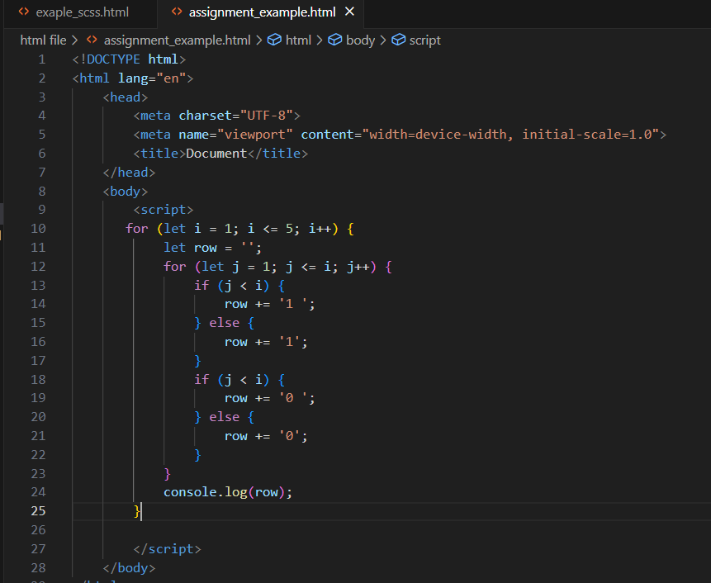

2) A

B C

D E F

G H I J

K L M N O

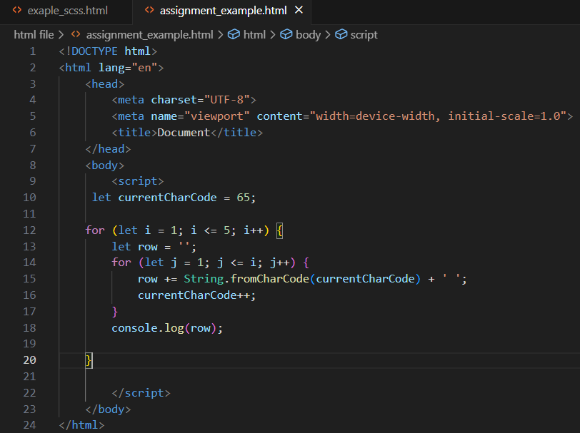

3) 1

2 3

4 5 6

7 8 9 10

11 12 13 14 15

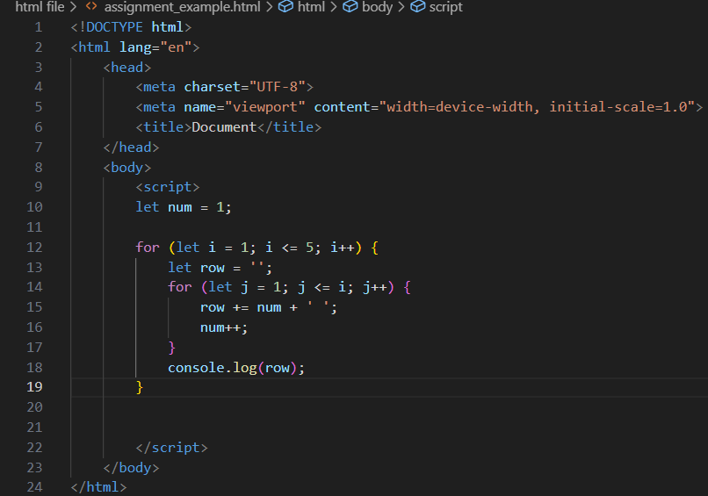

4) *

* *

* * *

* * * *

* * * * *

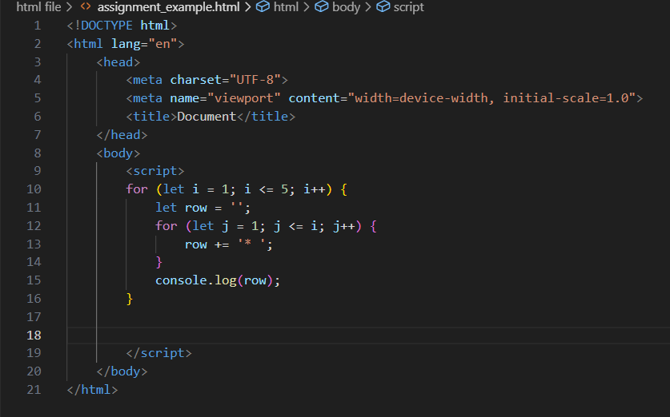

**Q.39 Accept 3 numbers from user using while loop and check each numbers palindrome?**

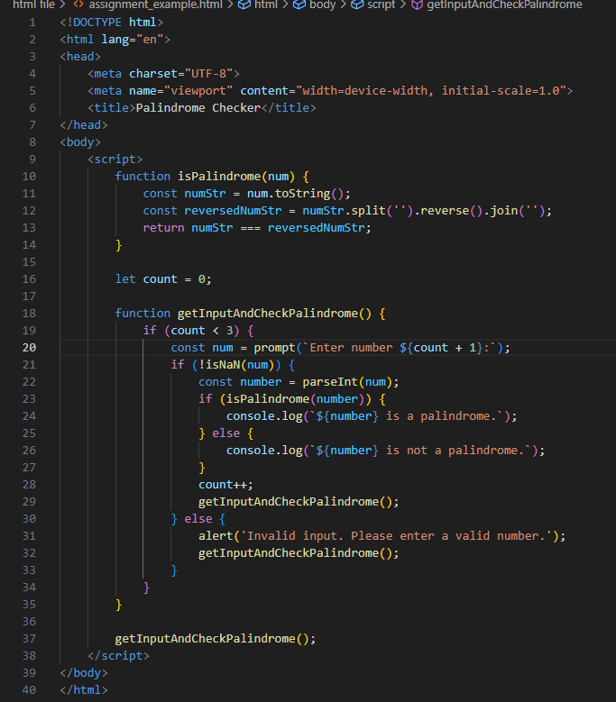

**(Array and object Question)**

**Q.40 Write a JavaScript Program to display the current day and time in the following format. Sample Output: Today is Friday. Current Time is 12 PM: 12 : 22 2 ?**

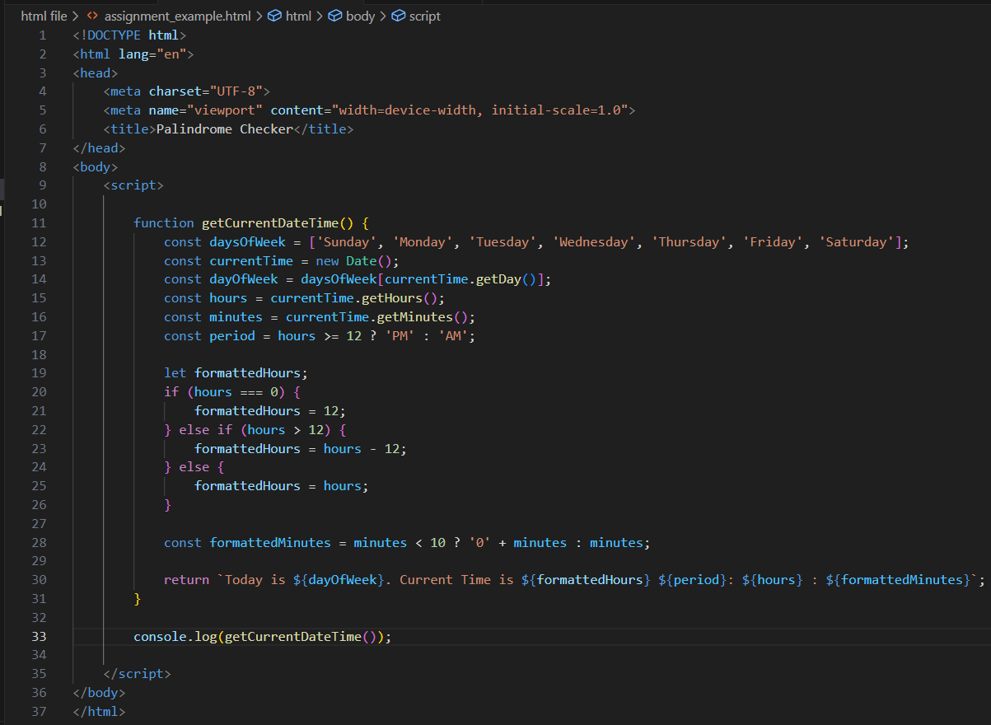

**Q.41 Write a JavaScript program to get the current date?**

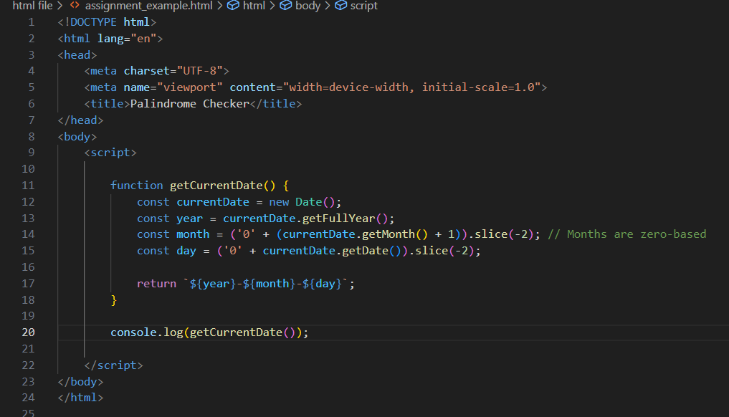

**Q.42 Write a JavaScript program to compare two objects?**

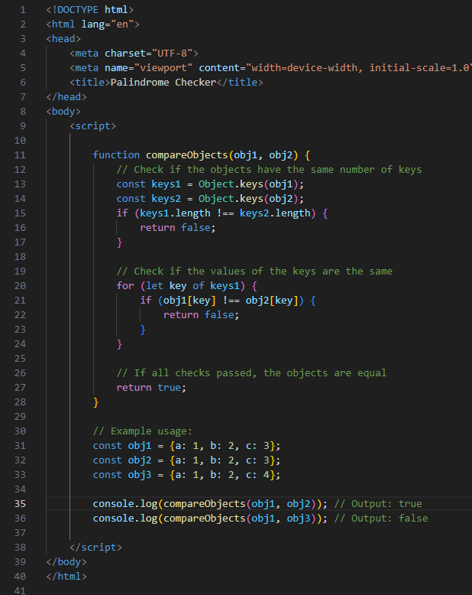

**Q.43 Write a JavaScript program to convert an array of objects into CSV string?**

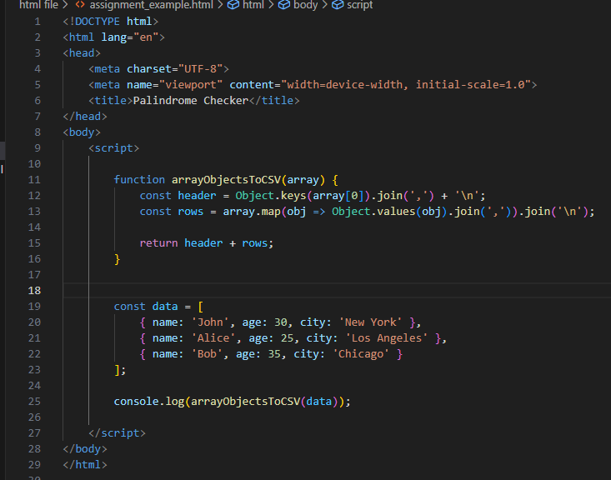

**Q.44 Write a JavaScript program to capitalize first letter of a string?**

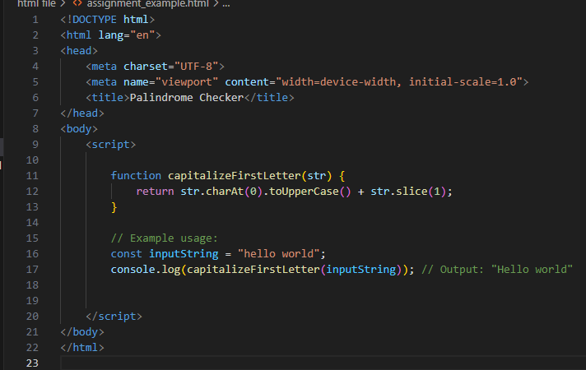

**Q. 45 Write a JavaScript program to determine if a variable is array?**

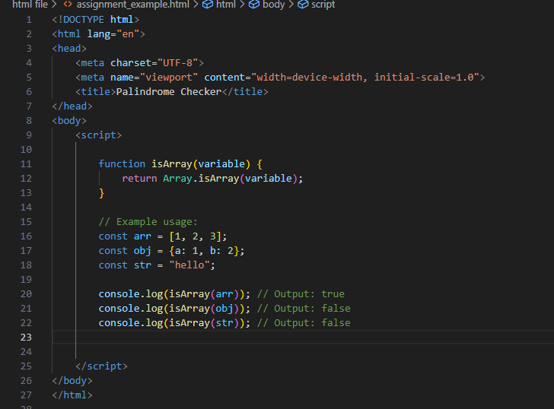

**Q.46 Write a JavaScript program to clone an array?**

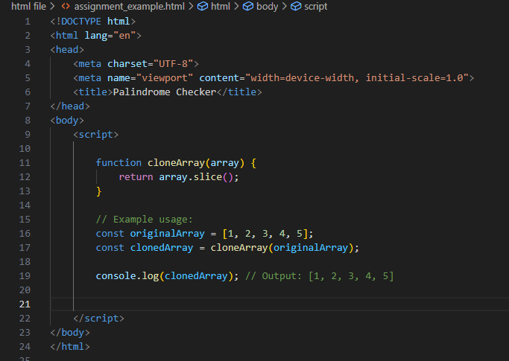

**Q.47 What is the drawback of declaring methods directly in JavaScript objects?**

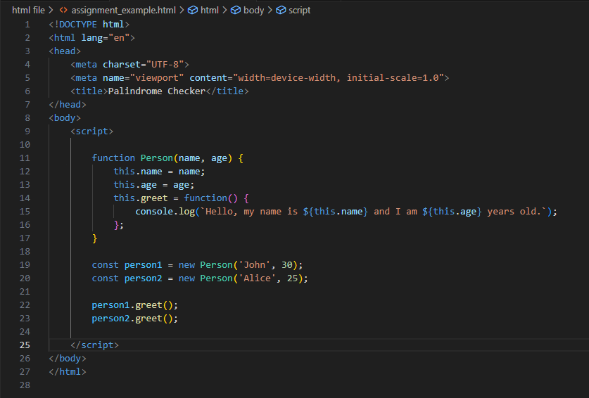

**Q.48 Print the length of the string on the browser console using console.log()?**

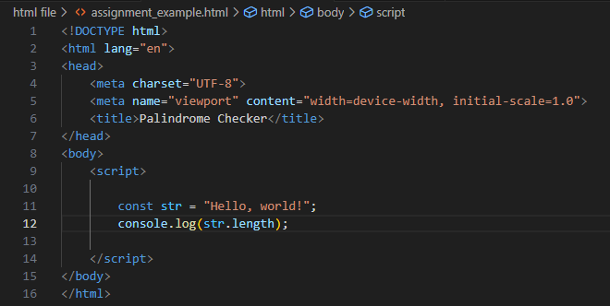

**Q.49 Change all the string characters to capital letters using toUpperCase() method?**

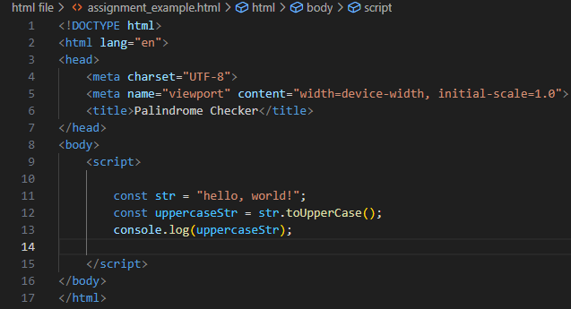

**Q.50 What is the drawback of declaring methods directly in JavaScript objects?**

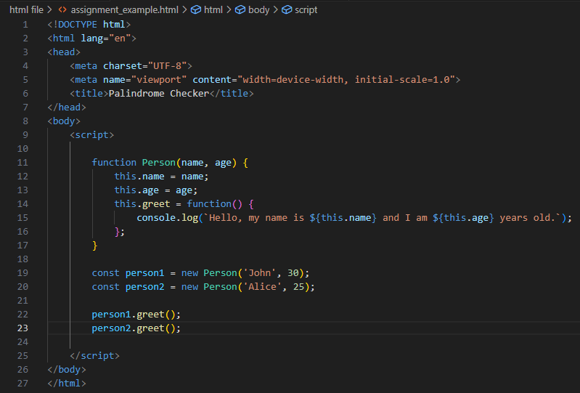

**Q.51 Write a JavaScript program to get the current date. Expected Output : mm-dd-yyyy, mm/dd/yyyy or dd-mm-yyyy, dd/mm/yyyy?**

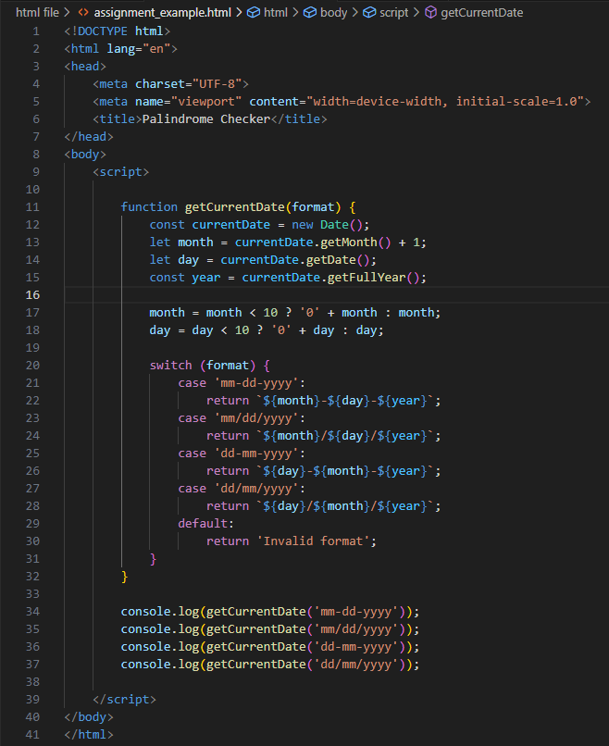

**Q.52 Use indexOf to determine the position of the first occurrence of a in 30 Days Of JavaScript?**

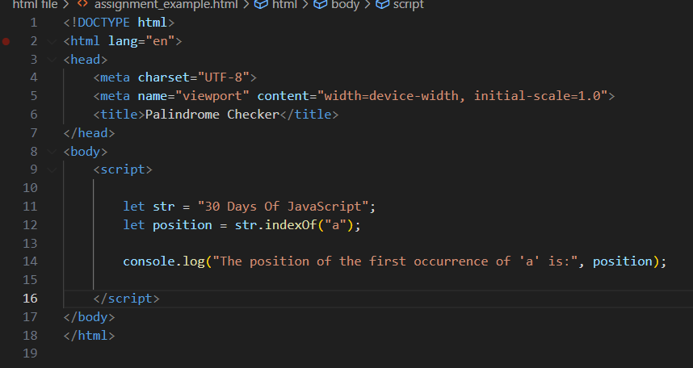

**Q,53 Use lastIndexOf to determine the position of the last occurrence of a in 30 Days Of JavaScript?**

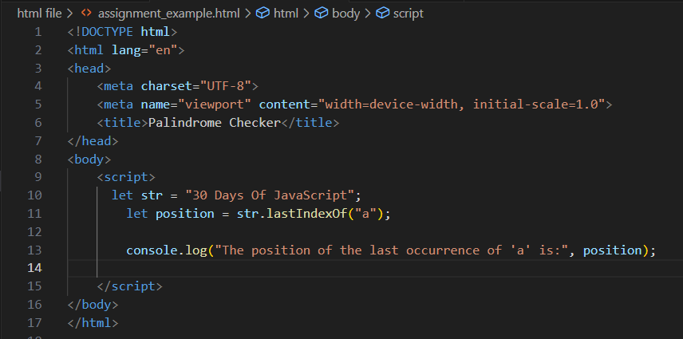

**Q.54 Form Validtion in JS?**

Form validation in JavaScript ensures that user input in a web form meets certain criteria before it's submitted to the server. This helps to ensure data integrity and accuracy

**Q.55 Form in Email, number, Password, Validation?**

**Q.56 Dynamic Form Validation in JS?**

Dynamic form validation involves validating form inputs as users interact with them, providing real-time feedback on whether the input is valid or not. This is commonly done using event listeners to detect changes in the input fields and then performing validation checks accordingly

**Q.57 how many type of JS Event? How to use it ?**

JavaScript events are actions that occur as a result of user interactions or system events, such as mouse clicks, keyboard inputs, or page loading.

• **Mouse Events**: These events occur when a user interacts with the mouse.

* click: Occurs when the user clicks on an element.
* mouseover: Occurs when the mouse pointer moves over an element.
* mouseout: Occurs when the mouse pointer moves out of an element.

• **Keyboard Events**: These events occur when a user interacts with the keyboard.

* keydown: Occurs when a key is pressed down.
* keyup: Occurs when a key is released.
* keypress: Occurs when a key is pressed and released.

• **Form Events**: These events occur when a user interacts with a form element.

* submit: Occurs when a form is submitted.
* input: Occurs when the value of an input element changes.
* focus: Occurs when an element gets focus.
* blur: Occurs when an element loses focus.

• **Window Events**: These events occur when the window or document is loaded, resized, or scrolled.

* load: Occurs when the window or document is fully loaded.
* resize: Occurs when the window is resized.
* scroll: Occurs when the document is scrolled.

• **Touch Events**: These events occur when a user interacts with a touchscreen device.

* touchstart: Occurs when a finger touches the screen.
* touchend: Occurs when a finger is lifted off the screen.
* touchmove: Occurs when a finger moves on the screen.

**Q.59 What is Bom vs Dom in JS?**

In JavaScript, "BOM" and "DOM" stand for "Browser Object Model" and "Document Object Model" respectively.

1. **BOM (Browser Object Model)**: BOM represents the various objects provided by the web browser environment, which are not part of the JavaScript language itself but are instead provided by the browser to interact with the browser window. This includes objects like window, navigator, history, screen, and location. BOM allows JavaScript to interact with the browser window and its components.
2. **DOM (Document Object Model)**: DOM represents the structured representation of the HTML document. It provides a way for JavaScript to interact with the elements of an HTML document dynamically. The DOM represents the document as a tree structure where each node represents a part of the document (like elements, attributes, and text). JavaScript can manipulate the DOM to change the structure, content, and style of the HTML document dynamically.

**Q.60 Array vs object defences in JS?**

• **Arrays**:

* Arrays are ordered collections of values, indexed by integers.
* They are typically used when you have a collection of similar items, such as a list of names or numbers.
* Arrays are mutable, meaning you can change their contents after creation.
* Defensive programming with arrays often involves checking array bounds to prevent accessing elements outside of the array's length, which can cause errors or unexpected behavior. For example, you might check the length of an array before accessing an index to avoid an "index out of bounds" error.

• **Objects**:

* Objects are collections of key-value pairs, where keys are strings (or symbols) and values can be any data type.
* They are often used to represent structured data, such as user profiles or configuration settings.
* Objects are mutable, and you can add, update, or delete properties dynamically.
* Defensive programming with objects often involves checking for the existence of properties before accessing them to avoid errors such as "undefined is not a function" or "cannot read property 'x' of undefined". You might use techniques like optional chaining (obj?.prop) or the in operator ('prop' in obj) to perform these checks.

**Q.61 Split the string into an array using split() Method?**

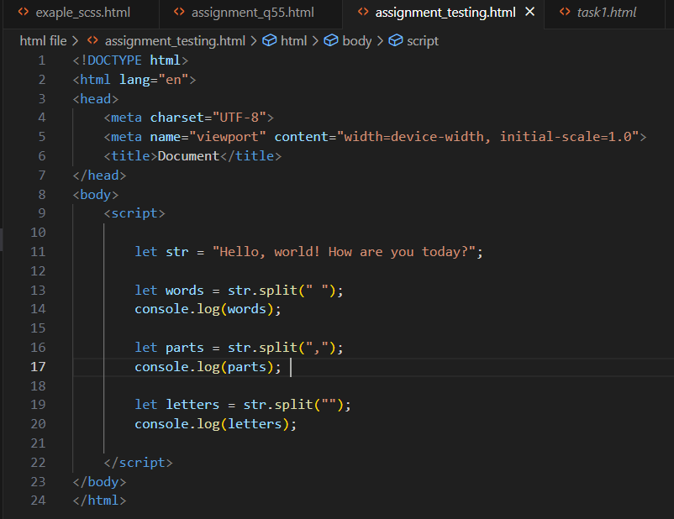

**Q.62 Check if the string contains a word Script using includes() method?**

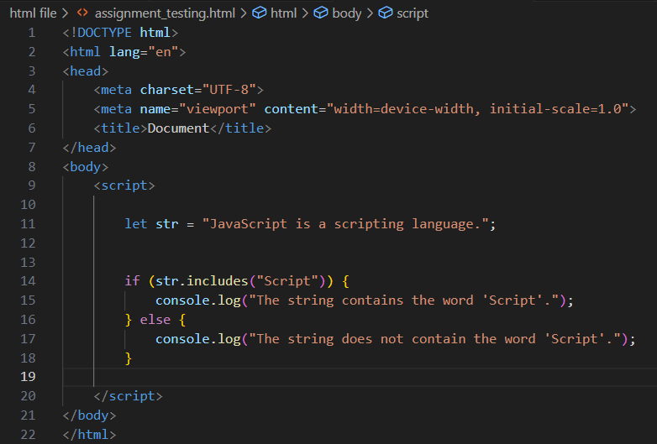

**Q.63 Change all the string characters to lowercase letters using toLowerCase() Method.**

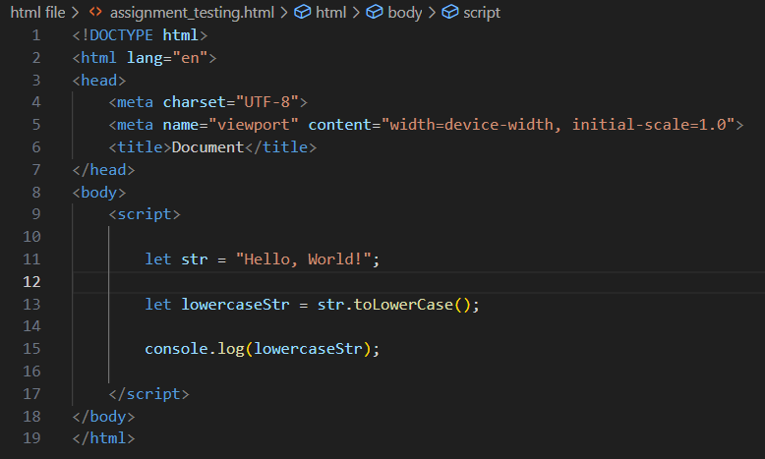

**Q.64 What is Character at index 15 in ’30 Days of JavaScript’ string? Use charAt() method. Q.65 copy to one string to another string in JS?**

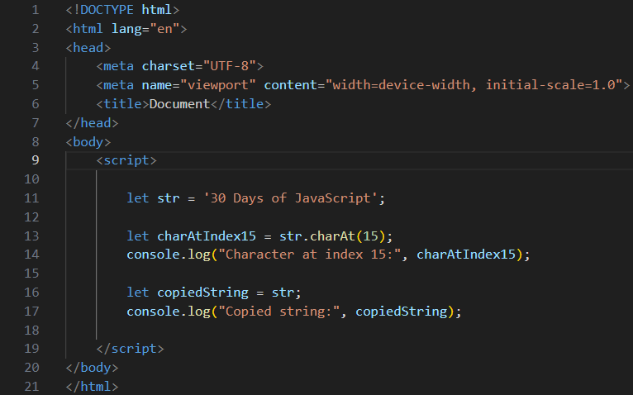

**Q.65 copy to one string to another string in JS?**

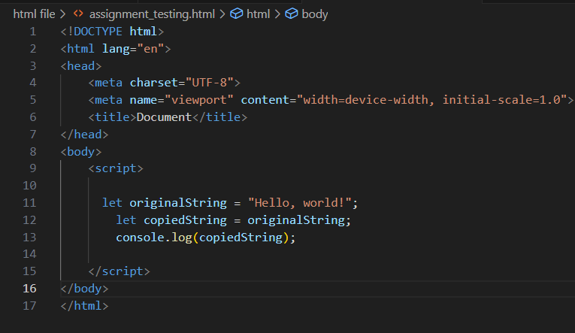

**Q.66 Find the length of a string without using libraryFunction?**

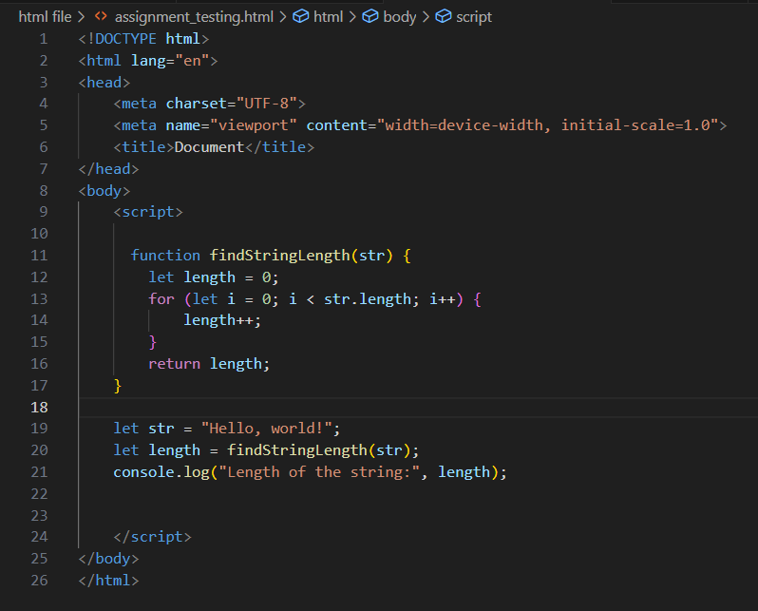

What is JavaScript?

JavaScript is a high-level, interpreted programming language primarily used for client-side web development. It was originally created by Brendan Eich at Netscape Communications Corporation in 1995. JavaScript allows developers to add interactivity and dynamic behavior to web pages.

**• What is the use of isNaN function?**

The isNaN() function in JavaScript is used to determine whether a value is NaN (Not-a-Number) or not. NaN is a special value in JavaScript that represents an invalid number

**• What is negative Infinity?**

Negative Infinity, represented in JavaScript as -Infinity, is a special value that represents the mathematical concept of negative infinity. It is used to denote a number that is smaller than any other negative number, as well as smaller than any positive number, including zero.

**• Which company developed JavaScript?**

JavaScript was developed by Netscape Communications Corporation. It was originally created by Brendan Eich in 1995 while he was working at Netscape. JavaScript was initially named "Mocha" and later "LiveScript" before being renamed to "JavaScript" to capitalize on the popularity of Java at the time.

**• What are undeclared and undefined variables?**

**Undeclared Variables**:

* Undeclared variables are variables that have not been declared using the var , let and const keywords before being used.
* When you try to access an undeclared variable, JavaScript will either create an implicit global variable (if not in strict mode) or throw a referenceError (if in strict mode).

**Undefined Variables**:

* Undefined variables are variables that have been declared but have not been assigned a value.
* When you try to access an undefined variable, its value will be undefined.

**• Write the code for adding new elements dynamically?**

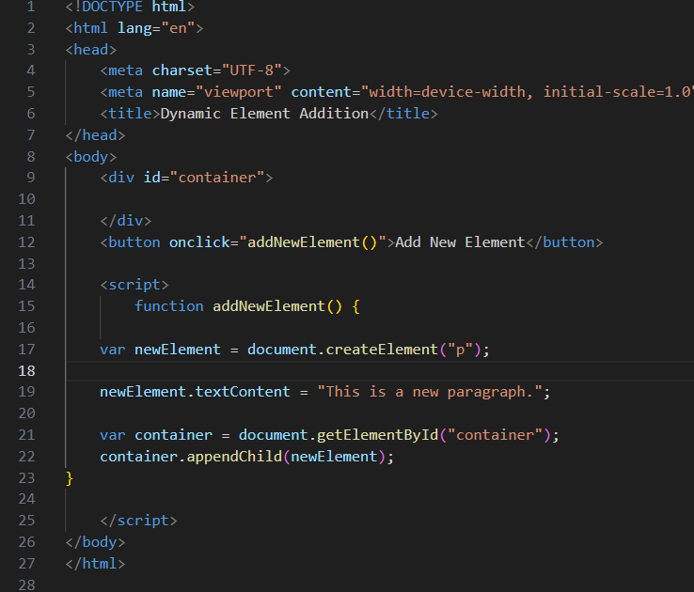

**• What is the difference between ViewState and SessionState?**

**ViewState**:

* ViewState is used to persist the state of a specific web page across postbacks.
* It stores the values of controls and other page-specific data in a hidden field within the page itself.
* ViewState is primarily used to maintain the state of controls (such as textboxes, checkboxes, etc.) between postbacks, allowing their values to be retained even after the page is submitted to the server and re-rendered.
* ViewState is scoped to the page level, meaning it is specific to a particular page and its contents.

**SessionState**:

* SessionState is used to persist data across multiple requests within a user session.
* It stores session-specific data on the server and associates it with a unique session identifier (usually stored as a cookie or in the URL).
* SessionState is typically used to store user-specific information that needs to be maintained throughout the user's interaction with the application, such as user preferences, shopping cart items, or authentication tokens.
* SessionState is scoped to the user session, meaning the stored data is accessible across multiple pages within the same session.

**• What is === operator?**

The === operator, also known as the strict equality operator, is a comparison operator in JavaScript. It is used to compare two values for equality without performing type conversion.

**• How can the style/class of an element be changed?**

**Changing Style Directly**: You can directly modify the style property of the element to change its inline CSS styles.

**Adding/Removing/Replacing Classes**: You can manipulate the class attribute of the element to add, remove, or replace CSS classes.

**Toggle Class**: You can toggle a class on an element, meaning if the class is present, it will be removed, and if it's not present, it will be added.

**Setting Class Attribute**: You can also set the entire class attribute of an element.

**• How to read and write a file using JavaScript?**

JavaScript doesn't have direct access to the file system for security reasons. However, if you're working in a Node.js environment or using a browser with support for the File API (such as Chrome or Firefox), you can read and write files using JavaScript

**• What are all the looping structures in JavaScript?**

JavaScript provides several looping structures to iterate over collections of data or execute a block of code repeatedly

**for Loop**: The for loop is used to iterate over a block of code a specified number of times.

**while Loop**: The while loop is used to execute a block of code as long as a specified condition is true.

**do...while Loop**: The do...while loop is similar to the while loop, but the code block is executed at least once, even if the condition is false.

**for...in Loop**: The for...in loop iterates over the enumerable properties of an object.

The for...of loop is used to iterate over iterable objects (arrays, strings, maps, sets, etc.).

**forEach() Method**: The forEach() method is available for arrays and is used to execute a provided function once for each array element.

**• How can you convert the string of any base to an integer in JavaScript?**

In JavaScript, you can convert a string representing a number in any base to an integer using the parseInt() function. The parseInt() function takes two arguments: the string to parse and the base of the number system (optional). If the base is not specified, parseInt() assumes base 10.

**• What is the function of the delete operator?**

n JavaScript, the delete operator is used to delete properties from objects. It can also be used to delete elements from arrays (though it's not recommended for that purpose, as it can leave "holes" in the array).

**• What are all the types of Pop up boxes available in JavaScript?**

**Alert Box**: The alert() method displays an alert dialog box with a specified message and an OK button. It is used to provide information to the user.

**Confirm Box**: The confirm() method displays a dialog box with a message and two buttons: OK and Cancel. It is used to confirm or cancel an action, and it returns true if the user clicks OK and false if the user clicks Cancel.

**Prompt Box**: The prompt() method displays a dialog box with a message, an input field for the user to enter text, and two buttons: OK and Cancel. It is used to prompt the user to input some data, and it returns the text entered by the user or null if the user clicks Cancel.

**• What is the use of Void (0)?**

The void operator in JavaScript evaluates an expression and then returns undefined. The most common usage of void is with the value void(0).

The use of void(0) is often seen in HTML anchor (<a>) tags to prevent the browser from navigating to a new page when the link is clicked. Instead, it ensures that the browser stays on the current page without any action.

1. How can a page be forced to load another page in JavaScript?
2. What are the disadvantages of using innerHTML in JavaScript?
3. Create password field with show hide functionalities