**MODULE: 4**

**Introduction to DBMS**

* **Introduction to SQL**

1. **Lab 1: Create a new database named school_db and a table called students with the following columns: student_id, student_name, age, class, and address.**

* create database school_db;

use school_db;

create table students(student_id int primary key auto_increment,

student_name varchar(50),

age int,

class varchar(20),

address varchar(100) );



1. **Lab 2: Insert five records into the students table and retrieve all records using the SELECT statement.**

* INSERT INTO students (student_name, age, class, address) VALUES

('Aarav Mehta', 14, '9A', 'Ahmedabad'),

('Simran Kaur', 13, '8B', 'Chandigarh'),

('Rohan Desai', 15, '10C', 'Mumbai'),

('Anjali Sharma', 12, '7A', 'Delhi'),

('Karan Verma', 14, '9B', 'Jaipur');

SELECT * FROM students;

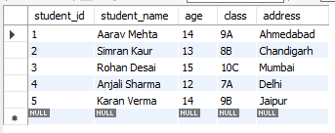

* **SQL Syntax**

1. **Lab 1: Write SQL queries to retrieve specific columns (student_name and age) from the students table.**

* select student_name, age from students;

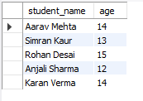

1. **Lab 2: Write SQL queries to retrieve all students whose age is greater than 13.**

* select * from students where age > 13;

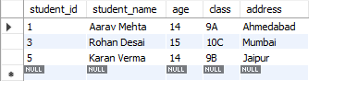

* **SQL Constraints**

1. **Lab 1: Create a table teachers with the following columns: teacher_id (Primary Key), teacher_name (NOT NULL), subject (NOT NULL), and email (UNIQUE).**

* create table teachers(teacher_id int primary key auto_increment,

teacher_name varchar(50) not null,

subject varchar(50) not null,

email varchar(100) unique

);

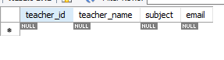

1. **Lab 2: Implement a FOREIGN KEY constraint to relate the teacher_id from the teachers table with the students table.**

* ALTER TABLE students ADD teacher_id INT;

ALTER TABLE students

ADD CONSTRAINT fk_teacher

FOREIGN KEY (teacher_id)

REFERENCES teachers(teacher_id);

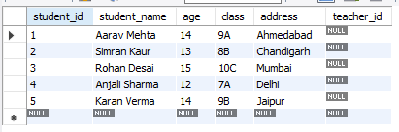

* **Main SQL Commands and Sub-commands (DDL)**

1. **Lab 1: Create a table courses with columns: course_id, course_name, and course_credits. Set the course_id as the primary key.**

* create table courses(course_id int primary key,

course_name varchar(50),

course_credits int

);

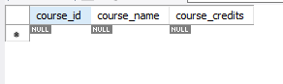

1. **Lab 2: Use the CREATE command to create a database university_db.**

* create database university_db;

use university_db;

* **ALTER Command**

1. **Lab 1: Modify the courses table by adding a column course_duration using the ALTER command.**

* alter table courses add course_duration varchar(50);

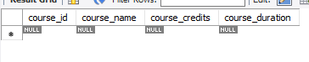

1. **Lab 2: Drop the course_credits column from the courses table.**

* alter table courses drop column course_credits;



* **DROP Command**

1. **Lab 1: Drop the teachers table from the school_db database.**

* drop table teachers;



1. **Lab 2: Drop the students table from the school_db database and verify that the table has been removed.**

* drop table students;

show tables;

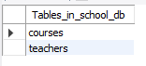

* **Data Manipulation Language (DML)**

1. **Lab 1: Insert three records into the courses table using the INSERT command.**

* insert into courses (course_id, course_name, course_duration) values

(101, 'Mathematics', '3 Months'),

(102, 'Physics', '4 Months'),

(103, 'Computer Science', '6 Months');

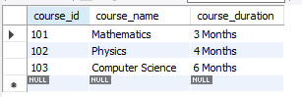

1. **Lab 2: Update the course duration of a specific course using the UPDATE command.**

* update courses set course_duration = '5 Month' where course_id = 102;

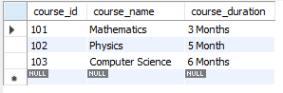

1. **Lab 3: Delete a course with a specific course_id from the courses table using the DELETE command.**

* delete from courses where course_id = 101;

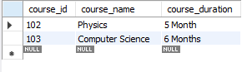

* **Data Query Language (DQL)**

1. **Lab 1: Retrieve all courses from the courses table using the SELECT statement.**

* select * from courses;

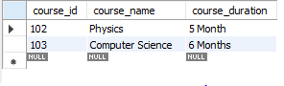

1. **Lab 2: Sort the courses based on course_duration in descending order using ORDER BY.**

* select * from courses order by course_duration desc;

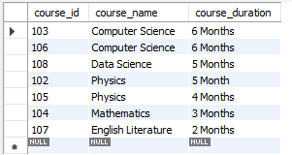

1. **Lab 3: Limit the results of the SELECT query to show only the top two courses using LIMIT.**

* select * from courses limit 2;

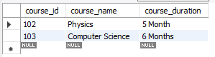

* **Data Control Language (DCL)**

1. **Lab 1: Create two new users user1 and user2 and grant user1 permission to SELECT from the courses table.**
2. **Lab 2: Revoke the INSERT permission from user1 and give it to user2.**

* **Transaction Control Language (TCL)**

1. **Lab 1: Insert a few rows into the courses table and use COMMIT to save the changes.**

* start transaction;

Insert into courses (course_id, course_name, course_duration) values

(109, 'Biology', '4 Months'), (110, 'Economics', '3 Months');

commit;

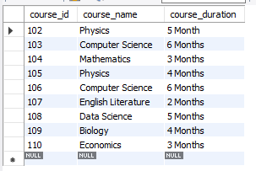

1. **Lab 2: Insert additional rows, then use ROLLBACK to undo the last insert operation.**

* start transaction;

Insert into courses (course_id, course_name, course_duration) values

(11, 'Geography', '3 Months'),

(12, 'Artificial Intelligence', '6 Months');

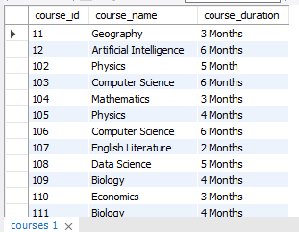

rollback;

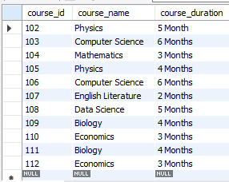

1. **Lab 3: Create a SAVEPOINT before updating the courses table, and use it to roll back specific changes.**

* start transaction;

insert into courses (course_id, course_name, course_duration)

values (10, 'History', '4 Months');

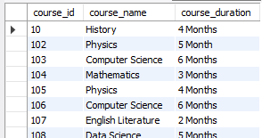

savepoint abc;

update courses set course_duration = '10 Months' where course_id = 10;

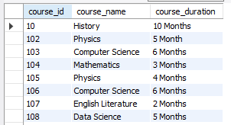

rollback to abc;

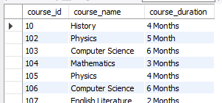

commit;

* **SQL Joins:**

1. **Lab 1: Create two tables: departments and employees. Perform an INNER JOIN to display employees along with their respective departments.**

* create table departments(dept_id int primary key, dept_name varchar(50) );

insert into departments (dept_id, dept_name) values

(1, 'HR'), (2, 'IT'), (3, 'Finance');

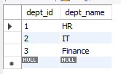

create table employees(emp_id int primary key, emp_name varchar(50), dept_id int,

foreign key (dept_id) references departments(dept_id) );

insert into employees (emp_id, emp_name, dept_id) values

(101, 'Alice', 1), (102, 'Bob', 2), (103, 'Charlie', 2), (104, 'David', 3);

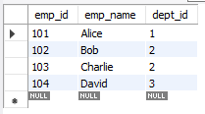

select employees.emp_id, employees.emp_name, departments.dept_name

from employees inner join departments on employees.dept_id = departments.dept_id;

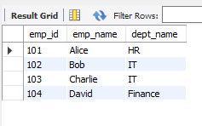

1. **Lab 2: Use a LEFT JOIN to show all departments, even those without employees.**

* select e.emp_id, e.emp_name, d.dept_name from

employees e join departments d

on e.dept_id = d.dept_id;

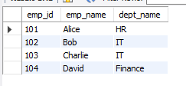

* **SQL Group By**

1. **Lab 1: Group employees by department and count the number of employees in each department using GROUP BY.**

* select departments.dept_name,

count(employees.emp_id) AS employees_cout

from employees

inner join departments on employees.dept_id = departments.dept_id

group by departments.dept_name;

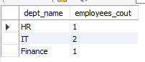

1. **Lab 2: Use the AVG aggregate function to find the average salary of employees in each department.**

* alter table employees add emp_salary decimal(10, 2);

update employees set emp_salary = 50000 where emp_id = 101;

update employees set emp_salary = 45000 where emp_id = 102;

update employees set emp_salary = 60000 where emp_id = 103;

update employees set emp_salary = 58000 where emp_id = 104;

select departments.dept_name,

avg(employees.emp_salary) AS average_salary

from employees

inner join departments on employees.dept_id = departments.dept_id

group by departments.dept_name;

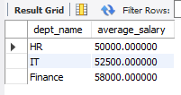

* **SQL Stored Procedure**

1. **Lab 1: Write a stored procedure to retrieve all employees from the employees table based on department.**

* CREATE DEFINER=`root`@`localhost` PROCEDURE `GetemployeesBydepartment`(In deptName varchar(100))

BEGIN

select emp_id, emp_name, emp_salary

from employees

inner join departments on employees.dept_id = departments.dept_id

where departments.dept_name = deptName;

END

CALL GetEmployeesByDepartment('HR');

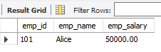

1. **Lab 2: Write a stored procedure that accepts course_id as input and returns the course details.**

* CREATE DEFINER=`root`@`localhost` PROCEDURE `GetCoursesDetails`(In input_course_id INT)

BEGIN

select course_id, course_name, course_duration

from courses

where course_id = input_course_id;

END

call GetCoursesDetails(10);

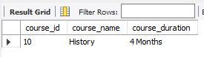

* **SQL View**

1. **Lab 1: Create a view to show all employees along with their department names.**

* select * from school_db.employeedepartmentview

where dept_name = ‘IT’;

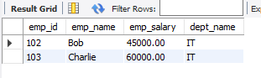

1. **Lab 2: Modify the view to exclude employees whose salaries are below $50,000.**

* select * from empdeptview;

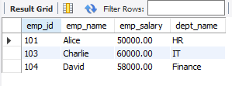

* **SQL Triggers**

1. **Lab 1: Create a trigger to automatically log changes to the employees table when a new employee is added.**

* delimiter //

create trigger after_employee_insert

after insert on employees

for each row

begin

insert into employees_log (emp_id, emp_name)

values (new.emp_id, new.emp_name);

end;

//

delimiter ;

insert into employees (emp_id, emp_name)

values (1, 'drashti modi');

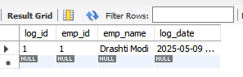

1. **Lab 2: Create a trigger to update the last_modified timestamp whenever an employee record is updated.**

* alter table employees

add last_modified timestamp default current_timestamp on update current_timestamp;

delimiter //

create trigger before_employee_update

before update on employees

for each row

begin

set new.last_modified = current_timestamp;

end;

//

delimiter ;

update employees

set emp_salary = emp_salary + 1000

where emp_id = 101;

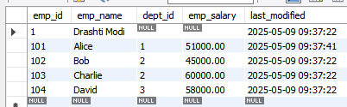

* **Rollback and Commit Savepoint**

1. **Lab 1: Perform a transaction where you create a savepoint, insert records, then rollback to the savepoint.**
2. **Lab 2: Commit part of a transaction after using a savepoint and then rollback the remaining changes.**