GREENCYCLE
System Architecture
GreenCycle is a Go service that recommends (and can autonomously schedule) the cleanest time window to run a household appliance, based on a carbon-intensity forecast. This document covers the deployment architecture, every component, and exactly how each one talks to the others.

1. Components
Nine moving parts, spanning two containers you don't control (external APIs, the webhook target) and four you do.
Component | Type | Responsibility
Client | External | curl / Postman / browser — issues HTTP requests to the app.
HTTP server | Go goroutine (app container) | chi router + handlers. Serves 10 REST endpoints: appliances CRUD, /calculate, /calculate/multi, /schedules.
Scheduler engine | Go goroutine (app container) | Polls Postgres every 15s for due jobs, claims them atomically, fires webhooks, records notifications.
Grid providers | In-process (mock) / external HTTPS (real) | Supply 24h carbon-intensity forecasts. Mock is synthetic; Electricity Maps and WattTime are real APIs, active only with credentials.
Postgres | Container, internal-only network | Persistent store: appliance, scheduled_run, notifications tables.
Redis | Container, internal-only network | Caches forecasts (TTL-based) to reduce provider calls and protect the rate-limit budget.
Adminer | Container, published on :8081 | Web-based DB browser for manually inspecting Postgres tables.
Webhook target | External, user-configured | Whatever URL is set in SCHEDULER_WEBHOOK_URL or per-schedule — receives the fire notification.

2. Deployment architecture
All services are defined in one docker-compose.yml and started with a single “docker compose up --build”. Only the app and Adminer publish ports to the host — Postgres and Redis are reachable solely inside the compose network, so nothing outside the stack can reach the database directly except through the app itself, or through Adminer for manual inspection.
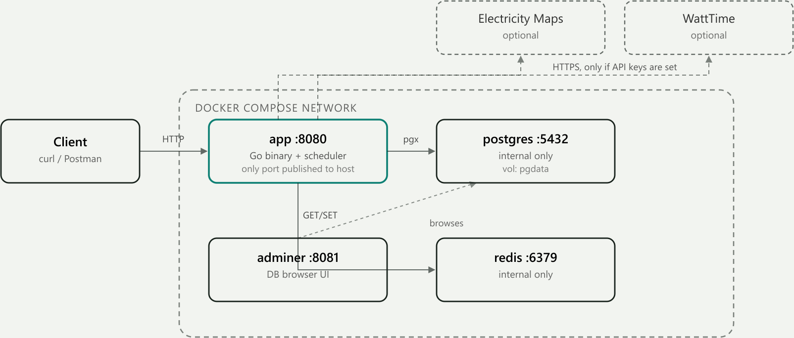
Figure 1 — Deployment view: containers, published ports, and the internal-only network boundary around Postgres and Redis.
Service | Image / build | Port published to host | Network
app | built from local Dockerfile (multi-stage, ~43MB final) | 8080 | compose network + host
postgres | postgres:16-alpine | none (internal only) | compose network only
redis | redis:7-alpine | none (internal only) | compose network only
adminer | adminer:4 | 8081 | compose network + host
Why Postgres and Redis have no host ports by default
So a Postgres or Redis instance already running on the developer's own machine can never collide with the containerized ones. Host ports for both are present in docker-compose.yml but commented out, ready to enable if direct external access is ever needed.

3. Component communication
Every pair of components that actually exchanges data, the protocol used, what's sent, and what causes the exchange.
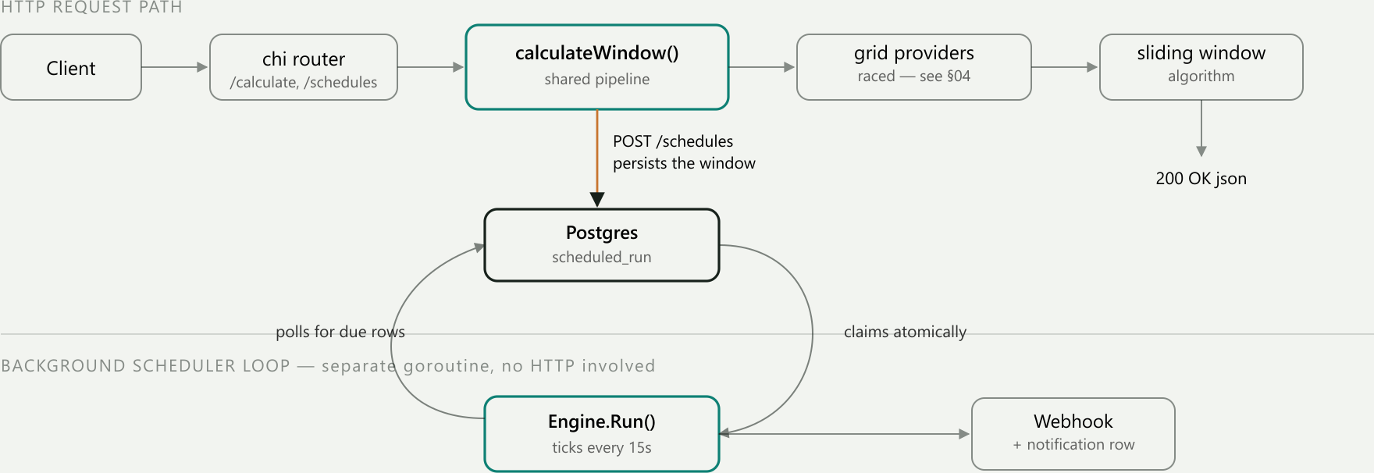
Figure 2 — Request-level view: the shared calculate pipeline (top) and the independent background scheduler loop (bottom), meeting only at Postgres.
From → To | Protocol | Data / payload | Triggered by
Client → HTTP server | HTTP/JSON, port 8080 | Query params or JSON body | Every API call
HTTP server → Postgres | SQL over TCP (pgx driver) | Appliance rows, scheduled_run rows | Every request needing data
HTTP server → Grid providers | In-process call (mock) or HTTPS (real) | Zip code in → 24 GridDataPoints out | Every /calculate and /calculate/multi call
HTTP server ↔ Redis | Redis wire protocol (RESP) | GET/SET forecast:{provider}:{zip} | Every grid-provider call
HTTP server → Client | HTTP/JSON response | OptimalWindow, ScheduledRun, or error body | Response to every request
Scheduler ↔ Postgres | SQL over TCP | SELECT due rows, atomic UPDATE…RETURNING claim, INSERT notifications | Every 15s tick + once on startup
Scheduler → Webhook target | HTTP POST/JSON | scheduledRunId, applianceName, zip, startTime, endTime, firedLate | The instant a claim succeeds
Electricity Maps / WattTime → HTTP server | HTTPS response | Provider-specific forecast JSON | Reply to outbound call, if credentials are set
Adminer → Postgres | SQL over TCP | Whatever query is run in its UI | Manual browsing

4. Key architectural notes
The HTTP server and the scheduler never call each other directly
They are two goroutines in the same process that only ever meet through Postgres. The HTTP server writes a scheduled_run row via POST /schedules; the scheduler discovers it later purely by polling the table. Neither holds a reference to the other. This is why the scheduler survives an app restart cleanly — it has no in-memory link to the request that created the job, only the database row.
Grid providers are reached through two layers of wrapping
The path is: HTTP server → RaceProviders (fans out to every configured provider concurrently) → each provider wrapped Cached(RateLimited(provider)). A cache hit short-circuits before the rate limiter or the network call ever run — so Redis is consulted on every request, but the real provider (Electricity Maps / WattTime) is only actually called on a genuine cache miss.
GreenCycle — Go rewrite. Repository: github.com/Drashya9/GreenCycle-Carbon-Aware-Scheduling-API

