MODULE TITLE: INFECTION PREVENTION AND CONTROL (IPC)

MODULE CODE: NMT 04101

NUMBER OF CREDITS: 15

SUBJECT CO-ODINATOR

MADAM – ZAKIA IDRISA

2021

MODULE TITLE: INFECTION PREVENTION AND CONTROL (IPC)

Session 1: Concepts of infection prevention and control in relation
to care of patients in hospital
Session 2: Use hand hygiene techniques in Preventing and
Controlling Infections
Session 3: Use personal protective equipment in preventing
spread of microorganisms in health care setting
SESSION 4: Processing Equipment and Materials in Health Care
Setting
Session 5: Maintain clean health facility environment according to
Standards and guidelines
Session 6: waste management in health care setting
Session 7: Healthcare Waste Disposal
Session 8: Handling of sharps using infection prevention
principles
Session 9: Microbiology in relation to nursing practice
Session 10: Microorganisms Causing Diseases in
Human Body
Session 11: Risk in Nosocomial Infection

Session 1: Concepts of infection prevention and control in
relation to care of patients in hospital
Learning Task
By the end of this session, students are expected to be able to:
- Define common terms used in infection prevention and control (standard precaution, infection, prevention, control
- Outline objectives of infection prevention and control (IPC) in health care facility
- Explain components of standard precautions in IPC (consider every person, hand hygiene, personal protective equipment, handle sharps, safe dispose of wastes and process instruments)

Definition of terms
Definition of terms standard precaution, infection, prevention, control
Standard precaution
- Standard precaution, are a simple set of effective practice guidelines (creating a physical, mechanical
or chemical barrier) to protect health service provider and clients/patients from infection with a range of pathogens including blood borne.
Infection
- Infection is the successful entrance in the body by pathogenic micro-organism and the reaction of the body to the presence of these micro-organisms.
OR
- Infection is the entry and development of many parasites or multiplication of an infectious agent in the body of humans or other animals.
Prevention
Prevention is behaviors designed to avoid deasese

Objectives of infection prevention and control (IPC) in health care
Facility
- To protect patients/ clients from nosocomial infections
- To protect health care workers from occupational infections
- To protect communities from infectious diseases
- To prevent the environment from pollution
Components of Standard Precautions in IPC
- Consider every person (patient or health workers) as potentially infectious and susceptible to infection
- Consider dead bodies as also potentially infectious
- All items from all clients must be handled as if they are contaminated and all clients treated as if they may be infected
- Use appropriate hand hygiene e.g: hand washing Hand hygiene- this includes hand washing and hand antisepsis, antiseptic and hand scrub.
- Wear personal protective equipment (PPE) including gloves, masks, goggles, caps, gowns, boots and aprons.
- Handle sharps, patient resuscitation and patient care equipment, linen appropriately.
- Manage patient placement and patient environmental cleaning appropriately
- Safe disposal of infectious waste materials today l. protect those who handle them and prevent injury or spread to the community.
- Process instruments by decontamination, cleaning and then either sterilize or HLD using recommended procedures
Key Points
- Standard precaution, are a simple set of effective practice guidelines (creating a physical, mechanical
- Standard precautions are used to protect patients/ clients from nosocomial infections protect health care workers from occupational infections , protect communities from infectious diseases,prevent the environment from pollution

- Consider every person (patient or health workers) as potentially infectious and susceptible to infection
Evaluation
- What does standard precaution means?
- What are the objectives of standard precautions?
- Mention the components of standard precautions?
References
Chin, J. (2000). Control of communicable diseases (17th ed.).
Washington DC: APHA. MOHSW. (2004). National infection prevention and control guidelines for health care services in Tanzania. Dar es Salaam:
Ministry of Health and Social Welfare. MOHSW. (2006). Health care waste management monitoring plan: Making medical. Dar es Salaam.
Ministry of Health and Social Welfare. MOHSW. (2006). Infection prevention pocket guide for health care workers. Dar es Salaam:
Ministry of Health and Social Welfare. MOHSW. (2006). National standard and procedures for health care waste. Dar es Salaam:
Ministry of Health and Social Welfare. MOHSW. (2007). National infection prevention and control guidelines for health care services in Tanzania. Dar es Salaam:

Session 2: Use hand hygiene techniques in Preventing and
Controlling Infections
Learning Task
By the end of this session, learner is expected to be able to:
- Define terms hand hygiene and hand washing
- Outline indications for hand hygiene
- List types for hand hygiene
- Perform routine hand washing
- Perform hand washing using antiseptics
- Perform antiseptic hand rub
- Perform surgical hand scrub
Definition of terms
Definition of terms hand hygiene and hand washing
Hand hygiene
- Hand hygiene is an action intended to prevent hand borne infections by removing dirt and debris and inhibiting or killing microorganisms on skin. It include care of hands, nails and skin

Hand washing
- Hand washing is process which mechanically removes dirty and debris from skin and reduces the number of transient micro-organism
Indications for hand hygiene
- Prevent transmission of infection to patient, health workers and family members
- Keep hand free from harmful microorganism
Types for hand hygiene
There are four types of hand hygiene with different uses for each
- Routine hand washing
- Hand antisepsis
- Alcohol hand rub
- Surgical hand scrub
Routine hand washing with liquid soap and running water
Four elements are essential for effective hand washing
- Liquid soap
- Running water
- Friction
- Drying
When should Health Care Worker (HCW) consider washing hands?
- Immediately on arrival at or and before leaving work
- Before and after using the toilet
- Before and after each patient contact
- Before and after putting on gloves
- Before and after any clinical procedure
- Whenever there is chance of contamination such as
-touching blood bodily fluids, secretions or, excretion and exudates from wound
-Contacts with items known or considered likely to contaminated with blood, body fluids, secretions, or excretions (e.g. bed bans, urinals, wound dressing)
-Attending to children’s needs ( after changing diaper or toilet, feeding and breastfeeding) after personal body functions such as using the toilets, wiping or blowing ones nose
-Between all procedures done on the same patient where soiling of hands is likely, to avoid cross contamination of body sites.
- Ensure all patients and family members are educated on proper hand washing

Procedure of routine hand washing (steps)
- Turn on tap.
- Wet hands thoroughly under running water at least 4 inches above the wrist.
- Soap hands adequately.
- Vigorously rub together all surfaces of lathered hands.
- Rub hands vigorously back and front, in between fingers up to and including the wrist, followed by thorough rinsing under running water. This should be for 10 – 15 seconds.
- Dry hands from tip of fingers to wrist with paper towel. If paper towels are not available, shake off excess water and allow hands to air-dry.
- Use the same paper towel to turn off tap if tap not elbow controlled.

Important Notes
• Immediate re-contamination of the hands by touching sink fixtures
may be avoided by using paper towel to turn off taps.
• When running tap water is not available, use a bucket with a tap that
can be turned on to wet hands, off to lather hands and turned on
again for rinsing. Design of the taps/sinks and the right purchase of
the taps, e.g., elbow, is desirable.
• If a bucket with a tap is not available, a bucket/basin and pitcher can
be used to create a running stream of water. A helper can pour water
from the pitcher over the hands being washed.
• Hand washing should not be repeated in the same container of water.
• Hands should be dried with paper towels/sterile towels per procedure

Hand antisepsis
Hand antisepsis removes soil and reduces or slows the growth of both transient and resident flora on the hands. The technique is similar to plain hand washing except that it involves the use of antiseptic agent instead of liquid soap.
This procedure removes transient microorganisms, dirt and kills or inhibits the growth of resident microorganisms.
It also may reduce the risk of infections in high-risk situations such as:
• When there is heavy microbial contamination before performing invasive procedures, (e.g., the placement and care of intravascular devices, indwelling urinary catheters);
Hand antisepsis should be performed before
- Examining or caring for highly susceptible patients (e.g. premature infants , elderly, patients those with advanced AID)
- Performing an invasive procedure such as insertion of the IUD; and NGT
- Leaving the room of patient with infections that can be transmitted through contact (e.g. flue, hepatitis A or E)who have drug resistance infections (eg, methicillin-resistant S. aureus)
- Contact with patients who have immune defects, damage to the integumentary system (e.g., burns, wounds) and percutaneous implanted devices;
- And after direct contact with patients who have antimicrobial-resistant organisms
- Antiseptic agents: Liquid soap with or without antimicrobial agent.
- Antiseptic agents recommended are: Povidone-iodine 7.5% surgical scrub or Chlorhexidine 5% surgical scrub (undiluted).

Antiseptic Hand Rub (Alcohol Hand Rub)
- Kills or inhibits the growth of most transient and resident micro-organisms but does not remove micro-organisms or dirty.
- Can be used when hand washing with soap and running water is not possible, as long as hands are not visibly soiled with dirty, blood, or other organic material
- Standard Operating Procedure for performing antiseptic hand rub is same as normal hand washing.
- The use of an antiseptic hand rub is more effective in killing transient and resident flora than hand washing with antimicrobial agents or plain soap and water. It is quick and convenient to perform and gives a greater initial reduction in hand flora (Girou et al., 2002). Antiseptic hand rubs also contain a small amount of an emollient such as glycerine, propylene glycol or sorbitol that protects and softens skin.
- To be effective, an adequate amount of hand rub solution should be used. For example, by increasing the amount of hand rub from 1 mL to 5 mL per application (about 1 teaspoonful), the effectiveness is increased significantly (Larson, 1988).
- **Note: Since antiseptic hand rubs do not remove soil or organic matter, if hands are visibly soiled or contaminated with blood or body fluids, hand washing with soap and water should be done first.

How to make Alcohol hand rub
To make your own, low cost hand rub, combine
- 100 mls of 60-90%Ethly or isopropyl alcohol and
- 2 mls of grecyline
- Shake and then it is ready for use
The technique involves
- Applying enough alcohol –based hand rub to cover the entire surface of hands and fingers (about a teaspoonful or 5 cc
- Rub the solution vigorously over the hands ( covering thumbs, palms and backs of the hands including between fingers, tips of fingers and under nails) until thorough dry
Surgical hand rub technique
- Surgical hand rub procedure involves hand washing with water and soap, and hand rubbing with alcohol-based hand rub and friction. The process mechanically removes dirty, debris and transient organisms reduces resident flora prior to performing any invasive surgical procedure for the duration of the procedure.
The goal of surgical hand rub is to prevent:
- Surgical area contamination by microorganisms from hands and palms of the surgeon and assistant.
- The growth of microorganisms (rubbing with antiseptic before beginning surgical procedures)

Steps of Hand washing

• Wet hands with water

• Apply enough soap to cover all hand surfaces

• Rub hands palm to palm

• Right palm over left dorsum with interfaced fingers and vice versa

• Palm to palm with fingers interfaced

• Backs of all fingers to opposing palms with fingers interlocked

• Rotational rubbing of left thumb clasped in right palm and vice versa

• Rotational rubbing backwards and forwards with clasped fingers of right hand in left palm and vice versa

• Rinse hands with water

• Dry thoroughly with a single use towel

• Use towel to turn off faucet and your hands are safe

NOTE:

o Immediate re-contamination of the hands by touching sink fixtures may be avoided by using paper towel to turn off taps.
o When running tap water is not available, use a bucket with a tap that can be turned on to wet hands, off to lather hands and turned on again for rinsing. Design of the taps/sinks and the right purchase of the taps, e.g., elbow.
o If a bucket with a tap is not available, a bucket/basin and pitcher can be used to create a running stream of water. A helper can pour water from the pitcher over the hands being washed.
o Hand washing should not be repeated in the same container of water.
o Hands should be dried with paper towels/sterile towels per procedure.

 Handout 6.3: Hand washing Technique with Soap and Water

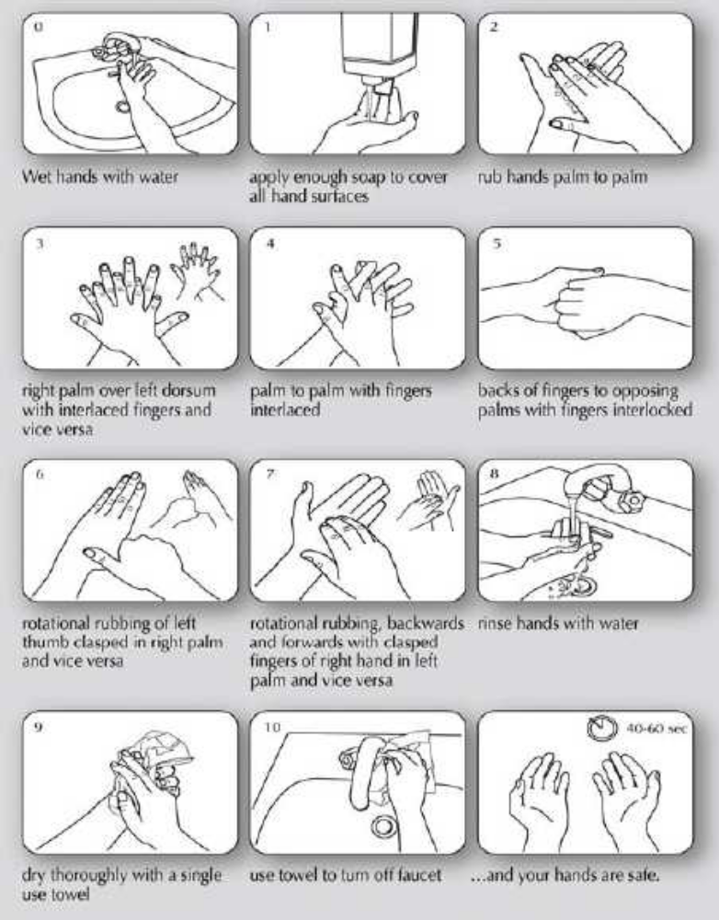

Key points
- Hand hygiene is an action intended to prevent hand borne infections by removing dirt and debris and inhibiting or killing microorganisms on skin. It include care of hands, nails and skin
- Hand washing is process which mechanically removes dirty and debris from skin and reduces the number of transient micro-organism
- Indications for hand hygiene include prevent transmission of infection to patient, health workers and family members and Keeping hand free from harmful microorganism
- The four types of hand hygiene are ,Routine hand washing, hand antisepsis alcohol hand rub and Surgical hand scrub
Evaluation
- Define Hand hygiene and Hand washing
- List the Indications for hand hygiene
- Mention four types of hand hygiene

References
Chin, J. (2000). Control of communicable diseases (17th ed.). Washington DC: APHA.
MOHCDGEC. (2018). National infection prevention and control guidelines for health care services in Tanzania. Dar es Salaam: Ministry of Health and Social Welfare.
MOHCDGEC. (2006). Health care waste management monitoring plan: Making medical. Dar es Salaam: Ministry of Health and Social Welfare.
MOHCDGEC. (2006). Infection prevention pocket guide for health care workers. Dar es Salaam: Ministry of Health and Social Welfare.
MOHCDGEC.. (2006). National standard and procedures for health care waste. Dar es Salaam: Ministry of Health and Social Welfare.
MOHCDGEC. (2007). National infection prevention and control guidelines for health care services in Tanzania. Dar es Salaam: Ministry of Health and Social Welfare
MOHCDGEC.(2010)National Family Planning procedure manual

Session 3: Use personal protective equipment in preventing
spread of microorganisms in health care setting
Learning Task
By the end of this session, learner is expected to be able to:
- Define the term personal protective equipment (PPE)
- Explain importance of personal protective equipment
- Describe Personal protective equipment’s and their use
Definition of the term Personal Protective Equipment (PPE)
Personal Protective Equipment’s
Personal Protective Equipment (PPE) is the equipment worn by a worker to minimize exposure to specific occupational hazard
In health facilities it’s defined as a physical barriers that help to prevent the spread of microorganisms from:
o Person to person
o Equipment/ instruments and environmental surfaces to people
Using PPE is only one element towards complete safety at work, it does not guarantee a permanent or total protection but it reduces the chance of being affected while at work

Importance of personal protective equipment
- Control hazards at the source
- Eliminate hazards from work places
- Isolate hazards from workers
- Protect clients from nosocomial infections
- Protect health care workers from occupational exposure to infections,
- Protect clients from non-occupational exposure to infections,
- Protect communities from infectious diseases and prevent environmental pollution.
Personal Protective Equipment (PPE ) and their use
Types of PPE
- Gloves
- Masks/respirators
- Eyewear
- Caps
- Gowns
- Aprons
- Boots

Types of Gloves and their use
- Examination gloves
- For examination and non-surgical procedures
- Contact with blood or body fluid anticipated
o Handling visibly soiled items
- When health worker has non-intact skin
- Surgical gloves
- For surgical invasive procedures only
- Utility Gloves/ Heavy Duty Gloves
- Used for decontamination and cleaning large equipment, walls, furniture such as beds and floors,
Care of Gloves
- Remove gloves before moving to another patient or after completing specific task
- Wash and dry hands immediately after removing gloves
- For utility gloves do not wash, decontaminate and reuse gloves
- Do not wear gloves while moving around unless transporting inserting an Intravenous infusion
- Gloves Protects hands of healthcare worker from infectious materials and protect patients from microorganisms on staff members’ hands They are the most important physical barrier for preventing the spread of infection
Other types of gloves
- Gauntlet gloves
- Elbow length gloves for obstetrics procedures
- Used when the hand and forearm need to be inserted into the vagina (manual removal of the placenta) or deep into the uterus to deliver the infant’s head
- Help to protect the provider from significant blood and amniotic fluid contamination
- If not available, improvise it.
Refer student to: 3.1
NB: Indications for double gloving:
- When the procedure involves coming in contact with a large amount of blood such as vaginal deliveries, caesarean section and laparotomy
- For orthopedic procedures
- When contact with blood and body fluids is anticipated
- As additional measures not replacement of hand washing
- Not required for routine procedures with limited skin contact
Uses of Gowns
- Avoid unnecessary use of gowns
- Gowns shall be used for protective isolation
- Don’t wear gowns outside work area
- Wear long gowns to protect uncovered skin and protect clothes
- Clinical coats and scrub suits shouldn't be worn outside work area, don’t transfer them to homes
Uses of Masks
- The tieback mask has four ties to fasten around the mouth and nose
- The ear loop mask has 2 elastic bands for fastening
- Surgical masks with attached face shields to protect against fluid and other splashes
- They are fluid resistant, light weight ideal for most procedures and isolation precautions when indicated

Uses of Caps
- To keep hair and scalp covered so that flakes of skin and hair are not shed into the
- wound during surgery
- Should be large enough to cover all hair
- Protect both patient and healthcare worker from splashes of blood and body fluids
Eye wear
Types of eye wear
- Plastic glasses with solid side shields
- Goggles
- Masks with clear vision
- Chin lens and face shield
Uses of eye wear
Protects staff from accidental splashes of blood or body fluid, special shoes
Uses of aprons
- Made of rubber or plastic
- Provides waterproof barriers along the front of the health worker’s body
- Should be worn when cleaning or procedure with blood and fluid products spills anticipated
- Should be thoroughly cleaned after procedure

Refer Students to Handout 3.1 Figure3.1: Essential Required PPE.

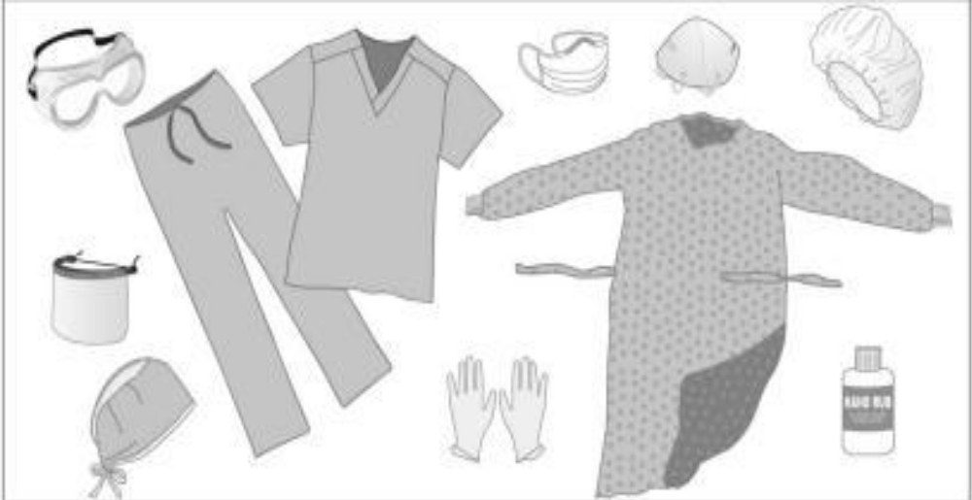

Fig: 5.3: Wearing of Gown and Apron
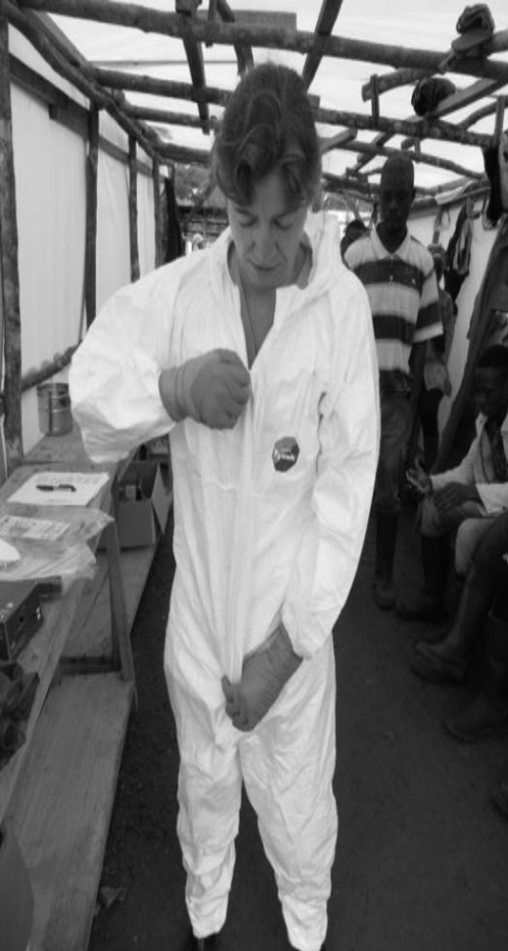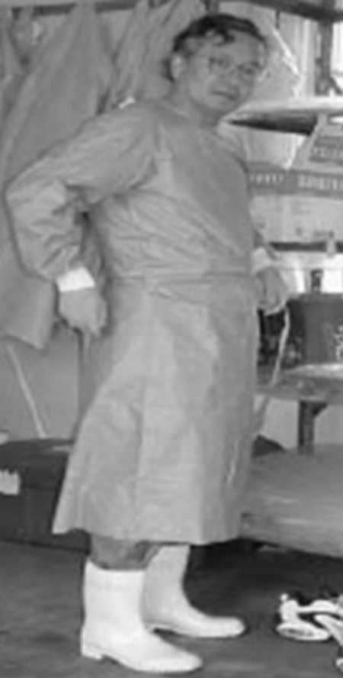

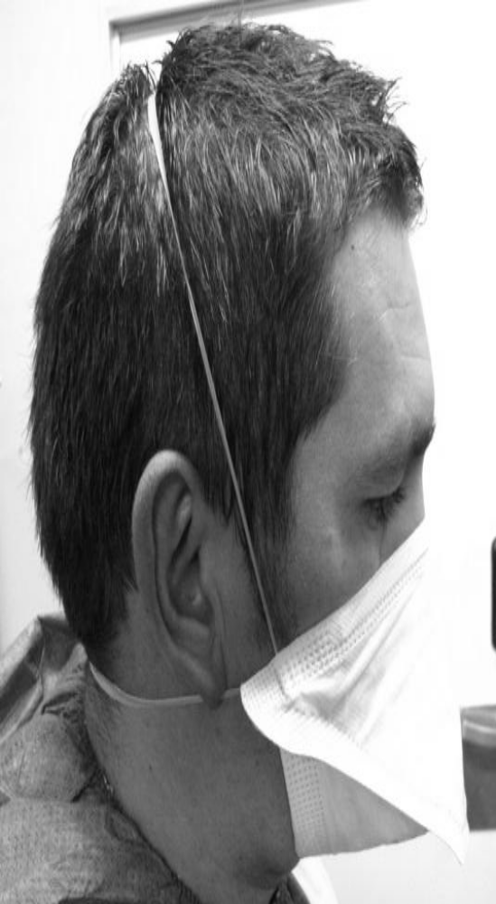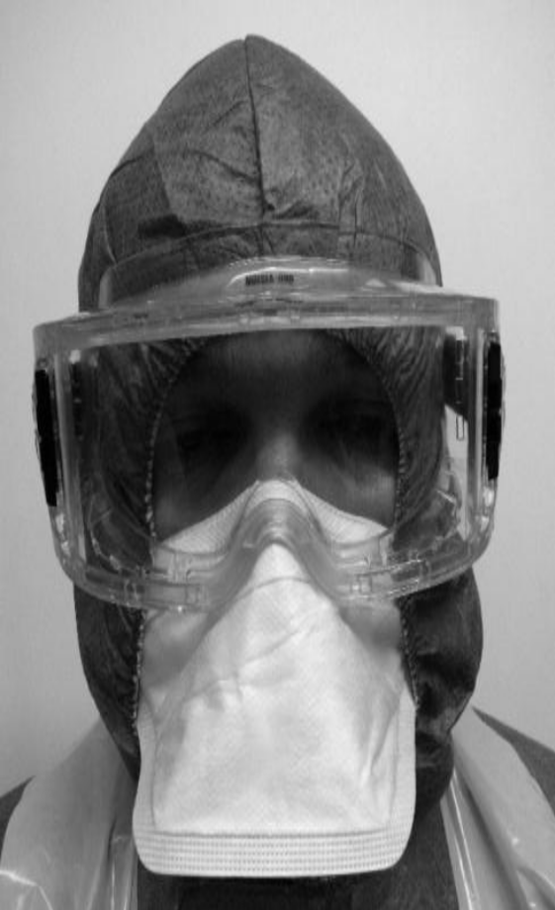

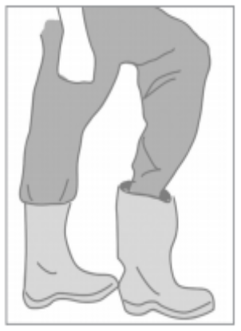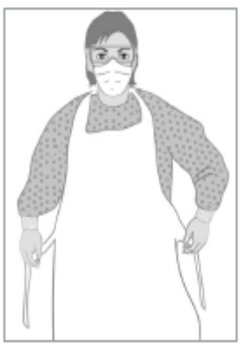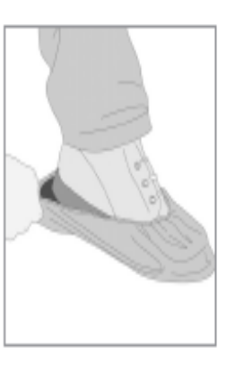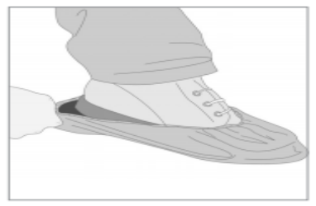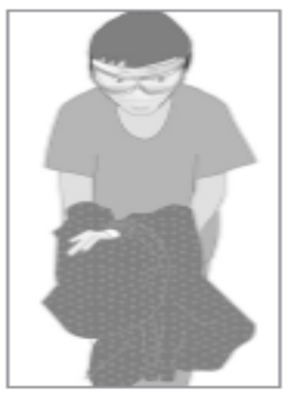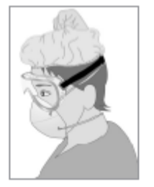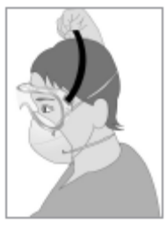Fig 5.10: Remove FaceProtection

Fig 5.12: Remove Mask
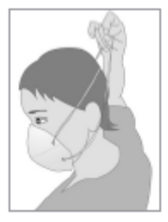

An Example of Recommended Personal
Protective Equipment

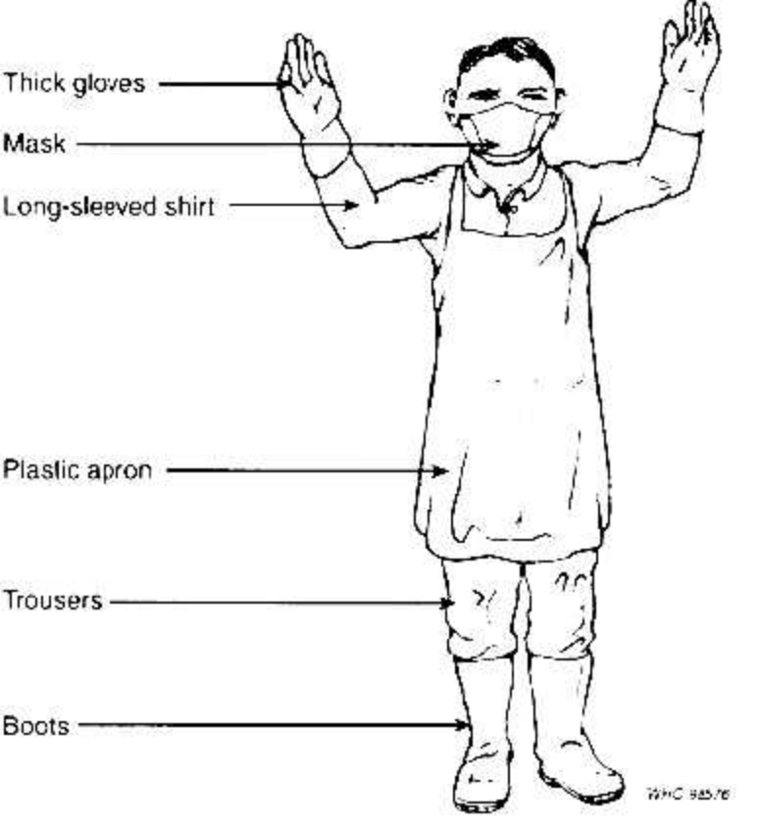
Key points
- Personal Protective Equipment (PPE) is the equipment worn by a worker to minimize exposure to specific occupational hazard
- Importance of personal protective equipment’s are control hazards at the source ,eliminate hazards from work places ,isolate hazards from workers ,protect clients from nosocomial infections, protect health care workers from occupational exposure to infections, protect clients from non-occupational exposure to infections, protect communities from infectious diseases and prevent environmental pollution
- Types of PPE include gloves, masks/respirators, eyewear, caps, gowns aprons and boots

Evaluation
- Define the term personal protective equipment (PPE)
- What are the importance of personal protective equipment
- What are the types of Personal protective equipment?

References
MOHCDGEC. (2018). National infection prevention and control guidelines for health care services in Tanzania. Dar es Salaam: Ministry of Health and Social Welfare
MOHCDGEC( Undated) National Family Planning Procedure Manual

 | Handout 3.1: Steps for putting on and removing gloves
----------------------------------------------------------------------------------------------------
Steps for putting on gloves
- Decontaminate the surface where gloves will be opened.
- Obtain the correct size of gloves.
- Wash hands and dry well. Lightly powder hands (not gloves) if inside of gloves are not powdered.*
- Open other sterile supplies (e.g., open end of IUD package).
- Open outer glove wrapper and lay the glove package out on a clean surface, with cuffs facing you. (This should be the bottom edge of the packet.) Take care not to touch the inner surface of the wrapper if you intend to use it as a sterile field.
- Pick up a glove by the folded-back cuff. Be careful to touch only the inside portion of the cuff (i.e., the side which will be touching your skin when the glove is on).
- While holding the glove, slip the other hand into the glove. Pointing the fingers of the glove to the floor will keep the fingers open by force of gravity. Be careful not to touch anything; holding the gloves above waist level will help.
- If the first glove is not fitting correctly, wait to make any adjustments until the second glove is on. (Then you can use the sterile fingers of one glove to adjust the sterile portion of the other.)
- To pick up the second glove, slide the fingers of the gloved hand between the folded cuff and the sterile portion of the second glove. This is very important; in order to avoid contaminating the gloved hand with the gloved hand.
- Place the second glove on the ungloved hand by maintaining a steady pull through the folded cuff.
- Do not attempt to adjust cuffs once the gloves are on, since this may cause the gloves to become contaminated.
- Adjust the position of the glove fingers until the gloves fit comfortably.
- Always keep gloved hands above the waist level and in sight to avoid accidental contamination.
- If a glove becomes contaminated, stop and ask yourself if the glove will touch a sterile or disinfected instrument, the client’s mucous membranes or sterile tissue. If yes, either remove that glove and re-glove, or put another sterile glove over the contaminated glove. Note: *Do not use powder for insertions of implants because the powder will adhere to the slapstick capsule, causing a foreign body reaction.
Steps for removing used gloves:
- When removing gloves, avoid allowing the surface that was sterile to come into contact with your hands (the exterior of the gloves is now contaminated).
- Dispose of gloves in a waste container for contaminated waste
- Grasp one of the gloves near the cuff and pull it partway down. The glove will turn inside out.
- With the first glove still covering your fingers, grasp the second glove near the cuff and pull it part way down. The glove will also turn inside out.
- Pull off the two gloves at the same time.
- Dispose the gloves in a waste bin.
- Wash hands immediately, with liquid soap an

Source: www.globus.co.uk 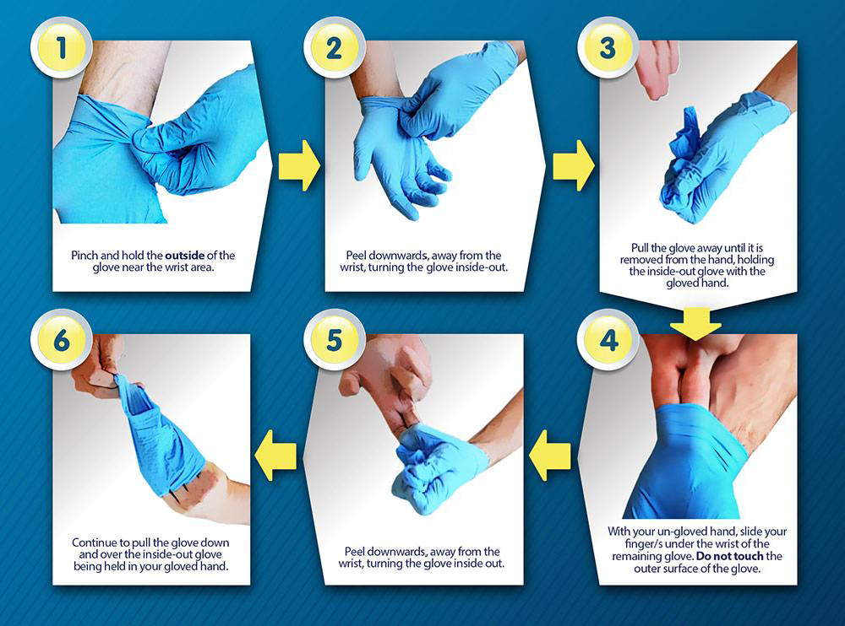

SESSION 4: Processing Equipment and Materials in Health
Care Setting
Learning Task
By the end of this session, a learner is expected to be able to:
- Define common terms used in processing equipment’s
- Explain key steps in processing equipment’s and materials
- Perform decontamination and cleaning
- Sterilize equipment and materials
- Perform high level disinfection

Definition of decontamination, cleaning, antiseptic, disinfectant, sterilization , linen, soap or detergent, soiled or contaminated linen and sort
- Decontamination
- Decontamination is a process of making equipment, instruments and linens safer to be handled by a health care provider.
- Decontamination According to OSHA, is “the use of physical or chemical means to remove, inactivate, or destroy blood-borne pathogens on a surface or item to the point where they are no longer capable of transmitting infectious particles and the surface of an item is rendered safe for handling, use, or dispose.
- Cleaning
- Cleaning is the removal of organic materials and debris (dust, dirty, blood or other bodily fluid) from used items by washing with soap and water and friction.
- Antiseptic
- Antiseptic chemicals that are applied to the skin or other living tissues to inhibit or kill microorganisms (both transient and resident) thereby reducing the total bacterial count
- Disinfectant
- Disinfectants are chemicals that kill or inhibit all microorganisms except bacteria endospores on inanimate objects.
- Sterilization
- Sterilization is a method applied to ensure that all microorganisms, including bacterial endospores are destroyed from the instruments
- linen,
- soap or detergent,
- soiled or contaminated linen
- and sort
Processing equipment and materials
The following are the recommended steps in processing contaminated instruments and materials :
- Decontamination
- Is the first step in handling used (soiled) instruments and gloves to make them safer to handle by the cleaning staff (This requires a 10-minute soak in a 0.5% chlorine solution)
- Decontamination kills Hepatitis B, C and HIV, Instruments with secretions or blood from a client must be decontaminated before being cleaned and high-level disinfected or sterilized. These include uterine sounds, tenaculum, specula, surgical instruments, etc. Decontamination is done to protect personnel who must handle the instruments. Supplies needed for decontamination include: water; a plastic or enamel pail; and chlorine
- Cleaning
- Is the physical removal of body materials, dust or foreign material .
- Cleaning will reduce the number of microorganisms as well as the soil, therefore allowing better contact with the surface being disinfected or sterilized and reducing the risk of soil being fixed to the surface.
- Removal of soil will reduce also the risk of inactivation of a chemical disinfectant and the multiplication of microorganisms
- The removal of contamination from an item to the extent necessary for further processing or for intended use
- Cleaning is accomplished by manual cleaning with cleaning chemicals (detergent) and water, brushing or flushing, or by using ultrasonic and or washer disinfectors to remove foreign material
- Sterilization
- Is the complete destruction or removal of microorganisms, including bacterial spores
- Sterilization validated process used to render a product free from viable microorganisms
- Processes include high-pressure steam (autoclave), dry heat, chemical sterilant or radiation (UV-light) or
- High level disinfection
- A process that eliminates all microorganisms except some bacterial endospores from inanimate objects, include:
- Boiling
- Steaming
- Use of chemical disinfectants
Decontamination process
Step one
- Wear protective gloves. (Keep a separate set of gloves, preferably utility gloves, for decontamination.)
- Submerge items in chlorine bleach solution for 10 minutes.
- Submerge metal items for 10 minutes.(never exceed 10 minutes)
- Remove the item(s)
- Submerge cool water, opening or disassembling them when possible.
Step two
- Clean equipment, instruments, and linen with soap
- Rinse equipment, instruments, and linen immediately with cool water to prevent corrosion
- Use brushes (a tooth brush works well) to remove soil and organic matter, paying attention to interior and hinged areas
- Submerge them in a basin with detergent and water prepared according to the manufacturer’s directions. Make suds as you would for dishes.
Step three
- Rinse equipment, instruments, and linen thoroughly in clean water
- Dry equipment, instruments, by air or clean towels before further processing
- Keep cleaning supplies and equipment in dry, clean condition.
Step four
- Send equipment and instruments for sterilization process as per institution policy guidelines
- Send linen to laundry for washing
Sterilizing equipment and materials
- Sterilization
- Heat Sterilization
An autoclave is necessary for heat sterilization.
- Procedures for Operating an Autoclave or Pressure Cooker
- Decontaminate, clean and dry the instruments to be sterilized.
- Disassemble the items as much as possible for best steam penetration.
- Wrap needles and sharp edges in gauze to prevent dulling them.
- Strictly follow the directions supplied by the manufacturer for operation of the autoclave
- Instructions for using autoclave:
- Loosely wrap instruments in a double layer of muslin or newsprint to allow steam to penetrate. Don’t tie the instruments tightly together with rubber bands or by other means.
- Arrange the packs so air can circulate and steam can penetrate all surfaces.
- Heat water until steam escapes from the pressure valve only, and then turn down the heat enough to keep steam coming out of the pressure valve only. Don’t allow it to boil dry. The temperature should be at 121oC (250oF); the pressure should be at 106 kPa or 15 lbs/ in2; sterilize wrapped objects for 30 min. or unwrapped objects for 20 min.
- After turning off the heat source, wait 20 - 30 minutes until the pressure gauge reads zero.
- Open the lid and let the packs dry completely (about 30 minutes) before removing. (Damp packs act like a wick to draw in bacteria, viruses and fungi.)

Processing Contaminated Instruments and Other Items
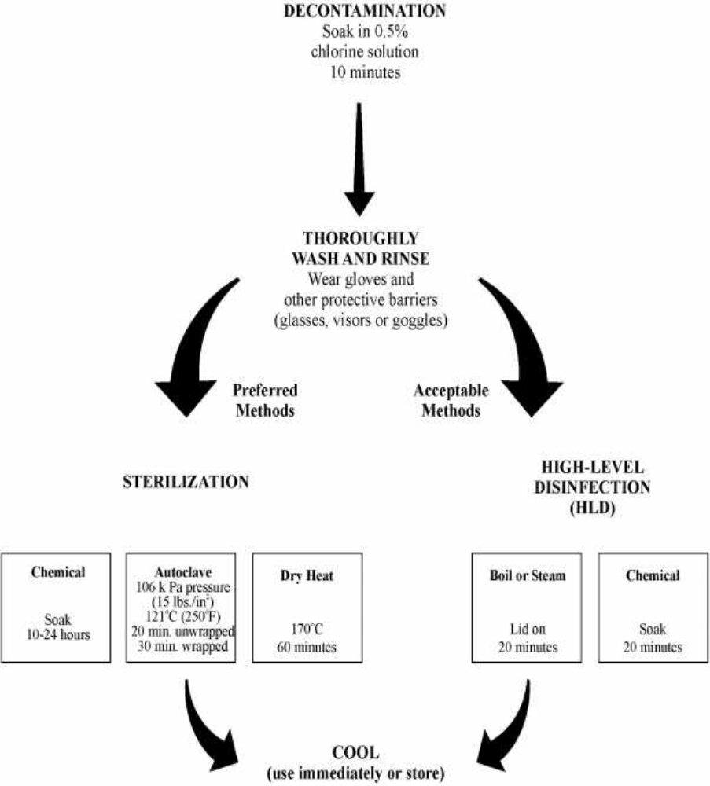

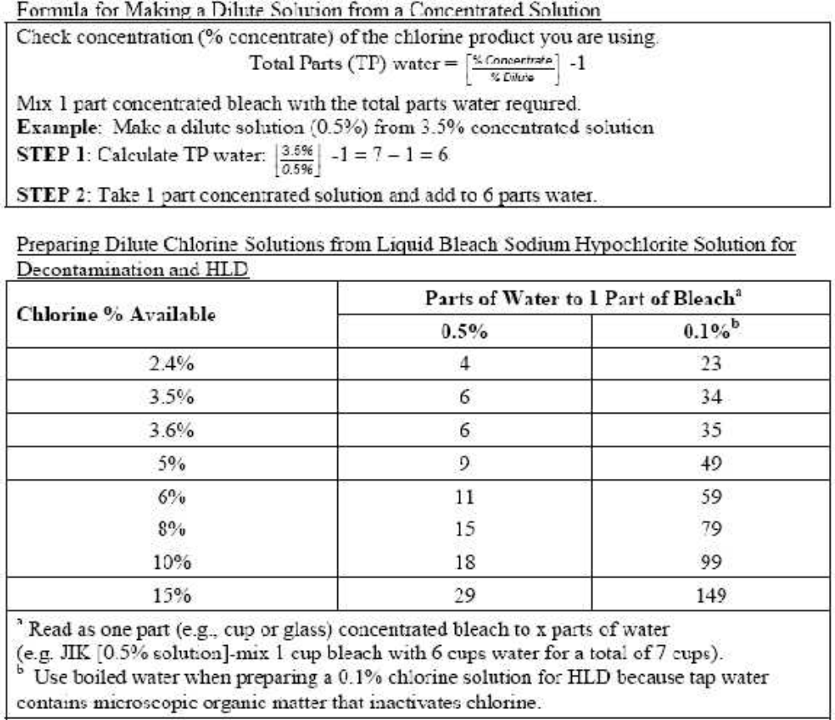
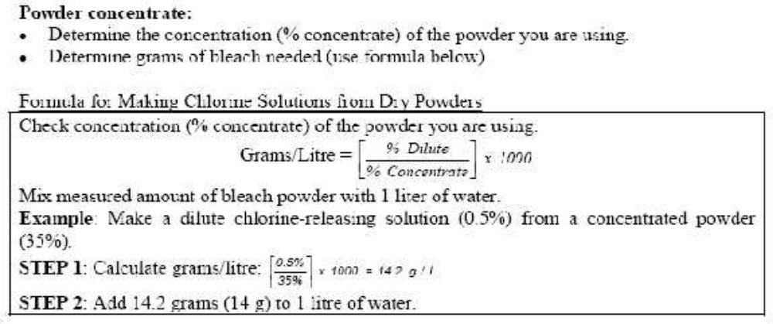

High-level disinfection (HLD):
HLD is a process that eliminates most or many disease-producing microorganisms (including viruses which cause hepatitis B or AIDS), except some bacterial endo-spores from inanimate objects, by boiling, steaming, or the use of chemical disinfectants. (Boiling and Chemical disinfections are common methods and are explained below)
- Procedures for Boiling
- Decontaminate and clean the items thoroughly. Disassemble equipment items when appropriate.
- Place the cleaned items in the boiler and completely cover them with clean water. Consider boiling the same kinds of items together for easier handling.
- Boil for 20 minutes. Begin timing when boiling action starts.
- If an additional item is put in after boiling has begun, start timing again.
- Remove items from boiler and put in covered, high-level disinfected or sterile containers using dry sterile or HLD handling forceps.
- Never let boiled items remain in water once it has cooled. Microorganisms can begin to grow in the cool water, and it is possible that instruments will start to rust in the water after this length of time.
- Store for up to one week in a high-level disinfected, covered container if dry.
- HLD Using Chemicals
- Chemical disinfection can also be used in certain situations, such as when the item to be high-level disinfected cannot withstand heat.
- When doing chemical HLD, soak the items in a high-level disinfectant for 20 minutes and then rinse well in boiled water. A variety of chemical disinfectants are available. These are listed in the chart Preparing and Using Chemical Disinfectants.
- Procedures for Chemical High-Level Disinfection
- Decontaminate and clean all instruments. Dry them so that water on the instruments does not dilute the disinfectant solution.
- Cover all items completely with the correct dilution of disinfectant.
- Soak for 20 minutes. 4. Remove the items with high-level disinfected or sterile large handling or pickup forceps.
- Rinse well with boiled water and allow to air dry.
- Store for up to one week in a HLD covered container or use immediately.
Note: To prepare an HLD container, fill with 0.5% chlorine solution, soak for 20 minutes and rinse the inside with boiled water or boil the container. Allow it to air dry before use.
Key points
- Decontamination is a process of making equipment, instruments and linens safer to be handled by a health care provider.
- Key steps in processing equipment’s and materials include decontamination, cleaning sterilization or high level disinfection
Evaluation
- What is cleaning?
- What are the key steps in processing equipment and materials?
- What is the recommended technique for decontamination?
References
- MOHCDGEC. (2018). National infection prevention and control guidelines for health care services
- in Tanzania. Dar es Salaam: Ministry of Health and Social Welfare
- MOHCDGEC( Undated) National Family Planning Procedure Manual

Session 5: Maintain clean health facility environment according to standards and guidelines

Learning Task
By the end of this session, a learner is expected to be able to:
- Define clean health facility environment
- Explain importance of clean health facility environment
- Explain principle of maintaining clean health facility environment
- Keep health facility environment clean and tidy

Definition of terms Clean, Health Environment
Clean Health facility environment
- Clean health facility environment denotes the situation where by the health facility ( surrounding in and outside) is deemed free from dirty, marks or morally uncontaminated maintained routinely

Importance of clean health facility environment
- Reduce the number of micro-organisms that may come into contact with the health workers, clients or members of the community who visit the facility
- Reduces the risk of incidence through prevention of accidents such as falls and so on
- Ensures a pleasant atmosphere for both health workers and patients/client
Principles of maintaining clean health facility environment
- Scrubbing (frictional cleaning) is the best way to physically remove dirt, debris and microorganisms
- Cleaning is required prior to any disinfection process because dirt, debris and other materials can decrease the effectiveness of many chemical disinfectants.
- Cleaning products should be selected on the basis of their use, efficacy, safety and cost.
- Cleaning should always progress from the least soiled areas to the most soiled areas and from high to low areas, so that the dirtiest areas and debris that falls on the floor will be cleaned up last.
- Dry sweeping, mopping and dusting should be avoided to prevent dust, debris and microorganisms from getting into the air and landing on clean surfaces. Airborne fungal spores are especially important as they can cause fatal infections in immunosuppressed patients (Arnow et al., 1991).
- Mixing (dilution) instructions should be followed when using disinfectants. (Too much or too little water may reduce the effectiveness of disinfectants).
- Cleaning methods and written cleaning schedules should be based on the type of surface, amount
and type of soil present and the purpose of the area.
- Routine cleaning is necessary to maintain a standard of cleanliness
Keeping health facility environment clean and tidy
Cleaning Methods
Cleaning should start with the least soiled area and move to the most soiled area and from high to low surfaces. Common methods of cleaning are briefly described below.
- Wet mopping
- Wet mopping is the most common and preferred method to clean floors.
- Single-bucket (basin) technique: One bucket of cleaning solution is used. The solution must be changed when dirty. (The killing power of the cleaning product decreases with the increased load of soil an organic material present);
- Double-bucket technique: Two different buckets are used, one containing a cleaning solution and the other containing rinse water.
- The mop is always rinsed and wrung out before it is dipped into the cleaning solution.
- The double-bucket technique extends the life of the cleaning solution (fewer changes are required), saving both labour and material costs;
- Triple-bucket technique: The third bucket is used for wringing out the mop before rinsing, which extends the life of the rinse water.
- Dusting
- Dusting is most commonly used for cleaning walls, ceiling, doors, windows, furniture and other environmental surfaces.
- Clean cloth or mops are wetted with cleaning solution contained in a basin or bucket
- The double-bucket system minimizes the contamination of contamination of the cleaning solution
- Dry dusting should be avoided, and dust cloths and mops should never be shaken to avoid the spread of microorganisms
- Dusting should be performed in a systematic way, using a starting point as a reference to ensure that all surfaces have been reached.
- Principles for Cleaning:
- Scrubbing is the best way to remove dirt and micro-organisms, hence always use it
- It is important to always wear gloves while cleaning, especially heavily contaminated areas such as toilets and areas with blood and body fluids spills
- Use a damp cloth for walls and floors
- Dry sweeping should be avoided as the particles spread dust, debris and micro-organisms
- Use separate equipment like cloths and brushes for cleaning high risk environment and others for low risk environment
- Change cleaning solutions when absolutely dirty
- Clean and dry the mops, dusters, cloths and other cleaning equipment after cleaning is over
- When washing walls, wash from top to bottom and when cleaning surfaces clean from less dirty to very dirty areas
- When using disinfectants, follow the manufacturer’s instructions about diluting the chemicals, their storage and disposal
Equipment and Essential Materials for Cleaning
Equipment and supplies used for cleaning | Materials used for cleaning
- Basins  - Dusting buckets  - Trolley  - Stepping ladder  - Hard broom Squeezer  - Soft brush  - Long sponge sweeper  - Gloves  - Cobweb remover  - Boots  - Hazard signs  - Apron  - Mop bucket and handle | - Soap  - Water  - Detergent  - Paper roll  - Disinfectant

Cleaning Procedure for Different Departments in HCF
Cleaning of patient room:
• Assessment
- Check for additional precautions signs and follow the precautions
- Check through room to determine what needs to be replaced (e g, toilet paper, paper towels, soap, Alcohol-Based Hand Rub (ABHR), gloves, sharps container) and whether any special materials are required; this may be done before or during the cleaning process
• Assemble supplies
- Ensure an adequate supply of clean cloths is available
- Prepare fresh disinfectant solution according to manufacturer’s instructions
- Clean hands, dry and put on gloves
• Procedure for Cleaning the Room:
- Working from clean to dirty and high to low areas of the room
- Use fresh duster for cleaning each patient’s bed
- If a bucket is used, do not ‘double-dip’ duster(s)
- Do not shake out duster(s)
- Change the cleaning duster when it is no longer saturated with disinfectant and after cleaning heavily soiled areas such as toilet and bedpan cleaner
- If there is more than one patient bed space in the room, use fresh duster(s) for each and complete the cleaning in each bed space before moving to the next
- Start by cleaning doors, door handles, push plate and touched areas of frame
- Check walls for visible soiling and clean if required
- Clean light switches and thermostats
- Clean wall mounted items such as alcohol-based hand rub dispenser and glove box holder
- Check and remove fingerprints and soil from low level interior glass partitions, glass door panels mirrors and windows with glass cleaner
- Check privacy curtains for visible soiling and replace if required
- Clean all furnishings and horizontal surfaces in the room including weighing scales, chairs, window sill, television, telephone, computer keypads, night table and other tables or desks
- Lift items to clean the tables
- Pay particular attention to high-touch surfaces
- Wipe equipment on walls such as top of suction bottle, intercom and blood pressure manometer as well as drip stand
- Clean bedrails, bed controls and call bell
- Clean floors
- Clean bathroom/ shower.
• Disposal
- Place soiled duster in designated container for laundering
- Check sharps container and change when ¾ full (do not dust the top of a sharps container)
- Remove soiled linen if bag is full;
- Place obvious waste in receptacles.
• Remove Waste
- Remove gloves and wash hands with soap and water
- Replace supplies as required (e g , gloves, Alcohol base hand rub, soap, paper towel)
- Clean hands with Alcohol base hand rub.

• Cleaning of Bathrooms and Toilets
- Run all taps for at least 5 minutes and sign the record sheet
- Fill buckets with cold water;
- Put out hazard signs at entrances
- Put on disposable gloves and apron
- Pull flush of toilet to ensure clean water in base
- Using the toilet brush push water backwards down the U-bend to reduce the amount of water in pan
- Spray around the rim and bowl of the toilet with disinfectant leave to activate for a few minutes
- Damp dust walls/tiles starting from the highest point to the lowest point
- Damp dust all surfaces, fixtures and fittings, including doors and door handles
- Spray inside of sink and bath with disinfectant, leave to activate for a few minutes
- Clean under sink with brush
- Clean inside toilet bowl with toilet brush
- Damp a clean piece of paper roll and wipe flush handle, toilet seat base and rim
- Pull flush cleaning toilet brush and holder in the running water, dry holder
- Pull flush again
- Empty bin and clean frame
- Mop floor with bucket and mop
- Remove utility gloves
- Clean out all buckets and dry thoroughly

• Disposal
- Place soiled duster in designated container for laundering
- Check sharps container and change when ¾ full (do not dust the top of a sharps container)
- Remove soiled linen if bag is full
- Place obvious waste in receptacles.
• Remove Waste
- Remove gloves and wash hands with soap and water;
- Replace supplies as required (e g , gloves, Alcohol base hand rub, soap, paper towel
- Remove disposable gloves and wash hands thoroughly
- Put on clean gloves remove mop head and place in clear bag and put out for laundry
- Remove disposable gloves, apron and wash hands thoroughly
- When the floor is dry return the hazard signs to the cleaning cupboard.
• Cleaning Sluice Room:

- Fill buckets with cold water and detergent
- Put mop head onto mop handle
- Put out hazard signs at entrances
- Wash hands and dry
- Put on apron, disposable gloves and utility
- Pull flush of sluice pan to ensure clean water in base
- Spray around the rim and bowl of the sluice pan with disinfectant leave to activate
- Damp dust walls/tiles starting from the highest point to the lowest point
- Clean sink removing all body fats
- Clean under sink well
- Clean sides of macerator with white paper roll
- Clean inside sluice pan with toilet brush
- Dampen a clean piece of paper roll and wipe flush handle, base and rim
- Pull flushes again
- Empty bin and clean frame
- Remove utility
- Mop floor with bucket and mop handle
- Remove mop head and place in clear bag
- Clean out all buckets and dry thoroughly
- Remove disposable gloves and apron and wash hands thoroughly
- When the floor is dry return the hazard sign to the cleaning cupboard

• Consultation/Clinicians Rooms and Corridors:
- Fill damp dusting buckets with cold water and detergent
- Fill mop bucket with warm water and detergent
- Put clean mop handle
- Put out hazard signs at entrances
- Put on disposable gloves
- Damp dust all walls fixtures, fitting and ledges starting from the highest point
- Damp dust tops of desk on nurses’ station
- Damp dust outside of any cupboards
- Empty bin if necessary
- Mop floors giving extra attention to the corners and edges
- Wet mop half the corridor at a time ensuring that there is a dry walkway for pedestrian to use
Key points
- Clean health facility environment denotes the situation where by the health facility ( surrounding in and outside) is deemed free from dirty, marks or morally uncontaminated maintained routinely
- Importance of clean health facility environment are to
- Reduce the number of micro-organisms that may come into contact with the health workers, clients or members of the community who visit the facility,
- Reduce the risk of incidence through prevention of accidents such as falls and so on
- Ensure a pleasant atmosphere for both health workers and patients/client
Evaluation
- What is clean health facility environment?
- What is the importance’s of clean health facility environment?
- What are the principles of maintaining clean health facility environment?
References
MOHCDGEC. (2018). National infection prevention and control guidelines for health care services in Tanzania. Dar es Salaam: Ministry of Health and Social Welfare
MOHCDGEC (Undated) National Family Planning Procedure Manual

Session 6: waste management in health care setting
Learning Task
By the end of this session, a learner is expected to be able to:
  - Define common terms used in waste management
  - Describe steps of waste management
  - Explain tips of disposing contaminated wastes
  - Explain risks associated with health care wastes

Definition of health care waste, non-contaminated wastes, contaminated wastes
Health care waste, non-contaminated wastes, contaminated wastes
- Health Care Waste
- Health care waste is defined as total waste generated by medical activities and includes both contaminated (potentially infectious/hazardous) waste and non-contaminated (non – infectious/ non-hazardous) materials
- Contaminated Waste /Hazardous Materials
- Contaminated waste is potentially infectious or toxic, if not disposed of properly
- Contaminated waste includes blood, body fluids, secretions and excretions, and items that have come in contact with them, such as sharps and used dressings, as well as medicines, medical supplies or other chemicals that may be toxic
- Contaminated waste must be incinerated, burned or buried in designated contaminated/ hazardous waste areas.
- Non Contaminated Waste /Non Hazardous Materials/
- A non-contaminated waste poses no infectious risk to person who handles it. Examples of non-contaminated waste include paper, trash, boxes, food remains, and bottles and plastic containers that products delivered to the clinic
- Non-contaminated waste can be picked up by the local authorities for disposal in municipal waste sites.

Steps of waste Management
Steps of waste Management
- Health Care Waste Minimization
- For efficient and effective minimization, of Health Care Waste, authorities, health facilities and other stakeholders shall establish and practice strategies for HCW waste avoidance, reduction, re-use and recycling as follows
- Minimization of HCW shall include source reduction, use of medical procedures that reduce the volume of waste generated.
- Healthcare facilities should put in place mechanisms that produce a lot of HCW.
- Restriction of purchase of supplies that produce a lot of healthcare waste
- Use of recyclable products at the onsite or off site
- Good management and control practices e.g., pharmaceuticals and chemicals through centralized purchasing
- Frequent ordering of small quantities rather than large amounts at one time
- Use of the oldest batch instead of the new (FEFO and FIFO) rules
- Use all contents in each open container before opening another container
- Frequent checking of expiry date at the time of delivery
- Recycling
- Healthcare facilities should use separate color coded containers placed at the source of waste generation for recyclable materials.
- Healthcare facilities should practice effective waste segregation at the point of generation to facilitate recycling of recyclable materials.
- All recyclable healthcare waste must be properly treated before taken out of the healthcare facilities
- Re-use
- Surgical equipment and other items which are designed for reuse and are sensitive to heat shall be sterilized by approved procedures.
- Operating and waste treatment costs should be reviewed periodically to evaluate any fluctuations. Data shall be collected to allow comparisons between HCF and to establish benchmarks.
- Segregation of Healthcare Waste
- The segregation of waste consists of separating the different waste materials based on the type, treatment and disposal practices
- HCF shall segregate waste to protect personnel from injury and infection by preventing hazardous waste entering inappropriate waste streams.
- All Standard Operating Procedures of HCW segregation, packaging and labeling shall be displayed in each department
- Segregation of healthcare waste shall be done at the generation point and is the responsibility of the person/institution that generate it .
- Segregation of waste shall be applied uniformly throughout the country
- Segregation receptacles must be placed close as possible to waste generator as this will avoid cross contamination
- Standard colour coded receptacles for each category of waste shall be provided by HCF;
- Segregation of healthcare waste shall consist of separating different waste materials based on the type, treatment and disposal or recyclable options
- The mixing of non-infectious/ non-hazardous and infectious/hazardous waste is not permitted. If mixing occurs, all waste contained together in, shall be classified and treated as hazardous waste
- Containers suitable for each type of waste should be available and used as intended.
- Staff engaged in the segregation of HCW shall wear appropriate personal protective equipment
- Standard Operating Procedures (SOPs) or posters for healthcare waste segregation should be displayed at the point of healthcare generation.
- Colour cording
- The color coding system aims at ensuring an immediate and non-equivocal identification of the hazards associated with the type of healthcare waste that is handled or treated
- In that respect, color coding system shall remain simple and be applied uniformly throughout the country
- All healthcare facilities shall apply the following color coding
WASTE CATEGORY | TYPE OF WASTE | COLOUR RECEPTACLES AND LINER
Non-infectious waste | Paper, packaging materials, plastic bottles, food remains, boxes, cartons | Blue Black
Infectious waste | Used gloves, dressing materials, specimen containers, infusion packages, catheters, urinal bags | Yellow
Highly infected waste | Anatomical waste, blood, body fluids, pathological waste, culture materials, stocks, petri dishes, waste from isolation ward or | Red
Sharp waste | Used syringes and needles, surgical blades,scapels needles pickers, blades, broken glass (eg pipettes) | Yellow safety boxes

- Health Care Waste storage
- For efficient and effective storage of Health Care Waste, authorities or health facilities shall:
- Provide a secured and fenced HCW storage bay
- The bay should have an impermeable, hard-standing floor with good drainage system, easy to clean and disinfect in line with standards and procedures for HCWM
- Ensure separate labeled storage compartment for various types of HCW
- Provide a separate compartment for radioactive waste storage
- Infectious waste must be stored not more than 48 hours from the time of generation.
- Internal transport
- For efficient and effective collection and transportation of Health Care Waste, authorities or health facilities management shall:
- Provide standard equipment for collection and transportation of health care waste.
- Provide appropriate personal protective equipment
- Supervise staff to adhere on use of personal protective equipment.
- All infectious waste shall be collected on daily basis
- Infectious/ Hazardous HC W and non-infectious/non-hazardous HCW shall be collected on separate trolleys.
- The collection/transport route shall be the most direct and shortest one from the collection point to the central storage facility or disposal point and should avoid where food preparation is done and the heavily populated areas.
- HCW should be transported using colour coded/labeled transportation equipment that are not used for any other purpose;
- Collection times should be fixed and reliable
- The collected waste shall not be left even temporarily anywhere other than at the designated central storage facility;
- Health-care waste shall not be transported by hands to avoid the risk of accident or injury
- All bin liners and /or containers of waste must be marked to identify the unit/ward where the waste was generated
- Spare trolleys/wheeled bins shall be available in case of breakdowns and maintenance
- The trolleys/ wheeled bins shall be cleaned and disinfected after every use.
- All waste bag seals should be in place and intact at the end of transportation.
- There should be separate, secured, storage rooms to maintain segregation of:
- Radioactive waste
- Waste containing mercury
- External Transportation
- For efficient and effective off-site transportation of Health Care Waste, authorities or health facilities shall comply the following:
- Before transportation of the waste, dispatch documents should be completed
- All arrangements should be made between consignor, carrier, and consignee
- In case of trans-boundary movement, the consignee should have confirmed with the relevant competent authorities that the waste can be legally transported
- Transport on public roads should only be conducted by licensed companies
- Transport vehicles and drivers must meet legal requirements for the transport of hazardous waste
- Health Care Waste treatment (HCW)
- HCW should be treated before disposal.
- Methods for treatment depend on the waste characteristics, technology, environmental and safety factors.
- There are five processes for the treatment of hazardous health-care waste that include thermal, chemical, irradiation, biological and mechanical.
- The choice of treatment system depends on local conditions and involves consideration of:
- Available resources including technical expertise
- Waste characteristics and volume
- technical requirements for installation, operation and maintenance of the treatment system
- Safety and environmental factors
- Cost considerations with respect to special waste which include waste containing radioactive materials and mercury shall require special treatment methods and receive special supervision with technical expertise..
- Disposal methods
- General non-infectious /non-hazardous and infectious/ hazardous waste that require direct disposal must be known by the healthcare facilities.
- The Ministry recommends the following disposal option for non-hazardous waste and hazardous waste that require direct disposal.
- Burning Chamber
- Rural health centers and dispensaries can use this option to burn waste in burning chamber as per MoHCDGEC Healthcare Waste Management guidelines.
- Open burning of contaminated waste is not recommended because it is hazardous.
- Incineration
- Incineration, which is a dry oxidation process, is used to reduce organic and combustible waste into inorganic incombustible matter at high temperature.
- Incineration provides high temperatures and destroys microorganisms and therefore is the best method for disposal of contaminated wastes. *Refer Healthcare Waste Management guidelines.
- Having centralized incineration is acceptable if health facility is not capable managing incineration by itself. Ashes from the incinerator should be disposed in an ash pit.
- HCW, which cannot be re-used, recycled or dumped in a landfill site, should be incinerated.
- There should be an efficient monitoring system for proper functioning of incinerators
- For an incineration process to work properly, it must be accompanied by the following:
- Clear operation procedures, which shall be posted near the incinerator
- Trained operators
- Reliable segregation system, so only infectious and non-polluting materials are incinerated
- Reliable transport system to get waste to the incinerator
- Ash pit to safely dump the incinerator ash
- Regular maintenance and repairs • Adequate supply of fuel
- Easily accessible site from waste storage via a paved walkway
- Things that must not be Incinerated
- PVC plastic (e.g. bottle caps)
- Mercury thermometers
- Batteries
- X-ray or photographic materials
- Aerosol cans or gas receptacles
- Glass vials (they can explode or if uncapped they melt and could block the incinerator grate)
- Non infectious/Non-hazardous waste
- Non infectious/ Non – hazardous waste shall be disposed off in public designated disposal sites.
- In case there is no public disposal site the authority shall establish a designated disposal site for Non-infectious /non-hazardous that meet public health and environmental requirement.
- Open burning is strictly not allowed for all types of waste
- The designated disposal site should be secured for unauthorized access and fenced
- Infectious /hazardous waste disposal Options
- Infectious/hazardous waste must be treated before final disposal.
- Pathological waste disposal:
- Every healthcare facility should have a standard designated placenta pit within the facility premises.
- Other pathological waste must be treated, incinerated or buried.
- In case of human remain must be cremated or buried in public cemetery
- Disposal of hazardous ash:
- Fly ash and bottom ash from incineration is generally considered to be hazardous, because of the possibility of having heavy metal content and containing dioxins and furans.
- Hazardous ashes should be disposed of in sites centralized designed for hazardous wastes
- In the absence of designated disposal sites, the HCF should construct a standard ash pit within or offsite the facility premises.
- Sharp waste disposal
- Even after sterilization, sharp waste may still pose physical risks.
- The HCF should do the following;
- Sterilized sharp waste can be disposed of in safe sharp pits on the health care facility premises or encapsulated by mixing waste with immobilizing material like cement before disposal.
- In case recycling opportunity exist, sharp waste should be sterilized and taken for recycling with licensed companies.
- Sharps can be incinerated where such high technology incinerators exist and needles smelted and ash disposed of by burial method.

- Disposal options in emergency situations
- The authority should take appropriate healthcare waste management practices in line with the type of waste generated.
- Appropriate disposal options and procedures must be followed including interim minimal disposal practices.
- Open dumping of boxes/bagged waste should be avoided.
- Liquid waste management
- There should be adequate, accessible and appropriate toilets for patients, staff, caretakers and people with special needs.
- Wastewater produced should be treated and disposed-off safely to protect workers and the environment.
- For the facilities with Onsite sanitation if involve the emptying of the sock away pit the content should be treated in the sedimentation ponds
- For the facilities connected to sewerage system, the liquid waste from health care facilities should be treated before discharged into sewerage or receiving body.
- Note that sludge and sewage from health-care facilities generated by a basic wastewater-management system should never be used for agricultural or aquaculture purposes. Effluents should have met the required BOD standards
- Liquid pharmaceuticals in vials (but not cytotoxic materials) can be crushed in a closed bucket, mixed with sawdust, and the solid mass incinerated or encapsulated.
- Special waste classes Chemical Wastes Containing Heavy Metals (mercury,), UPOPs, pharmaceutical and cosmetic waste, radioactive waste, e- waste See HCWM guidelines for this management and disposal
- Pharmaceutical waste and chemical waste should be stored until a safe disposal option has been identified. (refer guideline from pharmaceutical disposal

Disposing contaminated wastes
- Burning Pit
- Width should be 1 to 2 meters
- Pits shall be dug 1-2 meters wide and to depth of 2-5 meters, but at least 1.5 meters above the water table
- The pit shall be fenced and located away from public areas
- Burying
- Burying is placing waste into a pit and covering it with earth
- To build a waste burial pit, choose an appropriate site that is at least 50 metres away from any water source to prevent contamination of the source
- Pits shall be dug 1-2 metres wide and to depth of 2-5 metres, but at least 1.5 metres above the water table
- Keep waste covered, and every time waste is added to the pit, cover it with a 10 to 30 cm layer of soil
- When the level of waste reaches to within 30 to 50 meters of the surface of the ground, fill the pit with soil and dig another pit
- Expired vaccines shall be encapsulated and buried, and not burned
Risks Associated with Health Care Wastes

Key Points
- Health care wastes include non-infectious, infectious, pathological, radioactive, chemical, sharp and pharmaceutical wastes
- Disposal methods of health care wastes and contaminated materials are burning, burying and incineration.
Evaluation
- What are the different types of health care wastes?
- What are steps of health care waste management
- What are disposal methods of health care wastes and contaminated materials
References
MOHCDGEC. (2018). National infection prevention and control guidelines for health care services in Tanzania. Dar es Salaam: Ministry of Health and Social Welfare
MOHCDGEC (Undated) National Family Planning Procedure Manual
SESSION – 7 Healthcare Waste Disposal
Learning Tasks By the end of this session learners are expected to be able to:

• Define the common terms used in healthcare waste disposal

• Explain principles of healthcare waste disposal

• Describe methods of disposing health facility wastes

Define healthcare wastes transportation

• Describe different systems of transporting healthcare wastes

• Identify equipment needed for transporting healthcare wastes

• Describe the transportation of healthcare wastes to the disposing point

Definition of the Common Terms Used in Healthcare Waste Disposal

• Burning is a method of health care waste disposal which involves burning waste in burning pits

o The method is recommended in rural health centers and dispensaries

• Burying is a method of health facility waste disposal which involves placing waste into a pit and covering with soil.

• Incineration is a method of healthcare waste disposal which involves burning of waste in a special burning chamber

Principles of Healthcare Waste Disposal

• Apply technology that is reliable, affordable and sustainable in accordance with technical, human and financial resources available at each health care facility.

• Label waste package according to their categories

• Fence the disposal site with a gate and lock to prevent scavenging by both animals and people.

• Dispose Contaminated wastes into a waste container during or immediately following procedure

• Place sufficient number of waste containers, in convenient locations, to minimize carrying contaminated waste from one area to another

• Decontaminate waste bins with 0.5% chlorine solution for 10 minutes and rinsed with water between each use.

• Wear appropriate Person Protective Equipment (PPE) such as heavy-duty gloves, boots, aprons, masks when handling waste containers.

• Put body parts (placenta) in a plastic bag and then into a rigid container (metal or plastic container) if a patient or family member wants to take home body parts for disposal.

• Dispose liquid infectious wastes through a specific septic tank by carefully pouring wastes down utility sink drain or into a flushable toilet.

Methods of Disposing Health Care Waste (HCW)

• The most appropriate technology for treatment and disposal of HCW shall be selected from the available current technologies that should have the following criteria:

o Most reliable, affordable, and sustainable technology in accordance with the technical, human, and financial resources of each Health Facility.

o Minimizes the immediate public health risks associated with Health Care Waste Management (HCWM) and has the lowest impact on the environment.

o Use any of the following methods for appropriate waste disposal burning ,burying and incineration

Operation

o Every time waste is added to the pit, cover it with a 10-30cm layer of soil.

o When the level of waste reaches within 30-50 cm of the surface of the ground, fill the pit with soil and dig another pit.

• Incineration

o Incinerator provides high temperatures and destroys microorganisms and therefore is the best method for disposal of contaminated waste.

o The incinerator shall

▪ At least be 50 metres away from any water sources to prevent contamination of water sources

▪ Have proper drainage

▪ Be located downhill from the wells

▪ Be free from standing water

▪ Be in an area that does not flood

▪ Not be located on land that will be used for agriculture or development

o Incinerator operation procedures to maintain good working condition

▪ The ash and loading door must close correctly, they must not be broken, strainer cables to the chimney should be tight and there should be no risk that the chimney will fall down

▪ The metal parts (front door. Loading door, spigot, chimney etc) should not be corroded and the masonry should not be cracked to cause injury

o Preparation before incinerating

▪ Protective clothing must be available and in good working condition

▪ A container full of sand must be available (to serve as fire extinguisher)

▪ Rake, iron rod and spade must be available to operate the incinerator

▪ Make sure that more than 10 kg of renewable fuel (wood, coconut shells and other combustible agro waste) and one liter of kerosene/ diesel is available at the incinerator.

▪ Make sure that the medical waste stored in the incinerator is dry. If it is wet place it in a well ventilated spot inside the incinerator site to dry.

▪ Remove the ash from the incinerator and place it in the ash pit.

▪ Clean the area around the incinerator

▪ Weigh the medical waste to be incinerated and count the packages

▪ Record this quantities in the waste -disposal records

o NOTE don‘t sort or mix the waste before incineration

• Lighting and warm-up

o Lighting and warm-up must take at least 20-30 minutes

o First open the ash door fully and keep the loading door closed

o Place readily burnable (non-polluting) material on the grate.

o Pour a small quantity of kerosene or diesel over the material if necessary.

o Light the fire through the ash door. Use a taper of burning paper rather than a match or cigarette lighter. Avoid looking directly into the grate when lighting the fire.

Add approximately 1-2 kg of combustible material (not medical waste) to the burning fire through the ash door after steady burn is achieved (approximately 5 minutes)

o Observe the temperature gauge (if available) mounted on the chimney until the temperature of at least 6000C

• Loading and destroying medical waste

o Load only waste that has been weighed and recorded in the operators record

o Open the loading door just before depositing medical waste and close it immediately to avoid being exposed to toxic gases

o Load the safety boxes and the plastic bags for burning through the loading door at the top of the incinerator. When the temperature on the gauge is about 6000c but below 9000c. in case an incinerator not fitted with a temperature gauge a good visible strong flame through secondary air hole, the temperature must be more than 6000c

o Allow the incinerator to cool down for at least five hours after use before removing the ash

• Removing ashes
o Wear PPE
o Use the rake provided as part of incinerator tool kit to rake the ash and other non-burnable waste to the ash pit.

o Remove the ashes and other non-burnable waste in the following day before operating the incinerator if it is operated daily, and on the same day if the incinerator is not operated in daily basis.

o Carefully sweep the area around the incinerator to ensure that all the needles and non-combustible wastes are placed in the ash pit

o Always replace the trap door of the ash pit to avoid accidents.

o Two trap doors shall be provided in the concrete slab at ground level on either side of the incinerator, open this from time to time and distribute the ashes evenly within the pit

Categories of Waste

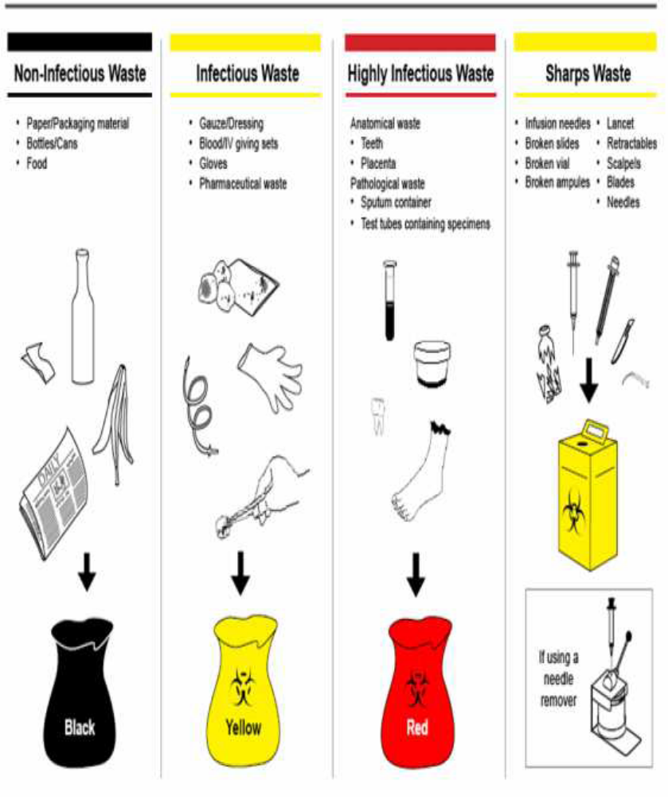

Definition of Health Care Wastes Transportation

• Health care waste transportation is a process of transferring health care waste from point of generation/storage to a new place or area for treatment and disposal

Systems of Transporting Healthcare Wastes

• On site transport system

o Healthcare wastes are transported within the health facility by means of wheeled trolleys, containers, or carts that are not used for other purpose and meet the following .specifications

▪ Easy to clean and unload

▪ No sharp edges that can damage waste bags when loading and unloading

▪ Easy to clean

• Off-site transportation system

o All healthcare providers are responsible for safe packing and adequate labelling of Health Waste Container

o All vehicles should be cleaned and disinfected after use

o All care handlers shall wear protective equipment (PPE) such as gloves, face masks, overalls,boots,plastic apron. They should be properly trained in handling, loading and unloading, transportation and disposal of yellow an read waste containers.

o Healthcare wastes are transported outside health facilities by means of special vehicles which are not used for other purpose.

Equipment Needed for Transporting Healthcare Wastes

• Onsite equipment used for transportation of healthcare waste are:

o Waste bins which can be carried to the storage area

o Wheeled waste bins

o Wheeled trolleys which can be loaded with waste or waste containers

o Wheel barrows that can be loaded with either containers or plastic bags

o Push-carts with compartments to load waste or waste bags

o Trailers used for waste

• Off site equipment used for transportation of waste

Special vehicles are used for collection of healthcare waste

Staff shall be fully aware of emergency procedures for dealing with accidents and spillage.

• Standard operating procedures for spillage management shall be conspicuously displayed in/on the vehicle for easy reference.

• Off-site transport of hazardous HCW on public streets/roads should comply with national regulations.

• Where there are no national regulations, responsible authorities may refer to recommendations on the transport of dangerous wastes

Key Points

• Methods of disposing healthcare waste include: Burning, burying and incineration The principles of healthcare waste disposal include: Disposing contaminated wastes into a waste container during or immediately following procedure and Placing sufficient number of waste containers, in convenient locations, to minimize carrying contaminated waste from one area to another

• Methods of disposing health care waste involve application of technology that is reliable, affordable and sustainable in accordance with technical, human and financial resources available at each health care facility.

• Healthcare waste transportation is a process of transferring healthcare waste from point of generation /storage to a new place or area for treatment and disposal

• There are two system for health care waste transportation which are are onsite and off-site

• Equipment used for onsite transportation of healthcare wastes are wheeled trolleys, containers, or carts

• Special vehicles are used for off-site transportation of health facility wastes

• Equipment used for transportation of healthcare wastes shall only be used for transportation for healthcare wastes

Evaluation Answer the following questions to check if you have understood the session
• What are the methods of healthcare waste disposal?

• What are the principles of healthcare waste disposal?

• What is healthcare wastes transportation?

• What are the systems used for healthcare wastes transportation?

• Which are the equipment used to transport healthcare wastes?

References CDC. (2003). Guideline for Environmental Infection control in health-care facilities. Atlanta: Centre for Disease Control. Department of Health. (2011). Healthcare Waste Management Manual (3rd ed.). Manila:
Republic of the Philippines. Retrieved on 22/04/2015 from http://www.wpro.who.int/philippines/publications/health_care_waste_management_manual_3rd_ed.pdf MoHSW. (2004). National Infection Prevention and Control guidelines for health care workers. Dar es Salaam: Ministry of Health and Social Welfare MoHSW. (2004). Nurses and midwives guidelines and Practice protocol for preventing HIV/AIDS infection from needle stick and sharp injuries in Tanzania (2nd ed.). Dar es Salaam: Ministry of Health and Social Welfare WHO. (2014). Safe management of wastes from healthcare activities (2nd ed.). Geneva: World Health Organization

Session 8. Handling of sharps using infection prevention principles
Learning Task
By the end of this session, a learner is expected to be able to:
- Define terms sharp instrument
- Explain principles of sharp disposal
- Demonstrate skill of safe disposal of sharps and needles
Definition of sharp instruments
Sharp instruments
- Sharp instruments: Anything capable of puncturing the skin (scissors, needles, scalpels or blades, etc.
Principles of sharp disposal
The principles of sharps disposal aims at preventing potential harm and transmission of disease from injury with a contaminated sharp object:
- Always dispose sharps in a puncture-resistant container
- Do not handle sharps carelessly, they should be disposed of directly, without manipulation (e.g., do not recap, remove or bend needles)
- Dispose sharps immediately after use at the point of use
- Ensure that sharps containers are readily available and conveniently located so that staff members do not have to carry sharp items any distance before disposal (preferably within arm’s reach)
- Sharps containers should be easy to see, recognize and use
- Mark them clearly so that people will not unknowingly use them for disposing of garbage or discarding cigarettes
- Don’t shake a container to settle its contents and make room for more sharps
- Don’t place containers in high traffic areas (corridors outside patient rooms or procedure rooms)
- Use only a puncture-resistant, disposable sharps container
- Dispose sharps container as a whole unit (incinerate, bury or encapsulate)

Safe disposal of needles and Sharps

- Safe Injection Practices (
- Dispose of the needle and syringe in a puncture-resistant container placed within arm’s reach at point of use
- Never leave a needle inserted in a vial cap (e.g. X-pen vial, chloramphenicol vial) to withdraw multiple doses
- Minimize handling of injection equipment
- Do not disassemble the needle and syringe after use
- Do not recap, bend or break needles prior to disposal
- If necessary, a one-handed recap method should be used, for example, after drawing blood using Vacutainer® or blood gas:
- First, place the cap on a hard, flat surface and remove hand from the cap
- Next, hold the syringe with one hand and use the needle to ‘scoop up’ the cap
- Finally, when the cap covers needle completely, use the other hand to secure the cap on the needle
- Do not over-fill sharps containers, filling them more than three-quarters (3/4) full may cause needle stick injuries
- Safe use of sharps containers (safety boxes)
- All sharp containers must be clearly marked “SHARPS” and/or have pictorial instructions for the use and disposal of the containers
- Place sharp containers away from high-traffic areas
- Place all sharps containers within arm’s reach during the procedure
- Do not place containers near light switches, overhead fans, or thermostat controls where people might accidentally put their hands on them
- Never reuse or recycle sharps containers for other purposes
- Dispose safety boxes when ¾ full
- Ensure that no sharp items are sticking out of containers
- Finally, dispose sharps containers by incineration or into sharp pits

Figure .1: One-Handed Recap Method

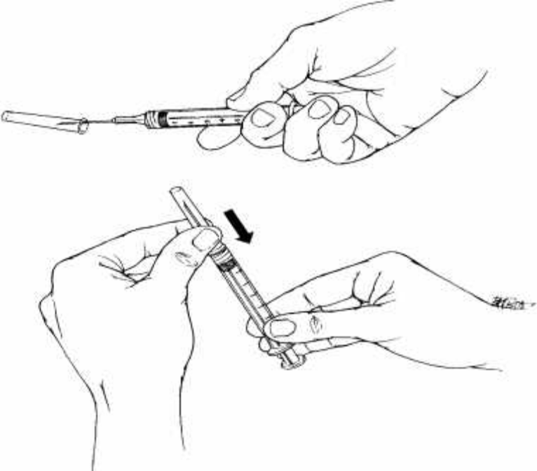

Source: (MOHSW, 2006)

Figure 2: Safe Use of Sharps Containers

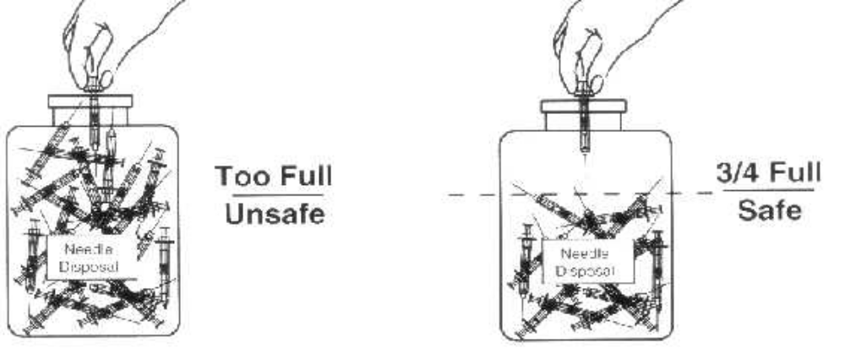

Source: (MOHSW, 2006)

Key Points
.
  - Sharp instruments include anything capable of puncturing the skin like scissors, needles, scalpels and blades.
  - The principles of sharps disposal aims at preventing potential harm and transmission of disease from injury with a contaminated sharp objects.
Evaluation
- Define sharp instruments
- Explain the principles of sharps disposal

Session 9: Microbiology in relation to nursing practice
By the end of this session, a learner is expected to be able to:
- Define the terms microbiology, virulence and pathogen
- Explain historical background of microbiology
- Explain importance of microbiology
- Describe modes of disease transmission
Definition the terms microbiology, virulence and pathogen

Microbiology, Virulence and Pathogen

Microbiology
Microbiology is the study of living organisms of microscopic size • Is the science that studies microorganism
Virulence
Virulence is a degree of pathogenicity of an infectious agent, indicated by case fatality rate or ability to invade the tissue of host
Pathogen
Pathogen a bacterium, virus or other microorganisms that can cause disease
historical background of Microbiology
- Microbiology is the study of living organisms of microscopic size; this term was introduced by French chemist Louis Pasteur (1822-95), who demonstrated that fermentation was caused by growth of bacteria and yeasts.
- Modern ideas of microbiology can be said to have started in 1546 when Fracastorius of Verona was the first to suggest that infection is composed of minute insensible particles and spread by means of them.
- The construction and use of the compound microscope was an essential prerequisite to study microbial forms.
- Antonius Van Leeuwenhoek 1676 ( Father of bacteriology)
- Bacteria were first seen by Antonius Van Leeuwenhoek using a primitive microscope of his own design and making in 1676
- He is known as “father of bacteriology” because it was he who first accurately described the different shapes of bacteria.

- Louis Pasteur 1833-1895 (Chemist and bacteriologist)
- In 1856 Pasteur a pure French chemist demonstrated that alcohol fermentation was brought about by scientific bacterial enzymes Subsequently this modified process of heating came to be known as pasteurization
- Pasteur established that different types of fermentations were due to the activity of different kinds of microbes.
- In the course of studies, Pasteur introduced the techniques of sterilization and developed steam sterilizer, hot –air oven and autoclave o Joseph Lister 1827-1912 ( British surgeon)
- An English surgeon and contemporary of Pasteur advocated the use of carbolic acid as an aerosol during surgery and for impregnation of dressing to reduce the risk of post surgical infections
- He established the guiding principle of antisepsis for good surgical practice upon which the present day specialists depend
- For this work he is known as “fatherof antiseptic surgery” o Robert Koch 1843-1910 (German Bacteriologist)
- Perfected the bacteriological techniques, staining procedures and methods of obtaining bacteria in pure culture using solid media during his studies on the culture and characters of anthrax bacillus.
- Koch describe the causative agents of bacillus of anthrax (1876), bacillus of tuberculosis (1882) and cholera vibrio (1883)
- Koch’s postulates are a definite sequence of experimental steps by which to prove the causal relationship between a disease agent and specific disease state:
- The organism must be present in the lesions in every case of the infectious diseases
- It should be possible to isolate the organism in pure culture from the lesions
- Inoculation of the pure culture into suitable laboratory animals should produce a similar disease ▪ It should again be possible to resolute the organism in pure culture from the lesions produced in the experimental animals.
- Other Pioneer/Investigators of Microbiology
    - Hansen described the leprosy bacillus in 1874
    - Neisser discovered the gonococcus in the pus discharge from urethra in 1879
    - Alexander Ogston in 1880 described the staphylococci in abscesses and suppuratve lesions
    - Eberth observed the typhoid bacillus in 1880
    - Klebs(1883)and Loeffler(1884) observed and described the diphtheria bacillus
- Rosenbach (1886) demonstrated the tetanus bacillus with round terminal spore
- Weichselbaun(1887) described and isolated the meningococcus from the spinal fluid of a patient
- Bruce (1887) identified the causative agent of Malta fever in 195 and Schaudinn and Hoffmann described the spirochaete of syphilis.
- In 1929 Alexander Fleming discovered penicillin which after 1940 proved to be the treatment of infection
- Microbial cultivation – an important development in the study and handling of microorganisms was the development of nutrient combinations called media
- Richard Petri developed a foolproof medium container known as the Petri dish
- The introduction of the solidifying agent AGAR –AGAR into media made possible the study of microorganisms that grow over a wide temperature range
Importance of Microbiology in Nursing

- The knowledge of the nature of the microorganisms which causes infection helps a nurse to understand the principles underlying control of infection
- The principal of personal and community hygiene are based in an understanding microbiology
- Microbiology is a practical subject in nursing. It’s of the greatest importance in the community and in the spheres of nursing experience
- In the hospital, it’s important for a nurse to have clear group of principles governing the source, distribution and growth of microorganisms because they are necessary for carrying out aseptic technique.
- Microbiology is important topic for nurses to study because infectious diseases are cause by microbes
- Learning about microbiology will help a nurse to prevent transfer of germs from one patient to another, prevent germs transfer to oneself and even prevent germs transfer from inanimate object
- The nurse will learn to appreciate the differences between pathogenic microbes and nonpathogenic microbes that play important role in the environment.
- The nursing students will even learn how the immune system can resist less pathogenic microbes but require prior exposure(vaccines)in order to resist more pathogenic varieties
Key Points
Microbiology is the study of living organisms of microscopic size.
The construction and use of the compound microscope was an essential prerequisite to study microbial forms
Microbiology assisted nurses in various angles such as: understanding the causes of infection and principles of infection prevention and control
Evaluations
List the founders of microbiology
Outline the important events in the history of microbiology
Explain the importance of microbiology
References

Session 10: Microorganisms Causing Diseases in
Human Body

Learning Task
By the end of this session, a learner is expected to be able to:
- List different types of microorganism
- Explain characteristics of different microorganism
- Explain disease transmission cycle
- Differentiate shapes of microorganisms
- Explain functions of microorganism

Definition of Microorganism
A microorganism is a microscopic organism which may exist in its single-celled form or in a colony of cells.

Types of microorganism
Types of microorganisms
- Bacteria
- Fungi
- Algae
- Protozoa
- Virus

Characteristics of Different Microorganisms

- Bacteria
- Classifications
- Bacteria are classified according to a number of criteria including
- Morphology
- Staining characteristics ▪ Nature of cell wall ▪ Ability to form spores
- Ability to grow in the presence of oxygen
Classification of Bacteria According to Morphology/Shape
- Cocci
- These are round or oval shaped bacteria.
- When multiplying cocci may form
- Pairs (called diplococcic for example meningococci and gonococci)
- Chains (called streptococci e.g. streptococcus pyogenes
Irregular groups or clusters (called staphylococci e.g. is staphylococci aureus)
- Bacilli
- These are rod shaped bacteria.
- When multiplying bacteria rods do not usually remain attached to one another, but separate, occasionally however, they may form:
- Chains e.g. are streptobacilli
- Branching chains, e.g. lactobacilli
- Mass together e.g. is mycobacterium leprae
- Remains attached at various angle e.g. Corn bacterium diphtheria
- Spiral
- These are small regularly coiled, rigid organisms e.g. spirillum minus
- Comma shaped
- These are small slightly curved rods (comma shaped) e.g. vibrio cholera
- Spirochetes
- These are flexible, coiled, motile organisms they progress by rapid body movement e.g. treponema species, borrelia species and leptospires
- Classification of Bacteria According to Staining Characteristics
- Gram positive bacteria
- When stained by Gram stain, appear blue reflecting the colour of primary stain (either gentian violet, crystal violet or methyl violet) e.g. staphylococci species
- Gram negative bacteria
- Are bacteria which appears red, after losing the colour of primary stain and adapting the colour of a counter stain (dilute carbofuchsin or saframin)
- Classification of Bacteria According to Nature of Cell Wall
- Rigid thick wall for example; streptococcus staphylococcus
- Wall less for example Mycoplasma
- Classification According to Ability to Form Spore
- Spores are highly resistant dominant state of bacteria with dense thick walls able to withstand dehydration, heat, cold and action of disinfectants
- In this kind of classification there are
- Spore forming bacteria e.g. bacillus species and clostridium species
- Non spores forming bacteria e.g. corynebacteria species like corynebacterium diphtheria
- Classification According to Ability to Grow in the Presence of or Absence of Air
- Grow in presence air (aerobic bacteria) e.g. bacillus anthracis
- Grow in the absence of air (anaerobic bacteria) e.g. clostridium species
- Fungi
- Are eukaryotic organisms that exist in two forms; yeast (cells) and moulds (filaments) e.g. candida albicans, Cryptococcus newformans and dermatophytes species
- Structure and Characteristics
- Morphologic characteristics
- They have at least one muscles and nuclear membranes
- They have endoplasmic reticulum and mitochondria
- They do not have chlorophyll or chloroplast
- Cell wall is made of chitin by forming spores
- General Characteristics
- Most fungi are obligate or facultative aerobe
- They are chemotropic
- They secrete enzymes that degrade a wide variety of organic substrates into soluble nutrients which are then passively absorbed or taken into the cell by active transport (saprophytic organism)
- They are three basic forms of fungi o Yeast (cells) for example Cryptococcus neuroformans o Moulds (filamentous) o Dimorphic (Yeast /filamentous)
- Yeasts
- Yeasts are single fungal cells
- They reproduce asexually by the process called budding, example if yeast includes Cryptococcus neoformans
- Virus
Characteristics
- They are small in size ranging from about 20 nm to about 300 nm in diameter
- They are akaryotic particles (neither eukaryotes nor prokaryotes)
- They contain either DNA or RNA and not both in as their genome
- They exhibit living properties when inside the living cells (i.e. they are incapable of independent reproduction unless they are in the living )
- They are non-motile o They can be grown in cell cultures
- Virus are known to infect unicellular organisms such as mycoplasmas, bacteria and algae and all higher plants and animal
- Structures
- Generally the virus structures is made three basic units
- Envelop made of glycoprotein and lipids
- Caspid
- Viral core (RNA or DNA)
- Protozoa
- Protozoa are diverse group of microscopic, single celled organisms that live in both aquatic and terrestrial environment
- Although microscopic, they are very complex organisms and much larger than prokaryotes
- Protozoa do not have a rigid cell wall
- Most protozoa require organic compounds as a source of food, which they ingest as particles
- Most groups of protozoa are motile, and a major feature of their classification is their means of locomotion

Infection Disease transmission cycle
Infection
Is a state that results from the presence of pathogens (microorganisms producing disease) in or on the body
An infection occurs as a result of a cyclic process, consists of six components as follows,
- Infectious agent
- The source
- Portal of exit
- Mode of transmission
- Portal of entry
- Susceptible host.

Infectious Agents
• The first link in the chain of infection is the microbial agent, which may be a Bacterium,
Virus, Fungus, and Parasite
• The ability of the infectious agent to cause disease depends on its pathogenicity,
virulence, invasiveness and specify.

The Reservoir or Source
• The source of organisms also called reservoirs is the elements in the environment,
Inanimate objects, human beings, soil, insects and animals are sources

Portal of Exit
The portal of exit provides a means for the microorganisms to leave the source
In humans, common portals of exit or escape routes includes;
- Respiratory for example secretions and expired air
- Gastrointestinal for example through faeces and vomitus
- Genitourinary tracts
- The skin
- Blood and tissue can also be portals of exit for pathogens.

Mode of Transmission
Refers to the way in which the organism moves or is carried from the source portal of
exit
The five main routes of transmission are:
- Contact
For example person to person or from person belongings
- Vehicle
For example water and food
- Droplet
- Airborne,
For example dust
- Vector borne
For example insects

Portal of Entry
• The portal of entry is the point at which organisms enter a new host
• The organisms must find a portal of entry to a host or it may die
• The entry route into the new host often is the same as the exit route from the prior
reservoir
- The urinary tract
- Respiratory tract (inhalation)
- Gastrointestinal tracts
- The skin
- Other openings eg Ear
• Those are common portals of entry.

Susceptible Host
- Microorganisms can continue to exist only in a source that is acceptable (a host) and
only if they overcome any resistance mounted by the host defenses.
- Susceptibility is the degree of resistance to the potential host has to the pathogens

Figure 10.1: Infection disease transmission cycle

Agent

Susceptible Host
Reservoir

Place of Entry
Place of Exist

Method of Transmission

Features of Prokaryotic and Eukaryotic Cells
FEATURE | PROKARYOTE | EUKARYOTE
Nucleus | - Absent  - No ending membrane | - Present  - Enclosed by a membrane
Cell membrane | Sterols absent | Sterols present
Cell membrane composition | Usually contains peptidoglycan | Usually contain cellulose or chitin
Mitochondria and chloroplasts | Absent | May be present
Location of chromosomes | In the cytoplasm usually attached to the cell membrane | Within a true nucleus separated from the cytoplasm by a nuclear membrane
Reproduction | Normally asexual | Asexual or sexual
Pill | Present | Absent
Size | Typically 1-5 micrometer | Normally greater than 10 micrometer
Chromosome number | One(i) | More than (ii)
Cell division | Mitosis and meiosis are absent | Exhibit mitosis and meiosis

Refer Students to: Handout 2.1: Structure of Prokaryotic/ Cells
Refer Students to: Handout 2.2: Structure of Eukaryotic Cells

Handout 2.1: Structure of Eukaryotic Cells

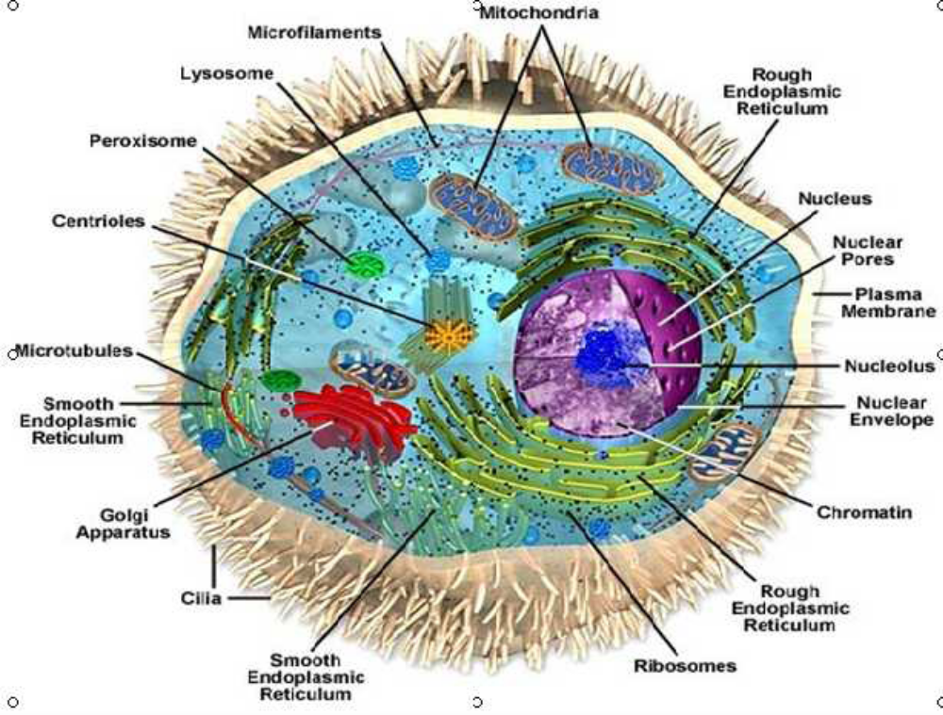

Shapes of Microorganisms
Figure 1: General Structure of Bacteria Cell

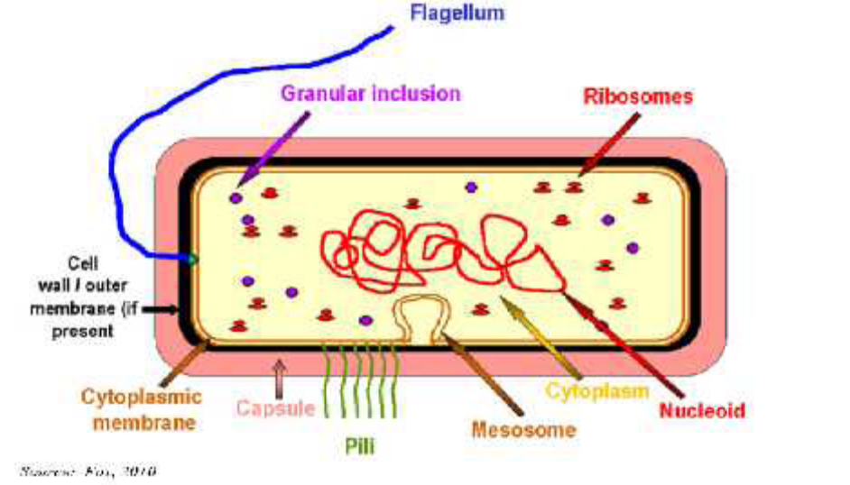

Figure 2: Different Forms of Fungi

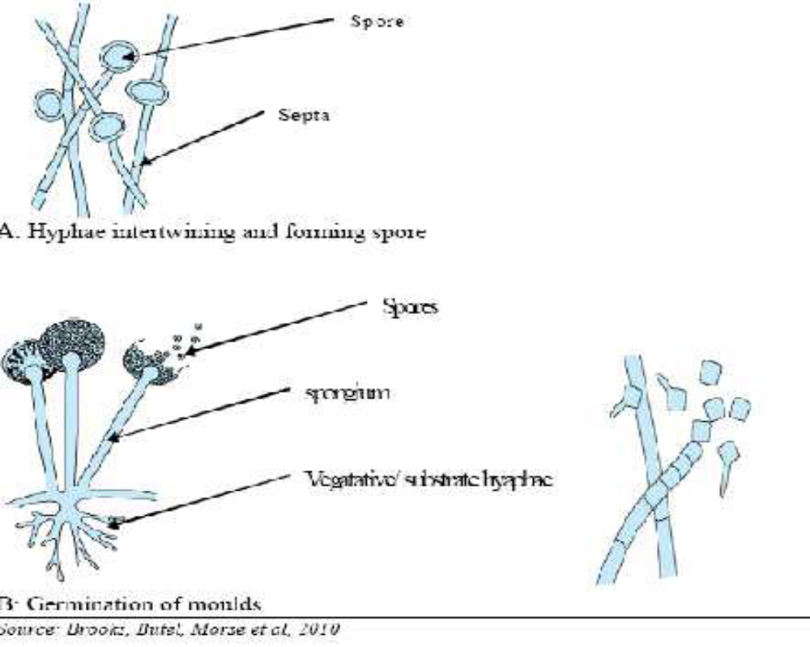

Figure 3: Basic structures of Virus

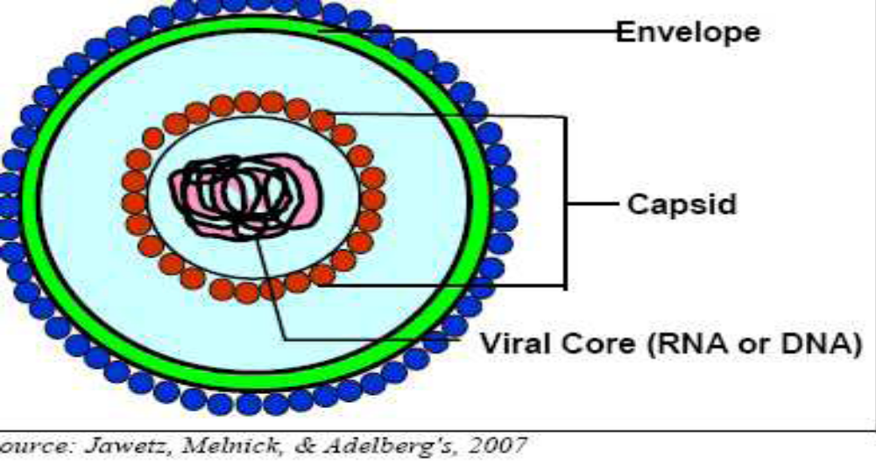 Source: (Jawetz, Melnick, & Adelberg, 2007)

Functions of Microorganisms
- Vital Activities of Microorganisms
- The activities of microorganisms are vital for survival of all other organisms including humans
- microorganisms replenish the oxygen on earth
- microorganisms degrade organic waste materials
- Bacterial are necessary to convert nitrogen gas in air into a form that plants and other organisms can use
- Application of Microbiology
- For thousands of years, bread, wine, beer, and cheeses have been made by using technology still applied today
- bacteria are being used to degrade dangerous toxic pollutants
- Bacteria are used to synthesize a variety of different products such as cellulose, ethanol, antibiotics and amino acids
- Genetic Engineering
- Microorganisms produce medically important products and can produce vaccine against a variety of diseases
- . Bacterium can transfer genes into plants and modify their properties
- Medical Microbiology
- Bacteria use the body as an ecological habitat and interact with other bacteria on its surface. Pathogens gains entrance to the body and find a protected habitat inside host cells.
Key Points
- Microorganisms may be classified into large biological groups: bacteria, fungi, viruses, and protozoa
- Applications of microbiology have transformed the diagnosis, prevention and cure of diseases.
Evaluation
- Outline four types of microorganisms
- Explain the important characteristic of microorganisms
- Explain the importance of microorganisms

References
Arora, D. R. & Arora, B. (2009). Microbiology for nurses & allied sciences. New Delhi: CBS Publishers. Greenwood, D., Slack, R. C. B., & Peutherer, J. F. (2002). Medical microbiology: A guide to microbial infections: Pathogenesis, immunity, laboratory diagnosis and control (6th ed.). Edinburgh: Churchill Livingstone. Nester, E. W., Anderson, D. G., Roberts Jr., C. E., Pearsall, N. N., Nester, M. T., & Hurley, D. (2004). Microbiology: A human perspective (4th ed.). Boston: McGraw Hill. Rosdahl, C. B. (1999). Textbook of basic nursing (7th ed.). Philadelphia: Lippincott.

Session -11: Risk in Nosocomial Infection

Learning Task
By the end of this session, students are expected to be able to:
• Define nosocomial infection
• Differentiate risk factors in nosocomial infection
• Describe infection risks in different health care settings

Nosocomial Infection
Nosocomial infection refers to “hospital acquired” infection or may be expanded to include infections acquired within 24hours of admission in a hospital
• Are the infections that a patient is incubating at the time he or she comes to the hospital
• Nosocomial infections are a significant problem throughout the world
• Although the exact data for the transmission of nosocomial infections in Tanzania health facilities are yet to be determined
• An average around 10% of all hospital patients will develop an infections as a result of their stay in hospital

Important Nosocomial Infections
• Maternal and newborn infections
• Infections following surgery
• Infection related to intravascular interventions
• Urinary tract infections
• Pneumonia
• Infectious diarrhea
• The organisms causing most nosocomial infections usually come from the patient’s own body (endogenous flora).
• They also can come from contact with staff (cross contamination), contaminated instruments and needles, and the environment (exogenous flora)

Risk Factors in Nosocomial Infection

• The longer the client is in a health care facility, the greater is her/his risk of infection.
• Exposure to the facility environment changes the client own normal body flora

Risk factors that contribute to the development of nosocomial infections can be grouped into three categories: -Environment,
-Therapeutic regimen, and
-Resistance of the client
o Environment
▪ Hospital, outpatient clinics, extended care facilities, the home, and schools are reservoir of organisms that pose threat to the increasing number of clients who have decreased resistance.
▪ The source of these organisms includes the air, other clients, families, and visitors, contaminated equipment, food and personnel.
▪ Pneumonia and influenza can spread rapidly among clients and other people in all types of facilities.
▪ Equipment that is not thoroughly cleaned, disinfected or sterilized can spread many pathogens.
o Therapeutic regimen
▪ Multiple factors involved in therapies used to cure clients also can contribute to the risk of infection.
▪ Drugs such as steroids, immunosuppressive agents, and cancer therapy, as well as
prolonged use of antibiotics predispose clients to infection.
▪ Equipment such as IV catheter, urinary catheters and feeding tubes that invade orifices provides routes for bacterial invasion
▪ Inadequate dressing techniques for wound can provide media for bacterial growth.
▪ Identifying treatments that pose risk and discontinuing their use as soon as possible decrease the chance of nosocomial infection.
o Client resistance
▪ Changes in the physical or psychological status of a client can affect his/her resistance to infection.
▪ Any break in the integrity of the skin or mucous membrane increase the chance of infection. Stress, fatigue, poor nutrition and chronic illness also can decrease the client ability to ward off infection.
▪ Adequate hygiene is important to decrease microorganisms on the skin that could contribute to infection risk.

Infection Risks in Health Care Settings
• Acute Care Setting
o As people live longer, more extensive surgeries are performed, and more technology is used.
o Rates are expected for rise in the future.
o This increase in nosocomial infection rates not only will increase health costs but also will place clients at risk for acquiring difficult- to- treat, drug –resistant pathogens
• Extended Care Facilities
o Nursing homes, psychiatric care facilities, drug and alcohol treatment centers, and group homes for the mentally or physically impaired are associated with high risks for infection.
o Frequently, such institutions are understaffed, and available personnel may lack extensive training in infection control measures.
o Residents, sometimes debilitated from chronic medical or psychiatric conditions may be incapable of maintaining their own personal hygiene.
o Communicable diseases are common in these facilities.

Ambulatory Care Settings
o Clients come to ambulatory care settings for wellness visits, diagnoses, and treatment
of health problems.
o Procedures used by personnel frequently involve invasive techniques that increase the risk of infection.
o Waiting rooms in such facilities may contain people with active infections, increasing risks of infection transmission
o This is very critical to children; they frequently play with office toys or interact with one another, thus increasing the risk of infection.
• Home Care
o Shortened lengths of hospital stays and earlier discharges to the home decrease the
incidence of hospital acquired infections.
o Still, clients being discharged to home can be seriously ill, requiring sophisticated invasive treatments to be performed at home
o Treatments such as indwelling urinary catheters, IV infusion for medication or nutrition and care of extensive open wounds and drainage collection systems are being seen more frequently in homes.
o Because people in homes are assuming the primary responsibility for these treatments, they need teaching about how to perform prescribed procedures using aseptic practices to reduce the client’s risks.
o Also learn how to prevent the spread of communicable diseases.
• Schools
o Classrooms and school health clinics pose risks of infection to students and their teachers.
o The incidence of communicable illness is high among children grouped together for study and play.
o Schools often employ nurses to teach health classes, monitor immunization schedules, and develop and monitor infection control practices and outbreaks of communicable diseases
o Their responsibility also includes evaluating children who may be infectious to help ensure proper treatment and prevent spread of infection to others.
• Work place
o Employees are exposed to, and can expose their coworkers to, infections. Working
conditions and materials that workers use may carry infectious risks.
o Many industries employ nurses to screen employees for communicable diseases, to
collaborate with building maintenance personnel to maintain hygienic conditions,
and to supervise waste disposal.
Key Points
• Nosocomial infections means infections acquired in health care delivery settings
• Risk factors that contribute to the development of infections must be considered when
making attempts to decrease the clients risk
• The incidence of infections associated with health care delivery (nosocomial infections)
can be decreased with good infection practices

Evaluation
• Define nosocomial infection?
• Explain the essential points to consider when making attempt to decrease the clients
risks
• Outline the infection risks in various health care settings.

References
Arora, D. R. & Arora, B. (2009). Microbiology for nurses & allied sciences. New Delhi:
CBS Publishers.
Craven, R. F. (2007). Fundamentals of nursing human health and function (5th ed.).
Philadelphia: Lippincott.
Greenwood, D., Slack, R. C. B., & Peutherer, J. F. (2002). Medical microbiology: A guide to
microbial infections: Pathogenesis, immunity, laboratory diagnosis and control
(6th ed.). Edinburgh: Churchill Livingstone.
MOHSW. (2004). National infection prevention and control guidelines for health care
services in Tanzania. Dar es Salaam: Ministry of Health and Social Welfare.
MOHSW. (2007). National infection prevention and control guidelines for health care
services in Tanzania: A pocket guide for health care providers. Dar es Salaam:
Ministry of Health and Social Welfare.
Nester, E. W., Anderson, D. G., Roberts Jr., C. E., Pearsall, N. N., Nester, M. T., &
Hurley, D. (2004). Microbiology: A human perspective (4th ed.). Boston: McGraw
Hill.
Rosdahl, C. B. (1999). Textbook of basic nursing (7th ed.). Philadelphia: Lippincott.
Tietjen, L., Bossemeyer, D., & McIntosh, N. (2003). Infection prevention guidelines for
healthcare facilities with limited resources. Maryland: JHPIEGO Corporation.

ADDITION TOPIC

Concepts of 5S
Learning Tasks By the end of this session you are expected to be able to:

• Define 5S

• Explain principle of 5S

• Identify targets of 5-s principle

• Describe five-S (5sStools

• Explain 5S targets for health facility

• Explain arrangement of equipment tools medicine and supplies

Definition of 5s

• 5S is a philosophy and a way of organizing and managing the workspace and workflow with the intent to improve efficiency by eliminating waste, improving flow and reducing process unreasonableness

• 5S is a management tool, It is used as a basic fundamental, systematic approach for productivity, quality and safety improvement in all types of organization

o 5S is originated in Japanese manufacturing sector.

o 5sS is abbreviation of the Japanese words seiri, seiton, seiso, seiketsu and shituke. In English is translated as Sort, set, shine, standardize, and sustain. In Swahili is translated as Sasambua, seti, safisha, sanifisha and shikilia

Principle of 5S

• 5S principle states that working environment is best improved through systematic implementation of a set of actions (5S-activiyies) with full participation of staff serving the institution

• The set of actions (5S-activities) can improve the quality of both work environment and service contents (eg healthcare services) provided to clients/patient

Targets of 5S Principles

• Zero changeover leading to product/services diversification

• Zero defects leading to higher quality (e.g. zero defects in an incinerator will lead to high quality of waste disposal)

• Zero waste leading to lower cost (e.g. proper collection of the health care waste at the point of production can minimize the cost for transportation and disposal)

• Zero delays leading to on time delivery

• Zero injuries thus promoting safety ( use of sharp boxes will promote safety of the Health Care Worker)

• Zero breakdown bringing better maintenance (preventing breakdown for an incinerator will lead to better maintenance)

• Zero customer complains i.e. client satisfaction

Zero red ink, i.e. betterment of organization‘s image
5S Tools

• They are physical items or techniques/means utilized to practice 5S (Sort, Set, Shine, Standardize, and Sustain) appropriately

• 5S tools can be combined to bring effective implementation of 5S activities.

• All tools requires an agreed set of rules, to be known by everyone using the facilities

The following are 5-S tools for actual implementation

• Alignment

• Numbering, Alphabetical cording

• Red tag

• Safety Signs

• Colour coding

• Sign board/Mapping

• Labelling

• Symbols

• X-Y axis

• Zone

• 5S Corner

Alignment:

• It is used for S2 ―SET‖ activities to organize files, equipment, material and other things in order to improve orderliness and beautification.

Numbering/alphabetical clothing:

• It is used for S2 ―SET‖ activity.

• Used to organize files and other items by numbers/alphabets.

Red tag:

• It is used for S1 ―SORT‖ activity.

• When some items are difficult to decide, whether it is necessary or unwanted items during sport practice.

Safety signs:

• This is used for S2 ―SET‖ and S4 ―STANDARDIZE‖ activities.

• This is used to warn visitors and workers to pay attention on hazardous items or areas.

Color cording:

• This is used for S2 ―SET‖ and S4 ―STANDARDIZE‖ activities.

• The tool is used for making facility users and visitors understand the meaning of something with different colours, e.g. colour coded waste bins for waste disposal.

Signboards/mapping:

• This is used for S4 ―STANDARDIZE‖ activities.

• This is used for identifying the location of places and guiding facility users to the place where they want to visit.
Labeling:

• This is used for S2 ―SET‖ activities and is used for visual communication to identify items and organizes them properly for quick finding.

Symbols

• This is used for S2 ―SET‖ ‘and S4 ―STANDARDIZE‖ activities. This is used for making everyone understand the meaning of something by marks/symbols without or minimum explanation

X-Y Axis

• This is used for S2 ―SET‖ activities for improvement of orderliness and beautification, also used to apply other 5S tools such as safety sign, direction boards and symbols and labeling.

Zone:

• This is used for S2 ―SET‖ and S4 ―STANDARDIZE‖ activities.

• Used to identify or recognize the proper location or storage of items.

• It helps to understand ―where it is supposed to be kept or park‖

Five-S (5S) Corner

• This is effective for S5,‖SUSTAIN‖.

• Utilizes existing notice board or establishment new notice board, apart from the existing notice board e.g. notice board showing amount of health care waste generated

Set5s Targets for Health Facility

• All health facilities are typical target of 5S, since these system are rather complicated and difficult to maintain for delivery of various service in the obtainable best condition.

Table 7.1: 5s Targets in Different Department of the Health Facility

Division/Sections | Expected outcomes/target of routine work
Incinerator

The area is clean, safe and well organized.
Wards | The area is clean, safe, with sufficient bins for infectious and non infections wastes and well organized
Laboratory | The area is clean, safe, with sufficient bins for infectious and non infections wastes and well organized
OPD | The area is clean, safe, with sufficient bins for infectious and non infections wastes and well organized
Pharmacy | The area is clean, safe, with sufficient bins for infectious and non infections wastes and well organized
Labor Room | The area is clean, safe, with sufficient bins for infectious and non infections wastes and well organized
CTC | The area is clean, safe, with sufficient bins for infectious and non infections wastes and well organized
Operating Theatre | The area is clean, safe, with sufficient bins for infectious and non infections wastes and well organized

 | Injection Room |  | The area is clean, safe, with sufficient bins for infectious and non infections wastes and well organized
 | RCH |  | The area is clean, safe, with sufficient bins for infectious and non infections wastes and well organized
 | Laundry |  | The area is clean, safe, Sound drainage system to dispose liquid waste with sufficient bins for non infectious and well organized
 | Mortuary |  | The area is clean, safe, Sound drainage system to dispose liquid waste with sufficient bins for non infectious and infectious and well organized

Arranging, equipment, tools, medicines and supplies

• In for the health facility to look tidy equipment, tools medicines, and supplies should be arranged properly

• Equipment and tools:

o Clean the storage areas

o Clearly label each section/shelf used for keeping the equipment

o Arrange equipment and tools in the separate places according to their type and use

o Should be easy to be found when needed

o Do not mix the functioning equipment and tools with those which are out of order

o Divide equipment into regular use and reserve stock.

• Medicines and supplies

o Ensure that there is sufficient storage space

o Prepare and clean the area for storing

o Arrange medicines and supplies to facilitate the first to expire first out rules

o Place liquid products in lower shelves

o Keep the store room tidy and well organized using 5S principles

Key Points

• 5s is a management tool used as a basic fundamental, systematic approach for productivity, quality and safety improvement in all types of organization. 5S principle states that working environment is best improved through systematic implementation of a set of actions (5S-activiyies) with full participation of staff serving the institution

• The set of actions (5S-activities) can improve the quality of both work environment and service contents (eg healthcare services) provided to clients/patient

• 5s tools includes Safety signs, Colour cording, Signboards/mapping and Labelling.

Evaluation Answer the following questions to check if you have understood the session

• What is5s?

• What are the principles of 5s?

• What are the targets of 5s principles?

References Ministry of Health and Social welfare (2006) Health waste Management National policy guidelines. MOHSW- Health education unit. Ministry of Health and Social welfare (2007) National Infection Prevention and control guidelines for Health Care Services in Tanzania. A pocket guide for Health care providers. JHPIEGO Ministry of Health and Social welfare (2013) Implementation guidelines for 5S-KAIZEN-TQM approaches in Tanzania. ―Foundation of all quality Improvement Programs‖ 3rd Edition. JICA

