

**《数据库课程设计》**

**实验报告**

**实验名称： 物业公司管理系统**

**班 级： 智科Q191班**

**组 员： 万强 陈纪鸿**

**指导老师： 刘琴**

**日 期： 年 月 日**

**评阅成绩：**

**教师签名：**

# 目 录

目 录 2

引 言 3

1数据库概念模型 4

1.1 需求分析 4

1.2 概念结构设计 4

1.2.1抽象出实体 4

1.2.2整体 E-R图 4

2数据库逻辑模型 4

2.1将E-R图转化为关系模式 4

2.2用户子模式建立 4

3数据库物理设计与实施 5

3.1创建数据库 5

3.2创建和管理基本表 5

3.2.1创建基本表 5

3.2.2管理基本表 5

3.2.3访问数据库 5

4程序设计 5

4.1创建应用程序 5

4.2连接数据库 5

4.3设计应用程序 5

5测试用例 6

6作业总结 6

附 件 7

# 引 言

物业公司管理系统

1. **背景资料**

（1）公司有很多个小区需要管理，每个小区都管理着许多用户。

（2）每个小区都有小区编号、小区名、小区地址等，每个用户都有自己的家庭编号、车辆编号等。

1. **基本要求**

能实现以下主要功能：

1：实现对小区、用户、员工的管理（添加、删除、更改、查找）。

2：实现对小区、用户、员工部分检索功能（如：只输入用户姓名就可以找出相应的用户信息）

3：可视化相应信息表格。

# 1数据库概念模型

## 需求分析

在现实生活中存在着许多用户与物业之间的矛盾，用户不能很好了解物业公司信息，所以很难享受物业管理带来的便利，物业公司也因为收集不到小区业主的相关信息不能很好的管理小区用户。归根结底是应为没有好的物业公司管理系统。开发这样一款管理系统可以解决物业与用户之间的信息不透明问题。有利于解决生活中两者的许多矛盾。

## 功能介绍：

**超级管理员：**

1）：实现对小区的添加，实现对小区信息的查询、添加、删除、更改。小区信息包括小区编号、小区地址、小区面积、开发商、小区宠物数量、小区住户数量、小区车辆数量、小区员工数量、小区楼栋数量、小区停车位数量、小区名

2）：实现对用户的添加，实现对用户信息的查询、添加、删除、更改。

用户信息包括：户主信息、家庭信息、宠物信息、车辆信息与停车位信息

3）：实现对员工的添加，实现对员工信息的查询、添加、删除、更改。

员工信息包括：员工编号、小区编号、职称、姓名、性别、年龄、电话、员工身份证号，薪资。

**普通管理员：**

1）：实现对小区信息的查询、添加、删除、更改。小区信息包括小区编号、小区地址、小区面积、开发商、小区宠物数量、小区住户数量、小区车辆数量、小区员工数量、小区楼栋数量、小区停车位数量、小区名

2）：实现对用户的添加，实现对用户信息的查询、添加、删除、更改。

用户信息包括：户主信息、家庭信息、宠物信息、车辆信息与停车位信息

3）：实现对员工的添加，实现对员工信息的查询、添加、删除、更改。

员工信息包括：员工编号、小区编号、职称、姓名、性别、年龄、电话、员工身份证号，薪资。

**用户：**

1）：查看小区信息。小区信息包括小区编号、小区地址、小区面积、开发商、小区宠物数量、小区住户数量、小区车辆数量、小区员工数量、小区楼栋数量、小区停车位数量、小区名

2）：查看小区员工信息。员工信息包括：员工编号、小区编号、职称、姓名、性别、年龄、电话、员工身份证号，薪资。

3）：查看户主信息。户主信息包括：身份证号、家庭编号、姓名、性别、年龄、电话

4）：查看家庭信息。家庭信息包括：家庭编号、小区编号、门牌号、拥有车位数量、家庭成员人数、拥有宠物数量、拥有车辆数量

5)：查看宠物信息。宠物信息包括：宠物编号、家庭编号、品种、雌雄、年龄

6)：查看车辆与停车位信息。车辆信息与停车位信息包括：车牌号、家庭编号、颜色、品牌、车型、停车位地址

物业公司管理系统基本规定如下：每个超级管理员可以管理多个小区，每个普通管理员只能管理自己对应的小区，每个小区拥有许多用户、员工、楼栋。每个用户可以有许多家庭成员，每个用户可以有许多宠物，每个用户可以有很多车辆和停车位。

## 1.3 概念结构设计

### 1.3.1抽象出实体

根据分析，物业管理系统含有10个实体，其中超级管理员的主键是ID，普通管理员的主键是ID, 业主的主键是ID, 小区的主键是小区编号，楼栋信息的主键是楼栋编号，家庭信息的主键是家庭编号，户主信息的主键是身份证号，宠物信息的主键是宠物编号，车辆信息的主键是车牌号，停车位信息的主键是停车位地址，员工的主键的员工编号。

### 1.3.2整体E-R图

### 

# 2数据库逻辑模型

## 2.1将E-R图转化为关系模式

（下划线为主键，波浪线为外键）

小区：小区编号、小区地址、小区面积、开发商、小区宠物数量、小区住户数量、小区车辆数量、小区员工数量、小区楼栋数量、小区停车位数量、小区名

楼栋信息：房产编号、小区编号、房产地址、房产住户数量、房产楼层数量、房产单元信息、房产住房数量

家庭信息：家庭编号、小区编号、门牌号、拥有车位数量、家庭成员人数、拥有宠物数量、拥有车辆数量

户主信息：身份证号、家庭编号、姓名、性别、年龄、电话

宠物信息：宠物编号、家庭编号、品种、雌雄、年龄

车辆信息：车牌号、家庭编号、颜色、品牌、车型

小区停车位信息：停车位地址、小区编号、家庭编号

员工：员工编号、小区编号、职称、姓名、性别、年龄、电话、员工身份证号，薪资。

管理员_超级：ID、密码

管理员_普通：ID、密码、员工编号

业主：ID、密码、家庭编号

# 3数据库物理设计与实施

# 4程序设计

## 4.1创建应用程序

## 4.2连接数据库

## 4.3设计应用程序

1）登入界面

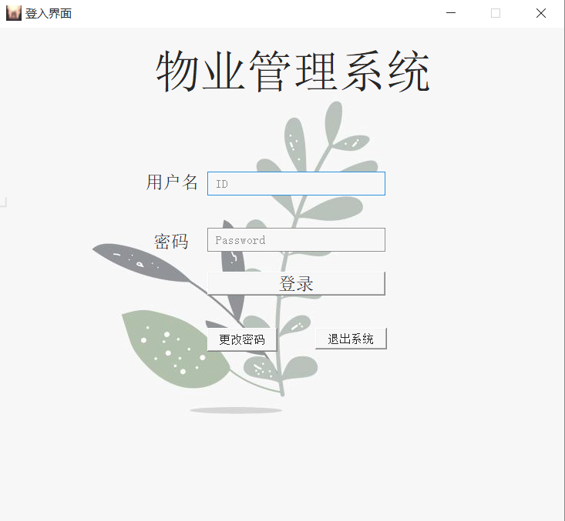

通过对输入的用户名和密码在数据库中查询后确定是否进入超级管理员界面、普通管理员界面、用户界面。

**相关代码：**

from PyQt5 import QtCore, QtGui, QtWidgets

from PyQt5.QtWidgets import *

import image.login_background

from change_password import *

import sys

class Ui_login(object):

def setupUi(self, MainWindow):

MainWindow.setObjectName("MainWindow")

MainWindow.resize(733, 644)

sizePolicy = QtWidgets.QSizePolicy(QtWidgets.QSizePolicy.Fixed, QtWidgets.QSizePolicy.Fixed)

sizePolicy.setHorizontalStretch(0)

sizePolicy.setVerticalStretch(0)

sizePolicy.setHeightForWidth(MainWindow.sizePolicy().hasHeightForWidth())

MainWindow.setSizePolicy(sizePolicy)

MainWindow.setMinimumSize(QtCore.QSize(733, 644))

MainWindow.setMaximumSize(QtCore.QSize(733, 644))

icon = QtGui.QIcon.fromTheme("D:\\python_projects\\DataBase\\image\\logo.png")

MainWindow.setWindowIcon(icon)

MainWindow.setWindowOpacity(0.85)

MainWindow.setStyleSheet(";\n"

"background-image: url(:/login_image/7.jpg);")

self.centralwidget = QtWidgets.QWidget(MainWindow)

sizePolicy = QtWidgets.QSizePolicy(QtWidgets.QSizePolicy.Fixed, QtWidgets.QSizePolicy.Fixed)

sizePolicy.setHorizontalStretch(0)

sizePolicy.setVerticalStretch(0)

sizePolicy.setHeightForWidth(self.centralwidget.sizePolicy().hasHeightForWidth())

self.centralwidget.setSizePolicy(sizePolicy)

self.centralwidget.setObjectName("centralwidget")

self.label_3 = QtWidgets.QLabel(self.centralwidget)

self.label_3.setGeometry(QtCore.QRect(200, 267, 51, 21))

self.label_3.setStyleSheet("font: 14pt \"Arial\";")

self.label_3.setObjectName("label_3")

self.pushButton_3 = QtWidgets.QPushButton(self.centralwidget)

self.pushButton_3.setGeometry(QtCore.QRect(410, 390, 93, 28))

self.pushButton_3.setObjectName("pushButton_3")

self.label_2 = QtWidgets.QLabel(self.centralwidget)

self.label_2.setGeometry(QtCore.QRect(190, 190, 71, 21))

self.label_2.setStyleSheet("font: 14pt \"Arial\";")

self.label_2.setObjectName("label_2")

self.lineEdit = QtWidgets.QLineEdit(self.centralwidget)

self.lineEdit.setGeometry(QtCore.QRect(270, 187, 231, 31))

sizePolicy = QtWidgets.QSizePolicy(QtWidgets.QSizePolicy.Fixed, QtWidgets.QSizePolicy.Fixed)

sizePolicy.setHorizontalStretch(0)

sizePolicy.setVerticalStretch(0)

sizePolicy.setHeightForWidth(self.lineEdit.sizePolicy().hasHeightForWidth())

self.lineEdit.setSizePolicy(sizePolicy)

self.lineEdit.setStyleSheet("background-color: qconicalgradient(cx:0.5, cy:0.5, angle:0, stop:0 rgba(35, 40, 3, 255), stop:0.16 rgba(136, 106, 22, 255), stop:0.225 rgba(166, 140, 41, 255), stop:0.285 rgba(204, 181, 74, 255), stop:0.345 rgba(235, 219, 102, 255), stop:0.415 rgba(245, 236, 112, 255), stop:0.52 rgba(209, 190, 76, 255), stop:0.57 rgba(187, 156, 51, 255), stop:0.635 rgba(168, 142, 42, 255), stop:0.695 rgba(202, 174, 68, 255), stop:0.75 rgba(218, 202, 86, 255), stop:0.815 rgba(208, 187, 73, 255), stop:0.88 rgba(187, 156, 51, 255), stop:0.935 rgba(137, 108, 26, 255), stop:1 rgba(35, 40, 3, 255));\n"

"background-color: rgb(255, 255, 255);")

self.lineEdit.setObjectName("lineEdit")

self.pushButton_2 = QtWidgets.QPushButton(self.centralwidget)

self.pushButton_2.setGeometry(QtCore.QRect(270, 390, 91, 31))

sizePolicy = QtWidgets.QSizePolicy(QtWidgets.QSizePolicy.Fixed, QtWidgets.QSizePolicy.Fixed)

sizePolicy.setHorizontalStretch(0)

sizePolicy.setVerticalStretch(0)

sizePolicy.setHeightForWidth(self.pushButton_2.sizePolicy().hasHeightForWidth())

self.pushButton_2.setSizePolicy(sizePolicy)

self.pushButton_2.setStyleSheet("")

self.pushButton_2.setObjectName("pushButton_2")

self.label = QtWidgets.QLabel(self.centralwidget)

self.label.setGeometry(QtCore.QRect(150, 27, 451, 61))

self.label.setStyleSheet("color: rgb(0, 0, 0);\n"

"font: 36pt \"Arial\";")

self.label.setObjectName("label")

self.pushButton = QtWidgets.QPushButton(self.centralwidget)

self.pushButton.setGeometry(QtCore.QRect(270, 317, 231, 31))

sizePolicy = QtWidgets.QSizePolicy(QtWidgets.QSizePolicy.Fixed, QtWidgets.QSizePolicy.Fixed)

sizePolicy.setHorizontalStretch(0)

sizePolicy.setVerticalStretch(0)

sizePolicy.setHeightForWidth(self.pushButton.sizePolicy().hasHeightForWidth())

self.pushButton.setSizePolicy(sizePolicy)

self.pushButton.setStyleSheet("font: 14pt \"Arial\";")

self.pushButton.setObjectName("pushButton")

self.lineEdit_2 = QtWidgets.QLineEdit(self.centralwidget)

self.lineEdit_2.setGeometry(QtCore.QRect(270, 260, 231, 31))

sizePolicy = QtWidgets.QSizePolicy(QtWidgets.QSizePolicy.Fixed, QtWidgets.QSizePolicy.Fixed)

sizePolicy.setHorizontalStretch(0)

sizePolicy.setVerticalStretch(0)

sizePolicy.setHeightForWidth(self.lineEdit_2.sizePolicy().hasHeightForWidth())

self.lineEdit_2.setSizePolicy(sizePolicy)

self.lineEdit_2.setStyleSheet("")

self.lineEdit_2.setText("")

self.lineEdit_2.setFrame(True)

self.lineEdit_2.setEchoMode(QtWidgets.QLineEdit.Password)

self.lineEdit_2.setObjectName("lineEdit_2")

MainWindow.setCentralWidget(self.centralwidget)

self.menubar = QtWidgets.QMenuBar(MainWindow)

self.menubar.setGeometry(QtCore.QRect(0, 0, 733, 26))

self.menubar.setObjectName("menubar")

MainWindow.setMenuBar(self.menubar)

self.statusbar = QtWidgets.QStatusBar(MainWindow)

self.statusbar.setObjectName("statusbar")

MainWindow.setStatusBar(self.statusbar)

self.retranslateUi(MainWindow)

QtCore.QMetaObject.connectSlotsByName(MainWindow)

def retranslateUi(self, MainWindow):

_translate = QtCore.QCoreApplication.translate

MainWindow.setWindowTitle(_translate("MainWindow", "登入界面"))

self.label_3.setText(_translate("MainWindow", "密码"))

self.pushButton_3.setText(_translate("MainWindow", "退出系统"))

self.label_2.setText(_translate("MainWindow", "用户名"))

self.lineEdit.setPlaceholderText(_translate("MainWindow", " ID"))

self.pushButton_2.setText(_translate("MainWindow", "更改密码"))

self.label.setText(_translate("MainWindow", " 物业管理系统"))

self.pushButton.setText(_translate("MainWindow", "登录"))

self.lineEdit_2.setPlaceholderText(_translate("MainWindow", " Password"))

2）修改密码界面

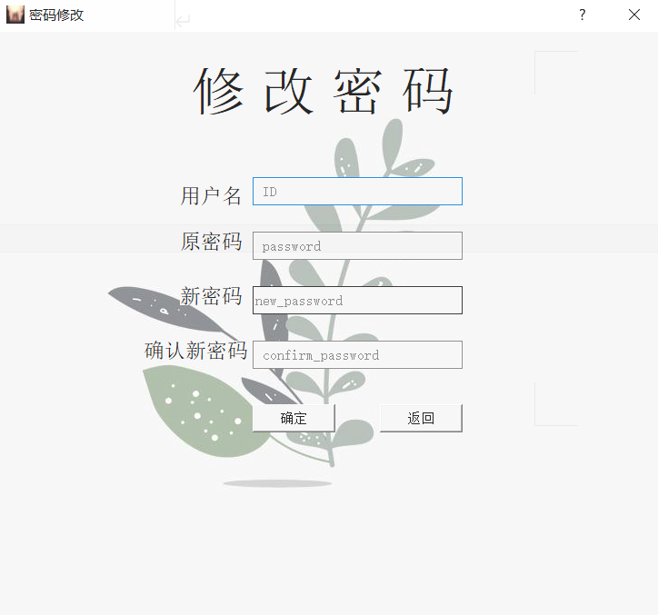

输入用户名、原密码、新密码确定密码的修改。

**相关代码：**

from PyQt5 import QtCore, QtGui, QtWidgets

import image.change_password

from PyQt5.QtWidgets import *

from change_password import *

import sys

class Ui_change_password(object):

def setupUi(self, Form):

Form.setObjectName("Form")

Form.resize(730, 644)

Form.setMinimumSize(QtCore.QSize(730, 644))

Form.setMaximumSize(QtCore.QSize(730, 644))

icon = QtGui.QIcon.fromTheme("D:\\python_projects\\DataBase\\image\\logo.png")

Form.setWindowIcon(icon)

Form.setWindowOpacity(0.85)

Form.setStyleSheet("background-image: url(:/background/7.jpg);")

self.label_2 = QtWidgets.QLabel(Form)

self.label_2.setGeometry(QtCore.QRect(200, 170, 71, 21))

self.label_2.setStyleSheet("font: 14pt \"Arial\";")

self.label_2.setObjectName("label_2")

self.lineEdit = QtWidgets.QLineEdit(Form)

self.lineEdit.setGeometry(QtCore.QRect(280, 160, 231, 31))

sizePolicy = QtWidgets.QSizePolicy(QtWidgets.QSizePolicy.Fixed, QtWidgets.QSizePolicy.Fixed)

sizePolicy.setHorizontalStretch(0)

sizePolicy.setVerticalStretch(0)

sizePolicy.setHeightForWidth(self.lineEdit.sizePolicy().hasHeightForWidth())

self.lineEdit.setSizePolicy(sizePolicy)

self.lineEdit.setStyleSheet("background-color: qconicalgradient(cx:0.5, cy:0.5, angle:0, stop:0 rgba(35, 40, 3, 255), stop:0.16 rgba(136, 106, 22, 255), stop:0.225 rgba(166, 140, 41, 255), stop:0.285 rgba(204, 181, 74, 255), stop:0.345 rgba(235, 219, 102, 255), stop:0.415 rgba(245, 236, 112, 255), stop:0.52 rgba(209, 190, 76, 255), stop:0.57 rgba(187, 156, 51, 255), stop:0.635 rgba(168, 142, 42, 255), stop:0.695 rgba(202, 174, 68, 255), stop:0.75 rgba(218, 202, 86, 255), stop:0.815 rgba(208, 187, 73, 255), stop:0.88 rgba(187, 156, 51, 255), stop:0.935 rgba(137, 108, 26, 255), stop:1 rgba(35, 40, 3, 255));\n"

"background-color: rgb(255, 255, 255);")

self.lineEdit.setObjectName("lineEdit")

self.lineEdit_2 = QtWidgets.QLineEdit(Form)

self.lineEdit_2.setGeometry(QtCore.QRect(280, 220, 231, 31))

sizePolicy = QtWidgets.QSizePolicy(QtWidgets.QSizePolicy.Fixed, QtWidgets.QSizePolicy.Fixed)

sizePolicy.setHorizontalStretch(0)

sizePolicy.setVerticalStretch(0)

sizePolicy.setHeightForWidth(self.lineEdit_2.sizePolicy().hasHeightForWidth())

self.lineEdit_2.setSizePolicy(sizePolicy)

self.lineEdit_2.setStyleSheet("background-color: qconicalgradient(cx:0.5, cy:0.5, angle:0, stop:0 rgba(35, 40, 3, 255), stop:0.16 rgba(136, 106, 22, 255), stop:0.225 rgba(166, 140, 41, 255), stop:0.285 rgba(204, 181, 74, 255), stop:0.345 rgba(235, 219, 102, 255), stop:0.415 rgba(245, 236, 112, 255), stop:0.52 rgba(209, 190, 76, 255), stop:0.57 rgba(187, 156, 51, 255), stop:0.635 rgba(168, 142, 42, 255), stop:0.695 rgba(202, 174, 68, 255), stop:0.75 rgba(218, 202, 86, 255), stop:0.815 rgba(208, 187, 73, 255), stop:0.88 rgba(187, 156, 51, 255), stop:0.935 rgba(137, 108, 26, 255), stop:1 rgba(35, 40, 3, 255));\n"

"background-color: rgb(255, 255, 255);")

self.lineEdit_2.setEchoMode(QtWidgets.QLineEdit.Password)

self.lineEdit_2.setObjectName("lineEdit_2")

self.label_3 = QtWidgets.QLabel(Form)

self.label_3.setGeometry(QtCore.QRect(160, 340, 121, 21))

self.label_3.setStyleSheet("font: 14pt \"Arial\";")

self.label_3.setObjectName("label_3")

self.lineEdit_3 = QtWidgets.QLineEdit(Form)

self.lineEdit_3.setGeometry(QtCore.QRect(280, 280, 231, 31))

sizePolicy = QtWidgets.QSizePolicy(QtWidgets.QSizePolicy.Fixed, QtWidgets.QSizePolicy.Fixed)

sizePolicy.setHorizontalStretch(0)

sizePolicy.setVerticalStretch(0)

sizePolicy.setHeightForWidth(self.lineEdit_3.sizePolicy().hasHeightForWidth())

self.lineEdit_3.setSizePolicy(sizePolicy)

self.lineEdit_3.setStyleSheet("background-color: qconicalgradient(cx:0.5, cy:0.5, angle:0, stop:0 rgba(35, 40, 3, 255), stop:0.16 rgba(136, 106, 22, 255), stop:0.225 rgba(166, 140, 41, 255), stop:0.285 rgba(204, 181, 74, 255), stop:0.345 rgba(235, 219, 102, 255), stop:0.415 rgba(245, 236, 112, 255), stop:0.52 rgba(209, 190, 76, 255), stop:0.57 rgba(187, 156, 51, 255), stop:0.635 rgba(168, 142, 42, 255), stop:0.695 rgba(202, 174, 68, 255), stop:0.75 rgba(218, 202, 86, 255), stop:0.815 rgba(208, 187, 73, 255), stop:0.88 rgba(187, 156, 51, 255), stop:0.935 rgba(137, 108, 26, 255), stop:1 rgba(35, 40, 3, 255));\n"

"background-color: rgb(255, 255, 255);")

self.lineEdit_3.setEchoMode(QtWidgets.QLineEdit.Password)

self.lineEdit_3.setObjectName("lineEdit_3")

self.label_4 = QtWidgets.QLabel(Form)

self.label_4.setGeometry(QtCore.QRect(200, 280, 71, 21))

self.label_4.setStyleSheet("font: 14pt \"Arial\";")

self.label_4.setObjectName("label_4")

self.lineEdit_4 = QtWidgets.QLineEdit(Form)

self.lineEdit_4.setGeometry(QtCore.QRect(280, 340, 231, 31))

sizePolicy = QtWidgets.QSizePolicy(QtWidgets.QSizePolicy.Fixed, QtWidgets.QSizePolicy.Fixed)

sizePolicy.setHorizontalStretch(0)

sizePolicy.setVerticalStretch(0)

sizePolicy.setHeightForWidth(self.lineEdit_4.sizePolicy().hasHeightForWidth())

self.lineEdit_4.setSizePolicy(sizePolicy)

self.lineEdit_4.setStyleSheet("background-color: qconicalgradient(cx:0.5, cy:0.5, angle:0, stop:0 rgba(35, 40, 3, 255), stop:0.16 rgba(136, 106, 22, 255), stop:0.225 rgba(166, 140, 41, 255), stop:0.285 rgba(204, 181, 74, 255), stop:0.345 rgba(235, 219, 102, 255), stop:0.415 rgba(245, 236, 112, 255), stop:0.52 rgba(209, 190, 76, 255), stop:0.57 rgba(187, 156, 51, 255), stop:0.635 rgba(168, 142, 42, 255), stop:0.695 rgba(202, 174, 68, 255), stop:0.75 rgba(218, 202, 86, 255), stop:0.815 rgba(208, 187, 73, 255), stop:0.88 rgba(187, 156, 51, 255), stop:0.935 rgba(137, 108, 26, 255), stop:1 rgba(35, 40, 3, 255));\n"

"background-color: rgb(255, 255, 255);")

self.lineEdit_4.setEchoMode(QtWidgets.QLineEdit.Password)

self.lineEdit_4.setObjectName("lineEdit_4")

self.label_5 = QtWidgets.QLabel(Form)

self.label_5.setGeometry(QtCore.QRect(200, 220, 71, 21))

self.label_5.setStyleSheet("font: 14pt \"Arial\";")

self.label_5.setObjectName("label_5")

self.pushButton = QtWidgets.QPushButton(Form)

self.pushButton.setGeometry(QtCore.QRect(280, 410, 91, 31))

self.pushButton.setObjectName("pushButton")

self.pushButton_2 = QtWidgets.QPushButton(Form)

self.pushButton_2.setGeometry(QtCore.QRect(420, 410, 91, 31))

self.pushButton_2.setObjectName("pushButton_2")

self.label = QtWidgets.QLabel(Form)

self.label.setGeometry(QtCore.QRect(110, 40, 471, 51))

self.label.setStyleSheet("color: rgb(0, 0, 0);\n"

"font: 36pt \"Arial\";")

self.label.setObjectName("label")

self.retranslateUi(Form)

QtCore.QMetaObject.connectSlotsByName(Form)

def retranslateUi(self, Form):

_translate = QtCore.QCoreApplication.translate

Form.setWindowTitle(_translate("Form", "密码修改"))

self.label_2.setText(_translate("Form", "用户名"))

self.lineEdit.setPlaceholderText(_translate("Form", " ID"))

self.lineEdit_2.setPlaceholderText(_translate("Form", " password"))

self.label_3.setText(_translate("Form", "确认新密码"))

self.lineEdit_3.setPlaceholderText(_translate("Form", "new_password"))

self.label_4.setText(_translate("Form", "新密码"))

self.lineEdit_4.setPlaceholderText(_translate("Form", " confirm_password"))

self.label_5.setText(_translate("Form", "原密码"))

self.pushButton.setText(_translate("Form", "确定"))

self.pushButton_2.setText(_translate("Form", "返回"))

self.label.setText(_translate("Form", " 修 改 密 码"))

3）超级管理员界面

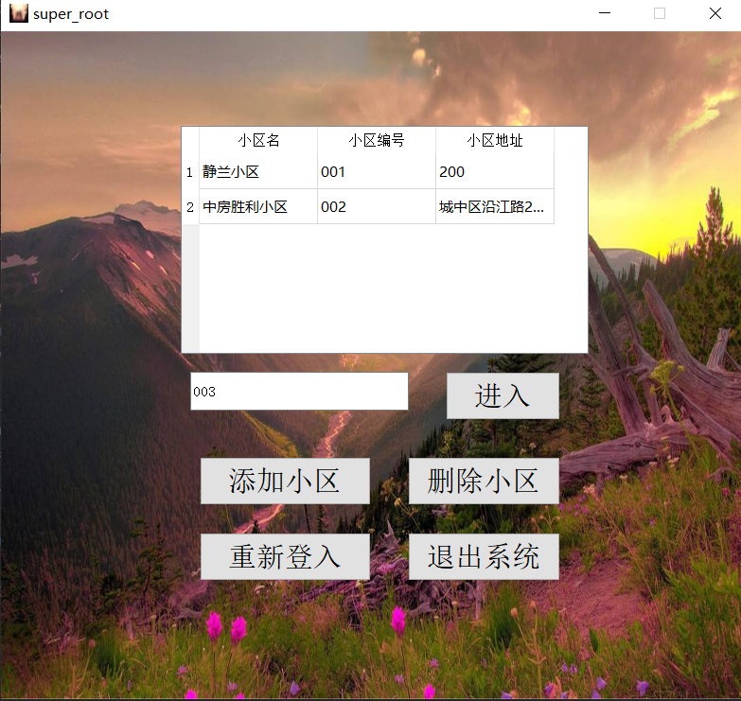

添加小区编号，点击进入不同小区界面。

**相关代码：**

from PyQt5 import QtCore, QtGui, QtWidgets

import image.super_root

class Ui_super_root(object):

def setupUi(self, MainWindow):

MainWindow.setObjectName("MainWindow")

MainWindow.resize(785, 706)

MainWindow.setMinimumSize(QtCore.QSize(785, 706))

MainWindow.setMaximumSize(QtCore.QSize(785, 706))

MainWindow.setWindowOpacity(1.0)

MainWindow.setStyleSheet("#centralwidget{border-image: url(:/background/background1.jpg);}")

self.centralwidget = QtWidgets.QWidget(MainWindow)

self.centralwidget.setObjectName("centralwidget")

self.lineEdit = QtWidgets.QLineEdit(self.centralwidget)

self.lineEdit.setGeometry(QtCore.QRect(200, 360, 231, 41))

self.lineEdit.setObjectName("lineEdit")

self.pushButton = QtWidgets.QPushButton(self.centralwidget)

self.pushButton.setGeometry(QtCore.QRect(470, 360, 121, 51))

self.pushButton.setStyleSheet("font: 18pt \"Arial\";")

self.pushButton.setObjectName("pushButton")

self.pushButton_2 = QtWidgets.QPushButton(self.centralwidget)

self.pushButton_2.setGeometry(QtCore.QRect(210, 450, 181, 51))

self.pushButton_2.setStyleSheet("font: 18pt \"Arial\";")

self.pushButton_2.setObjectName("pushButton_2")

self.pushButton_3 = QtWidgets.QPushButton(self.centralwidget)

self.pushButton_3.setGeometry(QtCore.QRect(430, 450, 161, 51))

self.pushButton_3.setStyleSheet("font: 18pt \"Arial\";")

self.pushButton_3.setObjectName("pushButton_3")

self.pushButton_4 = QtWidgets.QPushButton(self.centralwidget)

self.pushButton_4.setGeometry(QtCore.QRect(210, 530, 181, 51))

self.pushButton_4.setStyleSheet("font: 18pt \"Arial\";")

self.pushButton_4.setObjectName("pushButton_4")

self.pushButton_5 = QtWidgets.QPushButton(self.centralwidget)

self.pushButton_5.setGeometry(QtCore.QRect(430, 530, 161, 51))

self.pushButton_5.setStyleSheet("font: 18pt \"Arial\";")

self.pushButton_5.setObjectName("pushButton_5")

self.tableWidget = QtWidgets.QTableWidget(self.centralwidget)

self.tableWidget.setGeometry(QtCore.QRect(190, 100, 431, 241))

self.tableWidget.setObjectName("tableWidget")

self.tableWidget.setColumnCount(3)

self.tableWidget.setRowCount(10)

item = QtWidgets.QTableWidgetItem()

self.tableWidget.setVerticalHeaderItem(0, item)

item = QtWidgets.QTableWidgetItem()

self.tableWidget.setVerticalHeaderItem(1, item)

item = QtWidgets.QTableWidgetItem()

self.tableWidget.setVerticalHeaderItem(2, item)

item = QtWidgets.QTableWidgetItem()

self.tableWidget.setVerticalHeaderItem(3, item)

item = QtWidgets.QTableWidgetItem()

self.tableWidget.setVerticalHeaderItem(4, item)

item = QtWidgets.QTableWidgetItem()

self.tableWidget.setVerticalHeaderItem(5, item)

item = QtWidgets.QTableWidgetItem()

self.tableWidget.setVerticalHeaderItem(6, item)

item = QtWidgets.QTableWidgetItem()

self.tableWidget.setVerticalHeaderItem(7, item)

item = QtWidgets.QTableWidgetItem()

self.tableWidget.setVerticalHeaderItem(8, item)

item = QtWidgets.QTableWidgetItem()

self.tableWidget.setVerticalHeaderItem(9, item)

item = QtWidgets.QTableWidgetItem()

self.tableWidget.setHorizontalHeaderItem(0, item)

item = QtWidgets.QTableWidgetItem()

self.tableWidget.setHorizontalHeaderItem(1, item)

item = QtWidgets.QTableWidgetItem()

self.tableWidget.setHorizontalHeaderItem(2, item)

MainWindow.setCentralWidget(self.centralwidget)

self.retranslateUi(MainWindow)

QtCore.QMetaObject.connectSlotsByName(MainWindow)

def retranslateUi(self, MainWindow):

_translate = QtCore.QCoreApplication.translate

MainWindow.setWindowTitle(_translate("MainWindow", "super_root"))

self.lineEdit.setPlaceholderText(_translate("MainWindow", "请输入小区编号"))

self.pushButton.setText(_translate("MainWindow", "进入"))

self.pushButton_2.setText(_translate("MainWindow", "添加小区"))

self.pushButton_3.setText(_translate("MainWindow", "删除小区"))

self.pushButton_4.setText(_translate("MainWindow", "重新登入"))

self.pushButton_5.setText(_translate("MainWindow", "退出系统"))

item = self.tableWidget.verticalHeaderItem(0)

item.setText(_translate("MainWindow", "1"))

item = self.tableWidget.verticalHeaderItem(1)

item.setText(_translate("MainWindow", "2"))

item = self.tableWidget.verticalHeaderItem(2)

item.setText(_translate("MainWindow", "3"))

item = self.tableWidget.verticalHeaderItem(3)

item.setText(_translate("MainWindow", "4"))

item = self.tableWidget.verticalHeaderItem(4)

item.setText(_translate("MainWindow", "5"))

item = self.tableWidget.verticalHeaderItem(5)

item.setText(_translate("MainWindow", "6"))

item = self.tableWidget.verticalHeaderItem(6)

item.setText(_translate("MainWindow", "7"))

item = self.tableWidget.verticalHeaderItem(7)

item.setText(_translate("MainWindow", "8"))

item = self.tableWidget.verticalHeaderItem(8)

item.setText(_translate("MainWindow", "9"))

item = self.tableWidget.verticalHeaderItem(9)

item.setText(_translate("MainWindow", "10"))

item = self.tableWidget.horizontalHeaderItem(0)

item.setText(_translate("MainWindow", "小区名"))

item = self.tableWidget.horizontalHeaderItem(1)

item.setText(_translate("MainWindow", "小区编号"))

item = self.tableWidget.horizontalHeaderItem(2)

item.setText(_translate("MainWindow", "小区地址"))

4）普通管理员界面

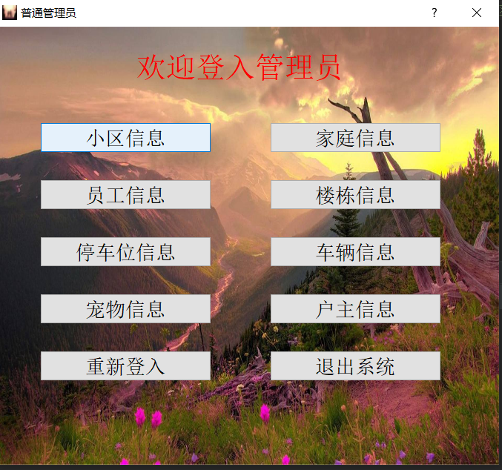

点击不同的按钮进入不同的信息界面进行相应信息的增删查改。

**相关代码：**

from PyQt5 import QtCore, QtGui, QtWidgets

import image.root_community

class Ui_root_community(object):

def setupUi(self, MainWindow):

MainWindow.setObjectName("MainWindow")

MainWindow.resize(1163, 882)

MainWindow.setMinimumSize(QtCore.QSize(1163, 882))

MainWindow.setMaximumSize(QtCore.QSize(1163, 882))

MainWindow.setStyleSheet("#centralwidget{border-image: url(:/background/background1.jpg);}")

self.centralwidget = QtWidgets.QWidget(MainWindow)

self.centralwidget.setObjectName("centralwidget")

self.tableWidget = QtWidgets.QTableWidget(self.centralwidget)

self.tableWidget.setGeometry(QtCore.QRect(130, 140, 881, 131))

self.tableWidget.setAlternatingRowColors(True)

self.tableWidget.setObjectName("tableWidget")

self.tableWidget.setColumnCount(11)

self.tableWidget.setRowCount(0)

item = QtWidgets.QTableWidgetItem()

self.tableWidget.setHorizontalHeaderItem(0, item)

item = QtWidgets.QTableWidgetItem()

self.tableWidget.setHorizontalHeaderItem(1, item)

item = QtWidgets.QTableWidgetItem()

self.tableWidget.setHorizontalHeaderItem(2, item)

item = QtWidgets.QTableWidgetItem()

self.tableWidget.setHorizontalHeaderItem(3, item)

item = QtWidgets.QTableWidgetItem()

self.tableWidget.setHorizontalHeaderItem(4, item)

item = QtWidgets.QTableWidgetItem()

self.tableWidget.setHorizontalHeaderItem(5, item)

item = QtWidgets.QTableWidgetItem()

self.tableWidget.setHorizontalHeaderItem(6, item)

item = QtWidgets.QTableWidgetItem()

self.tableWidget.setHorizontalHeaderItem(7, item)

item = QtWidgets.QTableWidgetItem()

self.tableWidget.setHorizontalHeaderItem(8, item)

item = QtWidgets.QTableWidgetItem()

self.tableWidget.setHorizontalHeaderItem(9, item)

item = QtWidgets.QTableWidgetItem()

self.tableWidget.setHorizontalHeaderItem(10, item)

self.lineEdit = QtWidgets.QLineEdit(self.centralwidget)

self.lineEdit.setGeometry(QtCore.QRect(130, 280, 231, 51))

self.lineEdit.setObjectName("lineEdit")

self.lineEdit_2 = QtWidgets.QLineEdit(self.centralwidget)

self.lineEdit_2.setGeometry(QtCore.QRect(410, 280, 271, 51))

self.lineEdit_2.setObjectName("lineEdit_2")

self.lineEdit_3 = QtWidgets.QLineEdit(self.centralwidget)

self.lineEdit_3.setGeometry(QtCore.QRect(750, 280, 271, 51))

self.lineEdit_3.setObjectName("lineEdit_3")

self.lineEdit_4 = QtWidgets.QLineEdit(self.centralwidget)

self.lineEdit_4.setGeometry(QtCore.QRect(130, 370, 231, 51))

self.lineEdit_4.setObjectName("lineEdit_4")

self.lineEdit_5 = QtWidgets.QLineEdit(self.centralwidget)

self.lineEdit_5.setGeometry(QtCore.QRect(410, 370, 271, 51))

self.lineEdit_5.setObjectName("lineEdit_5")

self.pushButton_3 = QtWidgets.QPushButton(self.centralwidget)

self.pushButton_3.setGeometry(QtCore.QRect(620, 610, 401, 81))

self.pushButton_3.setStyleSheet("font: 18pt \"Arial\";")

self.pushButton_3.setObjectName("pushButton_3")

self.pushButton_4 = QtWidgets.QPushButton(self.centralwidget)

self.pushButton_4.setGeometry(QtCore.QRect(120, 720, 401, 81))

self.pushButton_4.setStyleSheet("font: 18pt \"Arial\";")

self.pushButton_4.setObjectName("pushButton_4")

self.pushButton_6 = QtWidgets.QPushButton(self.centralwidget)

self.pushButton_6.setGeometry(QtCore.QRect(620, 720, 401, 81))

self.pushButton_6.setStyleSheet("font: 18pt \"Arial\";")

self.pushButton_6.setObjectName("pushButton_6")

self.label = QtWidgets.QLabel(self.centralwidget)

self.label.setGeometry(QtCore.QRect(460, 70, 281, 51))

self.label.setStyleSheet("font: 28pt \"Arial\";")

self.label.setObjectName("label")

self.pushButton_2 = QtWidgets.QPushButton(self.centralwidget)

self.pushButton_2.setGeometry(QtCore.QRect(120, 610, 401, 81))

self.pushButton_2.setStyleSheet("font: 18pt \"Arial\";")

self.pushButton_2.setObjectName("pushButton_2")

self.pushButton_1 = QtWidgets.QPushButton(self.centralwidget)

self.pushButton_1.setGeometry(QtCore.QRect(130, 80, 131, 51))

self.pushButton_1.setStyleSheet("font: 18pt \"Arial\";")

self.pushButton_1.setObjectName("pushButton_1")

self.lineEdit_6 = QtWidgets.QLineEdit(self.centralwidget)

self.lineEdit_6.setGeometry(QtCore.QRect(750, 360, 271, 51))

self.lineEdit_6.setObjectName("lineEdit_6")

self.lineEdit_7 = QtWidgets.QLineEdit(self.centralwidget)

self.lineEdit_7.setGeometry(QtCore.QRect(130, 450, 231, 51))

self.lineEdit_7.setObjectName("lineEdit_7")

self.lineEdit_8 = QtWidgets.QLineEdit(self.centralwidget)

self.lineEdit_8.setGeometry(QtCore.QRect(410, 450, 271, 51))

self.lineEdit_8.setObjectName("lineEdit_8")

self.lineEdit_9 = QtWidgets.QLineEdit(self.centralwidget)

self.lineEdit_9.setGeometry(QtCore.QRect(750, 450, 271, 51))

self.lineEdit_9.setObjectName("lineEdit_9")

self.lineEdit_10 = QtWidgets.QLineEdit(self.centralwidget)

self.lineEdit_10.setGeometry(QtCore.QRect(270, 530, 231, 51))

self.lineEdit_10.setObjectName("lineEdit_10")

self.lineEdit_11 = QtWidgets.QLineEdit(self.centralwidget)

self.lineEdit_11.setGeometry(QtCore.QRect(600, 530, 251, 51))

self.lineEdit_11.setObjectName("lineEdit_11")

MainWindow.setCentralWidget(self.centralwidget)

self.retranslateUi(MainWindow)

QtCore.QMetaObject.connectSlotsByName(MainWindow)

def retranslateUi(self, MainWindow):

_translate = QtCore.QCoreApplication.translate

MainWindow.setWindowTitle(_translate("MainWindow", "root_小区信息"))

item = self.tableWidget.horizontalHeaderItem(0)

item.setText(_translate("MainWindow", "小区编号"))

item = self.tableWidget.horizontalHeaderItem(1)

item.setText(_translate("MainWindow", "小区名"))

item = self.tableWidget.horizontalHeaderItem(2)

item.setText(_translate("MainWindow", "开发商"))

item = self.tableWidget.horizontalHeaderItem(3)

item.setText(_translate("MainWindow", "小区面积"))

item = self.tableWidget.horizontalHeaderItem(4)

item.setText(_translate("MainWindow", "小区员工数量"))

item = self.tableWidget.horizontalHeaderItem(5)

item.setText(_translate("MainWindow", "小区地址"))

item = self.tableWidget.horizontalHeaderItem(6)

item.setText(_translate("MainWindow", "小区住户数量"))

item = self.tableWidget.horizontalHeaderItem(7)

item.setText(_translate("MainWindow", "小区停车位数量"))

item = self.tableWidget.horizontalHeaderItem(8)

item.setText(_translate("MainWindow", "小区宠物数量"))

item = self.tableWidget.horizontalHeaderItem(9)

item.setText(_translate("MainWindow", "小区楼栋数量"))

item = self.tableWidget.horizontalHeaderItem(10)

item.setText(_translate("MainWindow", "小区车辆数量"))

self.lineEdit.setPlaceholderText(_translate("MainWindow", "请输入小区编号"))

self.lineEdit_2.setPlaceholderText(_translate("MainWindow", "请输入小区名"))

self.lineEdit_3.setPlaceholderText(_translate("MainWindow", "请输入开发商"))

self.lineEdit_4.setPlaceholderText(_translate("MainWindow", "请输入小区面积"))

self.lineEdit_5.setPlaceholderText(_translate("MainWindow", "请输入小区员工数量"))

self.pushButton_3.setText(_translate("MainWindow", "更改"))

self.pushButton_4.setText(_translate("MainWindow", "返回"))

self.pushButton_6.setText(_translate("MainWindow", "退出系统"))

self.label.setText(_translate("MainWindow", " 小区信息"))

self.pushButton_2.setText(_translate("MainWindow", "全部查询"))

self.pushButton_1.setText(_translate("MainWindow", "清屏"))

self.lineEdit_6.setPlaceholderText(_translate("MainWindow", "请输入小区地址"))

self.lineEdit_7.setPlaceholderText(_translate("MainWindow", "请输入小区住户数量"))

self.lineEdit_8.setPlaceholderText(_translate("MainWindow", "请输入小区停车位数量"))

self.lineEdit_9.setPlaceholderText(_translate("MainWindow", "请输入小区宠物数量"))

self.lineEdit_10.setPlaceholderText(_translate("MainWindow", "请输入小区楼栋"))

self.lineEdit_11.setPlaceholderText(_translate("MainWindow", "请输入小区车辆"))

5）用户界面

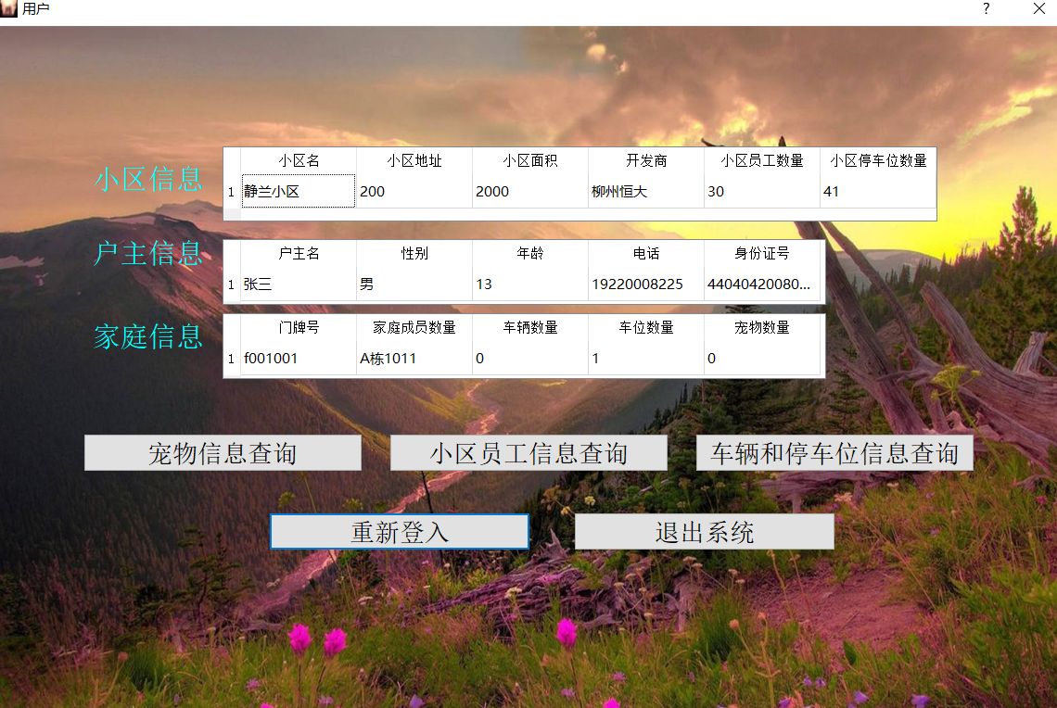

用户界面会自动判断当前登入用户属于哪个小区，并在打开时自动显示小区信息，户主信息，家庭信息。用户手动点击相关信息按钮查询自身相关信息。

**相关代码：**

from PyQt5 import QtCore, QtGui, QtWidgets

import image.root

class Ui_root(object):

def setupUi(self, Form):

Form.setObjectName("Form")

Form.resize(679, 591)

Form.setMinimumSize(QtCore.QSize(679, 591))

Form.setMaximumSize(QtCore.QSize(679, 591))

Form.setStyleSheet("#Form{border-image: url(:/background/background1.jpg);}")

self.label = QtWidgets.QLabel(Form)

self.label.setGeometry(QtCore.QRect(190, 30, 291, 51))

self.label.setStyleSheet("font: 24pt \"Arial\";\n"

"color: rgb(255, 0, 0);")

self.label.setObjectName("label")

self.widget = QtWidgets.QWidget(Form)

self.widget.setGeometry(QtCore.QRect(60, 100, 231, 411))

self.widget.setObjectName("widget")

self.verticalLayout = QtWidgets.QVBoxLayout(self.widget)

self.verticalLayout.setContentsMargins(0, 0, 0, 0)

self.verticalLayout.setObjectName("verticalLayout")

self.pushButton = QtWidgets.QPushButton(self.widget)

self.pushButton.setStyleSheet("font: 16pt \"Arial\";")

self.pushButton.setObjectName("pushButton")

self.verticalLayout.addWidget(self.pushButton)

self.pushButton_3 = QtWidgets.QPushButton(self.widget)

self.pushButton_3.setStyleSheet("font: 16pt \"Arial\";")

self.pushButton_3.setObjectName("pushButton_3")

self.verticalLayout.addWidget(self.pushButton_3)

self.pushButton_5 = QtWidgets.QPushButton(self.widget)

self.pushButton_5.setStyleSheet("font: 16pt \"Arial\";")

self.pushButton_5.setObjectName("pushButton_5")

self.verticalLayout.addWidget(self.pushButton_5)

self.pushButton_7 = QtWidgets.QPushButton(self.widget)

self.pushButton_7.setStyleSheet("font: 16pt \"Arial\";")

self.pushButton_7.setObjectName("pushButton_7")

self.verticalLayout.addWidget(self.pushButton_7)

self.pushButton_9 = QtWidgets.QPushButton(self.widget)

self.pushButton_9.setStyleSheet("font: 16pt \"Arial\";")

self.pushButton_9.setObjectName("pushButton_9")

self.verticalLayout.addWidget(self.pushButton_9)

self.widget1 = QtWidgets.QWidget(Form)

self.widget1.setGeometry(QtCore.QRect(370, 100, 231, 411))

self.widget1.setObjectName("widget1")

self.verticalLayout_2 = QtWidgets.QVBoxLayout(self.widget1)

self.verticalLayout_2.setContentsMargins(0, 0, 0, 0)

self.verticalLayout_2.setObjectName("verticalLayout_2")

self.pushButton_2 = QtWidgets.QPushButton(self.widget1)

self.pushButton_2.setStyleSheet("font: 16pt \"Arial\";")

self.pushButton_2.setObjectName("pushButton_2")

self.verticalLayout_2.addWidget(self.pushButton_2)

self.pushButton_4 = QtWidgets.QPushButton(self.widget1)

self.pushButton_4.setStyleSheet("font: 16pt \"Arial\";")

self.pushButton_4.setObjectName("pushButton_4")

self.verticalLayout_2.addWidget(self.pushButton_4)

self.pushButton_6 = QtWidgets.QPushButton(self.widget1)

self.pushButton_6.setStyleSheet("font: 16pt \"Arial\";")

self.pushButton_6.setObjectName("pushButton_6")

self.verticalLayout_2.addWidget(self.pushButton_6)

self.pushButton_8 = QtWidgets.QPushButton(self.widget1)

self.pushButton_8.setStyleSheet("font: 16pt \"Arial\";")

self.pushButton_8.setObjectName("pushButton_8")

self.verticalLayout_2.addWidget(self.pushButton_8)

self.pushButton_10 = QtWidgets.QPushButton(self.widget1)

self.pushButton_10.setStyleSheet("font: 16pt \"Arial\";")

self.pushButton_10.setObjectName("pushButton_10")

self.verticalLayout_2.addWidget(self.pushButton_10)

self.retranslateUi(Form)

QtCore.QMetaObject.connectSlotsByName(Form)

def retranslateUi(self, Form):

_translate = QtCore.QCoreApplication.translate

Form.setWindowTitle(_translate("Form", "普通管理员"))

self.label.setText(_translate("Form", "欢迎登入管理员"))

self.pushButton.setText(_translate("Form", "小区信息"))

self.pushButton_3.setText(_translate("Form", "员工信息"))

self.pushButton_5.setText(_translate("Form", "停车位信息"))

self.pushButton_7.setText(_translate("Form", "宠物信息"))

self.pushButton_9.setText(_translate("Form", "重新登入"))

self.pushButton_2.setText(_translate("Form", "家庭信息"))

self.pushButton_4.setText(_translate("Form", "楼栋信息"))

self.pushButton_6.setText(_translate("Form", "车辆信息"))

self.pushButton_8.setText(_translate("Form", "户主信息"))

self.pushButton_10.setText(_translate("Form", "退出系统"))

# 5测试用例

# 6作业总结

通过这次的《物业公司管理系统》数据库课程设计，我们学习并掌握了pyqt5 designer、pycharm、pymysql、mysql的简单使用 ，了解到了数据库设计在计算机领域的重要性。数据库作为一个永久存储形式在应用中发挥着重要的作用。

对于数据库的设计，应先做好需求分析和功能设计，设计好E-R图后根据E-R图转换的关系模式建立基本表。连接数据库，程序源代码与数据库的联系都很重要。此外还掌握概念关系数据模型的数据结构和基本术语，关系模型的完整性约束和关系代数运算。重点是关系模式完整性的分类和功能，以及关系代数中集合运算和关系运算。 对集成环境、一些控件的使用和界面的美化方面更加熟悉。因为《物业公司管理系统》中涉及到很多控件的使用，只有很好的使用这些控件才可以给出一个很好的界面呈现在用户的面前。这样更有利于数据库和用户之间的交流

# 附 录

（带注释的源程序。只要经典代码、核心代码）

小组成员任务清单

|  |  |  |
| --- | --- | --- |
| 组员 | 任务分工 | 评分 |
| 万强 | **需求分析、设计E-R图和界面，实现数据库功能与界面各控件之间关联功能** |  |
| 陈纪鸿 | **建立基本表，实现数据库的添加、查询、删除、修改与功能** |  |