University Wellness Program Website

**Work Done:** Admin Panel

This is the first month progress in creating the admin Panel.Below are the work done

* Creating super users (Admin)
* Creating a rough forum where questions can be put
* Creating Accounts for Staffs and Students within the admin panel

**Login page:**

1. 127.0.0.1.8000 is the local url for the website 127.0.0.1.8000 /admin shows the admin panel of the website
2. **Email id** of the admin
3. **Password** that was created while creating the superuser(admin)

**Note:** The page for sign up is still under work and this user was created using code.

* 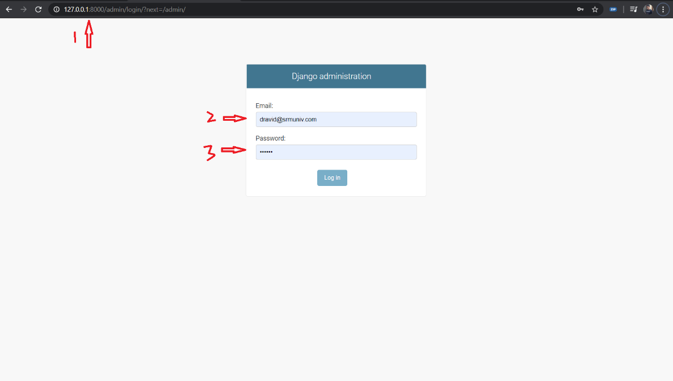

**Admin Page:**

**Three models where created as of now , below are the three**

Once logged in, the admin page will have the following as of now,

* **Accounts** – as in all the students and staffs account
* **Authentication and Authorization** – will list the level of access each group or individual has over the website.
* **Personal** – will consist of all the questions (This can be used to post FAQs about the website and the program)
* 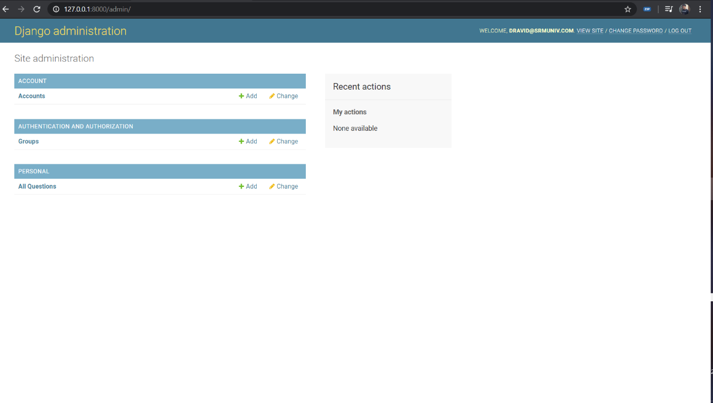

**Adding new account:**

**Note:** This still has corrections to do

The necessary credentials about the user is entered and listed whether the user is a staff, admin or a student (yet to add)

* 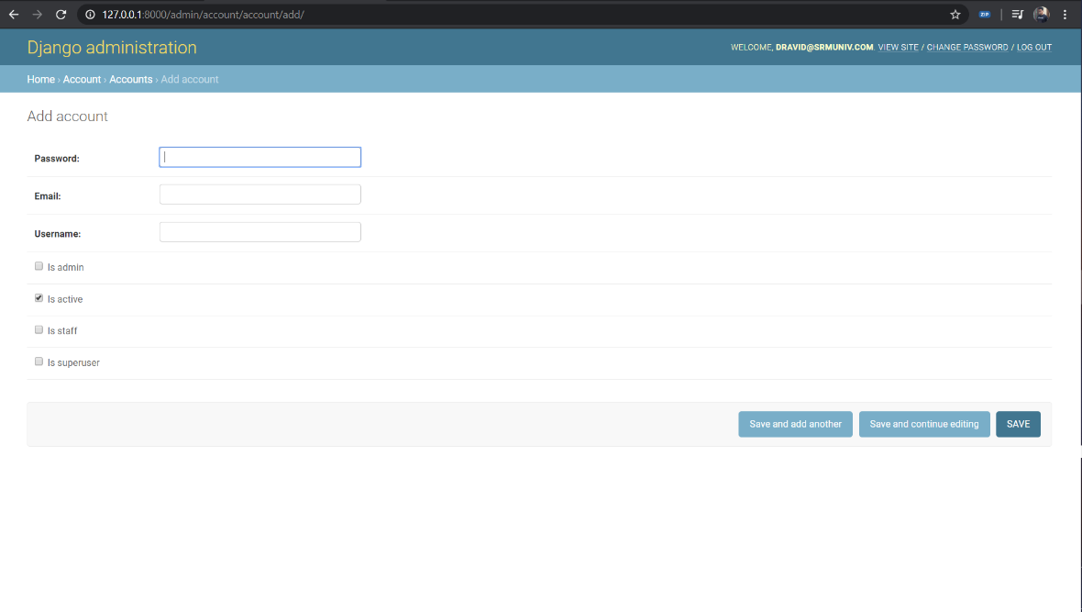
* After **creating an Account:**
  + 1. Current user
  + 2. List of accounts (only the admin can see this)
  + 3. Option to add new account

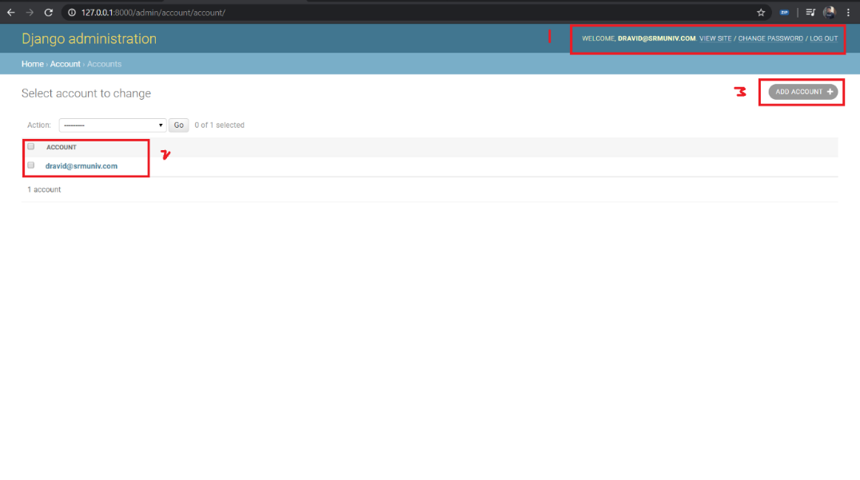

**Add Questions or Blog posts:**

* **Title** of the Blog or Question (topic)
* **Question** or about the post briefly
* **Priority** of the question or blog ( depends on the topic the importance will be classified by the admin)

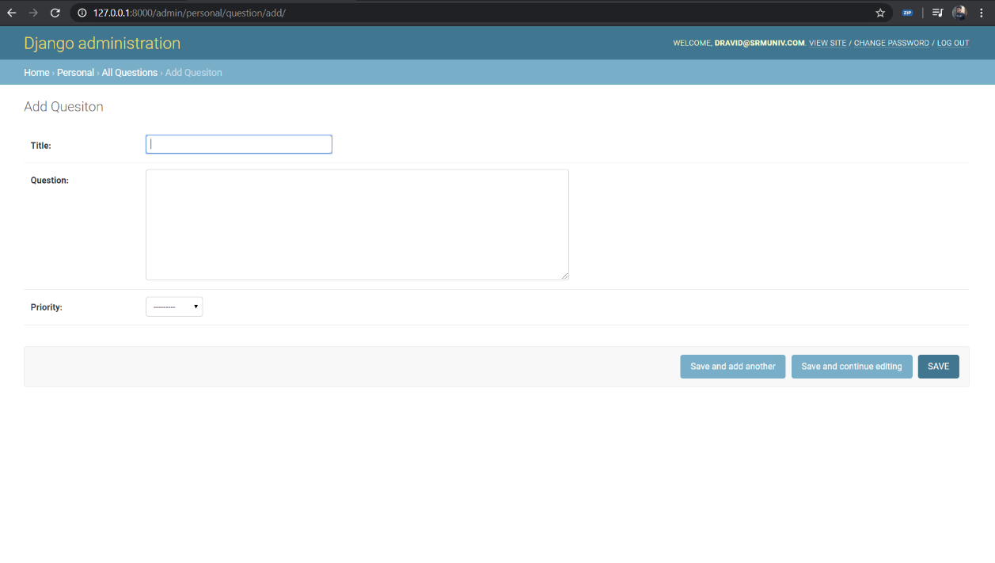

* After adding a question or a Post

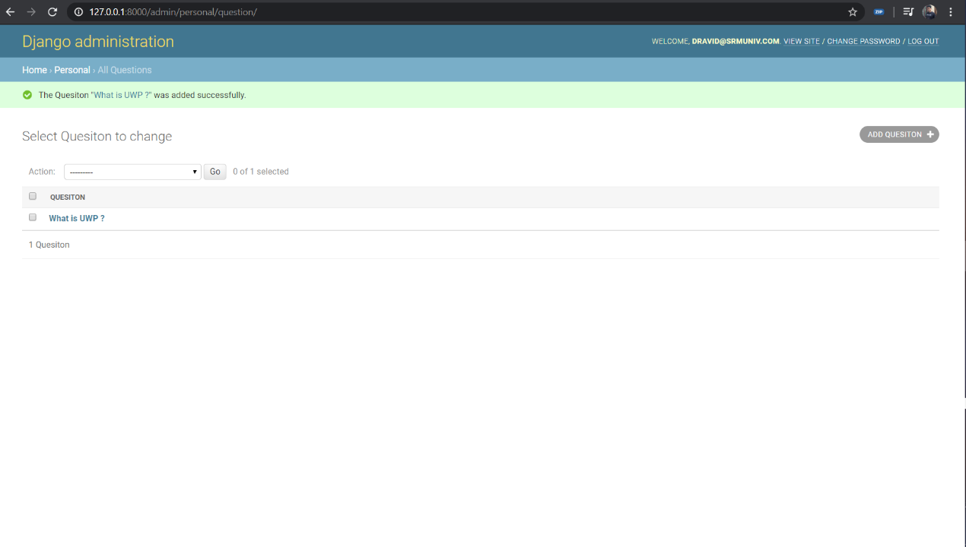

**Adding groups**

Add collaboration between student and staffs in a separate group to work with

* 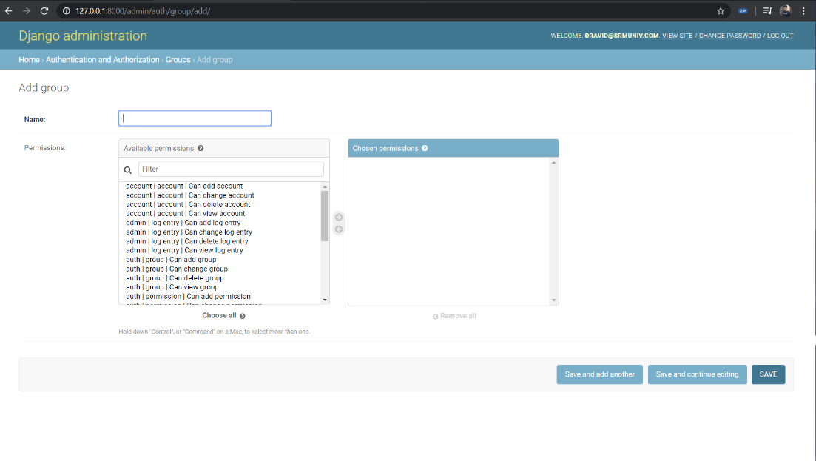

**Recent action panel:**

Admin will be able to see the recent changes in any of the three models (Account, Authorization, Personal)

* 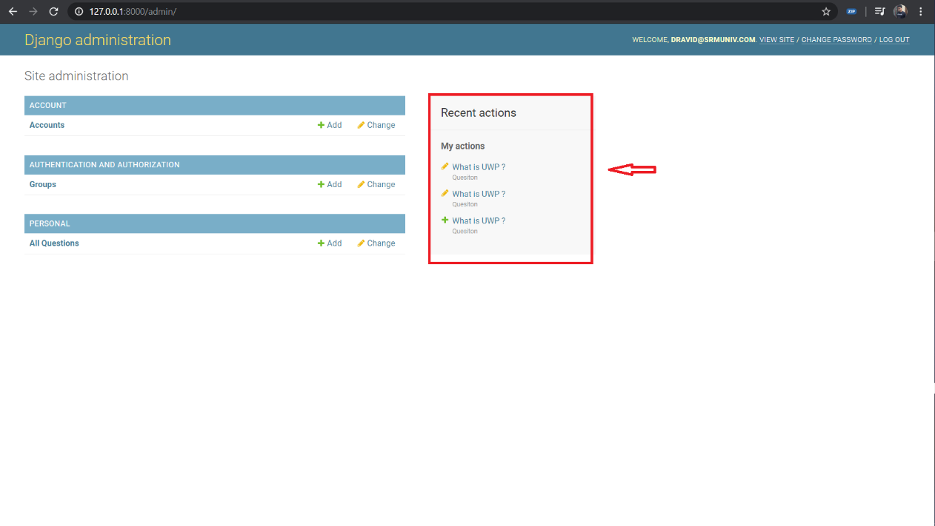

**Website –**

Note: There is still a lot (a lot) of work to be done on the main webpage

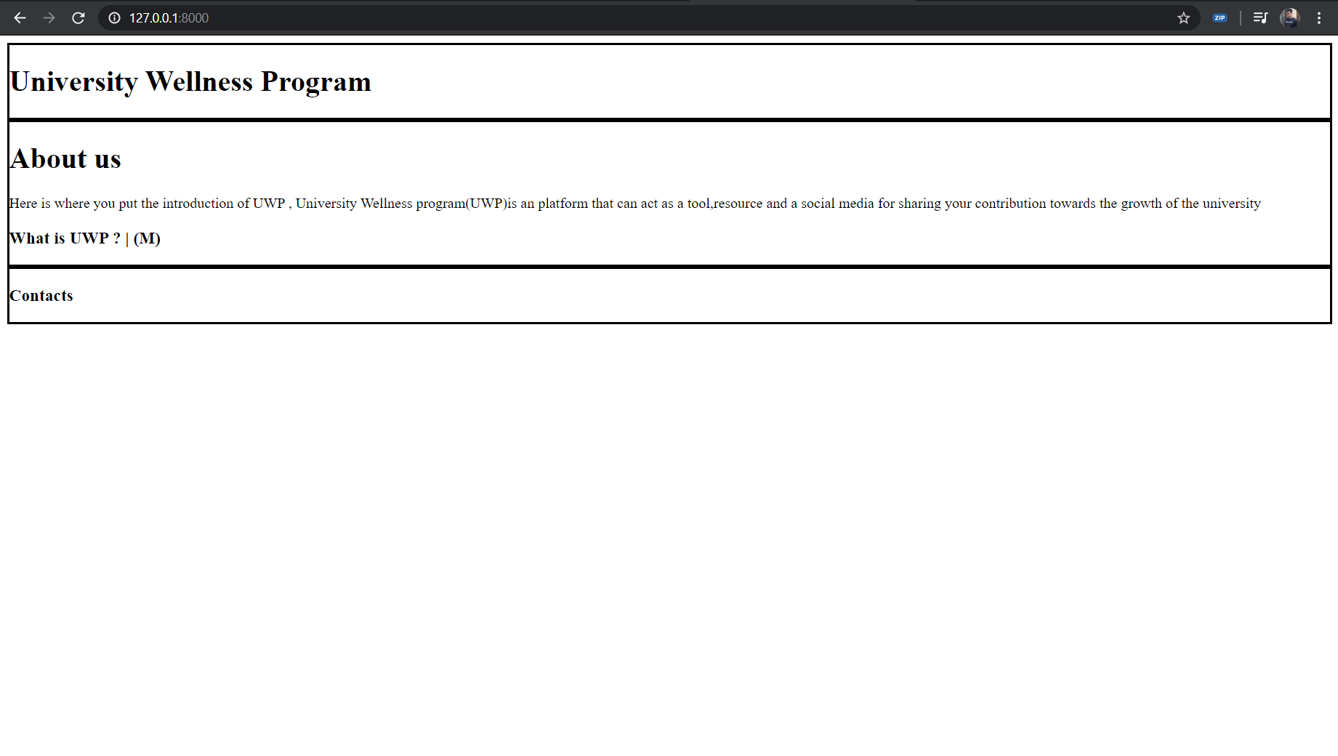

**Work done**

|  |  |  |
| --- | --- | --- |
| **Work** | **Dravid** | **Mukesh** |
| **Admin Panel** | Coded superuser module – admin control users | Coded user module – users other than admin |
| **Webpage** (front view) | Temporary webpage (above image) | Work yet to be done. |

**Code:** <https://github.com/Dravid92/UWP>

**Note:** There is still a lot of work to be done, in the next submission the registration panel and the login panel for users and a better Webpage will be accomplished.