PWM Signal Generator

The software implemented on the Spartan-3 Starter Board generates a pulse width modulated (PWM) signal, which shapes, amplitude, and frequency can be setup through the implemented menu by altering the buttons BTN0-BTN3 and switches SW0-SW7. The state of the menu and setup parameters can be viewed on DSP1 consisting of four 7 segment displays.

Features
BTN3: Resets all settings and return to the settings menu.
BTN2: Toggles between the settings menu and run.
BTN1: Toggles between S (shape), A (amplitude) and F (frequency)
BTN0: Accepts the value of the switches SW0-SW7 and displays the chosen value on display DSP1, AN0 and AN1.
SW0-SW7: Sets values for shape, amplitude, and frequency respectively.
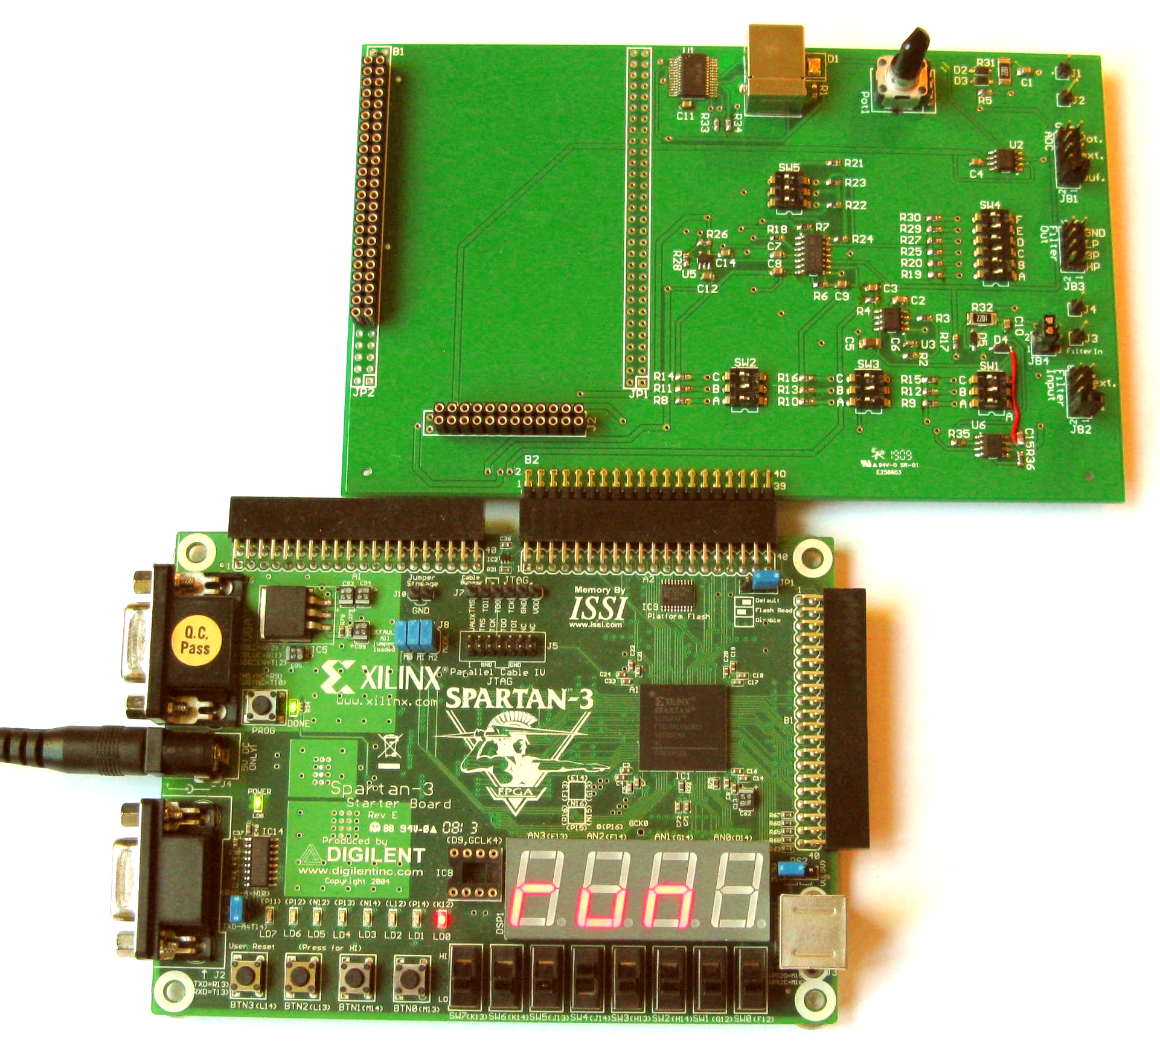
DSP1: When the display says “run” the PWM-signal is sent out on port PA-IO2. If not in the “run” mode you are in the settings menu and the display reads “S” (Shape),” A” (Amplitude) or “F” (Frequency) respectively and the current settings for each. All settings are shown in HEX numbers 00 to FF.

Settings menu
The settings menu is toggled on and off by pressing BTN2 or BTN3. Be aware, that BTN3 will reset all settings for the PWM-signal generator. When powering on, all settings will be default 0 (zero) and it starts up in the settings menu. When in the settings menu no PWM-signal is sent out.
Button BTN1 toggles between the three menus: S (shape), A (amplitude), and F (frequency).

Shape
The PWM-generator can generate four different PWM-signal all chosen by the combination of the switches. When the switches are set, push the accept button BTN0 and the setup is shown in the display.
Dec. Values | Switch settings | Display | Description
0 | 00000000 | S 00 | Constant DC voltage
1 | 00000001 | S 01 | Square-pulse
2 | 00000010 | S 02 | Saw-tooth
3 | 00000011 | S 03 | Sine wave

Amplitude
The amplitude of the shapes can be set from 0V to 3.3V divided between the 255 setting options from the switches SW0-SW7.
Dec. Values | Switch settings | Display | Description
0 | 00000000 | A 00 | 0V amplitude
127.5 | 01111111 | A 7F | Half amplitude, about 1.65V
255 | 11111111 | A FF | Full amplitude, about 3V

Frequency
The frequency of the shapes can be set from about 0Hz to 23kHz distributed on the 255 settings options from the switches SW0-SW7.
Switch settings | Display | Description
00000000 | A 00 | 0 Hz
00000001 | A 01 | 24 Hz
01111111 | A 7F | 11.5 kHz
11111111 | A FF | 23 kHz

Run menu
When all settings are made in the setup menu the PWM-signal is sent out on port PA-IO2 by entering the “run” menu pressing BTN2.
Light emitting diode LD0 is lightning when the signal is transmitted.
If you wish to enter the settings menu again for further settings press BTN2.
BTN3 also enters the settings menu but resets all settings to default zero.

VHDL Code
The VHDL consist of the following files in the indicated hiracy
SigGenTop.vhd
DivClk.vhd
SigGenControl.vhd
BTNdb.vhd
SigGenDatapath.vhd
SinusLUT.vhd
SevenSeg5.vhd

Pin Diagram
The pin diagram of the top component is as follows
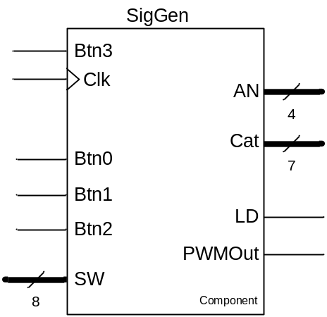

Btn3 input Asynchronous reset for all registers in the module. This signal shall be connected to BTN3
Clk input Master clock. The clock frequency shall be 50MHz
Btn0-2 input Representing the three push buttons BTN0, BTN1 and BTN2 on the SPARTAN 3 board.
An output A 4 bit value where each bit represent a common anode for the segment in each display. If the bit is low the corresponding display is able to light.
Cat output A 7 bit value where each bit represent a common cathode for the same segment in all four displays. If the bit is high the corresponding segment (in all displays) is able to light.
PWMOut output The pulse width modulated output of the component. After appropriate low pass filtering this pin will give an analogue signal with a shape determined by the Btn 0-2 selection. This pin shal be connected to D5 of the FPGA.
LD output A copy of the PWMOut signal that can be used for an LED.

Design
The functional diagram of the SigGenTop component is shown below
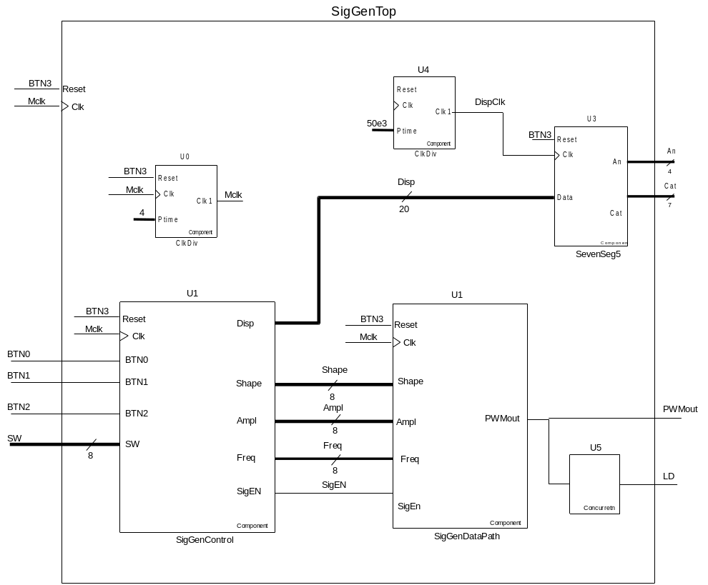

SubComponents

ClkDiv
ClkDiv is a clock divider that divides the clock (clk) by the input value Ptime. If the input clock frequency is 50MHz and Ptime is 50.000 the output clock (Clk1) has a frequency of 1 kHz.

SevenSeg5
SevenSeg5 is a driver for the four digit 7-segment display on the Digilent SPARTAN 3 board.

SigGenControl
SigGenControl is the controller of the signal generator. The module contains a state machine state machine to control the selection and adjustment of the Shape, Amplitude and Frequency if the generator. Is also contains registers for the three parameters. BTN1 and BTN2 is debounced to ensure proper control of the menu and the input to the three parameters are limited to the valid range.
The Functional diagram of the module is shown below:
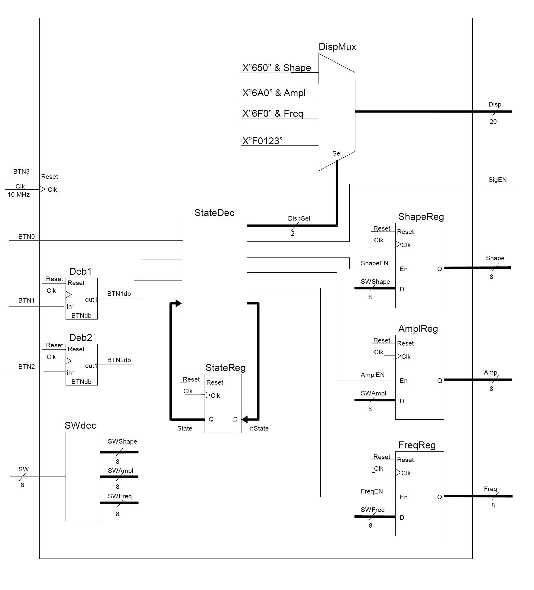

The state machine has the following states:

Shape Ampl Freq Run

Shape State where it is possible to enter a new Shape (using BTN0). When the BTN 1 is pressed the state change to Ampl.
Ampl State where it is possible to enter a new Amplitude (using BTN0). When the BTN 1 is pressed the state change to Freq.
Freq State where it is possible to enter a new Frequency (using BTN0). When the BTN 1 is pressed the state change to Shape.
Run State where the signal generator generates a PWM signal using parameters stored in the three registers. This state can be reached from any of the three states above by pressing BTN2. When the BTN2 is pressed again the state change to Shape.

ASM diagram

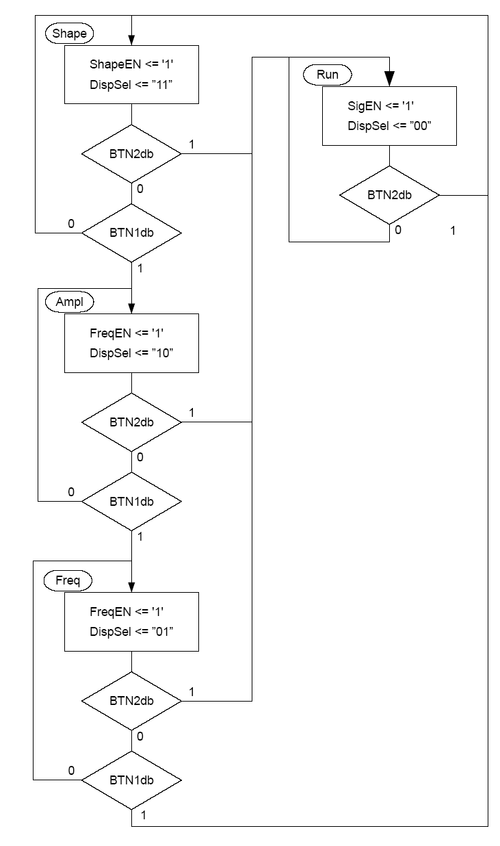

In the project you should exchange this module with a module to receive the Shape, Amplitude and Frequency parameters from the MCU through the SPI connection.

SigGenDataPath
SigGenDataPath is the datapath of the signal generator. The module contains a number of counters to generate the PWM signal. It also uses a large look up table to generate a sinusoidal signal.
The Functional diagram of the module is shown below:
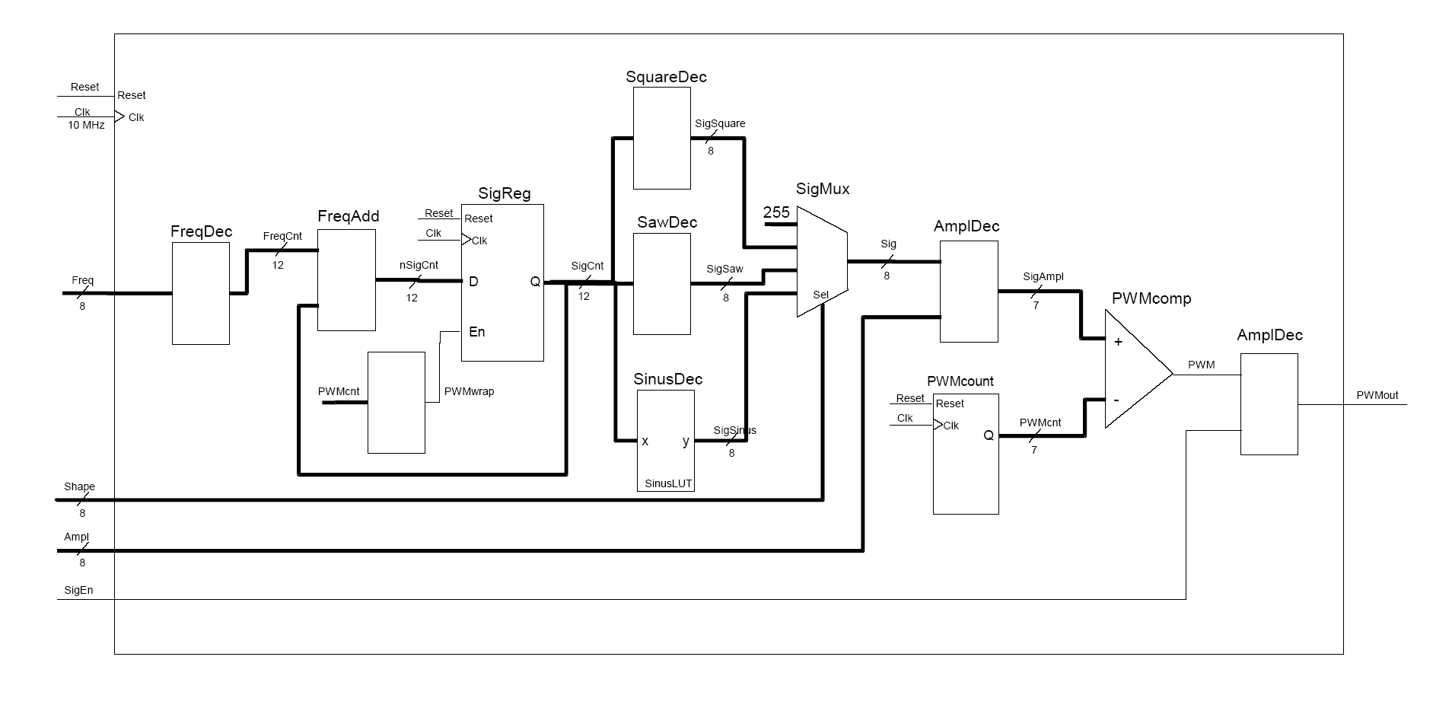
In the project you don’t need to change the SigGenDataPath module.

