Andres Melendez

CSD 430

8 / 15 / 2024

Module 1.2

https://github.com/Dre2322/CSD-340

Local Directory

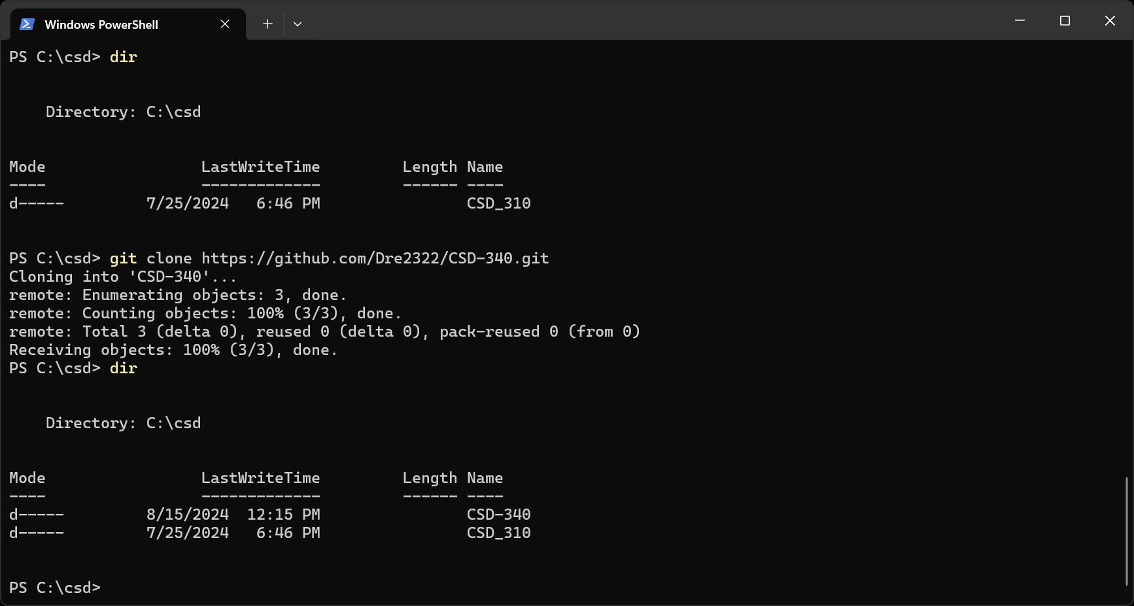

GitHub repository

