Andres Melendez

CSD 430

8 / 15 / 2024

Module 1.2

Local Directory

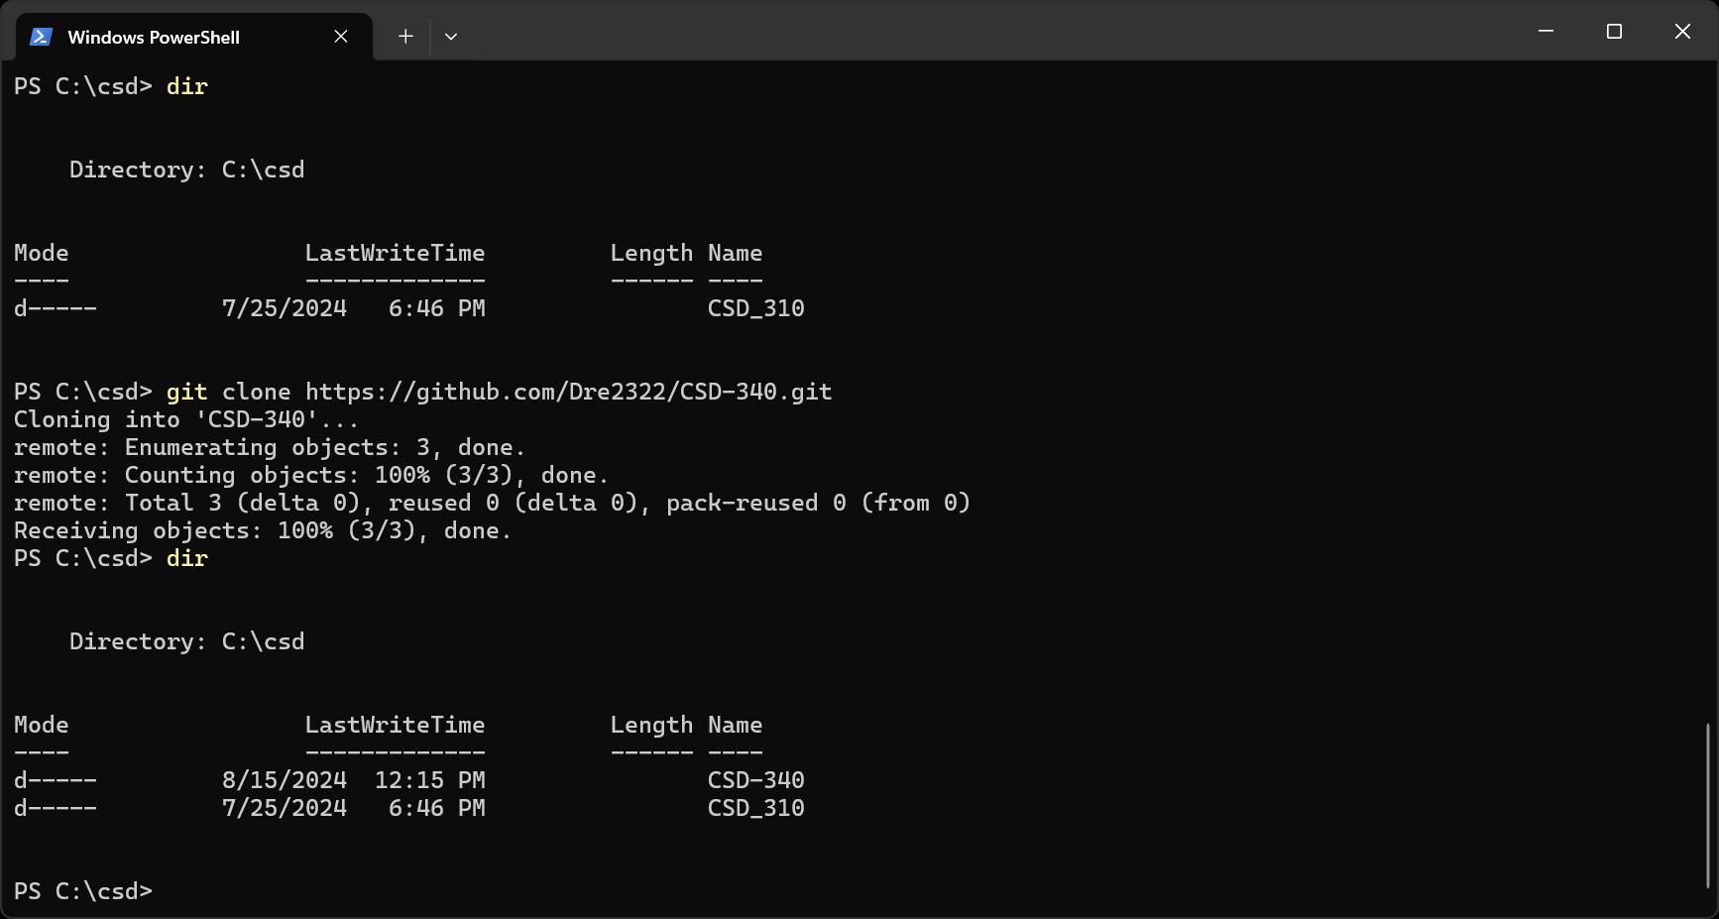

GitHub repository

