Andres Melendez

CSD 340

8 / 24 / 2024

GitHub Repository: <https://github.com/Dre2322/CSD-340/tree/main/module-3>

GitHub Landing Page: <https://dre2322.github.io/CSD-340/>

HTML Validators Results

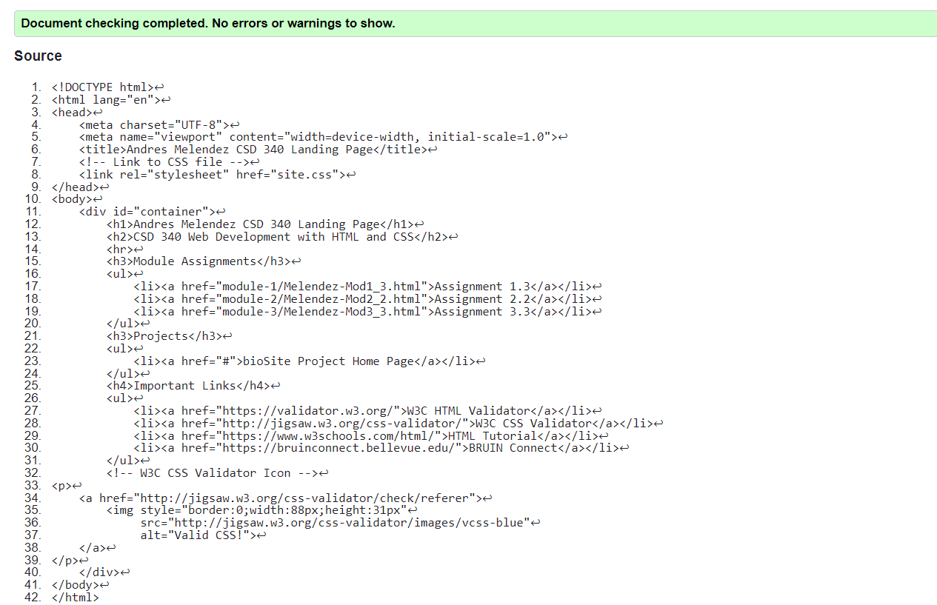

CSS Validators Results

Landing Page

