Andres Melendez

CSD 380

2 / 7 / 2025

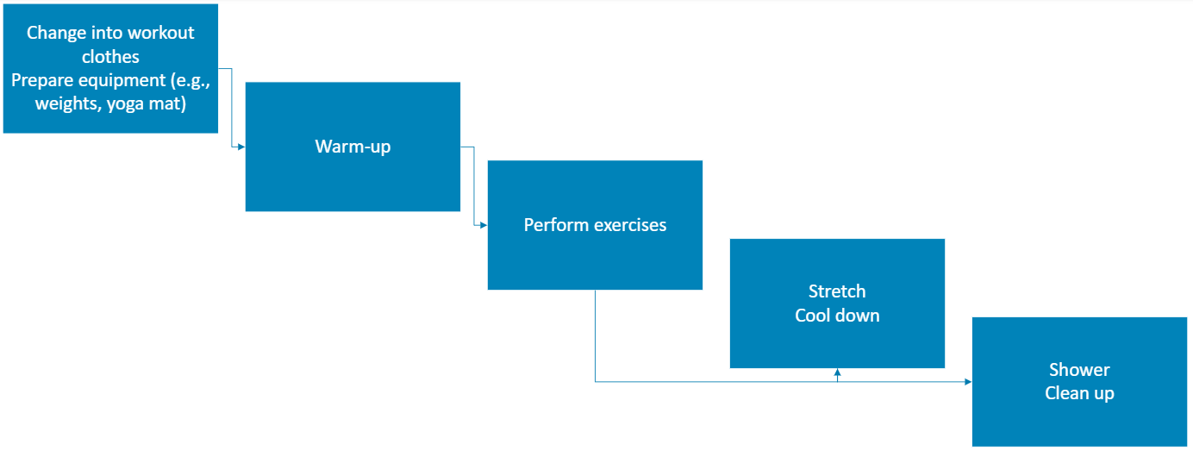

|  |
| --- |
| Analyzing lean metrics |

|  |
| --- |
| Estimated Average Flow Time |

|  |  |
| --- | --- |
| Preparation | 10 minutes |
| Warm-up | 5 minutes |
| Workout | 30 minutes |
| Cool-down | 10 minutes |
| Post-workout tasks | 15 minutes |

|  |
| --- |
| Estimated Cycle Time: 70 minutes |

|  |
| --- |
| **Optimization Ideas**  To optimize:   * Reduce transition times between activities (e.g., lay out clothes and equipment beforehand). * Combine warm-up and prep with light mobility exercises. * Simplify the post-workout routine (e.g., quick stretches). |