Andres Melendez

CSD 310

6 / 8 / 2024

Module 2.3

ERD

https://github.com/Dre2322/CSD_310/tree/main/module_2

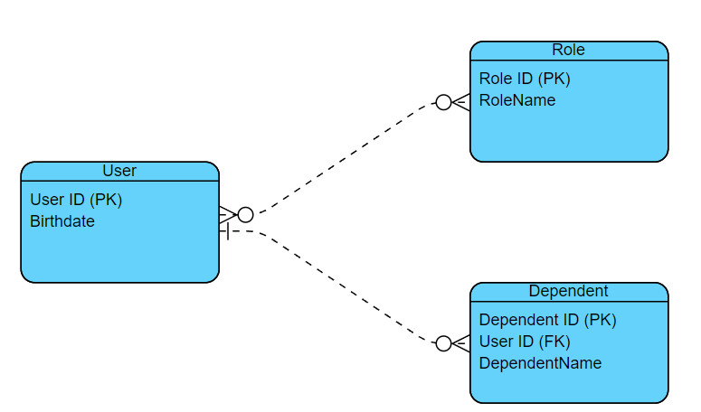

NoSQL

{

"UserID": "unique_user_id",

"Birthdate": "YYYY-MM-DD",

"Roles": [

{

"RoleID": "unique_role_id",

"RoleName": "role_name"

},

{

"RoleID": "unique_role_id",

"RoleName": "role_name"

}

],

"Dependents": [

{

"DependentID": "unique_dependent_id",

"DependentName": "dependent_name"

},

{

"DependentID": "unique_dependent_id",

"DependentName": "dependent_name"

}

]

}