Andres Melendez

CSD 310

6 / 21 / 2024

Module 5.2

**1. DATE_SUB**

**Explanation:** The DATE_SUB function subtracts a specified time interval from a date. It is useful when you need to calculate a past date relative to the current date.

**Alias:** Date_One_Week_Ago

**SQL Statement:**

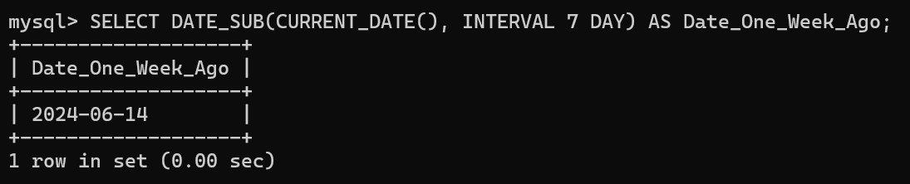

**2. DATEDIFF**

**Explanation:** The DATEDIFF function returns the difference in days between two dates. It is useful for calculating the number of days between two specific dates.

**Alias:** Days_Between

**SQL Statement:**

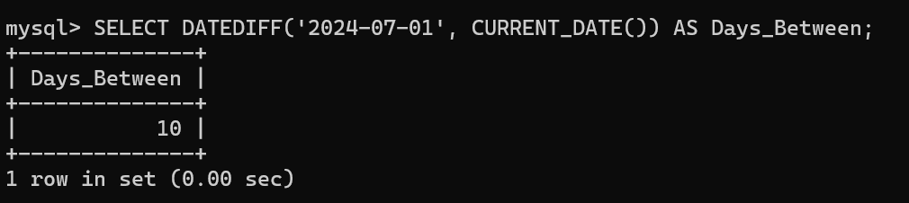

**3. DATE_ADD**

**Explanation:** The DATE_ADD function adds a specified time interval to a date. It is useful when you need to calculate a future date relative to the current date.

**Alias:** Date_Next_Week

**SQL Statement:**

