Andres Melendez

CSD 310

6 / 29 / 2024

Module 6

SQL Script

The result of SHOW TABLES

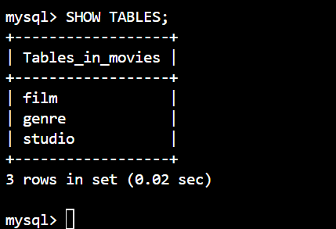

Python Script

