Module 5.1 Database Dev Screenshots
April 5, 2025
Team Alpha:
- Andres Melendez
- Jeffrey Reid
- Edgar Arroyo
- Jordany Gonzalez
- Matthew Trinh
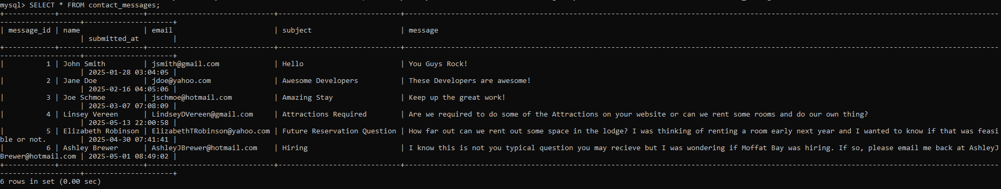
Contact Messages Table:
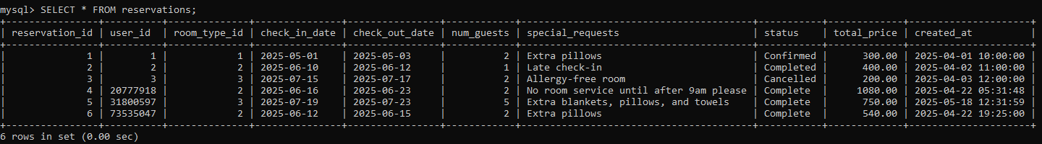
Reservations Table:
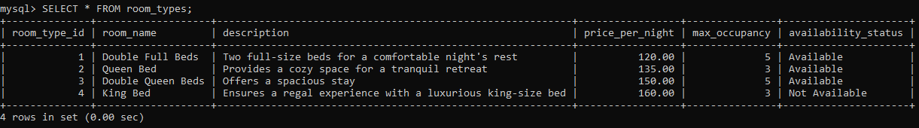
Room types:
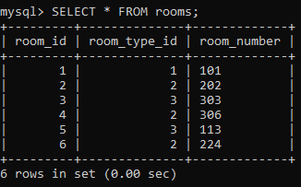
Rooms:

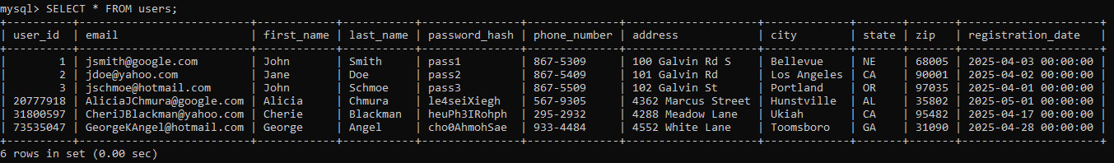
Users:

