Tracking the Planet’s Pulse: Analyzing CO₂, Global Temperature Anomalies, and Sea Level Rise
Carlos Escamilla, Tyler Heflin, Andres Melendez, Delilah Slabaugh
June 22, 2025
Table of Contents
Introduction 1
Methods/Analysis 1
Results 1
Recommendations & Ethical Considerations 4
Conclusion 4
References (APA Style) 4
Appendix 5

Introduction
Climate change is one of the most urgent issues of our time, and understanding the interaction between atmospheric CO₂, surface temperature anomalies, and sea level rise is critical for informing global policy. This project uses over a century of monthly time-series data to investigate the relationship between these three climate indicators.
Business Problem/Hypothesis: If CO₂ levels increase, global temperature anomalies and sea levels will exhibit positively correlated upward trends due to anthropogenic emissions.

Methods/Analysis
We sourced and combined datasets from NASA and NOAA:
- CO₂: Mauna Loa Observatory (1958–present)
- Temperature anomalies: NASA GISTEMP v4 (1880–present)
- Sea level: NOAA JPL RECON (1900–2018)
Process:
- Parsed dates and removed missing values
- Merged datasets on monthly timestamps
- Calculated 10-year rolling averages
- Created correlation matrices and visualizations
Tools used: Python (Pandas, Matplotlib, Seaborn), Jupyter Notebook

Results
Figure 1 shows long-term trends from 1880 to 2025 for:
- CO₂ Concentration (Mauna Loa): rising steadily at +1.67 ppm/year
- Global Temperature Anomalies: rising at +0.0123°C/year
- Sea Level Rise: increasing at +0.70 mm/year
All three indicators show significant upward trends, especially after 1950, consistent with known anthropogenic influence.
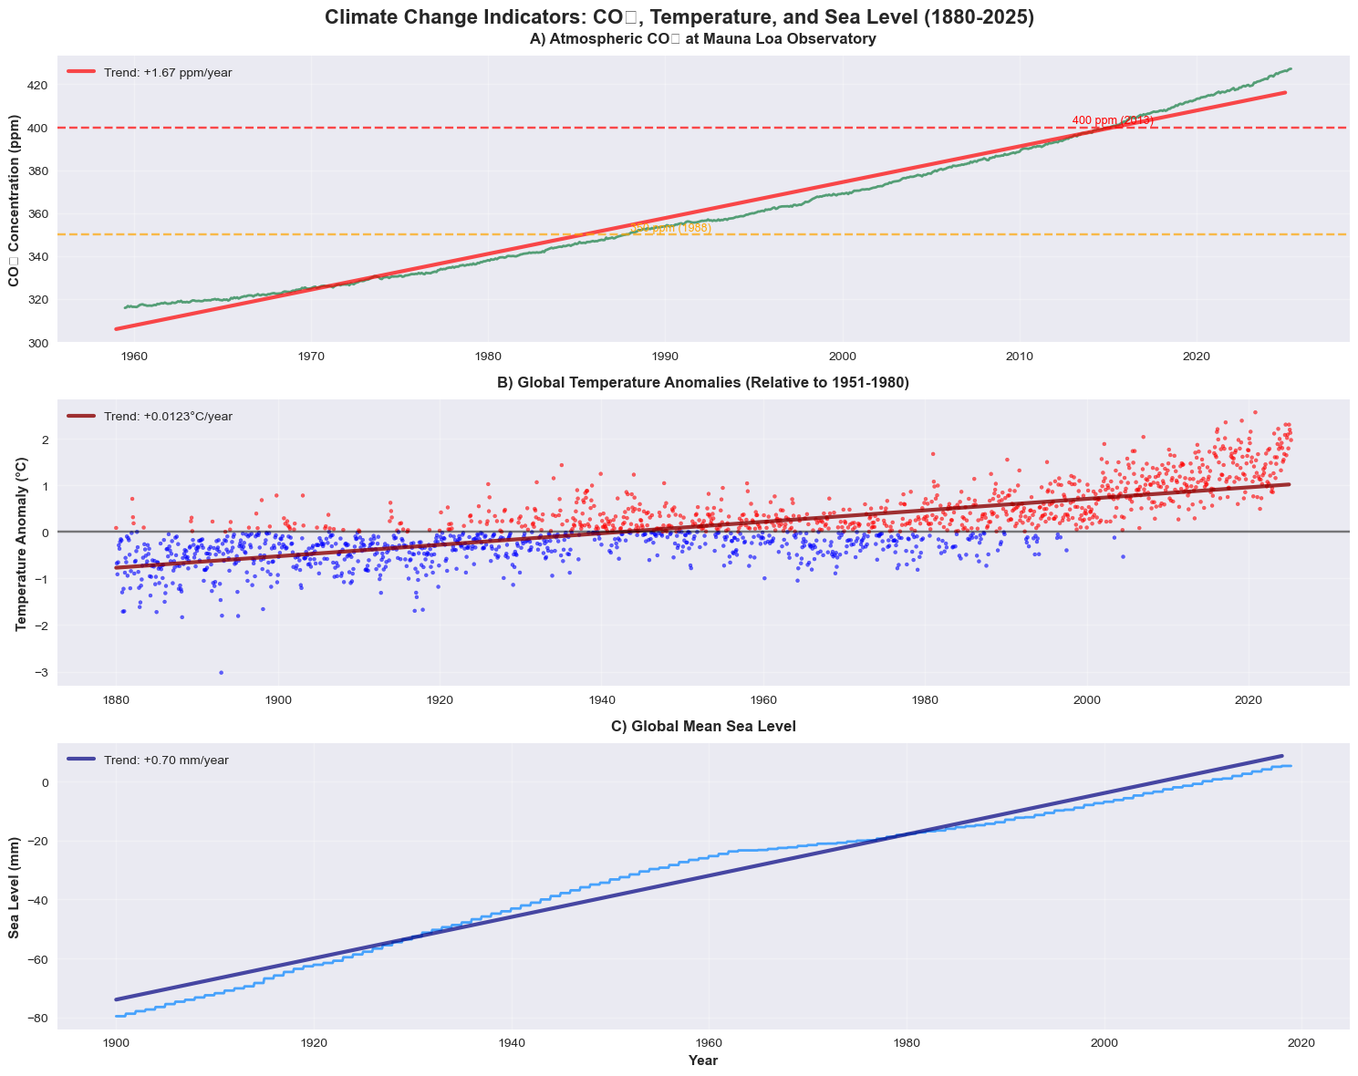
Figure 2 presents a multi-part correlation and lag analysis:
- A correlation matrix highlights a strong correlation between CO₂ and temperature.
- A lagged correlation indicates that the strongest CO₂-temp link occurs with a 1-month lag.
- A scatter plot reveals a direct relationship between CO₂ and temperature (r ≈ 0.803).
- The rate of CO₂ change has also accelerated post-1970, averaging +1.67 ppm/year.
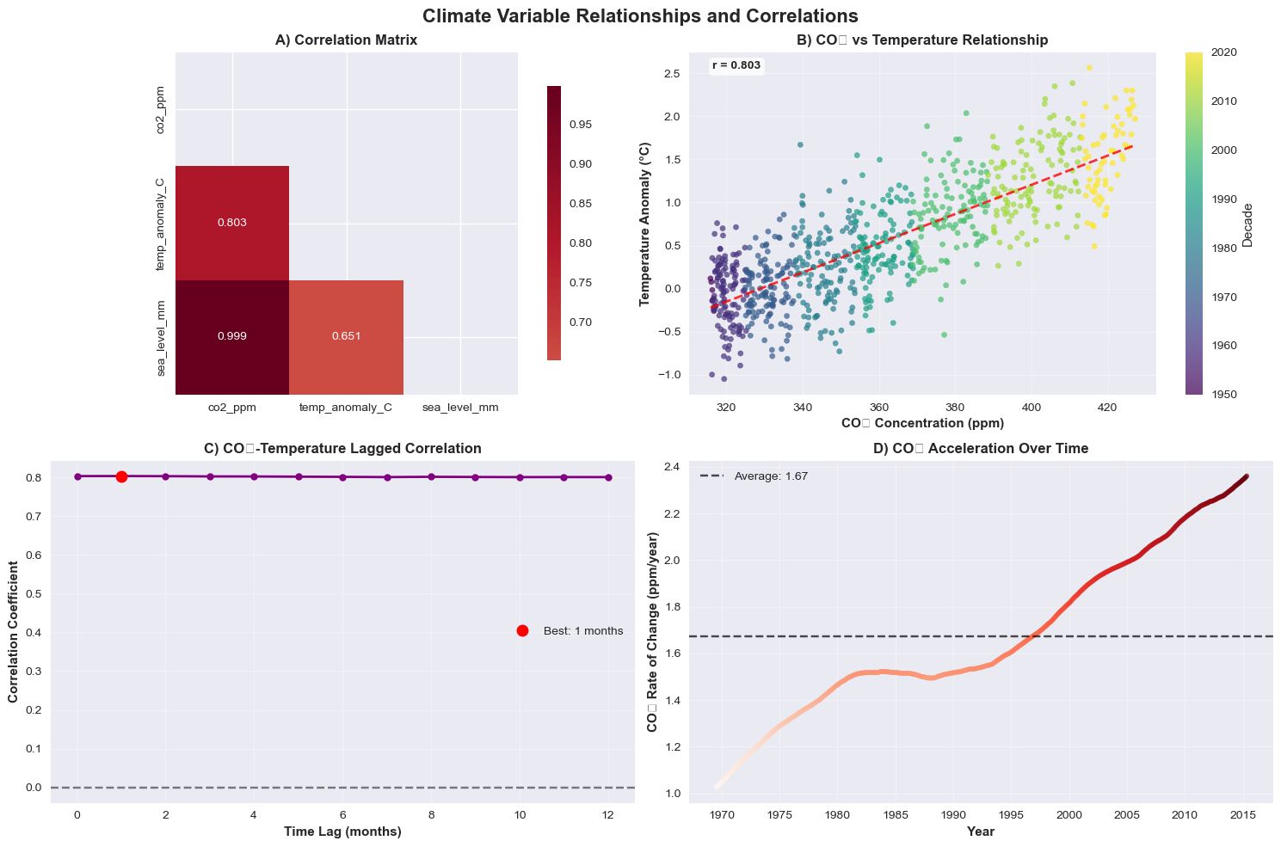
Figure 3 focuses on predictive modeling:
- Regression performance shows training R² = 0.484 but a negative R² on testing (-0.187), suggesting the model may be overfitting.
- Feature importance emphasizes CO₂ levels as a key predictor.
- Model projections illustrate temperature increases under various emission scenarios, with high emissions producing steep upward trajectories.
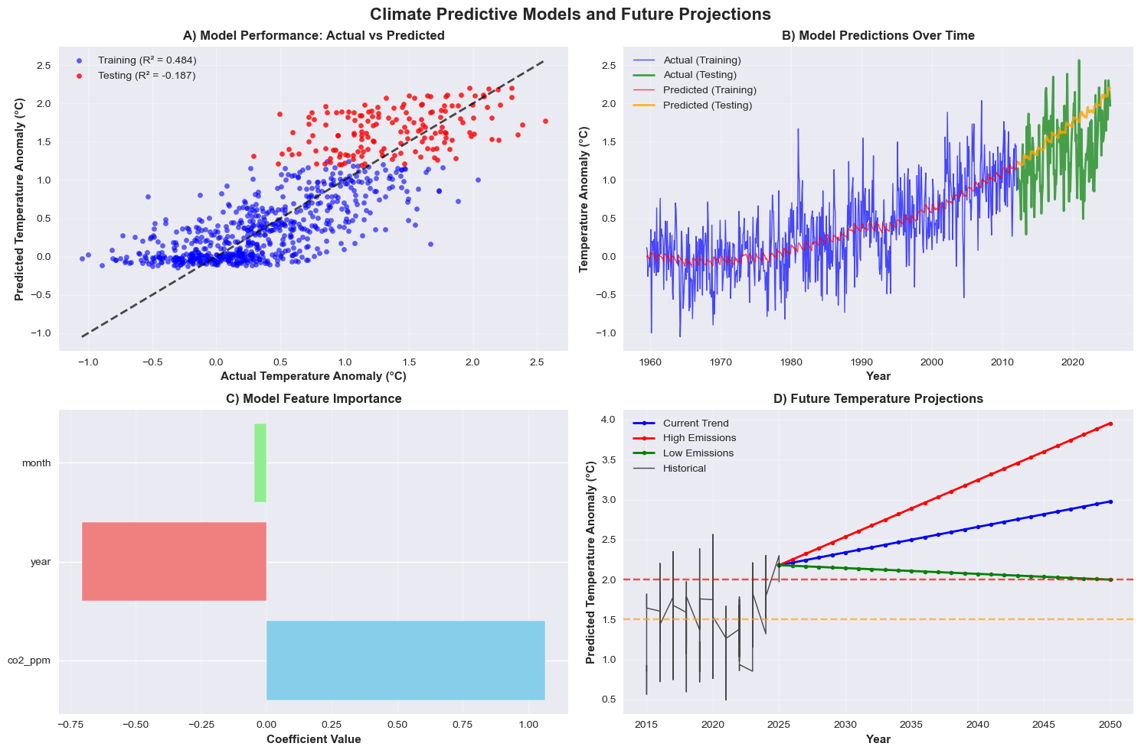

Recommendations & Ethical Considerations
Our results support the use of climate indicators for educational and policy purposes. Ethical considerations include avoiding alarmism and responsibly communicating predictive trends. Reproducibility is ensured by dataset documentation and consistent timestamp alignment.

Conclusion
We confirmed significant correlations among CO₂, temperature, and sea level rise using over a century of climate data. These findings support broader climate change evidence and suggest potential for predictive modeling in future work.

References (APA Style)
Thoning, K. W., Tans, P. P., & Komhyr, W. D. (1989). Atmospheric carbon dioxide at Mauna Loa Observatory 2. Journal of Geophysical Research: Atmospheres, 94(D6), 8549–8565.
GISTEMP Team. (2025). GISS Surface Temperature Analysis (GISTEMP), version 4. NASA Goddard Institute for Space Studies. https://data.giss.nasa.gov/gistemp/
Frederikse, T., et al. (2020). JPL_RECON_GMSL, Ver. 1.0, NASA PO.DAAC. https://doi.org/10.5067/GMSLT-FJPL1

Appendix
- Code notebooks: DSC450_Week3_Milestone2.ipynb
- Summary statistics of datasets
- Dataset source links and descriptions

