Name: Andre Freeman

Student ID: 410521320

Image Processing

Homework1: Image Enhancement

**Abstract**

In efforts to complete Homework1 I was entitled to create an algorithm that would perform the Power-Law transformation and Equalization. Finding an open source image was the first task at hand. Keep in mind the resolution of this image would also factor in the time taken for the algorithm to transform it. This image if not already a gray scale image had to be convert to gray scale. This means each grayscale pixel could only have the value ranging from 0 to 255. With power-law transformation technique, an image I can be transformed with the effect such that the resulting image is either darker or lighter. Experimentally, one can compare this phenomenon two (2) histogram matching techniques: (1) the grayscale pixel frequency approach or (2) the accumulative frequency approach. In this project we will utilize the accumulative frequency approach due to its relatively easier way of being represented on a graph.

Below is an image depicting the idea of histogram matching with accumulative frequency. Let us assume the original image is (4). A transformation resulting in a darker image would be of the form shown by image (1) and (2) and one resulting in a lighter image of the form image (2)

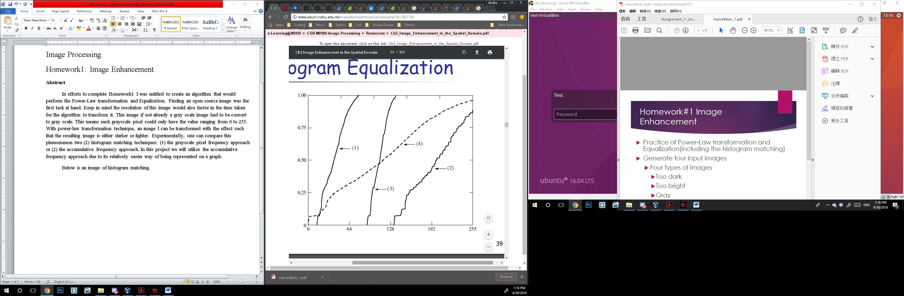

**Description of algorithm**

* The algorithm first starts by import necessary libraries to the necessary tasks. The power transformations gamma values selected are g1 and g2.
* Read in an image ‘IMG’ as GRAYSCALE
* Find the width and height of the inputted image
* Create and initialize to 0 a data structure for calculating the total number of a particular pixel is in the picture.
  + Since it is gray scale (i.e. value from 0 to 255) then the size the array is 256.
  + The array index would be used for a particular pixel and the index content would be the total number of that particular pixel is in the image.
  + Three variables of this data type is need for (1) the original image ‘IMG_H’ (2) the darker image ‘PT1_H’ and (3) the light image ‘PT2_H’
* Since the image ‘IMG’ variable is a 2D data structure.
  + Create a 1D data structure ‘IMG_F’ of original image using the flatten function. (For easy data manipulation purposes).
  + Create a variable to hold both the lighter ‘PT2_F’ and darker ‘PT1_F’ image 1D representation
  + N.B. The size of the variables are the original image width * height
* Do the power transformation by multiplying the gamma to each pixel in the image and obtain both a darker and light image
* Use an array to cycle through all the pixel while incrementing by one the value of that particular pixel total number pixels.
* Calculate the accumulative frequency by:
  + Let the first value in the accumulative frequency by the first value ‘0’ of the total number of pixel representations.
  + Then for each next accumulative frequency add the previous accumulative frequency and the current number of pixel.
* Use pyplot function to show a graphical representation fo the transformations
* Save newly transformed images to hard drive
* Display “Complete” on user terminal

**Results**

The original image



The Light image The darker image



**Comparison and Discussion**

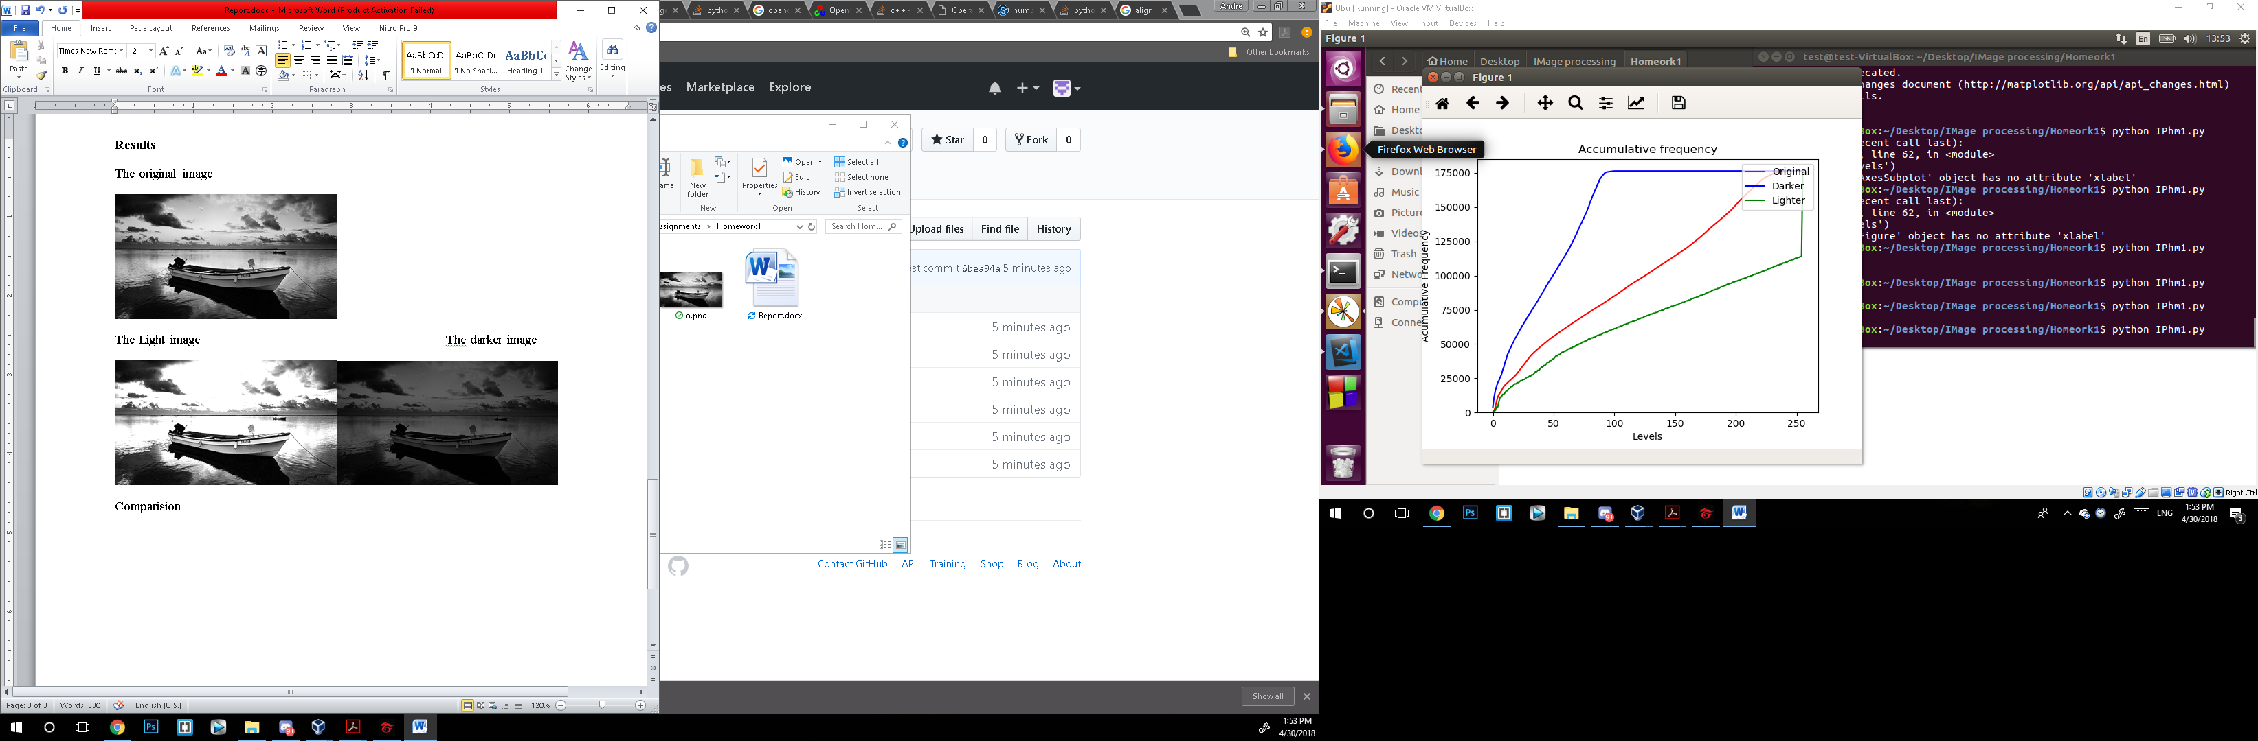

The figure above shows the accumulative frequency plotted over the each particular pixel element. By applying the same principal mention in the above segment, the original image plot lies in the middle of a (blue) darken image and a (green) lighter image. N.B. The darker image graph is further away due to the simple fact where the gamma for delta transformation was randomly chosen.

With the power transformation method it is safe to assume that it could be effectively applied to alter image contrast thus creating a light and/or darker image.