Name: Andre Freeman

Student Id: 410521320

Introduction to Machine Learning

Neural Network Programming Assignment1:

Image Decryption by a Single Layer Neural Network Report

Data Preparation

As we know the data being manipulated is a grayscale PNG file format. This implies that the images will be comprised of (width *height) number of pixels each ranging from 0 to 255. This project we will utilize the OpenCv package for reading and writing PNG file format image files. Since our algorithm iterates on a 1-Dimensional (1D) plane each import/exported image will have to restructure to a 1D plane for data manipulation and vice versa. The image data file was provided by the professor at: <http://www.elearn.ndhu.edu.tw/moodle/file.php/74278/Image_and_ImageData.zip>

The image provided key1.png ‘K1’, key2.png ‘K2’, I.png ‘I’, E.png ‘E’, Eprime.png ‘Eprime’.

Data Initialization

As suggested by the Homework assignment first establish that alpha α = 0.00001. Gradient Descent algorithms can only be as accurate as its step constant α; with that being the case, due to numerous testing it is safe to assume the best value for epsilon є is 0.01 and maxIterLimit (‘max_iter’) as 100. Epoch is also set to 1 as instructed. Assuming the width ‘W’ and height ‘H’ is the same for K1, K2, I and E then W and H calculated from getting the size of any one of the images.

With the given algorithm weight value ‘w’ of w[0] doesn’t not change but updates to weight is done in a w[i+1] manner. Thus w is declare with a size of w[width*height+1][3]. The first value of the weight w[0] is set to a random integer value between -1 to 1 (eg. w[0]=[-1,0,1]).

Results

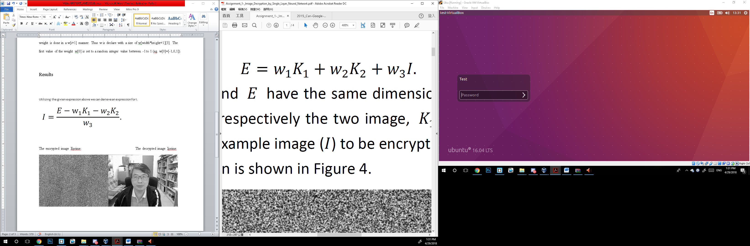

Utilizing the givien expression above we can derieve an expression for I.

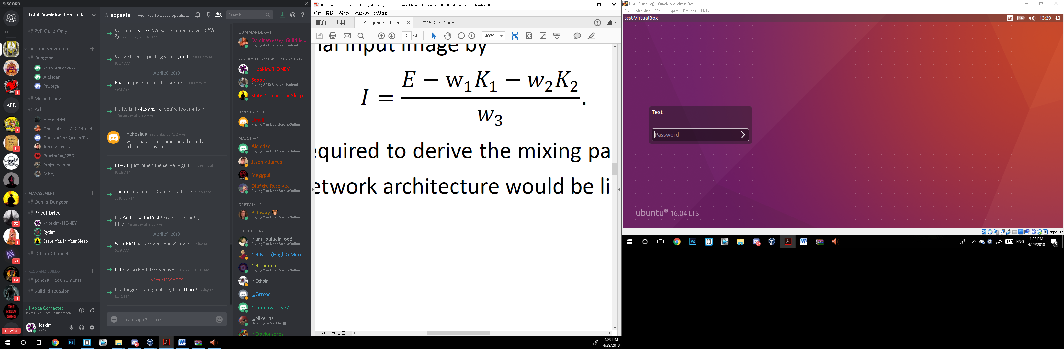

The encrypted image Eprime: The decrypted image Iprime:

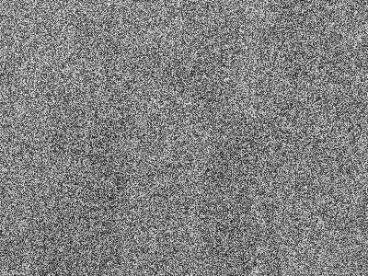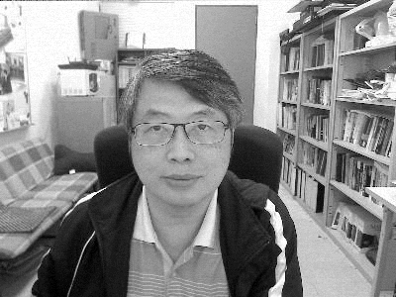

Challenges and Learned Experience

The first challenge was prior to this project, I had no previous expose in Python. There the basic structure and syntax had to be learned. Also OpenCv, numpy and random procedures and functionalities had to be learnt.

The second challenge was setting up a python coding environment. That is, downloading an installing Virtual machine, Ubuntu OS and application and packages on Linux OS to complete the IDE coding package.

The third challenge was I didn’t realize I can use MATLAB to do this project