CFD-ML-BASED TURBULENCE MODEL DEFINITION FOR FIDELITY IMPROVEMENT OF HORIZONTAL-AXIS WIND TURBINE RANS SIMULATIONS
Andrea Carloni¹, Giovanni Delibra², Filippo De Girolamo³, Lorenzo Tieghi⁴, Alessandro Corsini², Valerio Francesco Barnabei²
. Department of Electrical and Energy Engineering, Sapienza University of Rome, Italy; email: andrea.carloni@uniroma1.it
. Department of Mechanical and Aerospace Engineering, Sapienza University of Rome, Italy; email: giovanni.delibra@uniroma1.it
. Division of Fluid Mechanics, KTH Royal Institute of Technology, Stockholm, Sweden; email: fidg@kth.se
. Department of Civil, Environmental and Mechanical Engineering, University of Trento, Trento, Italy; email: lorenzo.tieghi@unitn.it
ABSTRACT
Accurate prediction of horizontal-axis wind turbine (HAWT) wakes is essential for wind farm layout optimisation and energy yield estimation, yet it remains a challenge for affordable simulation tools: Large Eddy Simulation (LES) is reliable but prohibitively expensive, while unsteady Reynolds-Averaged Navier-Stokes (URANS) systematically mis-predicts the wake recovery. This work proposes a CFD-ML methodology that defines, rather than post-processes, a machine learning-based turbulence closure for HAWT wakes. From a high-fidelity LES of the NREL-5MW turbine in a turbulent atmospheric boundary layer (ABL), an LES-equivalent eddy viscosity $ν_{t,eq}$ is extracted as regression target. A K-means clustering segments the flow into physically distinct regions and a Multi-Layer Perceptron (MLP) learns the local correction $Δν_{t}=ν_{t,eq}−ν_{t,RANS}$, which is embedded into a modified OpenFOAM PIMPLE solver using the $k$-$ω$ SST model. The network reproduces $ν_{t,eq}$ with a validation $R^{2}=0.9934$. Once embedded, the ML-based RANS model outperforms the standard RANS model in both near- and far-wake; most notably, on ultra-coarse grids it captures the post-breakdown wake recovery at a cost about $1.25$ times lower than the reference LES, while also reproducing the rotor forces and power coefficients.
: Wind turbine wake, URANS, Machine learning, Turbulence modelling

Introduction
Wind energy is a cornerstone of the transition toward sustainable electricity generation. When a turbine extracts kinetic energy from the incoming flow it leaves behind a wake characterised by a velocity deficit and elevated turbulence; downstream turbines operating within this region suffer reduced power output and increased fatigue loads [1]. Accurate prediction of HAWT wake behaviour is therefore essential for wind farm layout optimisation, energy yield estimation and structural load assessment. From a fluid-mechanics perspective the wake is a complex, multi-scale phenomenon, deeply coupled with the inherently unsteady atmospheric boundary layer (ABL), whose recovery is governed by shear-driven turbulent mixing [1].
Available modelling strategies trade physical fidelity against computational cost. Analytical engineering wake models are near-instantaneous but rely on strong simplifying assumptions; LES resolves the dominant turbulent structures and is the reference standard, but a single medium-sized wind farm simulation can demand ${10}^{5}$–$3×{10}^{6}$ CPU hours [2]. URANS occupies an intermediate position, roughly two orders of magnitude cheaper than LES [2], but the closure assumptions of standard models, most notably the Boussinesq eddy-viscosity hypothesis, introduce structural model-form errors that lead to a systematic mis-prediction of the wake recovery rate [3].
Machine Learning (ML) has emerged as a powerful complement to physics-based simulation. Most applications in wind energy use ML downstream of a physical model, e.g. for power forecasting or layout optimisation, leaving the turbulence model unchanged [4]. A more recent line of research instead corrects or replaces the turbulence closure itself, modifying the governing equations during the simulation [5], [6]. In the wind energy context, optimal corrective fields derived from time-averaged LES data have been used to build custom RANS closures, yielding improved multi-turbine wake predictions [2], [7].
The present work contributes to this direction with three specific novelties. First, a clustering algorithm based on the K-means method segments the flow domain into physically distinct regions, following [8], [9], improving generalisation and interpretability and reducing the sensitivity of the correction to mesh refinement. Second, an MLP is trained to predict the local correction $Δν_{t}=ν_{t,eq}−ν_{t,RANS}$ and the resulting data-driven closure is embedded directly into the OpenFOAM PIMPLE solver, enabling fully predictive RANS simulations. Third, the methodology is tested across multiple mesh refinement levels, showing that LES-quality wake recovery can be achieved at a cost lower than that of standard LES. In essence, ML is used here to define the turbulence model, building from scratch a problem-specific eddy-viscosity closure calibrated to reproduce high-fidelity LES statistics.

Methodology
The methodology combines a CFD part, used to generate the data and to test the model, and an ML part, used to train the clustering and neural-network models.

CFD dataset
Simulations are performed with OpenFOAM-v22.12 using an in-house Actuator Line Model (ALM) [10] based on the turbinesFoam library [11], under incompressible flow conditions, solving $\vec{U}$ and $p$ with the PIMPLE algorithm. RANS simulations use the $k$-$ω$ SST model [12]; LES uses the WALE model [13]. At the RANS inlet a logarithmic velocity profile is imposed; at the LES inlet, synthetic turbulent fluctuations from the Kaimal spectrum [14] are superimposed following [9], [15].
To generate the regression data, a modified RANS run imports the mean $\vec{U}$ and $p$ fields from the LES and, fixing those fields, performs a single step in which the $ν_{t}$ field is solved consistently with the LES input inside the turbulence correction loop, yielding the modified eddy viscosity $ν_{t,mod}$. The computational domain is a rectangular box with the rotor at 5$D$ from the inlet, 15$D$ from the outlet and 90 m from the terrain, extending 5$D$ on each side and 8$D$ in the vertical direction. The finest mesh has $∼$30.8 M cells (minimum cell size 1.75 m near the rotor). Coarser grids of $∼$15.9, $∼$9.1 and $∼$4.2 M cells are obtained by varying the minimum and maximum cell size, and are used to assess the mesh-refinement influence on the trained models.

LES-equivalent eddy viscosity and ML target
Here $ν_{t}$ denotes the kinematic turbulent viscosity entering the RANS equations through the effective viscosity $ν_{eff}=ν+ν_{t}$. The reference $ν_{t,eq}$ is obtained by projecting the deviatoric part of the LES turbulent stress (sum of resolved and subgrid-scale contributions) onto the Boussinesq form, $Σ_{ij}^{dev}≃−2 ν_{t,eq} S_{ij}$. Assuming a Smagorinsky-type subgrid stress $τ_{ij}^{sgs,dev}=−2 ν_{sgs} S_{ij}$ and minimising the Frobenius norm of the residual gives the closed form
$$ν_{t,eq}=ν_{sgs}−\frac{{\left(R_{ij}^{res}\right)}^{dev}S_{ij}}{2 S_{ij}S_{ij}},$$
where $S_{ij}$ is the resolved strain-rate tensor and $R_{ij}^{res}$ the resolved Reynolds stress tensor. Rather than predicting $ν_{t,eq}$ directly, the network is trained on the discrepancy with respect to the RANS baseline,
$$Δν_{t}=ν_{t,eq}−ν_{t,RANS}, ν_{t,ML}=ν_{t,RANS}+Δν_{t,ML}.$$

Clustering and neural network
A K-means clustering algorithm [8], [9], implemented in scikit-learn [16], identifies the distinct flow regions of the wake, moving the prediction from a cell-wise to a region-aware basis that is more robust to mesh refinement. The algorithm minimises the within-cluster sum of squares (the inertia reported by scikit-learn), i=1Kxj∈Ci​xj−μi2, and the optimal number of clusters $K$ is selected with the elbow method. Features are Min-Max normalised and projected on a cylindrical reference system centred on the rotor; a subset is retained based on PCA and physical reasoning.
The regression model is a Multi-Layer Perceptron (MLP) implemented in TensorFlow-Keras [17], with a single scalar output $Δν_{t,ML}$. The cell-level input vector includes ${\vec{U}}_{cyl}$, $k$, $ν_{t,RANS}$, the distance from the assigned cluster centroid, the non-dimensional coordinates $z/D$ and $x/D$, and the (one-hot encoded) cluster labels; continuous features and the target are standardised. The architecture is a sequence of fully connected residual blocks (Dense layer with L2 regularisation, Layer Normalization, GELU activation and Dropout) with progressively decreasing widths, trained by minimising a weighted Huber loss with the Adam optimizer; sample weights compensate for cluster imbalance and emphasise downstream wake samples. After a first standard $k$-$ω$ SST iteration, the clustering assigns a cluster to each cell and the MLP predicts $ν_{t,ML}$, which is then used to advance $\vec{U}$ and $p$ in the modified PIMPLE turbulence correction loop; the procedure is repeated every iteration.

Case study
The methodology is tested on the NREL-5MW [18] HAWT, modelled with the ALM with the number of nodes adapted to each grid so that $ϵ≤2Δx$ and $Δb/Δx≤0.75$ [19]. A hub-height ($90$ m) inflow velocity $U_{ref}=8 m/s$ is considered, with the ABL logarithmic profile
$$U(z)=U_{ref} \frac{ln​\left((z+z_{0})/z_{0}\right)}{ln​\left((z_{ref}+z_{0})/z_{0}\right)}.$$
The CFD dataset was validated against literature results [20], [21] as in [9] and is omitted here for brevity. Training data are sampled along two planes through the rotor centre (one parallel and one perpendicular to the terrain) on the finest grid, yielding $∼$180k cells; the far-upstream inflow region ($x/D<−2.5$) is excluded, retaining $∼$160k cells split 80/20 into training and validation sets, stratified by cluster.

Results
The clustering identifies a clear elbow at $K=7$, separating the undisturbed flow from the inlet/ABL-affected, near-wake, mixing/breakdown and far-wake regions, consistently with the underlying physics. Trained in $∼$0.24 s, it provides the region labels used by the network.
The MLP reaches early stopping at epoch 201 (best checkpoint at epoch 187). In physical space the reconstructed field attains $R^{2}=0.9935$ on training and $R^{2}=0.9934$ ($RMSE=0.2588$, $MAE=0.1831$) on validation. A residual underestimation bias persists only in the inlet region, where the synthetic boundary condition introduces numerical instabilities. An equivalent network trained without clustering attains a marginally lower MSE/MAE but a lower $R^{2}=0.9854$, reflecting a poorer reconstruction of the data variance; the benefit of clustering is most evident in the near-terrain region, where the clustered model is markedly more consistent with the LES reference.
The trained model is embedded in the RANS solver and evaluated across grids of different resolution. As shown in Fig. 1, on the fine grid ($∼$15.9 M cells) the ML-based RANS model consistently outperforms the standard RANS model, especially in the upper near-wake where the standard model underestimates the deficit; a moderate underestimation persists in the lower near-wake, while the far-wake (after breakdown, from $4D$) is slightly overestimated. The most relevant result is obtained on the ultra-coarse grids: the model retains its improved near-wake prediction while also providing a much more accurate far-wake, including the post-breakdown recovery that is critical to estimate the power production of downstream turbines. This is achieved at a reduced cost: on the $∼$4.2 M cells grid the ML-based RANS model is about $1.25$ times cheaper than the reference LES, making it a viable tool for large-scale wind farm simulations.
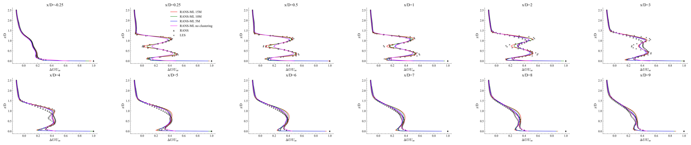
Velocity deficit along the $x$-axis at different streamwise distances from the rotor, for the ML-based RANS model on grids of different resolution, compared with the standard RANS model and the LES reference.
To assess the dynamic effects on the turbine and the associated power production, the predicted forces and the $C_{p}$/$C_{t}$ coefficients are reported in Fig. 4. They show good agreement with the reference curves, with a slight underestimation partly attributable to the fact that the reference refers to an isolated turbine, whereas the ML-based RANS model operates in a turbulent ABL affected by the ground. Overall, the model reproduces not only the velocity wake field but also the aerodynamic loading and power production, a key requirement for wind farm applications.
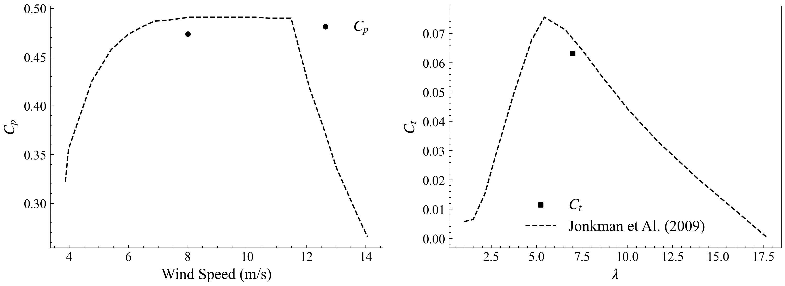 | 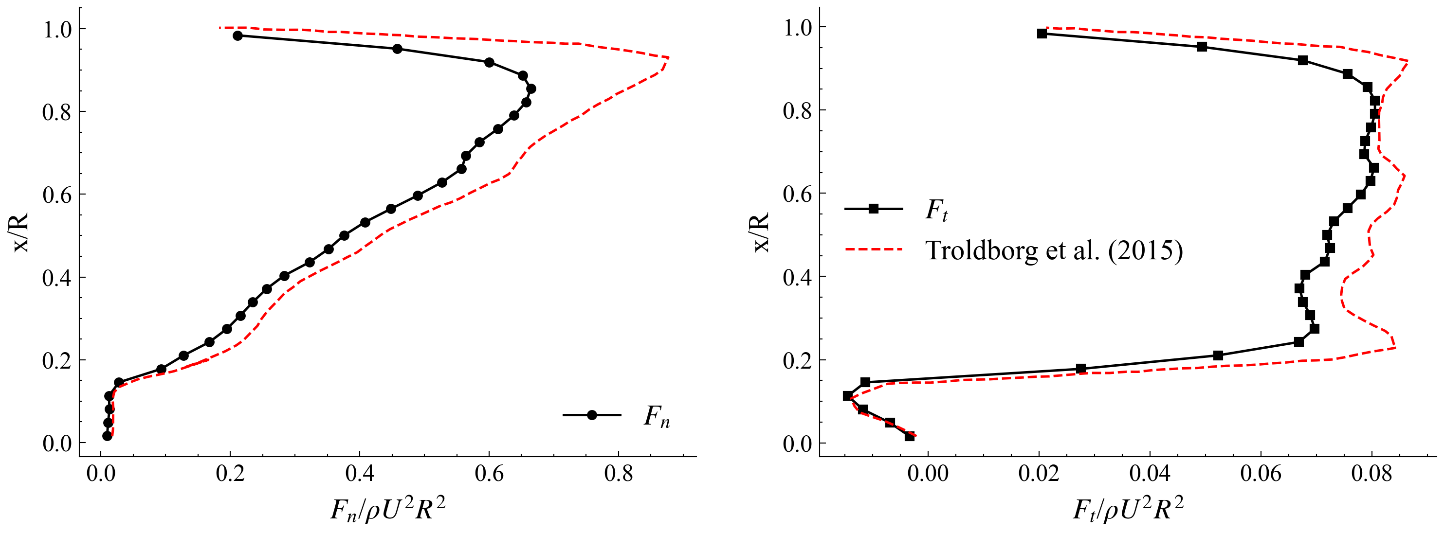
ML-based RANS model results: (a) $C_{p}$ and $C_{t}$ profiles, (b) force profiles.

Conclusions
A CFD-ML methodology was presented to build a turbulence closure that improves the fidelity of RANS simulations of HAWT wakes while keeping the computational cost compatible with wind farm applications. An LES-equivalent eddy viscosity extracted from a LES of the NREL-5MW turbine was used as target, a K-means clustering segmented the domain into seven physically meaningful flow regions, and an MLP learned the eddy-viscosity correction $Δν_{t}=ν_{t,eq}−ν_{t,RANS}$, embedded into a modified OpenFOAM PIMPLE solver. The network reproduced the LES-equivalent closure with a validation $R^{2}=0.9934$, and clustering proved decisive in the near-terrain region. Once embedded, the ML-based RANS model consistently outperformed the standard RANS model in both near- and far-wake; most notably, on ultra-coarse grids it accurately reproduced the post-breakdown far-wake recovery at a cost about $1.25$ times lower than the reference LES, while also reproducing the rotor forces and $C_{p}$/$C_{t}$ coefficients. The model was trained on a single operating condition and a relatively small dataset, which limits its generalisation; future work will enlarge the training dataset to multiple inflow conditions and extend the methodology to multi-turbine configurations, towards compact, data-driven closures suitable for real-time wind farm monitoring and control.
[1] F. Porté-Agel, M. Bastankhah, and S. Shamsoddin, “Wind-turbine and wind-farm flows: A review,” Boundary-Layer Meteorology, vol. 174, Jan. 2020, doi: 10.1007/s10546-019-00473-0.
[2] J. Steiner, R. Dwight, and A. Vire, “Data-driven RANS closures for wind turbine wakes under neutral conditions,” Computers & Fluids, vol. 233, p. 105213, Nov. 2021, doi: 10.1016/j.compfluid.2021.105213.
[3] J. Steiner, “Towards data-driven turbulence modeling for wind turbine wakes,” Dissertation (TU Delft), Delft University of Technology, 2023. doi: 10.4233/uuid:72116acd-c5aa-4b3b-8fc7-52f1b2fa9958.
[4] M. Gholami Anjiraki et al., “Wind farm layout optimization using a novel machine learning approach.” Sep. 2025. doi: 10.48550/arXiv.2509.07868.
[5] K. Duraisamy, G. Iaccarino, and H. Xiao, “Turbulence modeling in the age of data,” Annual Review of Fluid Mechanics, vol. 51, Jan. 2019, doi: 10.1146/annurev-fluid-010518-040547.
[6] J. Ling, A. Kurzawski, and J. Templeton, “Reynolds averaged turbulence modelling using deep neural networks with embedded invariance,” Journal of Fluid Mechanics, vol. 807, pp. 155–166, Nov. 2016, doi: 10.1017/jfm.2016.615.
[7] R. N. King, C. Adcock, J. Annoni, and K. Dykes, “Data-driven machine learning for wind plant flow modeling,” Journal of Physics: Conference Series, vol. 1037, no. 7, p. 072004, Jun. 2018, doi: 10.1088/1742-6596/1037/7/072004.
[8] L. Tieghi, D. Cerbarano, F. De Girolamo, V. Barnabei, and G. Delibra, “A novel methodology for the automatic decomposition of HAWT wakes with k–means clustering,” Wind Energy, vol. 28, May 2025, doi: 10.1002/we.70030.
[9] A. Carloni, G. Delibra, F. De Girolamo, V. F. Barnabei, and L. Tieghi, “Data-driven decomposition of horizontal-axis wind-turbine wakes,” in ASME turbo expo 2026, Milan, Italy, 2026.
[10] J. N. Sorensen and W. Z. Shen, “Numerical modeling of wind turbine wakes,” Journal of Fluids Engineering, vol. 124, no. 2, pp. 393–399, May 2002, doi: 10.1115/1.1471361.
[11] P. Bachant, A. Goude, and M. Wosnik, “turbinesFoam.” Zenodo, Apr. 2016. doi: 10.5281/zenodo.49422.
[12] F. R. Menter, “Two-equation eddy-viscosity turbulence models for engineering applications,” AIAA Journal, vol. 32, no. 8, pp. 1598–1605, 1994, doi: 10.2514/3.12149.
[13] F. Nicoud and F. Ducros, “Subgrid-scale stress modelling based on the square of the velocity gradient tensor,” Flow, turbulence and Combustion, vol. 62, no. 3, pp. 183–200, 1999.
[14] J. C. Kaimal, J. C. Wyngaard, Y. Izumi, and O. R. Coté, “Spectral characteristics of surface-layer turbulence,” Quarterly Journal of the Royal Meteorological Society, vol. 98, no. 417, pp. 563–589, 1972, doi: https://doi.org/10.1002/qj.49709841707.
[15] L. Davidson, “Using isotropic synthetic fluctuations as inlet boundary conditions for unsteady simulations,” Advances and Applications in Fluid Mechanics, vol. 1, pp. 1–35, 2007.
[16] F. Pedregosa et al., “Scikit-learn: Machine learning in Python,” Journal of Machine Learning Research, vol. 12, pp. 2825–2830, 2011.
[17] M. Abadi et al., “TensorFlow: Large-scale machine learning on heterogeneous systems.” 2015. Available: https://www.tensorflow.org/
[18] J. Jonkman, “Definition of a 5-MW reference wind turbine for offshore system development.” 2009. doi: 10.2172/947422.
[19] L. Martínez Tossas, S. Leonardi, M. Churchfield, and P. Moriarty, “A comparison of actuator disk and actuator line wind turbine models and best practices for their use,” Jan. 2012. doi: 10.2514/6.2012-900.
[20] L. Cappugi, A. Castorrini, A. Bonfiglioli, E. Minisci, and S. Campobasso, “Machine learning-enabled prediction of wind turbine energy yield losses due to general blade leading edge erosion,” Energy Conversion and Management, vol. 245, p. 114567, Oct. 2021, doi: 10.1016/j.enconman.2021.114567.
[21] N. Troldborg, F. Zahle, P.-E. Réthoré, and N. N. Sørensen, “Comparison of wind turbine wake properties in non-sheared inflow predicted by different computational fluid dynamics rotor models,” Wind Energy, vol. 18, no. 7, pp. 1239–1250, 2015, doi: https://doi.org/10.1002/we.1757.

