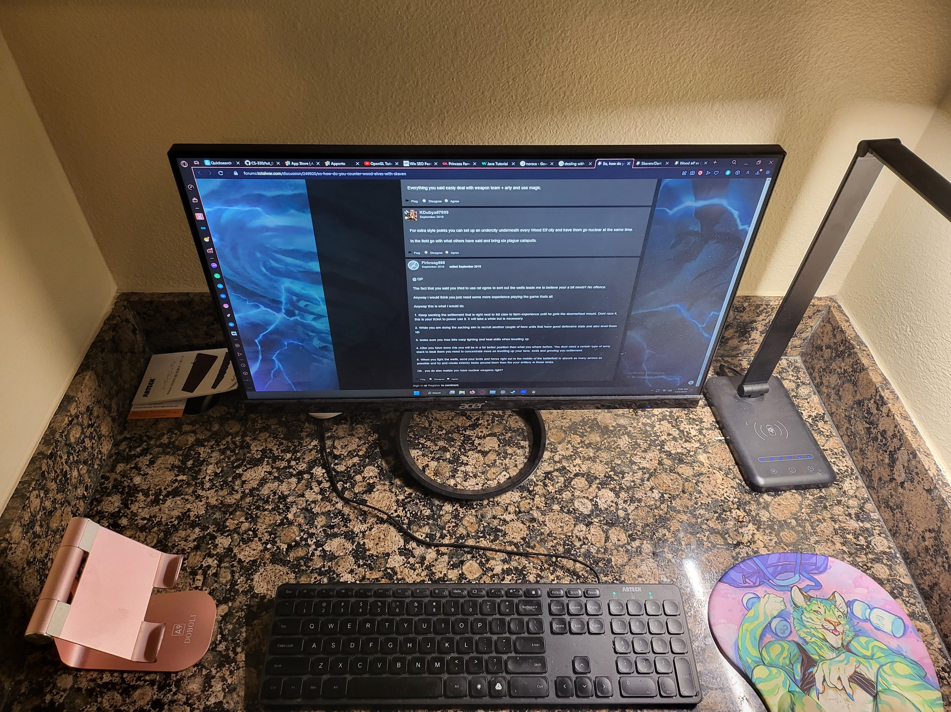

For this image I have my keyboard monitor tablet holder and my light.

The keyboard can be done with a cube or collection of cubes.

The tablet holder is going to be a bit more tricky its going to need to have mutiple planes for each surface jutting out of either cylinders or cubes.

The monitor is a rectangle but will require knowledge of texturing possible. Also for the stand there will be some difficulty in figuring out what to submit for that. Maybe a torus?

The lighting stand will require mutiple cubes for the base stalk and lighting arm and also cubes rotated at 45 degree angles for the joints otherwise cylinders.

If i include my mouse pad I might use a collection of cubes and spheres for the edges probably I would simplify it though