**MySQL安装**

# 下载安装包

下载地址：<http://dev.mysql.com/downloads/mysql/5.6.html#downloads>

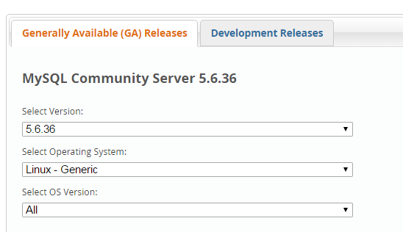

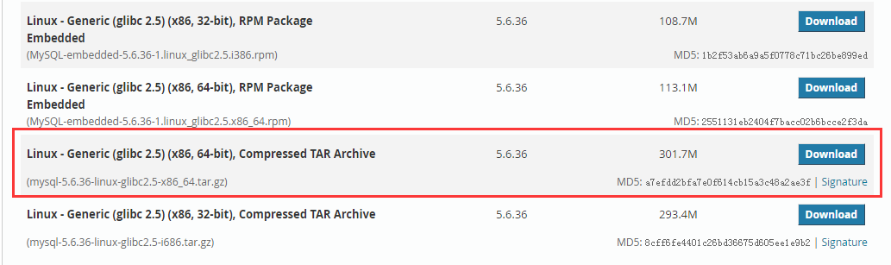

也可以直接复制64位的下载地址，

通过命令下载：wget <http://dev.mysql.com/get/Downloads/MySQL-5.6/mysql-5.6.33-linux-glibc2.5-x86_64.tar.gz>

# 解压

|  |  |
| --- | --- |
| 1  2  3  4 | #解压  tar -zxvf mysql-5.6.33-linux-glibc2.5-x86_64.tar.gz  #复制解压后的mysql目录  cp -r mysql-5.6.36-linux-glibc2.5-x86_64 /usr/local/mysql |

# 添加用户组和用户

|  |  |
| --- | --- |
| 1  2  3  4 | #添加用户组  groupadd mysql  #添加用户mysql 到用户组mysql  useradd -g mysql mysql |

# 安装

|  |  |
| --- | --- |
| 1  2  3  4  5  6  7  8  9  10  11  12  13  14  15  16  17  18  19  20  21  22  23  24  25  26  27  28  29  30  31  32  33  34  35  36  37  38  39  40  41  42  43  44  45  46  47 | cd /usr/local/mysql/ mkdir ./data/mysql  chown -R mysql:mysql ./  ./scripts/mysql_install_db --user=mysql --datadir=/usr/local/mysql/data/mysql  cp support-files/mysql.server /etc/init.d/mysqld  chmod 755 /etc/init.d/mysqld  cp support-files/my-default.cnf /etc/my.cnf    #修改启动脚本  vi /etc/init.d/mysqld    #修改项：  basedir=/usr/local/mysql/  datadir=/usr/local/mysql/data/mysql  #修改root用户密码  ./bin/mysqladmin -u root password '123456'  #启动服务  service mysqld start    #加入环境变量，编辑 /etc/profile，这样可以在任何地方用mysql命令了  export PATH=$PATH:/usr/local/mysql/bin  source /etc/profile  #测试连接  mysql –uroot –p123456  #选择数据库  use mysql;  #查看用户信息  select Host,User,Password from user;  #删除多余账户  delete from user where Host!='localhost' or User!='root';  #更新主机使其可以远程登录  update user set host = '%' where user ='root';  flush privileges;  #新建用户  grant select,insert,update,delete,create,drop on * to hadoop@'%' identified by '123456';  #关闭mysql  service mysqld stop  #查看运行状态  service mysqld status |

# 错误

　　5.1 sqlyog连接时，报1130错误，是由于没有给远程连接的用户权限问题

　　　　解决1:更改 ‘mysql’数据库‘user’表‘host’项，从‘localhost’改成‘%’。

use mysql;

select 'host' from user where user='root';

update user set host = '%' where user ='root';

flush privileges;

　　　　解决2：直接授权

　　　　　　GRANT ALL PRIVILEGES ON *.* TO ‘root’@'%’ IDENTIFIED BY ‘youpassword’ WITH GRANT OPTION;

　　5.2 安装时的一些错误

　　　　-bash: ./scripts/mysql_install_db: /usr/bin/perl: bad interpreter: 没有那个文件或目录  
　　　　解决： yum -y install perl perl-devel

　　　　Installing MySQL system tables..../bin/mysqld: error while loading shared libraries: libaio.so.1: cannot open shared object file: No such file or directory  
　　　　解决：yum -y install libaio-devel

# 其他

　　6.1 配置环境变量

　　　　vi + /etc/profile

　　　　export PATH=....:/usr/local/mysql/bin