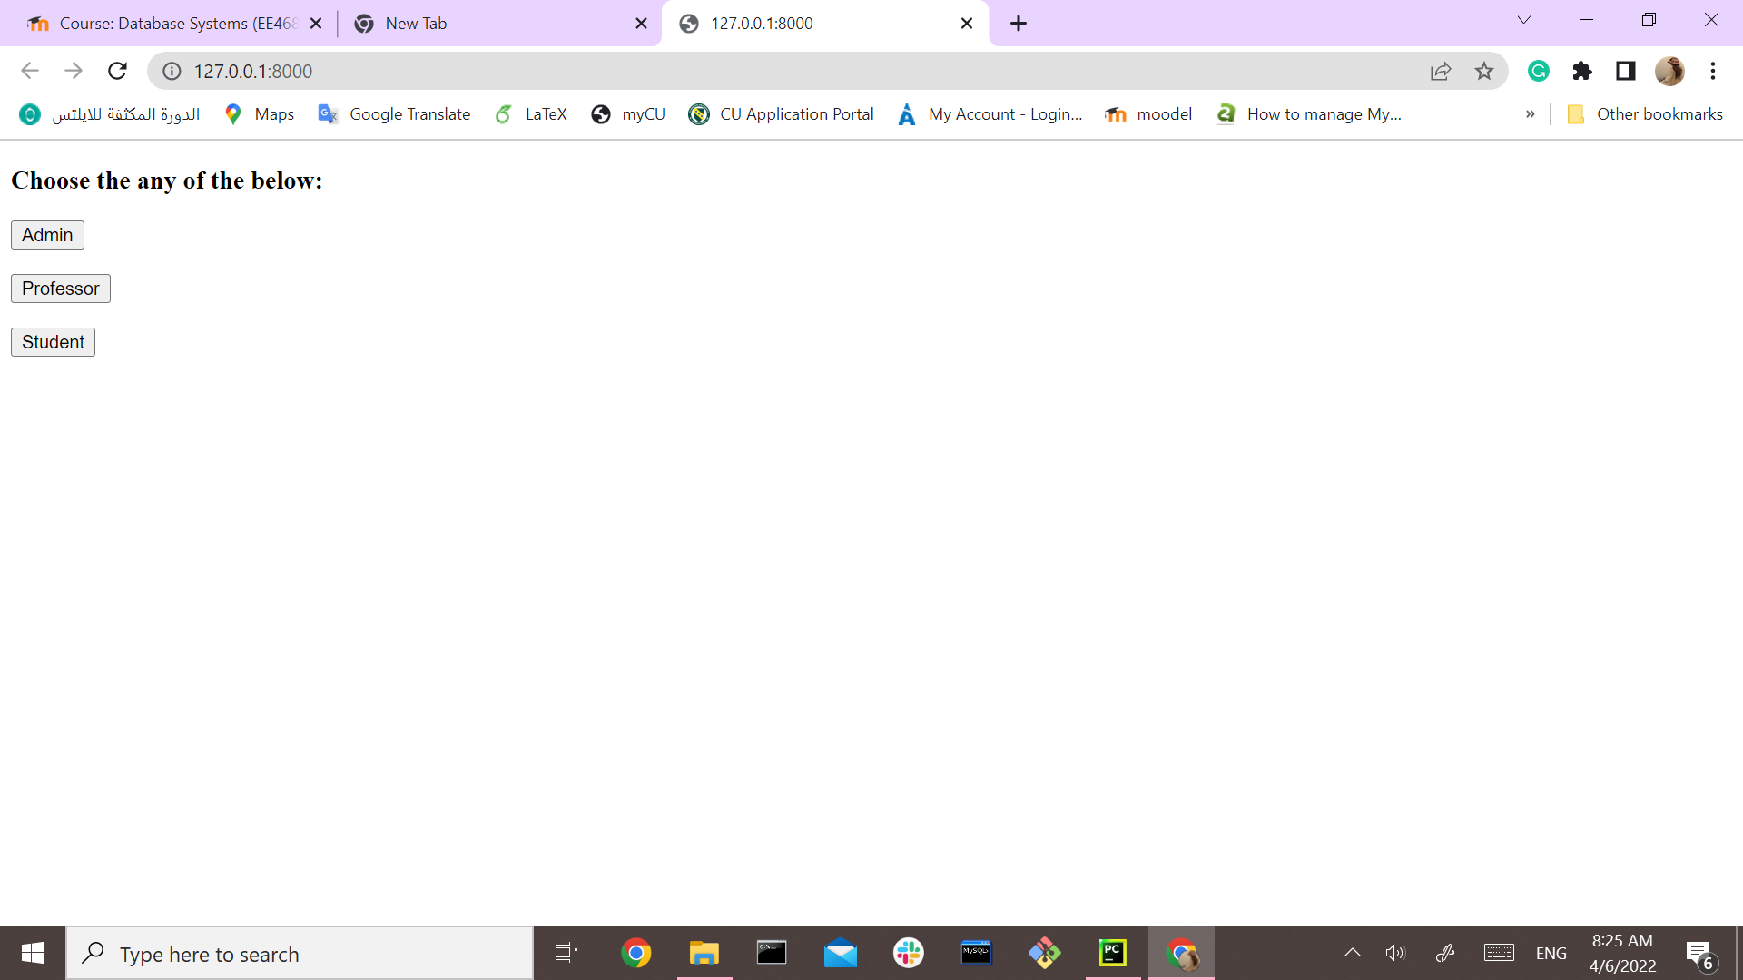

**Database Project-First Draft**

Submitted by:

Naveenkumar Venkataswamy

Norah Alshahrani

Irfan Yaqoob

Numan Zafar

GitHub link: <https://github.com/yaqoobirfan/DatabaseProjectDjango>

Today’s meeting with Professor:

The followings are the remarks from the Professor

1-Add classic authentication (Like we need to make login stuff for admin, professor, and students.

2-Add some styling to feel it is more user friendly

