Export EEG data as .edf from Profusion with a pre-defined montage

When exporting EEG data with Profusion, you can choose to export the data as it was originally acquired or as you are choosing to visualize it in Profusion.
If you need to export multiple recordings using parameters different from those used during acquisition, exporting EEG data with a pre-defined montage allows you to reduce mistakes in parameters. Here is a tutorial to create your own exporting montage.
To export the data with the parameters of acquisition, select “Toutes” instead of “Affichées uniquement” at step 5.
Note that the team recommends to export with a montage where you defined at least a good dynamic range (“Zoom” parameter) to avoid clipping or bad resolution problem and a high-pass filter of 0.01 Hz to remove the slow drift in long recordings such a whole night (that could end up in clipping as well).

Steps to export your EEG data as .edf with a montage:
- Open ProFusion PSG4 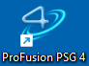

- Open a PSG file, by searching for the patient’s name and selecting the period of the recording (e.g., in the last month)
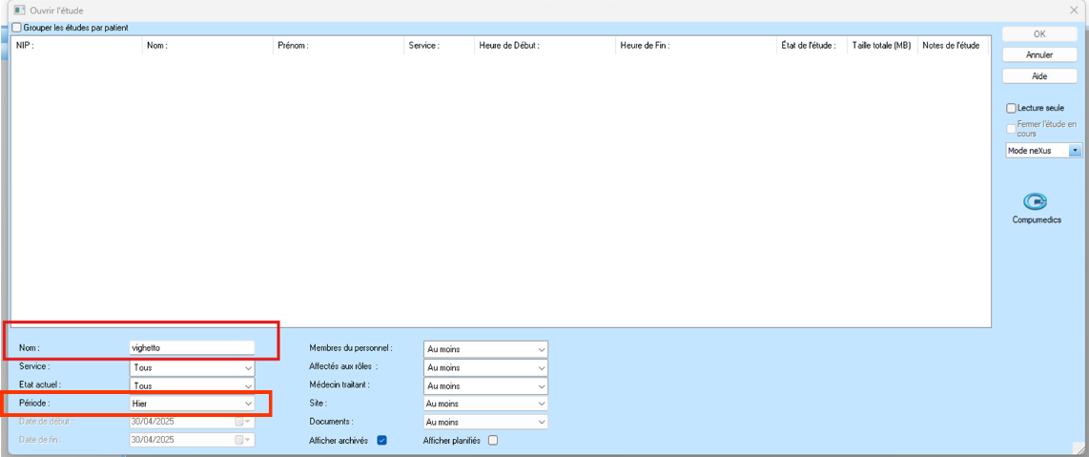

- From the dropdown menu, select the montage that you have created as an export montage.
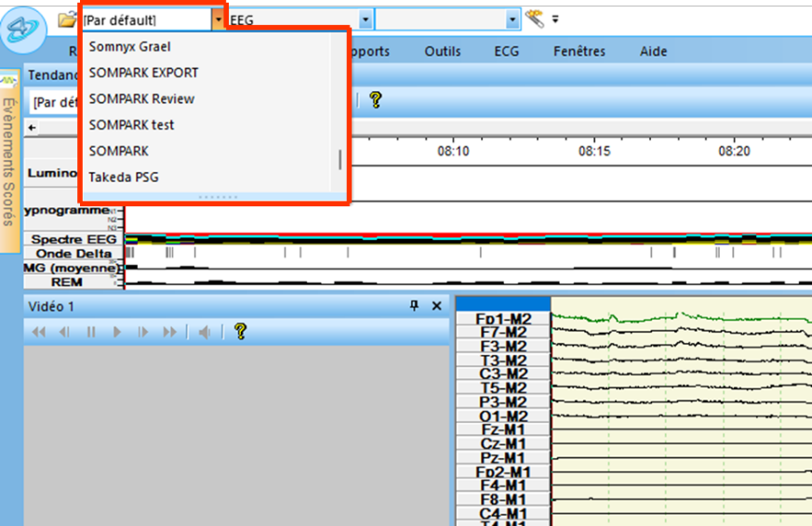

- You can always double-check that the montage parameters are ok by looking at the channel list (can you see all the channels that you need ?) and their parameters (single click on the channel)
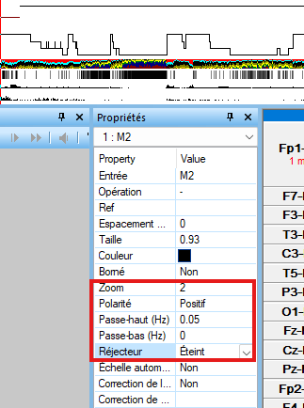

- Export the EDF : click on “Outils” then “Exporter en EDF”
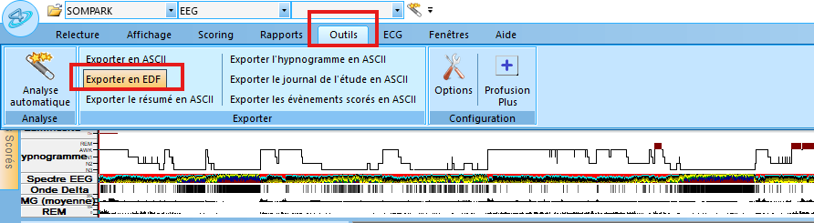
- Check the box « Anonymiser le patient »
- Define the folder and file name with which to save the EDF (three dots)
- Choose « Affichées uniquement »
  - The table you see displayed confirms how the recording will be exported. It corresponds to the parameters set in “fenêtre 1” of “configuration de l’affichage” when you created your montage. This means that you need to be sure that you have the correct montage!
- Click on “Exporter”
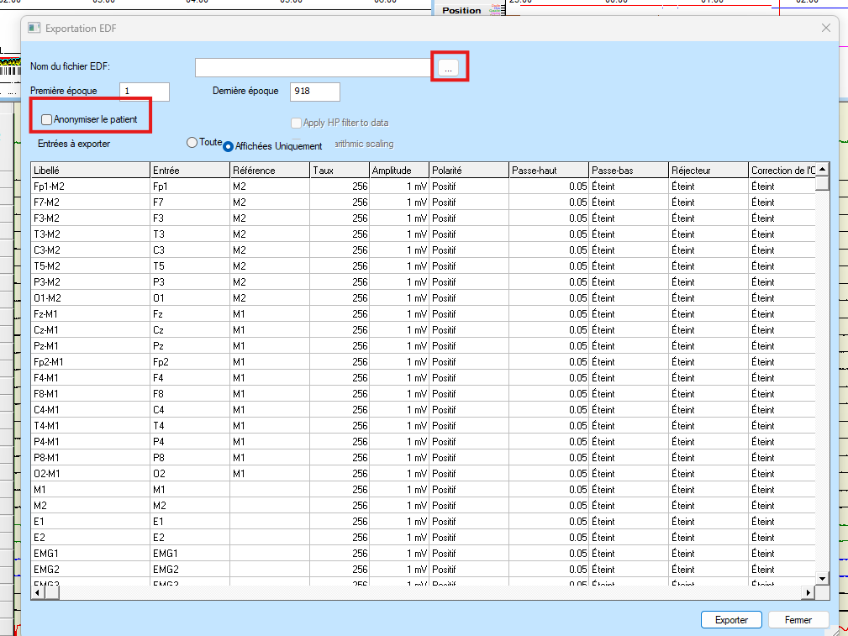

- Export the hypnogram (.txt file)
  - Define the folder and file name with which to save it.


