# 2nd Software Engineering Homework

1. Design your software based on the Class Diagram. Note that:
   1. You are supposed to briefly explain your diagrams, in addition to just putting Class diagrams in the homework.
   2. It is OK to add, modify, or delete Class in the future. In other words, your Class diagrams are not necessarily the final version.

## 1.USE CLASS DIAGRAMS

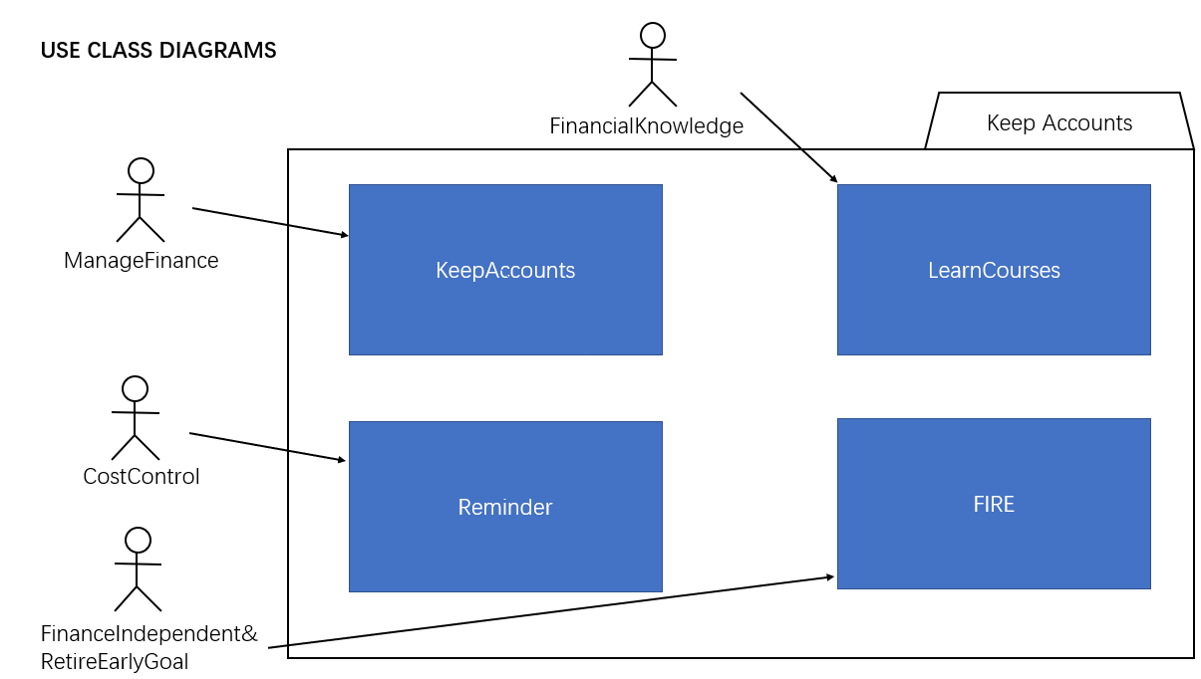

Ideally, through the use of the software, users can learn financial knowledge(or sense) under the course module of software, can take account and insist to use the software, which enables users to better control of their finances.

In the usual use process, the software will remind, tell and advise users that they should spend their money at a reasonable amount next.This part is like a calendar reminder items.

Use this software to set the goal of financial freedom. Through the accumulation of financial knowledge, users can start to pursue the goal of financial freedom when using this software, and finally have good financial knowledge and live a happier life.

## 2.CLASS DIAGRAMS

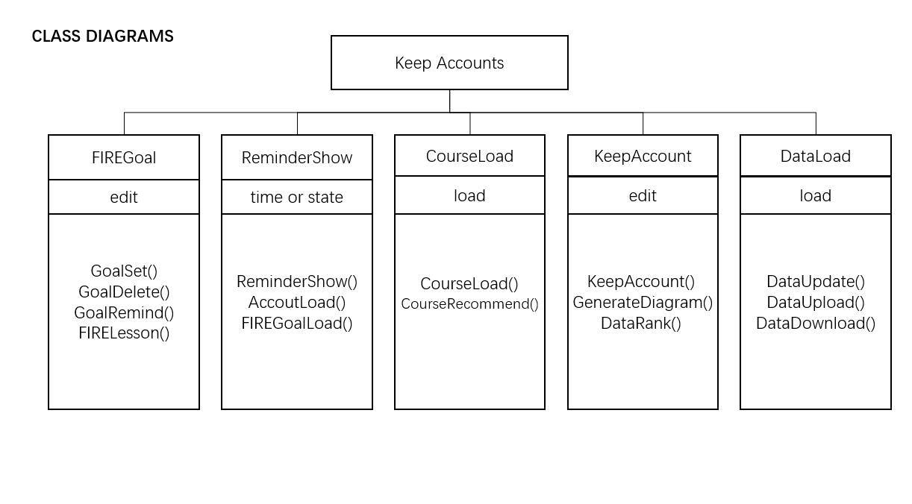

This software contains five sections, in fact, virtualized into five classes.

① FIREGoal class, its characteristics is to edit, that is, equivalent to the text operation, used to set up their own financial freedom goals, including the operation needs to set, delete, remind, jump to the financial knowledge course learning methods, etc. This module is also different from other accounting software on the market, which is an innovative part. It sets long-term financial planning plans for users and cultivates users' good spending habits.

②ReminderShow class, its characteristic is based on the time or the current state of the users to remind or alert users, which is equivalent to calendar reminder items, including the operation of the display alert box, loading the user's book data and the method of financial freedom target data, thus better able to remind users. At the same time, this module is also different from other similar software, can play a role of reminding and warning users, so as to better implement the function of this software, is conducive to the use of users.

③CourseLoad class has the feature of loading, that is, loading recommended websites which contained financial courses or recommend the financial courses in the sharing community to the users. That is to say, this software also needs to load courses and the method of course recommendation.

④KeepAccount class, whose feature is editing, text processing.It is also the main module of this software, providing users with an area for recording daily expenses, and saving it locally or better still in the cloud, and then after a certain period of bookkeeping accumulation, the software can produce spending lists and charts. In this way, users and software can better analyze their spending habits and put forward suggestions to assist users to improve their spending habits. Therefore, accounting operation with editing function is required, and the method of generating charts and rankings is required.

⑤DataLoad class, which features loading and uploading, requires uploading, downloading and updating functions if data is saved in the cloud. Even if data is saved locally, loading and saving functions are also required.