**Anti Theft Vault**

Course Title: Peripheral and Interfacing Laboratory

Course Code: CSE 3104

Date of Submission: 03 July, 2019

*Supervised By:*

Dr. Md. Sheikh Sadi

Professor

Dept. of CSE, KUET

And

Md. Milon Islam

Lecturer

Dept. of CSE, KUET

*Developed By:*

1607006 Md. Sajid Hasan

1607014 Soarov Chakraborty

3rd Year, 1st Semester

Dept. of CSE, KUET



Department of CSE

**Table of Contents**

|  |  |
| --- | --- |
| Title | Page |
| **Objectives** | 3 |
| **Introduction** | 3 |
| **Block diagram** | 5 |
| **Flow chart** | 6 |
| **Pseudo-code** | 7 |
| **Hardware Design** | 8 |
| **Working Procedure** | 9 |
| **Prototype design and implementation** | 9 |
| **Experimental Result** | 10 |
| **System Testing** | 10 |
| **Discussion** | 10 |
| **Conclusion** | 11 |
| **References** | 11 |
|  |

**Objectives:**

i.Use Raspberry Pi and learn details about Raspberry Pi.

ii. Gain knowledge about servo motor and motion sensor.

iii. Design a system to provide security to banking system.

iv. Use a camera to monitor the whole system.

**Introduction:**

**Raspberry Pi:**

The Raspberry Pi is a low cost, **credit-card sized computer** that plugs into a computer monitor or TV, and uses a standard keyboard and mouse. It is a capable little device that enables people of all ages to explore computing, and to learn how to program in languages like Scratch and Python. It’s capable of doing everything you’d expect a desktop computer to do, from browsing the internet and playing high-definition video, to making spreadsheets, word-processing, and playing games.

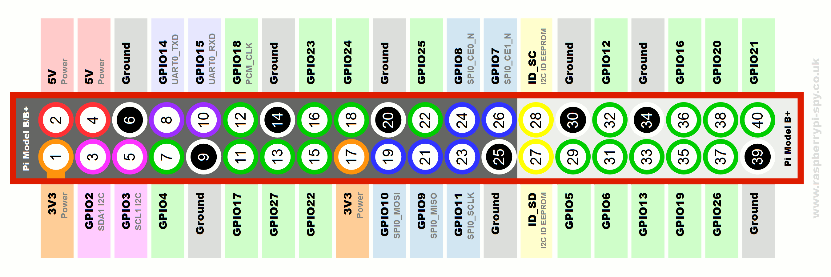

**Servo Motor:**

A **servomotor is a** [**rotary actuator**](https://en.wikipedia.org/wiki/Rotary_actuator) **or** [linear actuator](https://en.wikipedia.org/wiki/Linear_actuator) that allows for precise control of angular or linear position, velocity and acceleration.It consists of a suitable motor coupled to a sensor for position feedback. It also requires a relatively sophisticated controller, often a dedicated module designed specifically for use with servomotors.

**Motion Sensor:**

PIR (passive infrared) motion sensor detects any movement of objects, human or animals. Mostly they are used in automatically activated lighting and burglar alarm systems.

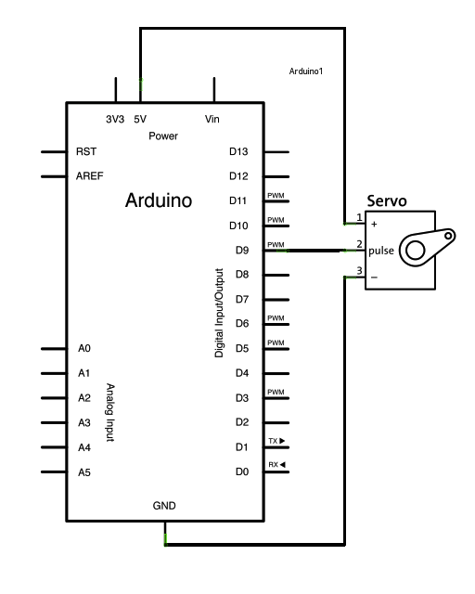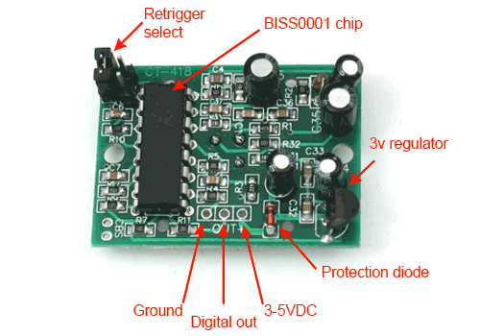

**RFID:**

RFID is an acronym for “radio-frequency identification” and refers to a technology whereby digital data encoded in RFID tags or smart labels (defined below) are captured by a reader via radio waves. RFID is similar to barcoding in that data from a tag or label are captured by a device that stores the data in a database. RFID, however, has several advantages over systems that use barcode asset tracking software. The most notable is that RFID tag data can be read outside the line-of-sight, whereas barcodes must be aligned with an optical scanner.

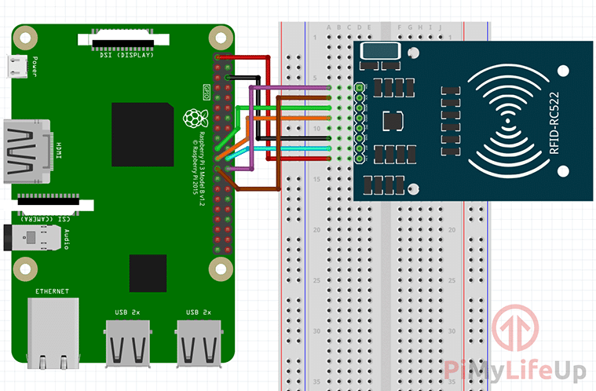

**Block Diagram:**

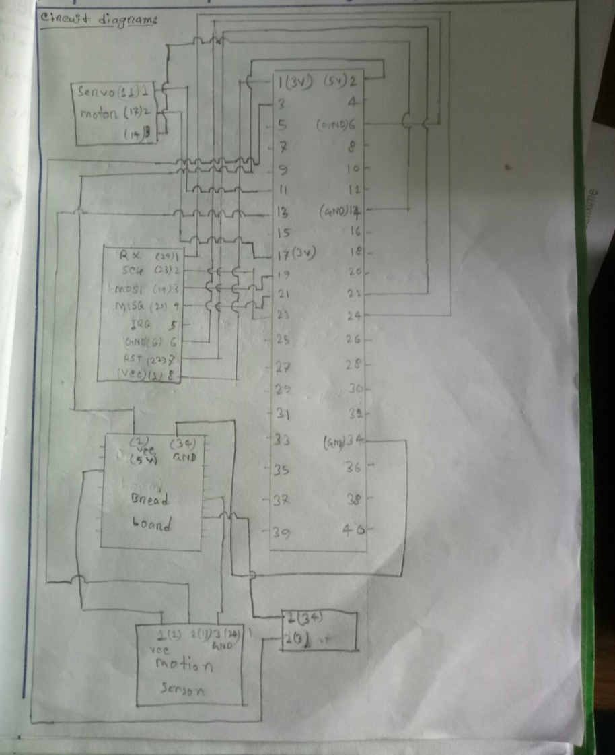

**Flow Chart:**

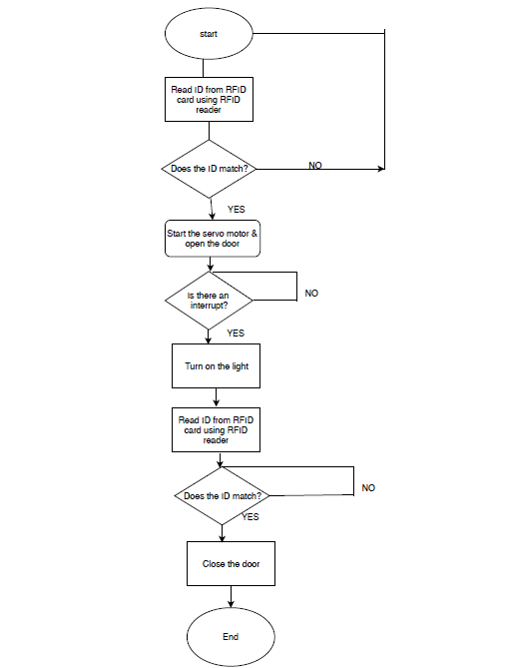

**Pseudo-code:**

import RPi.GPIO as GPIO

import sys

import time

sys.path.append('/home/pi/MFRC522-python')

from mfrc522 import SimpleMFRC522

GPIO.setwarnings(False)

GPIO.setmode(GPIO.BOARD)

#servo motor pin number

servoPIN = 11

GPIO.setup(servoPIN, GPIO.OUT) #output

p = GPIO.PWM(servoPIN, 50)# pin 11 for PWM with 50Hz

#motion sensor

GPIO.setup(13, GPIO.IN) #Read output from PIR motion sensor

GPIO.setup(3, GPIO.OUT)#for led

#Rfid card

reader = SimpleMFRC522()

writter = SimpleMFRC522()

try:

#start loop

while 1:

print("Hold a tag near the reader")

id, text = reader.read()

print(id)

if id==974914530910: #Rfid card value it's unique

p.start(0)

p.ChangeDutyCycle(12.5) #motor initial position

time.sleep(1)

p.ChangeDutyCycle(7.5) #motor turns 90 degree

time.sleep(1)

while 1:

i=GPIO.input(13)

if i==1: #When output from motion sensor is HIGH

print("Intruder detected")

GPIO.output(3, 1) #Turn ON LED

break

id, text = reader.read()

print(id)

if id==974914530910:

GPIO.output(3, 0) #Turn OFF LED

p.ChangeDutyCycle(12.5) #door go back to it's previous position

time.sleep(1)

print(text)

#finish loop

finally:

p.stop()

GPIO.cleanup()

**Hardware design:**



**Prototype Design & Implementation:**

We have designed a prototype for our anti-theft vault in the fig 5.

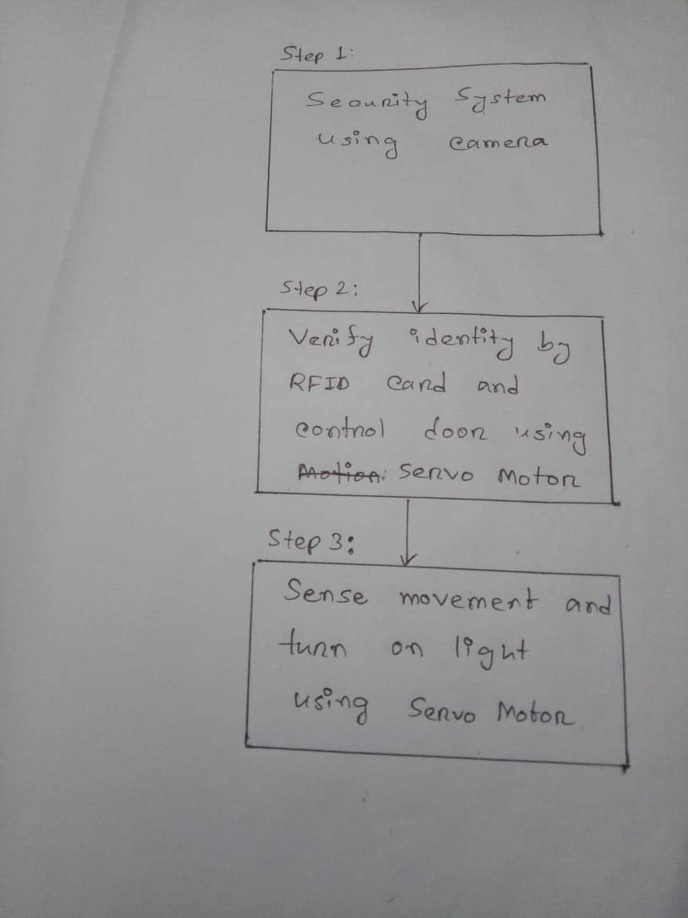

Then we implemented it in three steps.

In the first step, an android phone is used as a camera. The android phone access was given to the Raspberry Pi.

In the second step, there is a door controlled by the servo motor. If the RFID card’s ID matches with the ID in the code, the door will open.

In the third step, there is a motion sensor. If it recognizes any movement, it turns the lights on.

**Working Procedure:**

1. RFID reader/writer (RC522) grant access to the owner of the vault.

2. A servo motor control the sliding gate of the main access point.

3. A camera monitors the whole system for 24 hours a day.

4. Motion Sensor automatically activate the light if anyone try to open the vault.

**System Testing:**

We have tested the design system with joystick control system. The testing result we have found are:

**1.** When we move the joystick controller upward the servo_1 moves at 150 degree and the hand goes upward.

**2.** When we move the camera photo captured.

**3.** At the time of moving right and left the servo_2 moves 90 degree each side.

**4.** By using Rf id card door is controlled.

**Experimental Result:**

We have experimented the system to gather some statistical result. After the experience,

We have found that the rotating speed of servo1 is 10.71 degree per second and the servo2 was rotating faster than the servo1 with the speed of 14.56 degree per second. As the servo motors can rotate no more than 180 degree, so if we applied an input to rotate the hand to a direction that the door would rotating continuously, the door eventually stopped rotating after 90 degree in both sides.

**Discussion:**

In this project, we learnt how to use Raspberry Pi, motion sensor, servo motor, bread board. These components can be used in a single system to develop a security system. An RFID card was used to check entry. Also, a camera was used to monitor the whole system . The motion sensor turns the lights on when it recognizes any movement so that the security guards can be alerted. Raspberry Pi was used to control the whole system. Servo motor was used to close or open the door.

**Conclusion:**

The report has presented a novel and a simple control implementation of a smart Raspberry pi control door that employed by three servo motor to follow the joystick direction and android based application.

A laboratory prototype has been successfully built and tested to verify the effectiveness of the control implementation. Experiment results indicated that the developed system increased the working capability of human.

**Reference:**

1. <https://www.abr.com/what-is-rfid-how-does-rfid-work/>
2. <https://www.hackster.io/hardikrathod/pir-motion-sensor-with-raspberry-pi-415c04>
3. <https://www.hackster.io/hardikrathod/pir-motion-sensor-with-raspberry-pi-415c04>
4. <https://en.wikipedia.org/wiki/Servomotor>