**Assignment – 6**

**Q1. Create a abstract class Bank that has abstract method getROI(). Create three classes SBI, PNB, BOI inherited from Bank. Create a Main class that prints the rate of interest of each bank using super class memory reference.**

abstract class Bank {  
 public abstract double getROI();  
}  
  
class SBI extends Bank {  
 public double getROI() {  
 return 8.0;  
 }  
}  
  
class PNB extends Bank {  
 public double getROI() {  
 return 7.0;  
 }  
}  
  
class BOI extends Bank {  
 public double getROI() {  
 return 9.0;  
 }  
}  
  
class Main {  
 public static void main(String[] args) {  
 Bank bank;  
 bank = new SBI();  
 System.*out*.println("Rate of Interest of SBI: " + bank.getROI());  
 bank = new PNB();  
 System.*out*.println("Rate of Interest of PNB: " + bank.getROI());  
 bank = new BOI();  
 System.*out*.println("Rate of Interest of BOI: " + bank.getROI());  
 }  
}

**Output:**

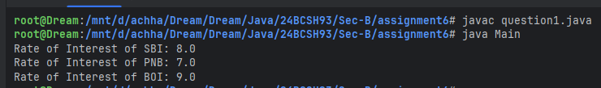

**Q2. Define an interface Calculator which has the basic methods add(), sub(), mul() and div(). Define a concrete class named as DemoCalculator that implements the interface. Define the Main class, which create object reference of the interface Calculator and perform all basic operation of the calculator.**

import java.util.Scanner;  
interface Calculator {  
 double add(double lhs, double rhs);  
 double sub(double lhs, double rhs);  
 double mul(double lhs, double rhs);  
 double div(double lhs, double rhs);  
}  
  
class DemoCalculator implements Calculator {  
 public double add(double lhs, double rhs) {  
 return lhs + rhs;  
 }  
  
 public double sub(double lhs, double rhs) {  
 return lhs - rhs;  
 }  
  
 public double mul(double lhs, double rhs) {  
 return lhs * rhs;  
 }  
  
 public double div(double lhs, double rhs) {  
 if (rhs == 0) {  
 System.*out*.println("Division by Zero");  
 System.*exit*(0);  
 }  
 return lhs / rhs;  
 }  
}  
  
class Main {  
 public static void main(String[] args) {  
 Scanner sc = new Scanner(System.*in*);  
 Calculator calculator = new DemoCalculator();  
 System.*out*.print("Enter two numbers: ");  
 double lhs = sc.nextDouble();  
 double rhs = sc.nextDouble();  
  
 System.*out*.println("\nAddition: " + calculator.add(lhs, rhs));  
 System.*out*.println("Subtraction: " + calculator.sub(lhs, rhs));  
 System.*out*.println("Multiplication: " + calculator.mul(lhs, rhs));  
 System.*out*.println("Division: " + calculator.div(lhs, rhs));  
 }  
}

**Output:**

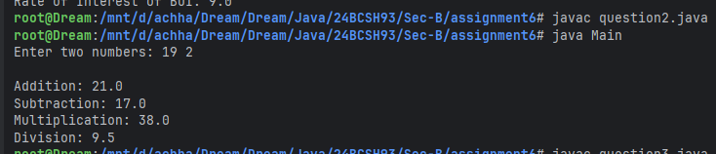

**Q3. Create an abstract class 'Shape' with three abstract methods namely 'RectangleArea' taking two parameters, 'SquareArea' and 'CircleArea' taking one parameter each. The parameters of 'RectangleArea' are its length and breadth, that of 'SquareArea' is its side and that of 'CircleArea' is its radius. Now create another class 'Area' containing all the three methods 'RectangleArea', 'SquareArea' and 'CircleArea' for printing the area of rectangle, square and circle respectively. Create an object of class 'Area' and call all the three methods.**

import java.util.Scanner;  
abstract class Shape {  
 public abstract void rectangleArea(double length, double breadth);  
 public abstract void squareArea(double side);  
 public abstract void circleArea(double radius);  
}  
  
class Area extends Shape {  
 public void rectangleArea(double length, double breadth) {  
 System.*out*.println("Area of the Rectangle is: " + length * breadth);  
 }  
  
 public void squareArea(double side) {  
 System.*out*.println("Area of the Square is: " + side * side);  
 }  
  
 public void circleArea(double radius) {  
 System.*out*.println("Area of the Circle is: " + Math.*PI* * radius * radius);  
 }  
}  
  
class Main {  
 public static void main(String[] args) {  
 Scanner sc = new Scanner(System.*in*);  
 Shape shape = new Area();  
  
 System.*out*.print("Enter length and breadth for the Rectangle: ");  
 double length = sc.nextDouble();  
 double breadth = sc.nextDouble();  
 shape.rectangleArea(length, breadth);  
  
 System.*out*.print("\nEnter side for the Square: ");  
 double side = sc.nextDouble();  
 shape.squareArea(side);  
  
 System.*out*.print("\nEnter radius for the Circle: ");  
 double radius = sc.nextDouble();  
 shape.circleArea(radius);  
 }  
}

**Output:**

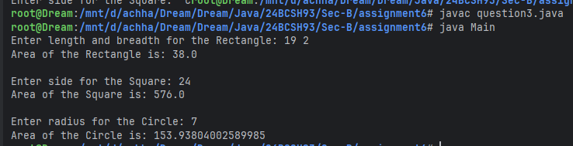

**Q4. Write a program to implement multiple inheritance using interface.**

interface Interface1 {  
 void method1();  
}  
  
interface Interface2 {  
 void method2();  
}  
  
interface Interface3 {  
 void method3();  
}  
  
class MultipleInheritance implements Interface1, Interface2, Interface3 {  
 public void method1() {  
 System.*out*.println("Method1 from Interface1");  
 }  
  
 public void method2() {  
 System.*out*.println("Method2 from Interface2");  
 }  
  
 public void method3() {  
 System.*out*.println("Method3 from Interface3");  
 }  
}  
  
class Main {  
 public static void main(String[] args) {  
 MultipleInheritance multipleInheritance = new MultipleInheritance();  
 multipleInheritance.method1();  
 multipleInheritance.method2();  
 multipleInheritance.method3();  
 }  
}

**Output:**

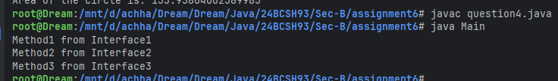

**Q5. Create an interface Servicing that has abstract methods getServiceTime(). Create two class Car, Bike that implement interface. Create a Main class that creates the objects of two class and displays the service time.**

interface Servicing {  
 void getServiceTime();  
}  
  
class Car implements Servicing {  
 public void getServiceTime() {  
 System.*out*.println("Servicing time for Car is: 9 AM");  
 }  
}  
  
class Bike implements Servicing {  
 public void getServiceTime() {  
 System.*out*.println("Servicing time for Bike is: 10 AM");  
 }  
}  
  
class Main {  
 public static void main(String[] args) {  
 (new Car()).getServiceTime();  
 (new Bike()).getServiceTime();  
 }  
}

**Output:**

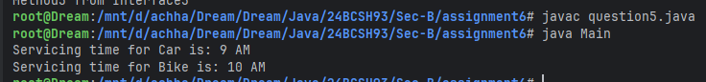

**Q6. Create a Package btech which has one class Student. Accept student detail through parameterized constructor of Student class. Write a method display() to display the student details. Create another class Main containing the main method which will use the package btech and calculate total marks and percentage of marks.**

package btech.arithmetic;  
public class MyMath {  
 public static double add(double lhs, double rhs) {  
 return lhs + rhs;  
 }  
  
 public static double sub(double lhs, double rhs) {  
 return lhs - rhs;  
 }  
  
 public static double mul(double lhs, double rhs) {  
 return lhs * rhs;  
 }  
  
 public static double div(double lhs, double rhs) {  
 *validate*(rhs);  
 return lhs / rhs;  
 }  
  
 public static double mod(double lhs, double rhs) {  
 *validate*(rhs);  
 return lhs % rhs;  
 }  
  
 private static void validate(double value) {  
 if (value == 0) {  
 System.*out*.println("Division by Zero");  
 System.*exit*(0);  
 }  
 }  
}

import java.util.Scanner;  
import btech.Student;  
class Main {  
 public static double getTotal(double[] marks) {  
 double total = 0.0;  
  
 for (double mark : marks) {  
 total += mark;  
 }  
 return total;  
 }  
  
 public static void main(String[] args) {  
 Scanner sc = new Scanner(System.*in*);  
 System.*out*.print("Enter Roll no:= ");  
 int rollNo = sc.nextInt();  
 System.*out*.print("Enter Name:= ");  
 String name = sc.next();  
 System.*out*.print("Enter marks in 3 subjects:= ");  
 double[] marks = new double[3];  
  
 for (int i = 0; i < 3; i++) {  
 marks[i] = sc.nextDouble();  
 }  
 Student student = new Student(rollNo, name, marks);  
 student.display();  
 double totalMarks = *getTotal*(student.getMarks());  
 double percentage = totalMarks / 3;  
 System.*out*.println("Total Marks: " + totalMarks);  
 System.*out*.println("Percentage: " + percentage);  
 }  
}

**Output:**

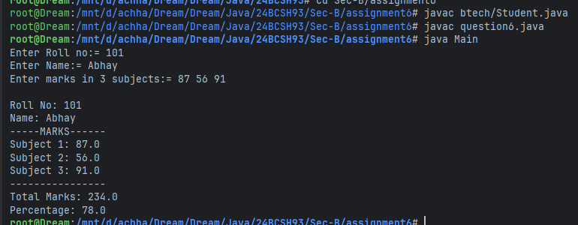

**Q7.** **Create a sub-package called arithmetic under the package btech. The arithmetic package should contain a class MyMath having methods to deal with different arithmetic operations (addition, subtraction, multiplication, division and mod). Create a class Main containing the main method which will use the methods of sub-package arithmetic.**

package btech.arithmetic;  
public class MyMath {  
 public static double add(double lhs, double rhs) {  
 return lhs + rhs;  
 }  
  
 public static double sub(double lhs, double rhs) {  
 return lhs - rhs;  
 }  
  
 public static double mul(double lhs, double rhs) {  
 return lhs * rhs;  
 }  
  
 public static double div(double lhs, double rhs) {  
 *validate*(rhs);  
 return lhs / rhs;  
 }  
  
 public static double mod(double lhs, double rhs) {  
 *validate*(rhs);  
 return lhs % rhs;  
 }  
  
 private static void validate(double value) {  
 if (value == 0) {  
 System.*out*.println("Division by Zero");  
 System.*exit*(0);  
 }  
 }  
}

import java.util.Scanner;  
import btech.arithmetic.MyMath;  
class Main {  
 public static void main(String[] args) {  
 Scanner sc = new Scanner(System.*in*);  
 System.*out*.print("Enter two numbers: ");  
 double lhs = sc.nextDouble();  
 double rhs = sc.nextDouble();  
  
 System.*out*.println("\nAddition: " + MyMath.*add*(lhs, rhs));  
 System.*out*.println("Subtraction: " + MyMath.*sub*(lhs, rhs));  
 System.*out*.println("Multiplication: " + MyMath.*mul*(lhs, rhs));  
 System.*out*.println("Division: " + MyMath.*div*(lhs, rhs));  
 System.*out*.println("Modulus: " + MyMath.*mod*(lhs, rhs));  
 }  
}

**Output:**

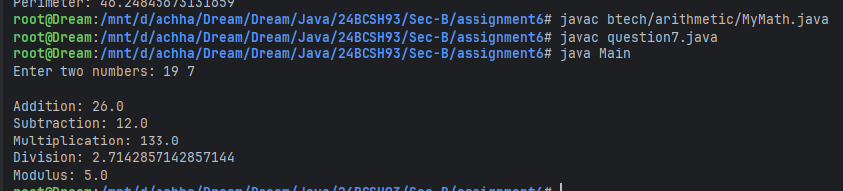

**Q8.** **Create a sub-package named shapes under a package org. Create some classes in the package representing some common geometric shapes like Square, Triangle, Circle and so on. The classes should contain the area() and perimeter() methods in them. Compile the package. Use this package to find area and perimeter of different shapes as chosen by the user.**

package org.shapes;  
public class Square {  
 private double side;  
  
 public Square(double side) {  
 this.side = side;  
 }  
  
 public double area() {  
 return side * side;  
 }  
  
 public double perimeter() {  
 return 4 * side;  
 }  
}  
  
package org.shapes;  
public class Circle {  
 private double radius;  
  
 public Circle(double radius) {  
 this.radius = radius;  
 }  
  
 public double area() {  
 return Math.*PI* * radius * radius;  
 }  
  
 public double perimeter() {  
 return 2 * Math.*PI* * radius;  
 }  
}  
  
package org.shapes;  
public class Triangle {  
 private double base, height;  
  
 public Triangle(double base, double height) {  
 this.base = base;  
 this.height = height;  
 }  
  
 public double area() {  
 return 0.5 * base * height;  
 }  
  
 public double perimeter() {  
 return base + height + Math.*sqrt*(base * base + height * height);  
 }  
}

import java.util.Scanner;  
import org.shapes.Circle;  
import org.shapes.Square;  
import org.shapes.Triangle;  
class Main {  
 public static void main(String[] args) {  
 Scanner sc = new Scanner(System.*in*);  
 System.*out*.println("Choose a shape to calculate:");  
 System.*out*.println("1. Square");  
 System.*out*.println("2. Circle");  
 System.*out*.println("3. Triangle");  
 System.*out*.print("Enter your choice: ");  
 int choice = sc.nextInt();  
 System.*out*.println();  
  
 switch (choice) {  
 case 1:  
 System.*out*.print("Enter side of the square: ");  
 double side = sc.nextDouble();  
 Square square = new Square(side);  
 System.*out*.println("Area: " + square.area());  
 System.*out*.println("Perimeter: " + square.perimeter());  
 break;  
  
 case 2:  
 System.*out*.print("Enter radius of the circle: ");  
 double radius = sc.nextDouble();  
 Circle circle = new Circle(radius);  
 System.*out*.println("Area: " + circle.area());  
 System.*out*.println("Perimeter: " + circle.perimeter());  
 break;  
  
 case 3:  
 System.*out*.print("Enter base of the triangle: ");  
 double base = sc.nextDouble();  
 System.*out*.print("Enter height of the triangle: ");  
 double height = sc.nextDouble();  
 Triangle triangle = new Triangle(base, height);  
 System.*out*.println("Area: " + triangle.area());  
 System.*out*.println("Perimeter: " + triangle.perimeter());  
 break;  
  
 default:  
 System.*out*.println("Invalid choice!");  
 }  
 }  
}

**Output:**

