Assignment – 1

Q1. Design a date command with options such that the output is

Today’s date : dd/mm/yyyy

Current time : hh:mm:ss

root@Dream:~/24BCSH93# echo "Today's date: $(date +%d/%m/%Y)"

Today's date: 18/08/2025

root@Dream:~/24BCSH93# echo "Current time: $(date +%T)"

Current time: 17:25:12

Q2. Design a cal command with options to print the calendar of a specific moth of a specific year.

root@Dream:~/24BCSH93# cal 08 2025

August 2025

Su Mo Tu We Th Fr Sa

1 2

3 4 5 6 7 8 9

10 11 12 13 14 15 16

17 18 19 20 21 22 23

24 25 26 27 28 29 30

31

Q3. Use touch command to create a file with date and time different from current date and time.

root@Dream:~/24BCSH93# touch -t 2506131536 file.txt

root@Dream:~/24BCSH93# ls -l

total 0

-rw-r--r-- 1 root root 0 Jun 13 15:36 file.txt

Q4. Use who command to find out number of users (user count) logged in.

root@Dream:~/24BCSH93# who -q

root

# users=1

Q5. Use ls command to sort the list according to

1. file name (descending) and display with their inode numbers.
2. size of file(ascending) and display names in one column.
3. root@Dream:~/24BCSH93# ls -i -r

127 file.txt

1. root@Dream:~/24BCSH93# ls -S -r

file.txt

Q6. Create a directory structure as given below.

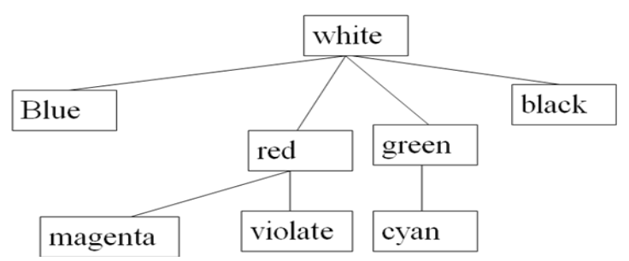

root@Dream:~/24BCSH93# mkdir white white/blue white/red white/green white/black white/red/magenta white/red/violet white/green/cyan

Q7. Change directory from white to violate.

root@Dream:~/24BCSH93# cd white

root@Dream:~/24BCSH93/white# cd red/violet

Q8. Change directory from violate to blue.

root@Dream:~/24BCSH93/white/red/violet# cd ../../blue

Q9. Change directory from blue to black.

root@Dream:~/24BCSH93/white/blue# cd ../black

Q10. Change directory from black to cyan.

root@Dream:~/24BCSH93/white/black# cd ../green/cyan

Q11. Create one file under blue and copy it into magenta directory.

root@Dream:~/24BCSH93/white/green/cyan# touch ../../blue/file.txt

root@Dream:~/24BCSH93/white/green/cyan# ls ../../blue

file.txt

root@Dream:~/24BCSH93/white/green/cyan# cp ../../blue/file.txt ../../red/magenta

root@Dream:~/24BCSH93/white/green/cyan# ls ../../red/magenta

file.txt

Q12. Move the file under magenta to black.

root@Dream:~/24BCSH93/white/green/cyan# mv ../../red/magenta/file.txt ../../black

root@Dream:~/24BCSH93/white/green/cyan# ls ../../black

file.txt

Q13. Move entire black directory to blue.

root@Dream:~/24BCSH93/white/green/cyan# mv ../../black ../../blue

root@Dream:~/24BCSH93/white/green/cyan# ls ../../blue

black file.txt

Q14. Delete the file under blue.

root@Dream:~/24BCSH93/white/green/cyan# rm ../../blue/file.txt

root@Dream:~/24BCSH93/white/green/cyan# ls ../../blue

black

Q15. Delete the directory cyan.

root@Dream:~/24BCSH93/white/green/cyan# cd ..

root@Dream:~/24BCSH93/white/green# rm -r cyan

Q16. Delete the directory red.

root@Dream:~/24BCSH93/white/green# rm -r ../red

root@Dream:~/24BCSH93/white/green# ls -r ../

blue green

Q17. Copy entire black directory under green.

root@Dream:~/24BCSH93/white/green# cp -r ../blue/black/ .

root@Dream:~/24BCSH93/white/green# ls

black

Q18. Delete the directory black under blue.

root@Dream:~/24BCSH93/white/green# rm -r ../blue/blacks