- Introduction to Assembly language programming using 8085 microprocessor.
- An assembly program to add two numbers and store the 8 bit sum in any general purpose register.
- An assembly program to add two numbers and store the 8 bit sum in any Memory location.
- An assembly program to subtract two numbers and store the result in any Memory location.

Assignment-5
- Write a program in 8085 assembly language to perform the following operations:
  - Initialize Register B with some data in Hex form
  - Initialize Register C with some data in Hex form
  - Initialize Register D with some data in Hex form
  - Add contents of register B and D
  - If the sum is zero then:
    - increment the content of register C by 1 else
    - decrement the content of register C by 1

- Write a program in 8085 assembly language to perform the following operations:
- Initialize Register B with 80H
- Initialize Register D with 84H
- Add contents of register B and D
- If the add operation generate an carry then:
  - store the carry bit in memory location 2021H and 8-bit sum in 2020H memory location.
else
  - store only the 8-bit sum in 2021H memory location.

- An assembly program to add two 8-bit Hexadecimal numbers and store result in decimal form only which will be a 16-bits number. 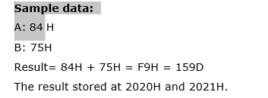
- An assembly program to multiply two numbers:
- Program to find square of 8-bit number.
- Program to find sum of digit of an 8-bit number

- Program to find sum of digit of an 8-bit number .

