Assignment – 1

Q1. Write HTML code to do the following tasks.
o Change the title of the page to "Internet and Web Technology Lab"
o Display the heading "Web Technology Basics" using an <h1> tag.
o Add at least two paragraphs describing the importance of web development.
o Create a hyperlink with a display text "Read More" to go to https://en.wikipedia.org/wiki/Internet.
o Create another link to open Google in a new tab.
o Insert an image of your choice into the webpage and control its height and width using attributes.
<html>
<head>
<title>Internet and Web Technology Lab</title>
</head>
<body>
<h1>Web Technology Basics</h1>
<p>
The Internet is the global system of interconnected computer networks that uses the Internet protocol
suite (TCP/IP) to communicate between networks and devices. It is a network of networks that
comprises private, public, academic, business, and government networks of local to global scope,
linked by electronic, wireless, and optical networking technologies. The Internet carries a vast
range of information services and resources, such as the interlinked hypertext documents and
applications of the World Wide Web (WWW), electronic mail, discussion groups, internet telephony,
streaming media and file sharing.
</p>
<p>
Most traditional communication media, including telephone, radio, television, paper mail, newspapers,
and print publishing, have been transformed by the Internet, giving rise to new media such as email,
online music, digital newspapers, news aggregators, and audio and video streaming websites. The
Internet has enabled and accelerated new forms of personal interaction through instant messaging,
Internet forums, and social networking services. Online shopping has also grown to occupy a
significant market across industries, enabling firms to extend brick and mortar presences to serve
larger markets. Business-to-business and financial services on the Internet affect supply chains
across entire industries.
</p>
<a href="https://en.wikipedia.org/wiki/Internet">Read More</a><br>
<a href="https://www.google.com">Google</a><br>
<img src="https://upload.wikimedia.org/wikipedia/commons/thumb/3/3f/Internet_map_1024_-_transparent%2C_inverted.png/250px-Internet_map_1024_-_transparent%2C_inverted.png"
width=250px height=250px>
</body>
</html>
Output:
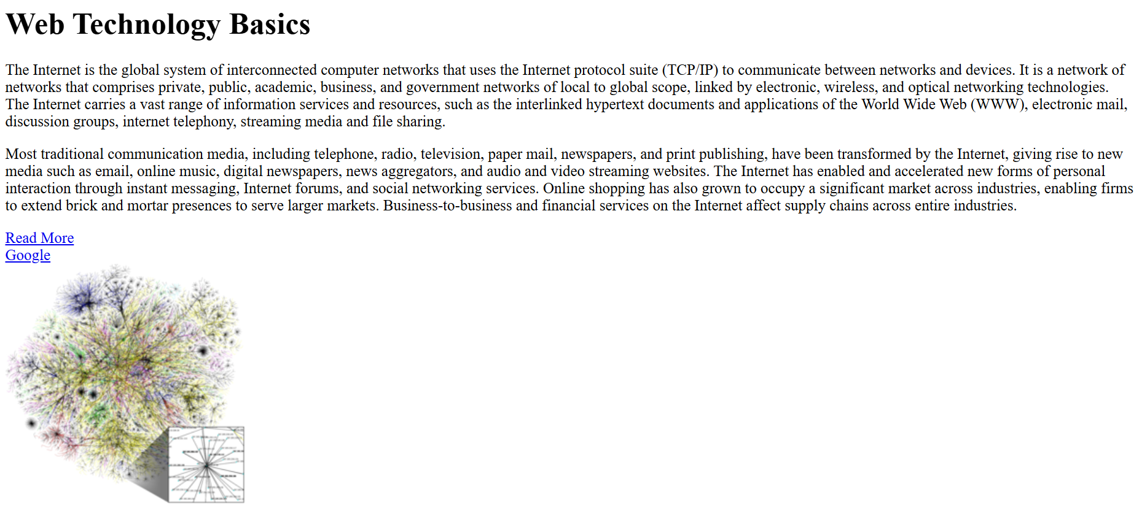
Q2. Write HTML code to generate the Lists
o Create an unordered list of at least five web browsers.
o Create an ordered list of at least five popular programming languages.
o Create a nested list showing Frontend Technologies (HTML, CSS, JavaScript) and Backend Technologies (Java,
Python, PHP).
<html>
<body>
<h3>Unordered List of 5 Web Browsers</h3>
<ul>
<li>Google Chrome</li>
<li>Microsoft Edge</li>
<li>Mozilla Firefox</li>
<li>Safari</li>
<li>Brave</li>
</ul>
<h3>Ordered List of 5 Programming Language</h3>
<ol>
<li>Python</li>
<li>JavaScript</li>
<li>Java</li>
<li>C++</li>
<li>C#</li>
</ol>
<h3>Nested List</h3>
<ul>
<li>Frontend Technologies</li>
<ol>
<li>HTML</li>
<li>CSS</li>
<li>JavaScript</li>
</ol>
<li>Backend Technologies</li>
<ol>
<li>Java</li>
<li>Python</li>
<li>PHP</li>
</ol>
</ul>
</body>
</html>
Output:
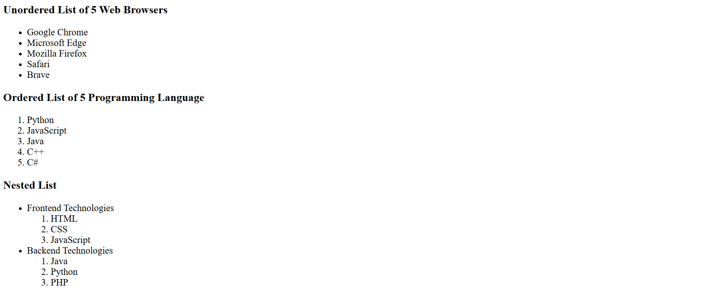

Q3. Write an HTML snippet to display the following text using proper formatting tags:
o Display the sentence "Internet and Web Technology" in bold.
o Display the word "HTML" in italic.
o Display the phrase "Core Concepts" with an underline.
o Write the formula for the square of a binomial:
(A + B)² = A² + 2AB + B²
o Write the chemical formula for water as: H₂O
<html>
<body>
<p><b>Internet and Web Technology</b></p>
<p><i>HTML</i></p>
<p><u>Core Concepts</u></p>
<p>(A + B)<sup>2</sup> = A<sup>2</sup> + B<sup>2</sup> + 2AB</p>
<p>H<sub>2</sub>O</p>
</body>
</html>
Output:
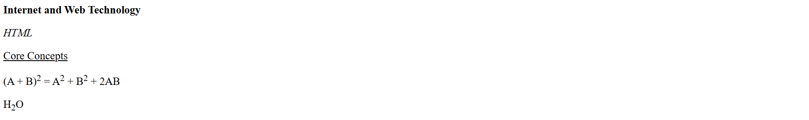

Q4. Create a navigation menu at the top with 3 links: Basic Tags, Lists, and Formatting Tags. On clicking each link,
the page should scroll to the respective section (use bookmarks/anchors).
<html>
<body>
<nav>
<a href="#basic-tags">Basic Tags</a>
<a href="#lists">Lists</a>
<a href="#formatting-tags">Formatting Tags</a>
</nav>
<section id="basic-tags">
<p>Basic Tags</p>
</section>
<section id="lists">
<p>Lists</p>
</section>
<section id="formatting-tags">
<p>Formatting Tags</p>
</section>
</body>
</html>
Output:
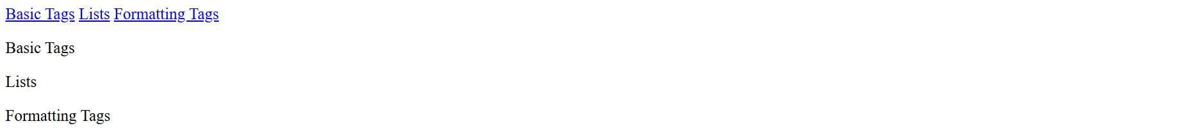

Q5. Download icons of LinkedIn and GitHub and add them to your page in such a way that once you click on them,
they will take you to your respective profiles.
<html>
<body>
<a href="https://www.github.com/Dream2503"><img src="github-logo.png" width="256" height="128"></a>
<a href="https://www.linkedin.com/in/swapnaraj-mohanty-a62905218/"><img src="linkedin-logo.png" width="128" height="128"></a>
</body>
</html>
Output:


