1. Create a heading (<h2>) with the text Hello World. Using JavaScript, change the text to
Welcome to DOM Manipulation when a button is clicked.
2. Write a paragraph of text and a button. When the button is clicked, toggle the visibility of the paragraph (show ? hide ? show). Change the button text accordingly.
3. Create three buttons: Red, Green, Blue. When a button is clicked, change the background color of a <div> accordingly. Before changing the color, ask confirmation from the user if they really want to change the background color.
4. Create a simple counter with an input box and two buttons: + and . + increases the value by 1.
decreases the value by 1 (not below 0).
5. Design a form to take a number as input and, with the help of JS, check if the number is prime or not. Display the message in an alert box.
6. You are tasked with building a currency converter app that allows users to convert amounts between different currencies. The app should have dropdown menus for selecting the source and target currencies, an input field for entering the amount to be converted, and an output field for displaying the converted amount. The conversion rates to be used are as follows:
conversionRates = {
USD: { EUR: 0.93, GBP: 0.82, INR: 82.74, AUD: 1.47 },
EUR: { USD: 1.08, GBP: 0.88, INR: 89.06, AUD: 1.58 },
GBP: { USD: 1.22, EUR: 1.14, INR: 101.5, AUD: 1.80 },
INR: { USD: 0.012, EUR: 0.011, GBP: 0.0098, AUD: 0.018 },
AUD: { USD: 0.68, EUR: 0.63, GBP: 0.55, INR: 55.87 }
};
The app should display an error message if any of the fields are empty or if the "From" and "To" currencies are the same.
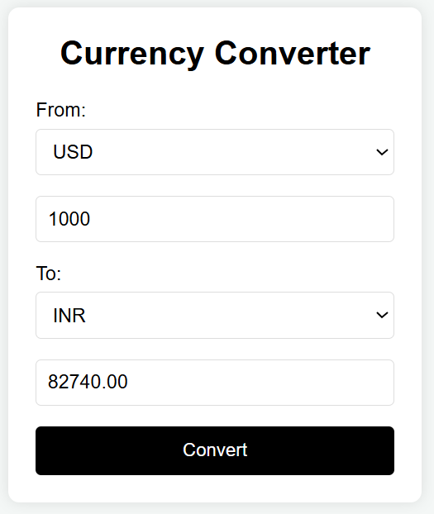

7. Create a registration form with fields for Name, Gender (radio button), Mobile, Address (textarea), Country (dropdown), Email, and Password. Use external JS to apply form validation to check
a. None of the fields should be empty.
b. Mobile number should be a 10-digit valid mobile number.
c. Email should have a valid format.
d. Length of the password must be between 6-15.

