Assignment – 9

Q1. Write a java program to creates three push buttons showing three different colors as their label. When a button is clicked, that particular color is set as background color in the frame.
import java.awt.*;
import java.awt.event.*;
class Main {
public static void main(String[] args) {
Frame frame = new Frame("Question-1");
Button button1 = new Button("Red");
Button button2 = new Button("Green");
Button button3 = new Button("Blue");
button1.setBounds(50, 70, 80, 40);
button2.setBounds(150, 70, 80, 40);
button3.setBounds(260, 70, 80, 40);
button1.addActionListener(new ActionListener() {
public void actionPerformed(ActionEvent event) {
frame.setBackground(Color.RED);
}
});
button2.addActionListener(new ActionListener() {
public void actionPerformed(ActionEvent event) {
frame.setBackground(Color.GREEN);
}
});
button3.addActionListener(new ActionListener() {
public void actionPerformed(ActionEvent event) {
frame.setBackground(Color.BLUE);
}
});
frame.addWindowListener(new WindowAdapter() {
public void windowClosing(WindowEvent event) {
System.exit(0);
}
});
frame.add(button1);
frame.add(button2);
frame.add(button3);
frame.setBackground(Color.LIGHT_GRAY);
frame.setSize(400, 300);
frame.setLayout(null);
frame.setVisible(true);
}
}

Output:
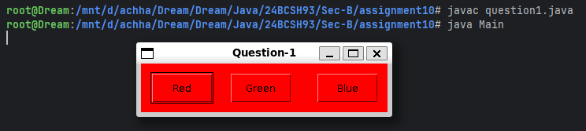
Q2. Write a java awt program, which will create 3 text field and one button labelled as Subtract. The program will take the input from the two text filed and upon pressing the Subtract button it will display the result in the third text field.
import java.awt.*;
import java.awt.event.*;
class MyFrame extends Frame {
private TextField textField1, textField2, resultField;
private Button subtractButton;
public MyFrame() {
setTitle("Question-2");
setSize(300, 250);
addWindowListener(new WindowAdapter() {
public void windowClosing(WindowEvent event) {
System.exit(0);
}
});
setLayout(null);
textField1 = new TextField();
textField2 = new TextField();
resultField = new TextField();
resultField.setEditable(false);
subtractButton = new Button("Subtract");
textField1.setBounds(50, 70, 130, 30);
textField2.setBounds(50, 120, 130, 30);
resultField.setBounds(50, 170, 130, 30);
subtractButton.setBounds(50, 220, 130, 30);
add(textField1);
add(textField2);
add(resultField);
add(subtractButton);
subtractButton.addActionListener(new ActionListener() {
public void actionPerformed(ActionEvent event) {
try {
int num1 = Integer.parseInt(textField1.getText());
int num2 = Integer.parseInt(textField2.getText());
int result = num1 - num2;
resultField.setText(Integer.toString(result));
} catch (NumberFormatException e) {
resultField.setText("Invalid Input");
}
}
});
}
}
class Main {
public static void main(String[] args) {
MyFrame frame = new MyFrame();
frame.setVisible(true);
}
}
Output:
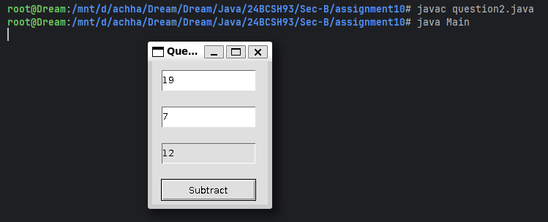
Q3. Write a java awt program, which will create 3 text field and two buttons labelled as Add and Subtract. The program will take the input from the two text filed and upon pressing the Add or Subtract button it will display the result in the third text field.
import java.awt.*;
import java.awt.event.*;
class MyFrame extends Frame {
private TextField textField1, textField2, resultField;
private Button addButton, subtractButton;
public MyFrame() {
setTitle("Question-3");
setSize(300, 250);
this.addWindowListener(new WindowAdapter() {
public void windowClosing(WindowEvent event) {
System.exit(0);
}
});
setLayout(null);
textField1 = new TextField();
textField2 = new TextField();
resultField = new TextField();
resultField.setEditable(false);
addButton = new Button("+");
subtractButton = new Button("-");
textField1.setBounds(70, 70, 130, 30);
textField2.setBounds(70, 120, 130, 30);
resultField.setBounds(70, 170, 130, 30);
addButton.setBounds(50, 220, 80, 40);
subtractButton.setBounds(150, 220, 80, 40);
add(textField1);
add(textField2);
add(resultField);
add(addButton);
add(subtractButton);
addButton.addActionListener(new ActionListener() {
public void actionPerformed(ActionEvent event) {
try {
int num1 = Integer.parseInt(textField1.getText());
int num2 = Integer.parseInt(textField2.getText());
resultField.setText(Integer.toString(num1 + num2));
} catch (NumberFormatException e) {
resultField.setText("Invalid Input");
}
}
});
subtractButton.addActionListener(new ActionListener() {
public void actionPerformed(ActionEvent event) {
try {
int num1 = Integer.parseInt(textField1.getText());
int num2 = Integer.parseInt(textField2.getText());
resultField.setText(Integer.toString(num1 - num2));
} catch (NumberFormatException e) {
resultField.setText("Invalid Input");
}
}
});
}
}
class Main {
public static void main(String[] args) {
MyFrame frame = new MyFrame();
frame.setVisible(true);
}
}

Output:
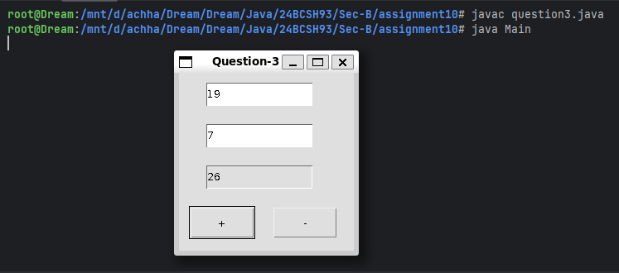
Q4. Write a java awt program, which will create 2 text field and one button labelled as Factorial. The user will enter a number in the 1st text field and upon pressing the button it will display the Factorial of the number in the 2nd text field.
import java.awt.*;
import java.awt.event.*;
class MyFrame extends Frame {
private TextField textField1, resultField;
private Button factorialButton;
public MyFrame() {
setTitle("Question-4");
setSize(300, 250);
this.addWindowListener(new WindowAdapter() {
public void windowClosing(WindowEvent event) {
System.exit(0);
}
});
setLayout(null);
textField1 = new TextField();
resultField = new TextField();
resultField.setEditable(false);
factorialButton = new Button("Factorial");
textField1.setBounds(50, 70, 130, 30);
resultField.setBounds(50, 120, 130, 30);
factorialButton.setBounds(50, 170, 130, 30);
add(textField1);
add(resultField);
add(factorialButton);
factorialButton.addActionListener(new ActionListener() {
public void actionPerformed(ActionEvent event) {
try {
int n = Integer.parseInt(textField1.getText());
int fact = 1;
for (int i = 2; i <= n; i++) {
fact *= i;
}
resultField.setText(Integer.toString(fact));
} catch (NumberFormatException e) {
resultField.setText("Invalid Input");
}
}
});
}
}
class Main {
public static void main(String[] args) {
MyFrame frame = new MyFrame();
frame.setVisible(true);
}
}
Output:
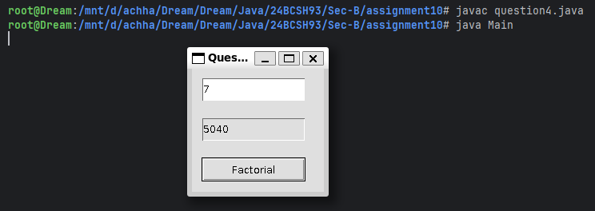
Q5. Write a java awt program, which will create 2 text field and one button labelled as Reverse. The user will enter a number in the 1st text field and upon pressing the button it will display the reverse of the number in the 2nd text field.
import java.awt.*;
import java.awt.event.*;
class MyFrame extends Frame {
private TextField textField1, resultField;
private Button reverseButton;
public MyFrame() {
setTitle("Question-5");
setSize(300, 250);
this.addWindowListener(new WindowAdapter() {
public void windowClosing(WindowEvent event) {
System.exit(0);
}
});
setLayout(null);
textField1 = new TextField();
resultField = new TextField();
resultField.setEditable(false);
reverseButton = new Button("Reverse");
textField1.setBounds(50, 70, 130, 30);
resultField.setBounds(50, 120, 130, 30);
reverseButton.setBounds(50, 170, 130, 30);
add(textField1);
add(resultField);
add(reverseButton);
reverseButton.addActionListener(new ActionListener() {
public void actionPerformed(ActionEvent event) {
try {
int n = Integer.parseInt(textField1.getText());
int reverse = 0;
while (n != 0) {
reverse = reverse * 10 + n % 10;
n /= 10;
}
resultField.setText(Integer.toString(reverse));
} catch (NumberFormatException e) {
resultField.setText("Invalid Input");
}
}
});
}
}
class Main {
public static void main(String[] args) {
MyFrame frame = new MyFrame();
frame.setVisible(true);
}
}
Output:
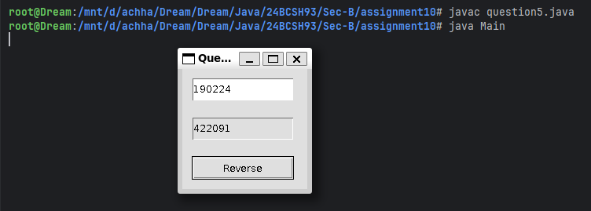

Q6. Design an AWT GUI application (called AWT Counter). Each time the "Count" button is clicked, the counter value should increase by 1 and each time the Reset button is clicked the counter value should be reset to zero.
import java.awt.*;
import java.awt.event.*;
class MyFrame extends Frame {
private int count = 0;
private TextField textField1;
private Button countButton, resetButton;
public MyFrame() {
setTitle("Question-6");
setSize(300, 250);
this.addWindowListener(new WindowAdapter() {
public void windowClosing(WindowEvent event) {
System.exit(0);
}
});
setLayout(null);
textField1 = new TextField();
textField1.setEditable(false);
countButton = new Button("Count");
resetButton = new Button("Reset");
textField1.setBounds(50, 70, 130, 30);
countButton.setBounds(200, 70, 80, 30);
resetButton.setBounds(50, 120, 80, 30);
add(textField1);
add(countButton);
add(resetButton);
textField1.setText(Integer.toString(count));
countButton.addActionListener(new ActionListener() {
public void actionPerformed(ActionEvent event) {
try {
textField1.setText(Integer.toString(++count));
} catch (NumberFormatException e) {
textField1.setText("Invalid Input");
}
}
});
resetButton.addActionListener(new ActionListener() {
public void actionPerformed(ActionEvent event) {
try {
count = 0;
textField1.setText(Integer.toString(count));
} catch (NumberFormatException e) {
textField1.setText("Invalid Input");
}
}
});
}
}
class Main {
public static void main(String[] args) {
MyFrame frame = new MyFrame();
frame.setVisible(true);
}
}
Output:
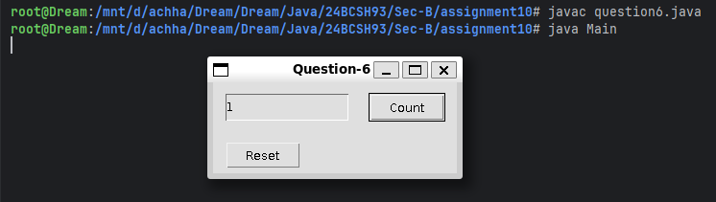
Q7. Create three color buttons (with caption “Red”, “Blue” and “Green”) and a text label. Initially the text should be displayed in black color. When the user clicks on a particular color button the text should be changed to that particular color as shown in the figure.
import java.awt.*;
import java.awt.event.*;
class Main {
public static void main(String[] args) {
Frame frame = new Frame("Question-7");
Label label = new Label("Welcome");
label.setAlignment(Label.CENTER);
label.setFont(new Font("Roboto Condensed Light", Font.BOLD, 20));
Button button1 = new Button("Red");
Button button2 = new Button("Green");
Button button3 = new Button("Blue");
button1.setBounds(50, 70, 80, 40);
button2.setBounds(150, 70, 80, 40);
button3.setBounds(260, 70, 80, 40);
label.setBounds(140, 120, 100, 80);
button1.addActionListener(new ActionListener() {
public void actionPerformed(ActionEvent event) {
label.setForeground(Color.RED);
}
});
button2.addActionListener(new ActionListener() {
public void actionPerformed(ActionEvent event) {
label.setForeground(Color.GREEN);
}
});
button3.addActionListener(new ActionListener() {
public void actionPerformed(ActionEvent event) {
label.setForeground(Color.BLUE);
}
});
frame.addWindowListener(new WindowAdapter() {
public void windowClosing(WindowEvent event) {
System.exit(0);
}
});
frame.add(button1);
frame.add(button2);
frame.add(button3);
frame.add(label);
frame.setSize(400, 300);
frame.setLayout(null);
frame.setVisible(true);
}
}
Output:
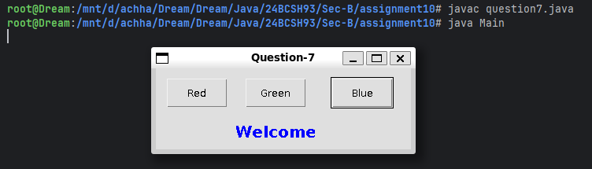
Q8. Write a AWT program, which creates 2 text field with two labels and one button labelled as Count. The program will take the input from one text filed. When we click the button it will count the number of digits of the given number and display the result in the second field. Label one will be written as "Input number" and second label will show "Number of digits: ".
import java.awt.*;
import java.awt.event.*;
class MyFrame extends Frame {
private TextField textField1, resultField;
private Button digitsButton;
private Label label1, label2;
public MyFrame() {
setTitle("Question-8");
setSize(300, 250);
this.addWindowListener(new WindowAdapter() {
public void windowClosing(WindowEvent event) {
System.exit(0);
}
});
setLayout(null);
textField1 = new TextField();
resultField = new TextField();
resultField.setEditable(false);
digitsButton = new Button("Compute");
label1 = new Label("Input number");
label2 = new Label("Number of digits");
label1.setBounds(50, 70, 130, 30);
textField1.setBounds(150, 70, 130, 30);
label2.setBounds(50, 120, 130, 30);
resultField.setBounds(150, 120, 130, 30);
digitsButton.setBounds(80, 170, 130, 30);
add(textField1);
add(resultField);
add(digitsButton);
add(label1);
add(label2);
digitsButton.addActionListener(new ActionListener() {
public void actionPerformed(ActionEvent event) {
try {
int n = Integer.parseInt(textField1.getText());
int res = 0;
while (n != 0) {
res++;
n /= 10;
}
resultField.setText(Integer.toString(res));
} catch (NumberFormatException e) {
resultField.setText("Invalid Input");
}
}
});
}
}
class Main {
public static void main(String[] args) {
MyFrame frame = new MyFrame();
frame.setBackground(Color.LIGHT_GRAY);
frame.setVisible(true);
}
}
Output:
