Experiment – 9
Verilog code for designing Negative-Edge JK Flip-Flop.
design.sv
module negedge_jk_flipflop (CLK, not_RST, not_PRE, {J, K}, Q, not_Q);
input CLK, not_RST, not_PRE, J, K;
output reg Q, not_Q;
always @(negedge CLK or negedge not_RST or negedge not_PRE) begin
if (not_RST & not_PRE) begin
case ({J, K})
2'b00:
{Q, not_Q} <= {Q, not_Q};
2'b01:
{Q, not_Q} <= 2'b01;
2'b10:
{Q, not_Q} <= 2'b10;
2'b11:
{Q, not_Q} <= {not_Q, Q};
endcase
end else if (~not_RST) begin
{Q, not_Q} <= 2'b01;
end else begin
{Q, not_Q} <= 2'b10;
end
end
endmodule
Verilog code for designing Negative-Edge 3-bit Up Counter using JK Flip-Flop.
design.sv
module negedge_3bit_up_counter(CLK, not_RST, not_PRE, Q0, Q1, Q2);
input CLK, not_RST, not_PRE;
output reg Q0, Q1, Q2;
wire not_Q0, not_Q1, not_Q2;
negedge_jk_flipflop FF2(CLK, not_RST, not_PRE, 2'b11, Q0, not_Q0);
negedge_jk_flipflop FF1(Q0, not_RST, not_PRE, 2'b11, Q1, not_Q1);
negedge_jk_flipflop FF0(Q1, not_RST, not_PRE, 2'b11, Q2, not_Q2);
endmodule
testbench.sv
module negedge_3bit_up_counter_test();
reg CLK, not_RST, not_PRE;
wire Q0, Q1, Q2;
negedge_3bit_up_counter negedge_3bit_up_counter_dut(CLK, not_RST, not_PRE, Q0, Q1, Q2);
initial begin
CLK = 1;
forever #5 CLK = ~CLK;
end
initial begin
not_RST = 0; not_PRE = 1; #10;
not_RST = 1; not_PRE = 1; #80;
$finish;
end
initial begin
$dumpfile("test.vcd");
$dumpvars(1, negedge_3bit_up_counter_test);
end
endmodule
Output Waveform
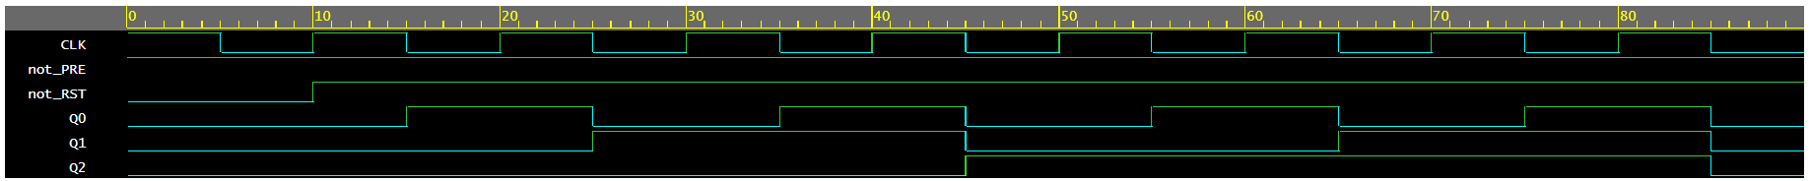

Verilog code for designing Negative-Edge 3-bit Down Counter using JK Flip-Flop.
design.sv
module negedge_3bit_down_counter(CLK, not_RST, not_PRE, Q0, Q1, Q2);
input CLK, not_RST, not_PRE;
output reg Q0, Q1, Q2;
wire not_Q0, not_Q1, not_Q2;
negedge_jk_flipflop FF2(CLK, not_RST, not_PRE, 2'b11, Q0, not_Q0);
negedge_jk_flipflop FF1(not_Q0, not_RST, not_PRE, 2'b11, Q1, not_Q1);
negedge_jk_flipflop FF0(not_Q1, not_RST, not_PRE, 2'b11, Q2, not_Q2);
endmodule
testbench.sv
module negedge_3bit_down_counter_test();
reg CLK, not_RST, not_PRE;
wire Q0, Q1, Q2;
negedge_3bit_down_counter negedge_3bit_down_counter_dut(CLK, not_RST, not_PRE, Q0, Q1, Q2);
initial begin
CLK = 1;
forever #5 CLK = ~CLK;
end
initial begin
not_RST = 1; not_PRE = 0; #10;
not_RST = 1; not_PRE = 1; #80;
$finish;
end

initial begin
$dumpfile("test.vcd");
$dumpvars(1, negedge_3bit_down_counter_test);
end
endmodule
Output Waveform
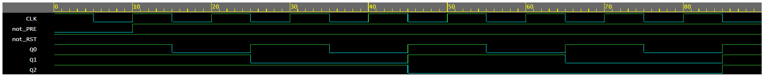

Verilog code for designing Positive-Edge JK Flip-Flop.
design.sv
module posedge_jk_flipflop (CLK, not_RST, not_PRE, {J, K}, Q, not_Q);
input CLK, not_RST, not_PRE, J, K;
output reg Q, not_Q;
always @(posedge CLK or negedge not_RST or negedge not_PRE) begin
if (not_RST & not_PRE) begin
case ({J, K})
2'b00:
{Q, not_Q} <= {Q, not_Q};
2'b01:
{Q, not_Q} <= 2'b01;
2'b10:
{Q, not_Q} <= 2'b10;
2'b11:
{Q, not_Q} <= {not_Q, Q};
endcase
end else if (~not_RST) begin
{Q, not_Q} <= 2'b01;
end else begin
{Q, not_Q} <= 2'b10;
end
end
endmodule

Verilog code for designing Positive-Edge 3-bit Up Counter using JK Flip-Flop.
design.sv
module posedge_3bit_up_counter(CLK, not_RST, not_PRE, Q0, Q1, Q2);
input CLK, not_RST, not_PRE;
output reg Q0, Q1, Q2;
wire not_Q0, not_Q1, not_Q2;
posedge_jk_flipflop FF2(CLK, not_RST, not_PRE, 2'b11, Q0, not_Q0);
posedge_jk_flipflop FF1(not_Q0, not_RST, not_PRE, 2'b11, Q1, not_Q1);
posedge_jk_flipflop FF0(not_Q1, not_RST, not_PRE, 2'b11, Q2, not_Q2);
endmodule
testbench.sv
module posedge_3bit_up_counter_test();
reg CLK, not_RST, not_PRE;
wire Q0, Q1, Q2;
posedge_3bit_up_counter posedge_3bit_up_counter_dut(CLK, not_RST, not_PRE, Q0, Q1, Q2);
initial begin
CLK = 0;
forever #5 CLK = ~CLK;
end
initial begin
not_RST = 0; not_PRE = 1; #10;
not_RST = 1; not_PRE = 1; #80;
$finish;
end
initial begin
$dumpfile("test.vcd");
$dumpvars(1, posedge_3bit_up_counter_test);
end
endmodule
Output Waveform
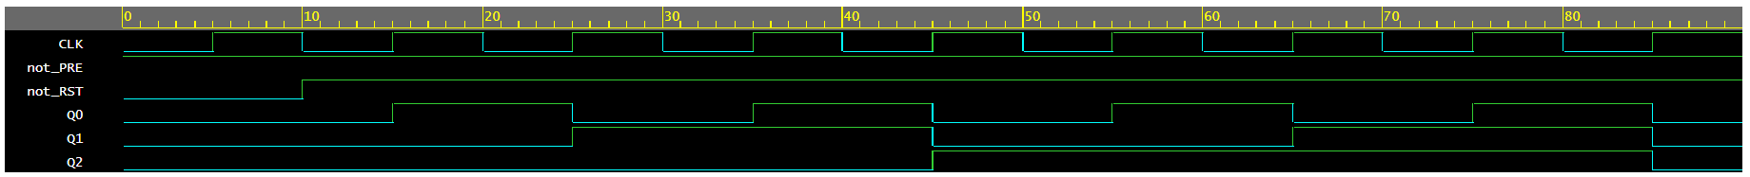

Verilog code for designing Positive-Edge 3-bit Down Counter using JK Flip-Flop.
design.sv
module posedge_3bit_down_counter(CLK, not_RST, not_PRE, Q0, Q1, Q2);
input CLK, not_RST, not_PRE;
output reg Q0, Q1, Q2;
wire not_Q0, not_Q1, not_Q2;
posedge_jk_flipflop FF2(CLK, not_RST, not_PRE, 2'b11, Q0, not_Q0);
posedge_jk_flipflop FF1(Q0, not_RST, not_PRE, 2'b11, Q1, not_Q1);
posedge_jk_flipflop FF0(Q1, not_RST, not_PRE, 2'b11, Q2, not_Q2);
endmodule
testbench.sv
module posedge_3bit_down_counter_test();
reg CLK, not_RST, not_PRE;
wire Q0, Q1, Q2;
posedge_3bit_down_counter posedge_3bit_down_counter_dut(CLK, not_RST, not_PRE, Q0, Q1, Q2);
initial begin
CLK = 0;
forever #5 CLK = ~CLK;
end
initial begin
not_RST = 1; not_PRE = 0; #10;
not_RST = 1; not_PRE = 1; #80;
$finish;
end
initial begin
$dumpfile("test.vcd");
$dumpvars(1, posedge_3bit_down_counter_test);
end
endmodule
Output Waveform
