Assignment – 9

Q1. Write a JAVA program to read a string from the key board and print its reverse. Also check whether the string is palindrome or not.
import java.util.Scanner;
class Main {
public static void main(String[] args) {
Scanner sc = new Scanner(System.in);
System.out.print("Enter a String: ");
String string = sc.next();
StringBuilder reversed = new StringBuilder(string).reverse();
System.out.println("Reversed String is: " + reversed);
if (string.contentEquals(reversed)) {
System.out.println(string + " is a palindrome");
} else {
System.out.println(string + " is not a palindrome");
}
}
}
Output:
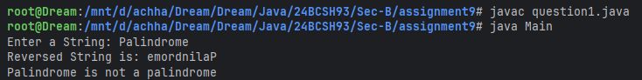
Q2. Write a JAVA program to capitalize first letter of each word in an inputted sentence from keyboard.
Sample Output:
Enter a sentence: india is great
India Is Great
import java.util.Scanner;
class Main {
public static void main(String[] args) {
Scanner sc = new Scanner(System.in);
System.out.print("Enter a sentence: ");
String string = sc.nextLine();
StringBuilder stringBuilder = new StringBuilder(string.length() + 1);
for (String word : string.split(" ")) {
stringBuilder.append(Character.toUpperCase(word.charAt(0))).append(word.substring(1)).append(' ');
}
System.out.println("Transformed String is: " + stringBuilder);
}
}
Output:
Q3. Write a JAVA program to convert a string into uppercase.
import java.util.Scanner;
class Main {
public static void main(String[] args) {
Scanner sc = new Scanner(System.in);
System.out.print("Enter a String: ");
System.out.println("Upper-Case String is: " + sc.nextLine().toUpperCase());
}
}
Output:
Q4. Write a Java program to input a string and print the total number of characters present in the string.
import java.util.Scanner;
class Main {
public static void main(String[] args) {
Scanner sc = new Scanner(System.in);
System.out.print("Enter a String: ");
System.out.println("Total number of characters present: " + sc.nextLine().length());
}
}
Output:
Q5. Write a java program to replace a substring with another string.
import java.util.Scanner;
class Main {
public static void main(String[] args) {
Scanner sc = new Scanner(System.in);
System.out.print("Enter a String: ");
String string = sc.nextLine();
System.out.print("Enter the Sub-String: ");
String subString = sc.nextLine();
System.out.print("Enter the String to replace with: ");
String replaceWith = sc.nextLine();
System.out.println("String after sub-string replacement: " + string.replace(subString, replaceWith));
}
}
Output:
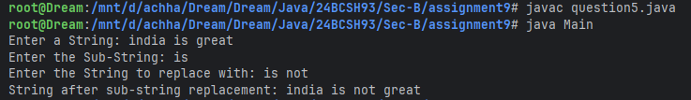

Q6. Write a program that computes your initials from your full name and displays them.
import java.util.Scanner;
class Main {
public static void main(String[] args) {
Scanner sc = new Scanner(System.in);
System.out.print("Enter your full name: ");
String string = sc.nextLine();
String[] words = string.split(" ");
StringBuilder stringBuilder = new StringBuilder(words.length);
for (String word : words) {
stringBuilder.append(Character.toUpperCase(word.charAt(0)));
}
System.out.println("Initials String is: " + stringBuilder);
}
}
Output:
Q7. Write a program that receives two strings and check whether they are equal or not.
import java.util.Scanner;
class Main {
public static void main(String[] args) {
Scanner sc = new Scanner(System.in);
System.out.print("Enter a String: ");
String string1 = sc.next();
System.out.print("Enter a String: ");
String string2 = sc.next();
if (string1.equals(string2)) {
System.out.println(string1 + " and " + string2 + " are equal");
} else {
System.out.println(string1 + " and " + string2 + " are not equal");
}
}
}
Output:
